Name………………………………………………………. Adm No…………………………..

Class……………………………….
121/1
Mathematics
Paper 1
2 ½ Hours
JULY/AUG 2014

BUSIA COUNTY JOINT EVALUATION TEST -2014
Kenya Certificate of Secondary Education ( K.C.S.E )

INSTRUCTIONS TO CANDIDATES

- Write your name and Admission number in the spaces provided at the top of this page.
- This paper consists of two sections: Section I and Section II.
- Answer ALL questions in section 1 and ONLY FIVE questions from section II
- All answers and workings must be written on the question paper in the spaces provided below each question.
- Show all the steps in your calculation, giving your answer at each stage in the spaces below each question.
- Non – Programmable silent electronic calculators and KNEC mathematical tables may be used, except where stated otherwise.

FOR EXAMINERS USE ONLY
SECTION I
1 | 2 | 3 | 4 | 5 | 6 | 7 | 8 | 9 | 10 | 11 | 12 | 13 | 14 | 15 | 16 | TOTAL

SECTION II GRAND TOTAL

17 | 18 | 19 | 20 | 21 | 22 | 23 | 24 | TOTAL

SECTION I ( 50 MARKS )
Answer ALL Questions in this Section
1. Evaluate the following; (3 marks)

- Use square roots, reciprocal and square tables to evaluate to 4 significant figures the expression; ( 4 marks)
$${\left(0.06458\right)}^{\frac{1}{2}}+ {\left(\frac{2}{0.4327}\right)}^{2}$$

- Solve for x in the equation (3mks)

4. The points A, B and C lie on a straight line. The position vectors of A and C are
2i + 3j + 9k and 5i – 3j + 4k respectively; B divides AC internally in the ration 2:1. Find
the
- Position vector of B. (2 marks)

(b) Distance of B from the origin. (1 mark)

- Without using tables, evaluate $\frac{0.51 X 5700}{6.8 X 0.0095}$ giving the answer in standard form
(3 marks)

- Evaluate (3 marks)

- Simplify (3 marks)

- What is the equation of the circle whose center lies on the line y - 2y + 2 = 0 and which touches the positive axes? (3 Marks)

- Find the value of x in the equation in the range listed below.
0º ≤ x ≤ 180º (3mks)

10. A farmer has a piece of land measuring 840m by 396m. He divides it into square plots of equal size. Find the maximum area of one plot. (3 marks)

11. Give the equation of the normal to the curve y = x³ + 2x + 1 at (1, 4) ( 3 marks)

12. The position of two towns P and Q are given as P(45ºN, 10ºW) and Q(45ºN,170ºE).Calculate the difference in distance (i) Through the North Pole and (ii) along the parallel of latitude in nautical miles. (3 marks)

13. A liquid spray of mass 384g is packed in a cylindrical container of internal radius 3.2 cm. Given that the density of the liquid is 0.6g/cm³, calculate to 2dp the height of the liquid in the container. (3 marks)

- (a) Find the inverse of the matrix $\left(\begin{matrix}4 & 3 \\ 3 & 5\end{matrix}\right)$ ( 1 mark)

(b) Hence solve the simultaneous equation using the matrix method ( 2 marks)
4x +3y = 6
3x + 5y = 5

15. Find the percentage error in the total length of four rods measuring 12.5cm, 24.5cm, 12.9cm and 10.1cm all to the nearest 0.1cm. (3 marks)

16. The following data was obtained from the mass of a certain animal. Complete the table and the histogram below. (3 marks)
Mass(kg) | frequency
41-50 | 20
51-55
56-65 | 40
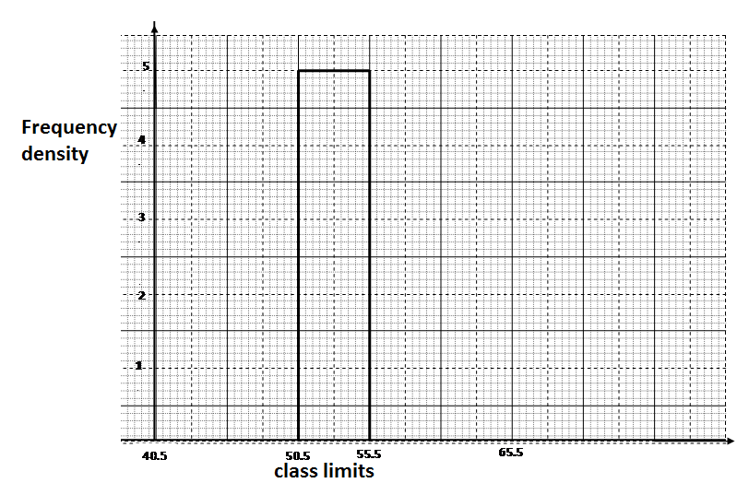

SECTION II ( 50 MARKS )
Answer any Five Questions in this Section
17. A businessman obtained a loan of Kshs.450,000 from a bank to buy a matatu valued at the same amount. The bank charges interest at 24% per annum compound quarterly:
(a) Calculate the total amount of money the businessman paid to clear the loan in 1½ years. (4 marks)

(b) The average income realized from the matatu per day was Kshs.1500. The matatu
worked for 3 years at an average of 280 days per year. Calculate the total income from
the matatu. (2 marks)

(c) During the three years, the value of the matatu depreciated at the rate of 16%per
annum. If the businessman sold the matatu at its new value, calculate the total profit he realized by the end of three years. (4 marks)

18. PQRS is a regular tetrahedron of side 4cm.
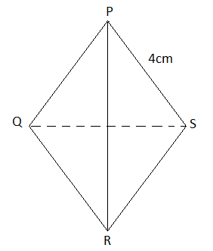
- Calculate the angle between planes PSR and QRS ( 4 marks)

- Calculate the volume of the Tetrahedron ( 6 marks)

19. (a) The first term of an Arithmetic Progression(AP) is 2. The sum of the first 8 terms of the
AP is 156.
(i) Find the common difference of the AP. (2 marks)

(ii) Given that the sum of the first n terms of the AP is 416, find n. (2 marks)

- The third, fifth and eighth terms of another AP form the first three consecutive terms of a Geometric Progression (GP). If the common difference of the AP is 3, find
  - The first term of the GP; (4 marks)

  - The sum of the first 9 terms of the GP, to 4 significant figures. (2 marks)

20. Using a ruler and compasses only, construct a triangle ABC such that BC = 8cm, angle
ABC = 60⁰ and angle BAC = 45⁰.

(a) On the same diagram, measure the length of : (5 marks)
(i) AC
(ii) BC

(b) Draw the circumcircle of the triangle ABC. (2 marks)

(c) Construct the locus of a point P within the triangle by shading the unwanted region inside the circumcircle such that the following conditions are satisfied: (3 marks)
(i) P is closer to A than B.
(ii) Angle PAB angle PAC.

21. (i) By calculations show that y = x³ – 3x² + 2x and y + 3 = 3x intersect at x = -1, 1 and 3 (3 marks)

- Sketch the curve and the line on the same axis, hence calculate the area enclosed by the curve, lines x = 0 and y + 3 = 3x (7 marks)

22. In the figure below DA is a diameter of the circle ABCDE centre O. TCS is a tangent to the circle at C, AB = BC and angle DAC = 38⁰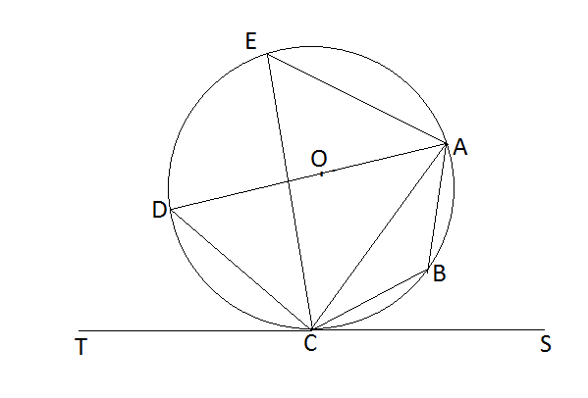
Giving reasons, determine the following angles:
(a) (2 marks)

(b) (2 marks)

(c) (2 marks)

(d) (2 marks)

(e) (2 marks)

23. The coordinates of a triangle ABC are A(1, 1) B(3, 1) and C (1, 3).
(a) Plot the triangle ABC. (1 mark)
(b) Triangle ABC undergoes a translation vector$\left(\begin{matrix}2 \\ 2\end{matrix} \right)$. Obtain the image of A' B' C ' under the transformation, write the coordinates of A' B' C'. (2 marks)
(c) A' B' C' undergoes a reflection along the line X = 0, obtain the coordinates and plot on the graph points A" B" C", under the transformation (2 marks)
(d) The triangle A" B" C" , undergoes an enlargement scale factor -1, centre origin. Obtain the coordinates of the image A'" B"' C"'. (2 marks)
(e) The triangle A"' B"' C"' undergoes a rotation centre (1, -2) angle 120⁰. Obtain the coordinates of the image A^{iv} B^{iv} C^{iv}. (2 marks)
(f) Which triangles are directly congruent. (1 mark)

24. A matatu and Nissan left town A for town B 240km away at 8.00a.m travelling at 90km/hr and 120km/hr respectively. After 20 minutes the Nissan had a puncture which took 30 minutes to mend.
a) How far from town A did the Nissan catch up with the matatu? (6 marks)

b) At what time did the Nissan catch up with the matatu? (1 mark)

c) At what time did the matatu reach town B? (3 marks)

