NAME ........................................................... SCHOOL .........................ADM.NO. .....................

INDEX NO. ...................................................DATE .........................SIGN. .................................

KASSU JET – JUNE 2013
Kenya Certificate of Secondary Education
Physics Paper 2
2 Hours

INSTRUCTIONS TO CANDIDATES:

- Write your name, school, admission number and index number is the spaces provided above.
- Sign and write the date of examination in the spaces above.
- Answer ALL the questions in section A and B in the spaces provided.
- All working MUST be clearly shown.
- Non-programmable silent electronic calculators and KNEC mathematical tables may be used.
- This paper consists of 15 pages.
- Candidates should check the question paper to ascertain that ALL the pages are printed and that no questions are missing.

FOR EXAMINER’S USE ONLY.

SECTION | QUESTIONS | MAX. SCORE | CANDIDATE’S SCORE
A | 1 -11 | 25
B | 12 | 8
 | 13 | 15
 | 14 | 16
 | 15 | 7
 | 16 | 9
 | TOTAL | 80
- In the figure below the lamps in the two circuits, A and B are identical and the cells have the same electromotive force.
(A)
(B)
Lamp

Explain why the lamps in B may glow brighter than those in A when the circuits are closed at
the same time.

..................................................................................................................................................................................................................................................................................................................................................................................................................................................................
.....................................................................................................................................(2 marks)
- The figure below shows two rays drawn from an object on to the mirror.

Mirror
Object

Complete the ray diagram to show the position of the image. (2 marks)

- (a) A compass needle is placed below a current carrying conductor as shown below.

N
Conductor

Indicate on the diagram the direction of the current. (1 mark)

(b) State the difference between a soft magnetic material and a hard magnetic material.
..............................................................................................................................................................................................................................................................................................................................................................................................................................
(1 mark)
- (a) Define diffraction with respect to waves.
................................................................................................................................................................................................................................................................................................
(1 mark)
(b) In the diagram below the size of the aperture at the barrier is 10cm while the distance
Wave front
Barrier
between two consecutive wave fronts is 3cm. If the waves are moving towards the barrier, draw the wave fronts as they appear after passing through the aperture. (2 marks)

- The figure below shows a set up used to study sound waves.
Metal plate
wire
cork
air
bottle

It is observed that when the bottle is shaken sound from the metal plates is heard. State and explain the observation that would be made if a little hot water is poured into the bottle then the cork is tightly replaced and the bottle shaken.
...............................................................................................................................................................................................................................................................................................................................................................................................................................................................................................................................................................................................................................................................................................................................(2 marks)
- The figure below (drawn to scale) shows the image I, formed by a convex mirror. F is the virtual principal focus of the mirror.

I
F

Using ray diagrams locate the position of the object and draw the object. (3 marks)

- State and explain two factors affecting the strength of an electromagnet.
........................................................................................................................................................................................................................................................................................................................................................................................................................................................................................................................................................................................................(2 marks)
- An alternating voltage of peak value 15v and frequency 25Hz is applied to the terminals of a Cathode ray oscilloscope. The Y-gain is set at 5 v/cm and the time base at 10 ms/cm. Draw the trace observed on the screen. (2 marks)
1cm
1cm

- (a) Name all the radiations of the electromagnetic spectrum which have higher wavelengths
than the visible light.

................................................................................................................................................................................................................................................................................................................................................................................................................................................
(1 mark)

(b) State the radiation that is detected using a blackened bulb of a thermometer.
................................................................................................................................(1 mark)

- Your house is supplied with 240 v from a power source which is fitted with a 13 A safe fuse. What is the maximum number of 60w bulbs that can be fitted in the house?

........................................................................................................................................................................................................................................................................................................................................................................................................................................................................................................................................................................................................(2 marks)
- A resistance wire is 2 m long and has a cross-sectional area of 0.50 mm². If its resistance is 2.6Ω, calculate its resistivity.

.................................................................................................................................................................................................................................................................................................................................................................................................................................................................
…………………………………………………………………………………………………...………………………………………………………………………………………………….……………………………………………………………………………………....(3 marks)

SECTION II

- (a) The figure below shows a charged electroscope and two aluminum plates A and B
Earthing
A
B
d
arranged as shown

State and explain the observations made on the leaf divergence when plate A is moved closer to B.

...............................................................................................................................................................................................................................................................................................................................................................................................................................................................................................................................................................................................
(2 marks)
- The figure below shows a circuit having the following components: a 20 v p.d. source, a voltmeter, three switches S₁, S₂ and S₃ and two capacitors C₁ and C₂ of capacitances 13µF and 8µF respectively.

C₁
C₂
S₂
v
20 v
S₁
13µF
8µF
S₃

- Determine the charge on C₁ when switches s₂ and s₃ are closed while s₁ is open
..............................................................................................................................................................................................................................................................................................................................................................................................................................
...........................................................................................................................................................................................................................................................(2 marks)
- After some time s₃ is opened and both s₁ and s₂ are closed. Find the maximum voltage,V, recorded by the voltmeter.

............................................................................................................................................................................................................................................................................................................................................................................................................
......................................................................................................................................................................................................................................................(2 marks)
- Calculate the energy stored in c₂.
............................................................................................................................................................................................................................................................................................................................................................................................................
.................................................................................................................................... ....................................................................................................................................
(2 marks)

- (a) The diagram below (drawn to scale) shows a ray of light incident on the boundary
between air and a transparent plastic block. At the boundary the ray can take either of
the two directions indicated on the diagram.

Z⁰
Air
X⁰
Y⁰
Normal
Boundary
Plastic

The two graphs below represent the variations of angles Z and Y for different sizes of incident angle, X.

P
R
O
Y
Or
Z

X

- What process is represented by:

- Line OR ...................................................................... (1 mark)

- Curve OP .................................................................... (1 mark)

- For the plastic material, determine:

- The refractive index
..................................................................................................................................................................................................................................................................................................................................................................................................................................................................................................................................................................................................................................................................................................................
(2 marks)
- The critical angle
..................................................................................................................................................................................................................................................................................................................................................................................................................................................................................................................................................................................................................................................................................................................
(2 marks)

(b) The following graph shows the variation of image distance, v, with magnification, m, for a
converging lens.
Image distance,V(cm)
10
Magnification, M
4
2
3
1
40
30
20

Using the graph and the equation $\frac{V}{f}=M+1$ to determine:
- The object position when the image position is 45cm.
..............................................................................................................................................................................................................................................................................................................................................................................................................................
...............................................................................................................................................................................................................................................................(2 marks)
- The focal length of the lens.
.....................................................................................................................................................................................................................................................................................................................................................................................................................................................................................................................................................(2 marks)

- The power of the lens.
..............................................................................................................................................................................................................................................................................................................................................................................................................................
.......................................................................................................................................... ..........................................................................................................................................
(2 marks)
(c) The following figure 4 shows an eye defect

Fig 4

Name the defect and illustrate on the same diagram how the defect could be corrected.
.................................................................................................................... (3 marks)

14. a) What do you understand by the term mutual induction?
...............................................................................................................................................................................................................................................................................................................................................................................................................................................
(1 mark).
b) State two factors that determine magnitude of e.m.f induced in a coil.
.............................................................................................................................................................................................................................................................................................................................................................................................................................................................................................................................................................................................................................................................................................................................(2 marks).

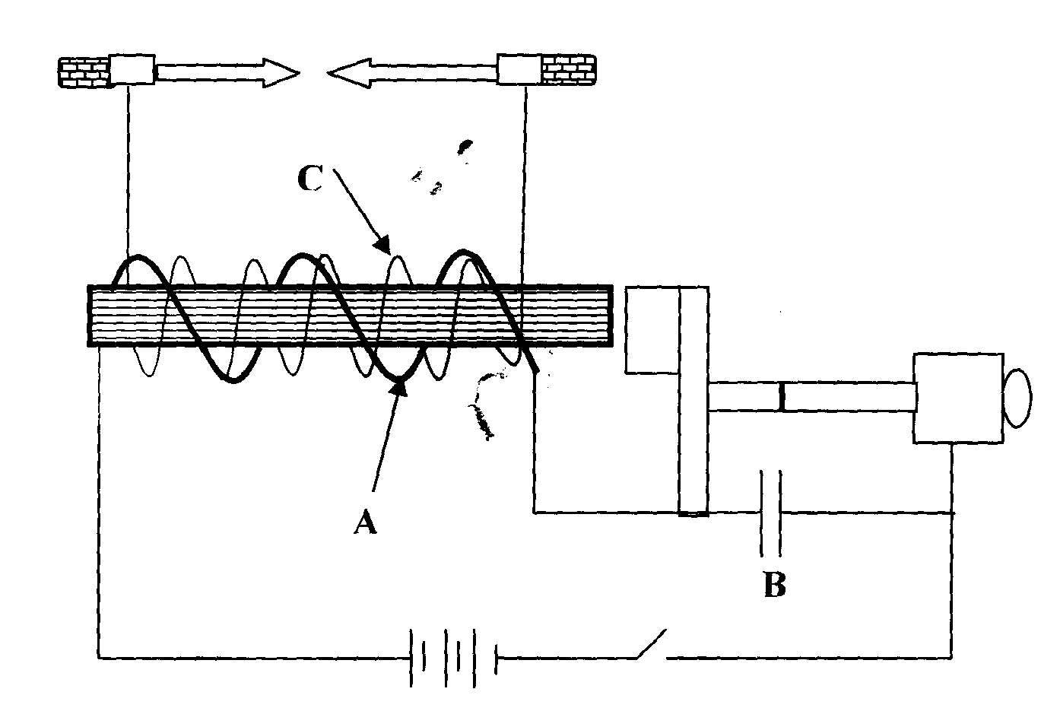
c) The diagram below shows an induction coil used to produce sparks.
armature
contact

(i) Name parts labeled A and B.
................................................................................................................................................................................................................................................................................................
(2 marks)
- Briefly explain how the induction coil works.
........................................................................................................................................................................................................................................................................................................................................................................................................................................................................................................................................................................................................................................................................................................................................................................................................................................................................................................................................(3 marks)
d) A transformer is used on a 240V a.c supply to deliver 12A at 120V to a heating coil. If 20% of energy taken from the supply is dissipated in the transformer. Calculate the current in the primary coil.

...............................................................................................................................................................................................................................................................................................................................................................................................................................................................................................................................................................................................................................................................................................................................................
(2 marks)

(e) (i) Define doping
............................................................................................................................................................................................................................................................................................................................................................................................................
(1 mark)
- With the help of a diagram, describe how a p-type semiconductor is made.

......................................................................................................................................................................................................................................................................................................................................................................................................................................................................................................................(3 marks)

- Explain what happens to the depletion layer when a diode is forward biased.
.....................................................................................................................................................................................................................................................................................................................................................................................................................................................................................................................................................................................................................................................................................................................................................................................................(2 marks)
15. (a) Define the terms:
- Work function
............................................................................................................................................................................................................................................................................................................................................................................................................
(1 mark).
- Threshold frequency.
................................................................................................................................................................................................................................................................................................................................................................................................................................................................................................................................................
(1 mark).
(b) Figure 11 shows Ultra-violet light striking a polished Zinc plate placed on a positively charged gold-leaf electroscope.

UV light
Figure 11
Zinc plate

- Explain the observations that the leaf did not fall.
........................................................................................................................................................................................................................................................................................................................................................................................................(1 marks)
(ii) In an experiment using a photocell, U.V light of varying frequency but constant intensity was made to strike a metal surface. The maximum kinetic energy (KE_{Max}) of photoelectrons for each frequency, f, was measured. The graph shows how KE_{Max} varies
2
F x 10¹⁵ Hz
8
6
4
Max. K.E.x10⁻¹⁹ J
with f.

1
3
2
4

Given that KE_{Max}=hf - Ø, determine the values:

- Constant h
...............................................................................................................................................................................................................................................................................................................................................................................................................................................................................................................................................................................................................................................................................................................................(2 marks)
II) Constant Ø
.............................................................................................................................................................................................................................................................................................................................................................................................................................................................................................................................................................................................................................................................................................................................( 2 marks)
16. (a) A G.M tube may register some effect in the absence of a radioactive source. Explain this
observation and state one cause.

...............................................................................................................................................................................................................................................................................................................................................................................................................................................................................................................................................................................................................................................................................................................................(2 marks)
(b) A radioactive element A of half life 31 days decays to element B. A sample of A of
mass 32g is kept in a container. Assuming B is stable, calculate the mass of B that will
be in the container after 124 days.

............................................................................................................................................................................................................................................................................................................................................................................................................................................................................................................................................................................................................................................................................................................................................................................................................................................................................................................................................................................................................................................................................................................................................................................(3 marks)

- The figure below shows the features of an x-ray tube.

Filament
Cathode
Copper block
Tungsten
Vacuum

- Why is a thick copper block used at the anode
....................................................................................................................................................................................................................................................................................
(1 marks)
- State how the strength of the X-rays can be increased.
........................................................................................................................................................................................................................................................................................................................................................................................................(1 marks)
- X-ray tube operates at 1000KV between the cathode and the anode. Calculate the maximum energy of the X-ray photons produced.
(charge of an electron, $e=1.6x{10}^{-19} C$ ).

.......................................................................................................................................................................................................................................................................................................................................................................................................................................................................................................................................................(2 marks)
THE END

