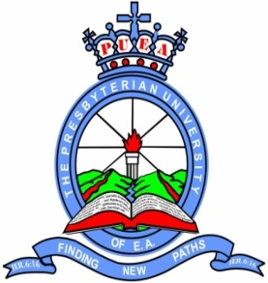

The Presbyterian University of East Africa

School: HEALTH SCIENCES
Program: DIPLOMA
Semester: FINAL QUALIFYING EXAM
Course Code: MSU 333
Course Title: SURGERY PAPER I (TRAUMATOLOGY & ORTHOPAEDIC)
Date: 5TH JULY 2012
Campus: KIKUYU

Read the instructions carefully:
- Mobile phones ARE NOT allowed in the examination room
- Time allowed is 2 Hours
- Answer ALL questions on the examination answer book provided
- No bags OR reference material of any kind should be in the examination room
- Do not write on the question paper. Any rough work should be written at the back of the examination booklet and crossed through.

- a) Describe Colle’s fracture.
b) Discuss its management and complications.

- a) Name the Types of Supracondylar fracture humerus.
b) Discuss the management
c) What are the likely complications?

- Discuss the management of compound fracture Tibia using Gustilo & Anderson classification.

- What is the current surgical management of long bone shaft fractures? Discuss

- Name three congenital malformations of the foot and discuss one, by describing clinical features and management.

- a) Define Septic arthritis
b) Discuss its causes and management.

- Discuss the investigations and management of acute esteomyelitis of the Tibia.

- Discuss the clinical features, investigations and management of TB Spine

- Name and write short notes on Benign Bone Tumours.

- Discuss the Clinical Features, investigations and management of

- Osteogenic Sarcoma
- Multiple Myeloma

