Name.................................................................................................. Index No...............................

443/1
AGRICULTURE
PAPER 1
JULY/AUGUST 2014

NAKURU DISTRICT SEC. SCHOOLS JOINT MOCK EXAMINATION 2014

AGRICULTURE
PAPER 1
2 HOURS

INSTRUCTIONS TO CANDIDATES

a) Write your name and Index number in the spaces provided above
b) This paper consists of three sections A, B and C.
c) Answer all the questions in section A and B
d) Answer any two questions in section C.

For Examiners Use only
Section | Questions | Maximum score | Candidates score
A | 1-19 | 30
B | 20-22 | 20
C | 23-25 | 40
TOTAL SCORE |  | 90

SECTION A (30 MARKS)
Answer all questions in this section in the spaces provided

1. State four factors that determine the number of cultivation on a field before it is ready for
planting (2 marks)
………………………………………………………………………………………………………………………………………………………………………………………………………………………………………………………………………………………………………………………………………………………………………………………………………………………………
2. State four advantages of using vegetative propagation instead of seed in an orange production
(2marks)
………………………………………………………………………………………………………………………………………………………………………………………………………………………………………………………………………………………………………………………………………………………………………………………………………………………………
3. State four factors which should be considered when siting compost pit (2 marks)
………………………………………………………………………………………………………………………………………………………………………………………………………………………………………………………………………………………………………………………………………………………………………………………………………………………………
4. Name two examples of working capital. (1 mark)
………………………………………………………………………………………………………………………………………………………………………………………………………………
5 State four reasons for practicing crop rotation. ( 2marks)
………………………………………………………………………………………………………………………………………………………………………………………………………………………………………………………………………………………………………………………………………………………………………………………………………………………………

6. State two growing habits that trees or shrubs for agroforestry should have. (1mark)
………………………………………………………………………………………………………………………………………………………………………………………………………………
7 State any four non-chemical methods of controlling storage pest in a maize granary (2 marks)
………………………………………………………………………………………………………………………………………………………………………………………………………………………………………………………………………………………………………………………………………………………………………………………………………………………………
8. Give two forms in which Nitrogen is absorbed from soil by plants. (1 mark)
………………………………………………………………………………………………………………………………………………………………………………………………………………
9 State four effects of excessive application of nitrogen fertilizer on crop growth. (2 marks)
………………………………………………………………………………………………………………………………………………………………………………………………………………………………………………………………………………………………………………………………………………………………………………………………………………………………
10 Give two reasons why maize should be harvested at milk stage for making silage (1 mark)
………………………………………………………………………………………………………………………………………………………………………………………………………………………………………………………………………………………………………………………
11 State four ways by which a farmer can make efficient use of a pasture crop. (2 marks)
………………………………………………………………………………………………………………………………………………………………………………………………………………………………………………………………………………………………………………………………………………………………………………………………………………………………

12 Give two ways by which overheating can be avoided in the process of making silage (1 mark)
………………………………………………………………………………………………………………………………………………………………………………………………………………
13 State four effects of excessive application of Nitrogen fertilizer on crop growth. (2 marks)
………………………………………………………………………………………………………………………………………………………………………………………………………………………………………………………………………………………………………………………………………………………………………………………………………………………………
14 State any two disadvantages of pastoral - nomadism method of farming (1 mark)
………………………………………………………………………………………………………………………………………………………………………………………………………………………………………………………………………………………………………………………………………………………………………………………………………………………………
15 Name four types of water pumps which can be used on the farm (2 marks)
………………………………………………………………………………………………………………………………………………………………………………………………………………………………………………………………………………………………………………………………………………………………………………………………………………………………
16 Outline four qualities of a mother plant from which vegetative propagation material should be
obtained (2 marks)
………………………………………………………………………………………………………………………………………………………………………………………………………………………………………………………………………………………………………………………………………………………………………………………………………………………………
17. Give two conditions under which blossom end rot disease may occur in tomatoes (1 mark)
………………………………………………………………………………………………………………………………………………………………………………………………………………

18. State two factors to consider when grading tomatoes for fresh market. (1 mark)
………………………………………………………………………………………………………………………………………………………………………………………………………………

19. Give four ways of controlling weeds in a field of maize. (2 marks)
……………………………………………………………………………………………………………………………………………………………………………………………………………………………………………………………………………………………………………………………………………………………………………………………………………………………

SECTION B. (20MARKS)
ANSWER ALL THE QUESTIONS IN THE SPACES PROVIDED
20 Below is a diagram of a nursery for raising tomato seedlings
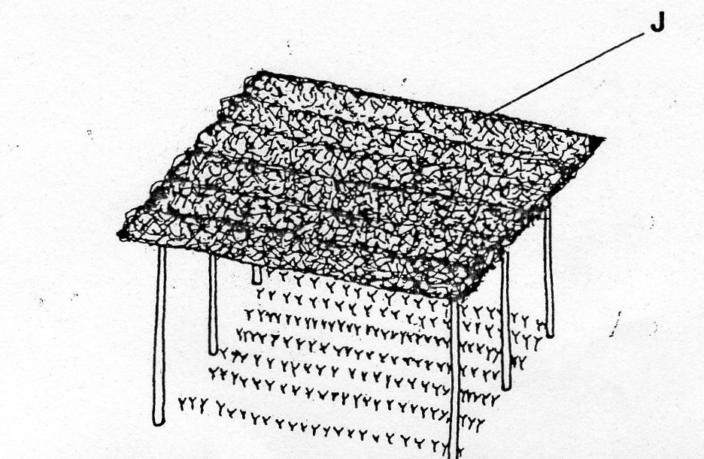
(a) State four advantages of having the part marked J. (2 marks)
……………………………………………………………………………………………………………………………………………………………………………………………………………………………………………………………………………………………………………………………………………………………………………………………………………………………

(b) State any four management practices that should be carried out on the nursery from time the
seedlings emerge to the stage of transplanting (2 marks)
………………………………………………………………………………………………………………………………………………………………………………………………………………………………………………………………………………………………………………………………………………………………………………………………………..
(c) At what stage of growth should tomato seedlings be transplanted (1 mark)
……………………………………………………………………………………………………………………………………………………………………………………………………………………………………………………………………………………………………………………………………………………………………………………………………….
(d) How would damage to the seedlings be minimized when uprooting them for transplanting?
(1mark)
…………………………………………………………………………………………………………………………………………………………………………………………………………………………………………………………………………………………………………………………………………………………………………………………………………
21 The illustrations below shows a FOUR heap system of making compost manure.
Study it and answer the questions that follow.

A
B
A
C
THE FIELD

- By use of arrows indicate how the decomposing materials should be transferred from one heap to another till the manure is applied in the field ( ½ x 4 = 2 marks)

- How long does the material take to be ready for application in the field as manure? (1 mark)

………………………………………………………………………………………….

- Give one reason for turning the material in the heaps regularly. (1 x 1 = 1 mark)

…………………………………………………………………………………………………………………………………………………………………………………………………
- Give two reasons why it is necessary to sprinkle water on the heap. (½ x 2 = 1mark)

……………………………………………………………………………………………………………………………………………………………………………………………………
22 The following are illustrations of weeds labeled G, H and L.
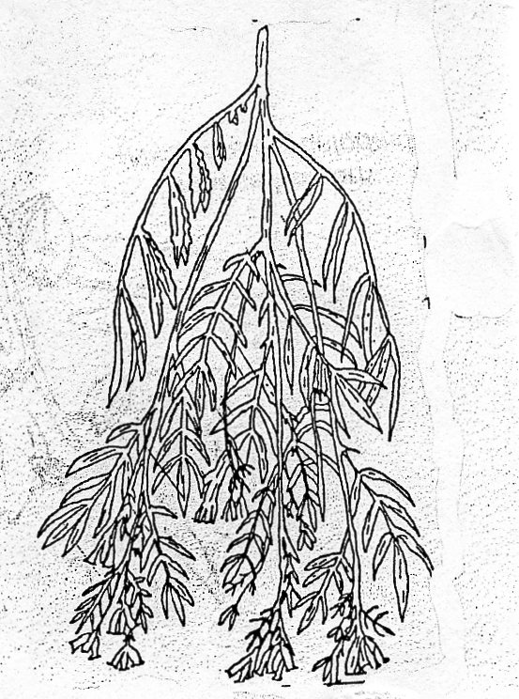
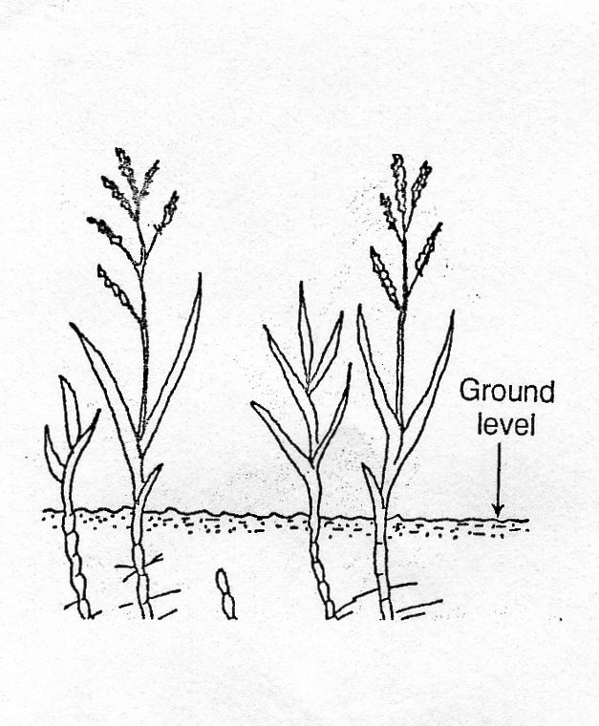
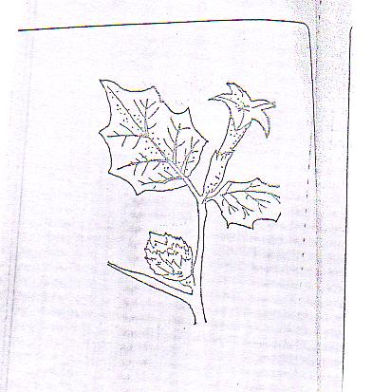
H
G

L

(a) Identify the weeds (½ x 3 = 1½mark)
G…………………………………………
H…………………………………………
L…………………………………………
- State three economic importance of the weed labeled G (1 ½ mark)
…………………………………………………………………………………………………………………………………………………………………………………………………………………………………………………………………………………………………………………………………………………………………………………………………………
- Why is it difficult to control the weed labeled G? (1mark)
…………………………………………………………………………………………………………………………………………………………………………………………………………
…………………………………………………………………………………………………………………………………………………………………………………………………………

- Why should the weed labeled H be removed from a field of fodder crop before the fodder is utilized.
………………………………………………………………………………………………………………………………………………………………………………………………………………………………………………………………………………………………………
- What is the effect of weed labeled L on dairy farming (1 mark)

………………………………………………………………………………………………………………………………………………………………………………………………………………………………………………………………………………………………………
23 A farmer has four plots P₁, P₂, P₃ and P₄ as shown on the diagrams below. Each of the plots has an agronomic problem as indicated.
P₄
Prone to soil erosion
P₃
Infested with witch weed Striga SPP.
P₂
Deficient in Nitrogen
P₁
Infested with bacterial wilt

The farmer intends to grow maize, Irish potatoes, peas and Rhodes grass. Plan a rotational programme for the first year of the rotation system

Crops Plot
Rhodes grass ………………………..
Irish potatpes ………………………
Peas ………………………
Maize ……………………….

SECTION C (40 MARKS)
Answer any two questions from this section in the spaces provided after question 25

24 (a) Describe the management of trees grown under various agroforestry systems (10 marks)
(b) Outline five ways in which high temperature affects agricultural production in Kenya
(5 marks)
(c) Explain five advantages of mulching in crop production (5 marks)

25 (a) Describe the processes involved in water treatment using a chemical treatment system.
(10 marks)

(b) State and explain five factors which may influence the spacing of crops (5 marks)
(c) Explain five factors that influence seed rates in crop production (5 marks)

26 (a) Describe the role of agricultural co-operatives in Kenya (5 marks)
(b)Discuss the importance of budgeting in Agricultural production. (5 marks)
(c) Outline the advantages of a mixed grass-legume over a pure grass pasture (5 marks)
……………………………………………………………………………………………………………………………………………………………………………………………………………………………………………………………………………………………………………………………………………………………………………………………………………………………………………………………….
………………………………………………………………………………………………………………………………………………………………………………………………………………………………………………………………………………………………………………………………………………
……………………………………………………………………………………………………………………………………………………………………………………………………………………………………………………………………………………………………………………………………………………………………………………………………………………………………………………………….
……………………………………………………………………………………………………………………………………………………………………………………………………………………………………………………………………………………………………………………………………………………………………………………………………………………………………………………………….
………………………………………………………………………………………………………………………………………………………………………………………………………………………………………………………………………………………………………………………………………………
………………………………………………………………………………………………………………………………………………………………………………………………………………………………………………………………………………………………………………………………………………
……………………………………………………………………………………………………………………………………………………………………………………………………………………………………………………………………………………………………………………………………………………………………………………………………………………………………………………………….
………………………………………………………………………………………………………………………………………………………………………………………………………………………………………………………………………………………………………………………………………………
……………………………………………………………………………………………………………………………………………………………………………………………………………………………………………………………………………………………………………………………………………………………………………………………………………………………………………………………….

