NAME………………………………………………………………….. INDEX NO………………………………
443/2
PAPER 2
AGRICULTURE
JULY/AUGUST 2014
TIME: 2 HOURS

NAKURU DISTRICT SEC. SCHOOLS JOINT MOCK EXAMINATION 2014
AGRICULTURE
PAPER 2
2 HOURS

INSTRUCTIONS TO CANDIDATES
a) Write your name and Index number in the spaces provided above

b) This paper consists of three sections A,B, and C.

c) Answer all questions in section A and B.

d) Answer any two questions in section C.

e) Answers should be written in spaces provided.

FOR EXAMINERS USE ONLY

SECTION | QUESTIONS | MAXIMUM SCORE | CANDIDATE SCORE
A | 1-19 | 30
B | 20-23 | 20
C | 24-26 | 40
TOTAL SCORE |  | 90

SECTION A. (30 MARKS:
Answer all questions in this section in the spaces provided
- State four practices that should be carried out on wooden fencing posts to make them last long (2 marks)
----------------------------------------------------------------------------------------------------------------------------------------------------------------------------------------------------------------------------------------------------------------------------------------------------------------------------------------------------------------------------------------------------------------------------------------------------------------------------------------------

- Give two harmful effects of keds (melophagus orinus) in sheep. (1 mark)
--------------------------------------------------------------------------------------------------------------------
------------------------------------------------------------------------------------------------------------------------------------------------------------------------------------------------------------------------------------------------------------------------------------------------------------------------------------------------------------------------
- Name the breeds of livestock described below.
- A pig breed which is white in colour, with straight snout and long ears dropping over the face
(1 mark)

--------------------------------------------------------------------------------------------------------------
- A beef cattle, deep red in colour; the face and part of the legs below the knees and hocks are always white (1 mark)

---------------------------------------------------------------------------------------------------------------
- State four construction features necessary in a fish pond (2 marks)
----------------------------------------------------------------------------------------------------------------------------------------------------------------------------------------------------------------------------------------------------------------------------------------------------------------------------------------------------------------------------------------------------------------------------------------------------------------------------------------------
- State four ways of controlling tsetse flies (2 marks)
------------------------------------------------------------------------------------------------------------------------------------------------------------------------------------------------------------------------------------------------------------------------------------------------------------------------------------------------------------------------
- Give two reasons for the practice of foot trimming in sheep management (1 mark)
------------------------------------------------------------------------------------------------------------------------------------------------------------------------------------------------------------------------------------------------
- Name any two methods recommended for identifying goats (1 mark)
------------------------------------------------------------------------------------------------------------------------------------------------------------------------------------------------------------------------------------------------
- Give reasons why farm tools and equipment should be maintained (2marks)
-----------------------------------------------------------------------------------------------------------------------------------------------------------------------------------------------------------------------------------------------
- List two appropriate hand tools needed to finish off the handle of a fork jembe (1 mark)
--------------------------------------------------------------------------------------------------------------------------------------------------------------------------------------------------------------------------------------
- How does cross breeding improve livestock production ? (1 mark)
--------------------------------------------------------------------------------------------------------------------------------------------------------------------------------------------------------------------------------------------------------------------------------------------------------------------------------------------------------
- Differentiate between prepotency and prolificacy as used in selection of breeding stock (2marks
--------------------------------------------------------------------------------------------------------------------------------------------------------------------------------------------------------------------------------------
- List four routes through which pathogens can enter the body of an animal (2 marks)
--------------------------------------------------------------------------------------------------------------------------------------------------------------------------------------------------------------------------------------------------------------------------------------------------------------------------------------------------------------------------------------------------------------------------------------------------------------------------
- Name two notifiable diseases of cattle (1 mark)
--------------------------------------------------------------------------------------------------------------------------------------------------------------------------------------------------------------------------------------
- State four reasons why a farmer would choose to use a disc plough rather than a mould board plough (2 marks)

----------------------------------------------------------------------------------------------------------------------------------------------------------------------------------------------------------------------------------------------------------------------------------------------------------------------------------------------------------------------------------------------------------------------------------------------------------------------------
- Why are the following conditions maintained during artificial incubation of eggs in poultry production (2 marks)

- Proper ventilation

---------------------------------------------------------------------------------------------------------------------------------------------------------------------------------------------------------------------------------------------------------------------------------------------------------------------------------------------------------
- Relative humidity at 60%

-------------------------------------------------------------------------------------------------------------------------------------------------------------------------------------------------------------------------------------------------------------------------------------------------------------------------------------------------------
- State how the following practices can be used to control livestock diseases

- Quarantine …………………………………………………………………….. (1 mark)

- Prophylactic measures ……………………………………………………….. ( 1mark)

- Name two livestock diseases that are caused by protozoa (1 mark)

--------------------------------------------------------------------------------------------------------------------------------------------------------------------------------------------------------------------------------------
- Name two functions of the crop in the digestive system of chicken (1mark)

--------------------------------------------------------------------------------------------------------------------------------------------------------------------------------------------------------------------------------------
- State two reasons why proper nutrition is important in animal’s health. (2 marks)

--------------------------------------------------------------------------------------------------------------------------------------------------------------------------------------------------------------------------------------
SECTION B (20 MARKS)
Answer ALL the questions in this section in the spaces provided.

- The diagram below shows the Petrol fuel system of a tractor engine. Study it carefully and answer the questions that follow.
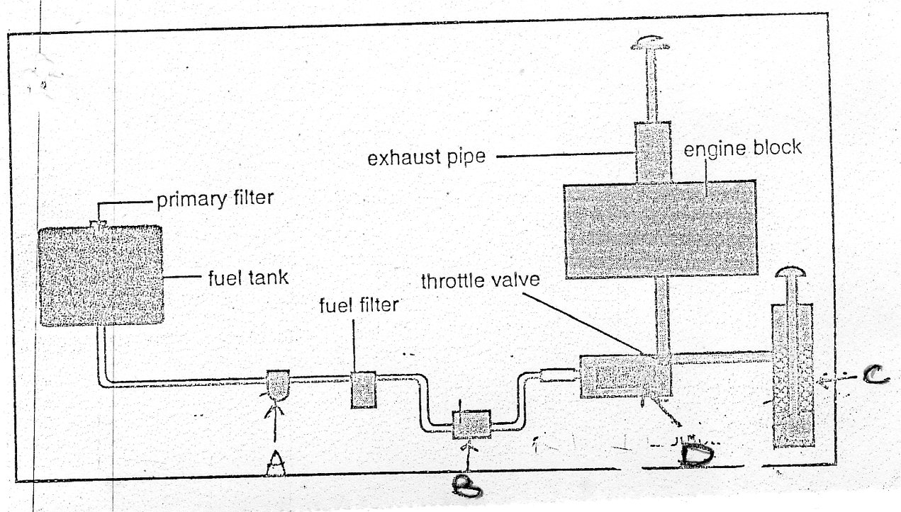

Name the parts labeled A,B,C and D. (2 marks)

A…………………………………………………. B………………………………….

C………………………………………………… D…………………………………

- State the functions of the parts labeled A, C and D (3 marks)

A………………………………………………………………………………………………

C……………………………………………………………………………………………….

D………………………………………………………………………………………………

- E, F, G and H are diagrams of farm tools. Study them and answer the questions that follow

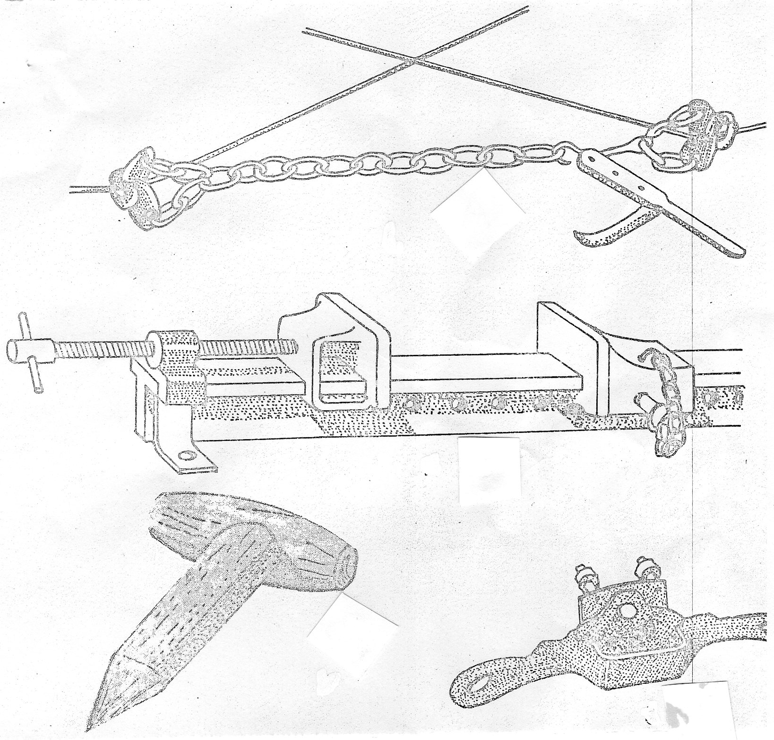
F
G
H
E

(a)(i) Identify the farm tools. (2 marks)

E---------------------------------------------- F……………………………………………

G……………………………………… H …………………………………………….

(ii) State the use of each tool.

E…………………………………………………………………………………………………...

F…………………………………………………………………………………………………

G……………………………………………………………………………………………….

H………………………………………………………………………………………………….

(b) Give ONE maintenance practice of the tool labelled F.

……………………………………………………………………………………………

- The diagram below shows a plunge dip.

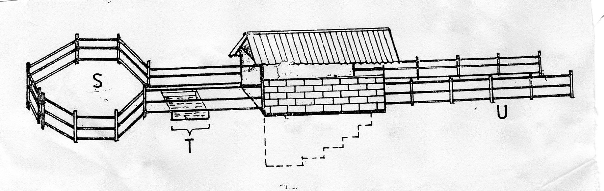
L
K
J

- State one use of each of the parts of the dip labeled J, K and L (3 marks)

J……………………………………………………………………………………………

K………………………………………………………………………………………….

L…………………………………………………………………………………………..

- State TWO precautions a farmer should take on the dip wash to ensure effective dipping.
(2 marks)

------------------------------------------------------------------------------------------------------------------------------------------------------------------------------------------------------------------------------------------------------------------------------------------------------------------------------------------
- State TWO uses of the roof of the dip. (1 mark)

--------------------------------------------------------------------------------------------------------------------------------------------------------------------------------------------------------------------------------------
- You are provided with the following feed stuffs.
- Maize meal
- Blood meal
Assume that maize meal contains 8% crude protein and blood meal contains 28% crude protein. Calculate the quantity of maize meal and blood meal that should be mixed to make 200kg of feed containing 16% crude protein. Use Pearson square method. (4 marks)

----------------------------------------------------------------------------------------------------------------------------------------------------------------------------------------------------------------------------------------------

SECTION C. (40 MARKS)
Answer any TWO questions from this section in the spaces provide after question 26

24 (a) State and explain six methods of controlling internal parasites in livestock (6 marks)
(b) Describe the management practices that a farmer should carry out to improve milk production in a
herd of dairy goats. (10 marks)
(c) State four disadvantages of natural mating as a method of breeding in dairy cattle production
(4 marks)

25 (a) Outline the daily maintenance practices that should be carried out on a farm tractor. (10 marks)
(b) Describe the body conformation features of beef cattle (4 marks)
(c) Outline six causes of stress to a flock of layers. (6 marks)

26 (a) Describe mastitis in dairy cattle under the following subheadings
- Predisposing factors (4 marks)
- Symptoms (3 marks)
(b) State factors considered when siting farm structures (8 marks)
(c) Outline the structural requirements of a deep litter house (5 marks)
-----------------------------------------------------------------------------------------------------------------------------------------------------------------------------------------------------------------------------------------------------------------------------------------------------------------------------------------------------------------------------------------------------------------------------------------------------------------------------------------------------------------------------------------------------------------------------------------------------------------------------------------------------------------------------------------------------------------------------------------------------------------------------------------------------
----------------------------------------------------------------------------------------------------------------------------------------------------------------------------------------------------------------------------------------------------------------------------------------------------------------------------------------------------------------------------------------------------------------------------------------------------------------------------------------------------------------------------------------------------------------------------------------------------------------------------------------------------------------------------------------------------------------------------------------------------------------------------------------------------

-------------------------------------------------------------------------------------------------------------------------------------------------------------------------------------------------------------------------------------------------------------------------------------------------------------------------------------------------------------------------------------------------------------------------------------------------------------------------------------------------------------------------------------------------------------------------------------------------------------------------------------------------------------------
------------------------------------------------------------------------------------------------------------------------------------------------------------------------------------------------------------------------------------------------------------------
----------------------------------------------------------------------------------------------------------------------------------------------------------------------------------------------------------------------------------------------------------------------------------------------------------------------------------------------------------------------------------------------------------------------------------------------------------------------------------------------------------------------------------------------------------------------------------------------------------------------------------------------------------------------------------------------------------------------------------------------------------------------------------------------------
---------------------------------------------------------------------------------------------------------------------------------------------------------------------------------------------------------------------------------------------------------------------------------------------------------------------------------------------------------------------------------------------------------------------------------------------------------------------------------------------------------------------------------------------------------------------------------------------------------------------------------------------------------------------------------------------------------------------------------------------------------------------------------------------------------------------------------------------------------------------------------------------------------------------------------------
------------------------------------------------------------------------------------------------------------------------------------------------------------------------------------------------------------------------------------------------------------------
-------------------------------------------------------------------------------------------------------------------------------

