NAME………………………………………………………….INDEX NO………………………
SCHOOL…………………………………………………….. DATE……………………………
SIGN…………………………….
231/1
BIOLOGY
PAPER 1
(Theory)
JULY/AUGUST 2014
TIME: 2 HOURS

NAKURU DISTRICT SEC. SCHOOLS TRIAL EXAMINATIONS 2014
Kenya Certificate of Secondary Education

INSTRUCTIONS TO CANDIDATES
- Write your name and index number in the spaces provided above
- Sign and write the date of examination in the spaces provided above
- Answer all questions
- Answers must be written in the spaces provided in the question paper
- Additional pages must not be inserted
- Candidates should check the question paper to ascertain that all the pages are printed as indicated and that not questions are missing
- Candidates should answer the questions in English.

FOR EXAMINERS USE ONLY
Question | Maximum score | Candidates Score
1-30 | 80

- State the name given to the study of
- Chemical changes in living organisms …………………………………………………..(1mark)

- Insects……………………………………………………………………….…………....( 1mark)

- Below is a diagram of an organelle that is involved in respiration

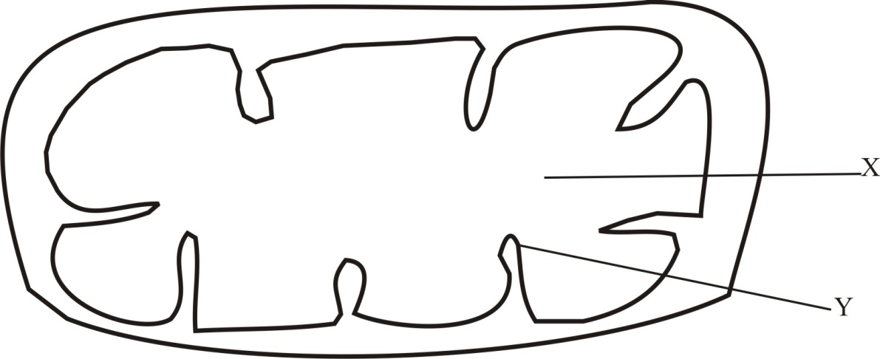

- Name t he organelle ……………………………………………………………........ ( 1mark)

- Name the part labeled X………………………………………………………… (1 mark)

- What is the purpose of the part labeled Y (1 mark)

………………………………………………………………………………………………………..

……………………………………………………………………………………………………….

………………………………………………………………………………………………………..

- Explain what would happen to an amoeba when placed in distilled water (3 marks)

…………………………………………………………………………………………………………

…………………………………………………………………………………………………………

…………………………………………………………………………………………………………

- (a) State the category of variation into which the following traits fall (2 marks)

- Skin pigmentation ……………………………………………………………………………

- Blood group …………………………………………………………………………………

(b) Give two possible genotypes of blood group A. (1 mark)

………………………………………………………………………………………………………..

…………………………………………………………………………………………………………

- State three characteristics of monera that are not found in other kingdoms (3 marks)

i)……………………………………………………………………………………………………….

ii)…………………………………………………………………………………….........................

iii) ……………………………………………………………………………………………………

- (a) Name two excretory products produced by both plants and animals (2 marks)

i)……………………………………………………………………………………………………..

ii)……………………………………………………………………………………....................

(b) What is the name given to the process in which excess amino acids are broken in the liver.

………………………………………………………………………………………..……………(1 mark)
- (a) What is meant by the following terms?

- Autoecology…………………………… …………………………………………(1mark)

- Habitat…………………………………………………………… …………………(1mark)

- State two ways in which floating leaves of aquatic plants are adapted to gaseous exchange
(2marks).
………………………………………………………………………………………………….

……………………………………………………………………………………....................

- In an experiment to investigate a certain factor necessary for photosynthesis, a leaf shown below was used.
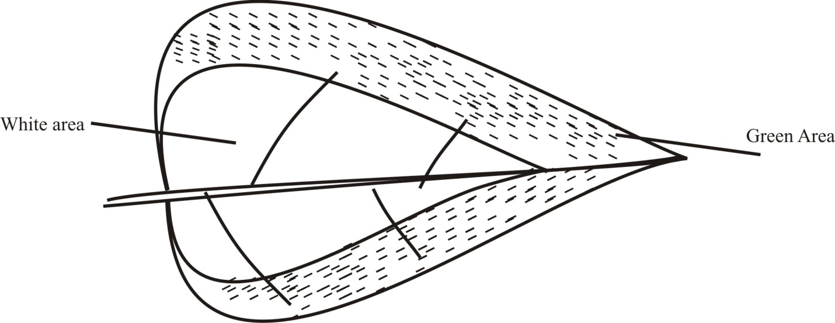
- What was the aim of the experiment? (1 mark)

…………………………………………………………………………………………………..

……………………………………………………………………………………..................

- What term is used to describe such a leaf?.......................................................................(1 mark)

- In the space provided below, sketch the expected observations when starch test is carried on the leaf (2 marks)

.

- The equation below represents a chemical process which occurs in the mammalian body
2H₂O₂ 2H₂O + 2O₂
Name the;
- Enzyme that controls the reaction ……………………………………………………....(1 mark)

- Major organ in which the reaction occurs………………………………………………( 1mark)

- What is the importance of the process? ( 1mark)
…………………………………………………………………………………………………………

…………………………………………………………………………………………………………

…………………………………………………………………………………………………………
- Name the hormones which control the following
- Development of male secondary characteristic…………………………………………(1 mark)

- Inhibits side branching in plants………………………………………………… (1 mark)

- Moulting in insects ……………………………………………………………… .( 1mark)

- During a biological excursion a group of form three students collected a plant specimen,
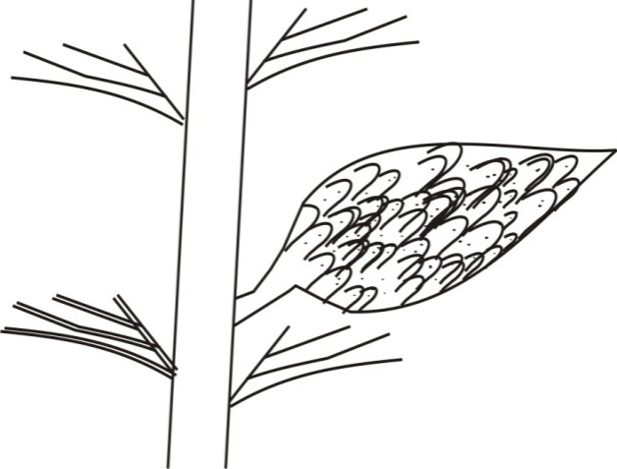
whose reproductive organ is shown below.

- Name the sub-division of the plant from which the above specimen was obtained (1 mark)

………………………………………………………………………………………………

- Other than the presence of the above characteristic, state two characteristics of the plants in the sub-division name above ( 2 marks)

i)…………………………………………………………………………………………………….

ii)……………………………………………………………………………………......................

- The shirt of a student was stained by a solution of DCPIP. A friend advised him to wash with lemon juice. Explain (2 marks)

…………………………………………………………………………………………………………

………………………………………………………………………………………………………..

……………………………………………………………………………………………………..
13 (a) State one distinguishing feature of fungal cells (1 mark)
…………………………………………………………………………………………………

(b) State one similarity between members of kingdom animalia and fungi ( 1mark)

………………………………………………………………………………………………………..
14 State the functions of each of the following parts of the axial skeleton
(a) Odontoid process ……………………………………………………………………… (1 mark)
………………………………………………………………………………………………………
(b) Zygapophyses …………………………………………………………………………(1 mark)
…………………………………………………………………………………………………………………………………………………………..
15 Antibiotics are used to treat people with bacterial infections. Explain the danger of the widespread use of antibiotics to treat disease (3 marks)
…………………………………………………………………………………………………………

…………………………………………………………………………………………………………

………………………………………………………………………………………………………

…………………………………………………………………………………………………………

………………………………………………………………………………………………………

16 (a)(i) Identify the plant support structure illustrated below ( 1 mark)

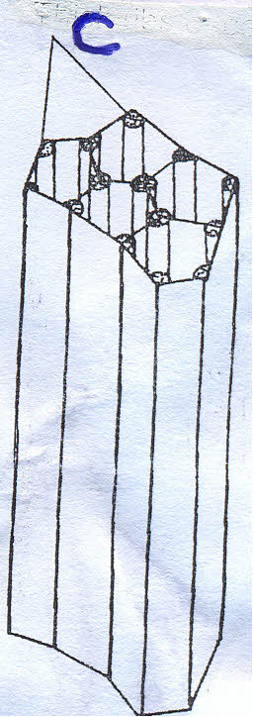
(ii) Name the part labeled C……………………………………………………………... (1mark)
(b) State three biological importance of tropism in plants (3 marks)
……………………………………………………………………………………………………..

…………………………………………………………………………………………………….

17 (a) Define the term oxygen debt (2 marks)
………………………………………………………………………………………………………

……………………………………………………………………………………………………..

……………………………………………………………………………………………………
- State what happens to the lactic acid produced by active muscles during anaerobic
respiration (2 marks)
……………………………………………………………………………………………………….

……………………………………………………………………………………………………….

………………………………………………………………………………………………………
18 Give a reason for each of the following
(a) The trachea of the tracheal system have circular rings of chitin ( 1 mark)
……………………………………………………………………………………………………….

……………………………………………………………………………………………………….

……………………………………………………………………………………………………..

(b) Tracheoles of the tracheal system lacks rings of chitin (1 mark)
………………………………………………………………………………………………………

……………………………………………………………………………………………………..

…………………………………………………………………………………………………….
19 (a) What is the meaning of the term organic evolution? (2 marks)
……………………………………………………………………………………………………….
………………………………………………………………………………………………………..

(b) Explain the following terms;
(i) Analogous structures (1 mark)
……………………………………………………………………………………………………….

………………………………………………………………………………………………………

(ii) Comparative embryology (1 mark)
…………………………………………………………………………………………………………

…………………………………………………………………………………………………………

………………………………………………………………………………………………………..
20 The figure below represents a type of muscle
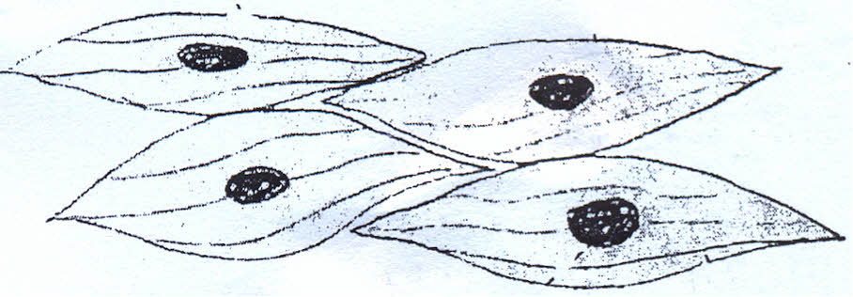

(a)(i) Identify the type of muscle …………………………………………………. …… (1 mark)
(ii) Give one reason for your answer in (a)(i) above (1mark)
…………………………………………………………………………………………………..
(b) Name two parts of the human body where this type of muscle can be found. (2marks)
………………………………………………………………………………………………………..

……………………………………………………………………………………………………….

21 Describe how turgor pressure builds up. (3marks)
……………………………………………………………………………………………………….

…………………………………………………………………………………………………………

…………………………………………………………………………………………………………
22 Name the flower part that produces male gamets ( 1 mark)
…………………………………………………………………………………………………………

23 (a) The diagram below shows a cell undergoing a stage in cell division
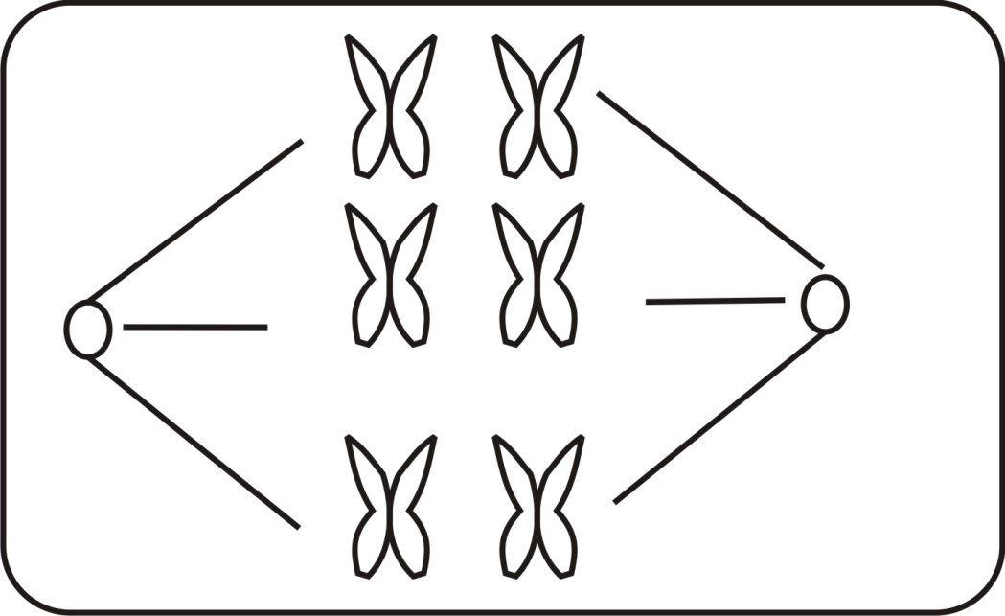

- With reason, identify this stage (2 marks)

Identity ………………………………………………………………………………………….

Reason …………………………………………………………………………………………….

- Draw a diagram to show the next stage of cell division (1mark)

24. Name the parts of the brain that perform the following functions
(a) Controls secretion of hormones by pituitary glands ……………………………. …… (1 mark)
(b) Controls muscular movements body posture and balance……………………… …….. (1mark)
(c) Controls reflex activities………………………………………………………… ( 1mark)
25 Name the vector and causal organism of bilharzia (2 marks)
Vector……………………………………………………………………………………………….
Causal organism ……………………………………………………………………………………
26 (a) Name an end product of photosynthesis that may be found in the intercellular air spaces of
a leaf ……………………………………………………………………………………….(1 mark)
(b) State what happens to the product named in (a) above (2 marks)
…………………………………………………………………………………………………………
…………………………………………………………………………………………………………

…………………………………………………………………………………………………………
27. Name two structures in the mammalian ear that are used in body balance and posture (1mark)
…………………………………………………………………………………………………………
…………………………………………………………………………………………………………

…………………………………………………………………………………………………………
28 What characteristics do gills of a fish and the mouth cavity of a frog have in common that enables them to be efficient in gaseous exchange. (3 marks)
…………………………………………………………………………………………………………

…………………………………………………………………………………………………….....

…………………………………………………………………………………………………………
………………………………………………………………………………………………………..

