Name…………………………………………… Index No…………………/…….
School………………………………………… Candidates Signature…………… Date…………………………….
233/2
CHEMISTRY
Paper 2
(THEORY)
July/August 2014
TIME 2 HOURS

NAKURU DISTRICT SEC. SCHOOLS TRIAL EXAMINATIONS - 2014
Kenya Certificate of Secondary Education (K.C.S.E)

233/2
CHEMISTRY
Paper 2
(THEORY)
July/August 2014
TIME: 2 HOURS

INSTRUCTIONS TO CANDIDATES

- Write your name and Index Number in the spaces provided above.
- Sign and write date of examination in the spaces provided above.
- Answer ALL questions in the spaces provided.
- Mathematical tables and electronic calculators may be used.
- All workings must be clearly shown where necessary.

Questions | Maximum Score | Candidate’s Score
1 | 10
2 | 12
3 | 12
4 | 13
5 | 12
6 | 11
7 | 10
TOTAL | 80

This paper consists of 9 printed pages
Candidates should check the question paper to ensure that all the
Papers are printed as indicated and no questions are missing

- The table below shows elements, atomic numbers and their melting points. The letters do not represent actual symbols of the elements. Study it and answer the questions.

Elements | Atomic numbers | Melting point
J | 11 | 98ºc
K | 16 | 115 ºc (119 ºc)
L | 15 | 44 ºc
M | 14 | 1410 ºc
N | 12 | 650 ºc

(a) Write the formula of the oxide of M (1 mark)
..................................................................................................................................................................

...............................................................................................................................................................

(b) Choose an element that would give a basic oxide when burned in air. Give a reason.
(2 marks)
...............................................................................................................................................................

................................................................................................................................................................

..................................................................................................................................................................

(c) Element K has two melting points. Explain why? (2 marks)

..................................................................................................................................................................

..................................................................................................................................................................

..................................................................................................................................................................

- The melting point of element M is 1410ºc. What is the possible structure of element M.
(1 mark)
.............................................................................................................................................................

...............................................................................................................................................................

- Compare the reactions of J and water to that of N and water (2 marks)

................................................................................................................................................................

..................................................................................................................................................................

..................................................................................................................................................................

- Choose an element that would form only covalent compounds. Explain (2 marks)

.................................................................................................................................................................

................................................................................................................................................................

..................................................................................................................................................................

- Write an equation for reaction of L and oxygen (1 mark)

..................................................................................................................................................................

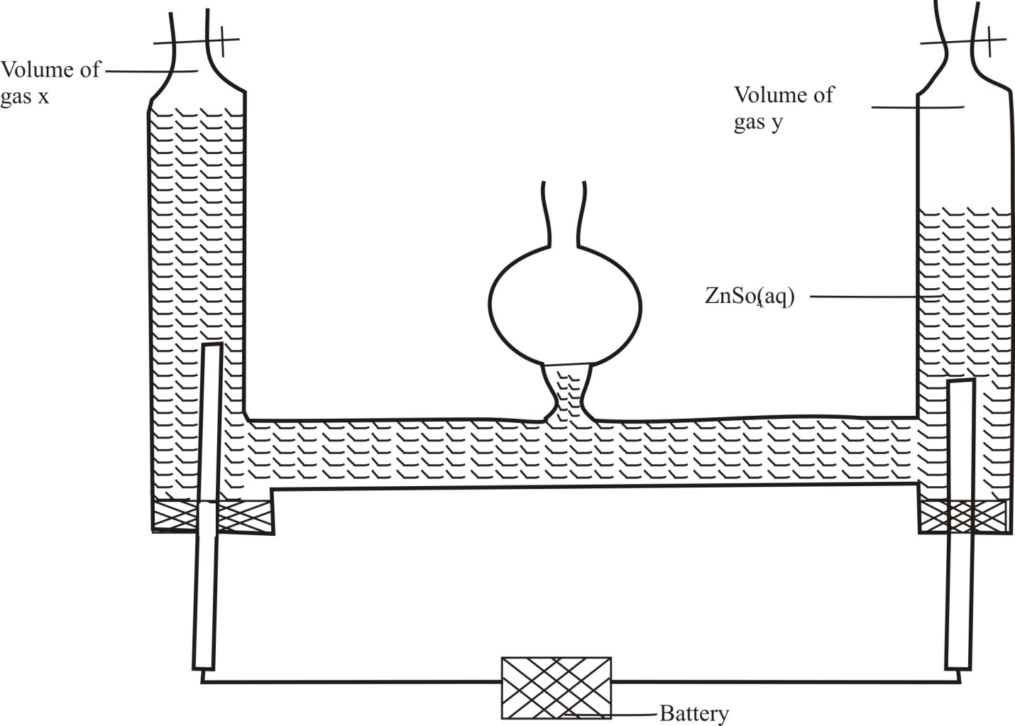
- An aqueous solution of zinc sulphate is electrolysed using platinum electrodes as shown below in the set up.

a)(i) Write down the ionic equation for the reaction taking place at electrode producing gas X (1 mark)
..............................................................................................................................................................

..............................................................................................................................................................

..............................................................................................................................................................

(ii) Identify the gas produced at Y; give a reason
…………………………………………………………………………………………………………

…………………………………………............................................................................ (2 marks)
(b) 0.22 g of metal g is deposited by electrolysis when a current of 0.06 amperes flows for
99 minutes. (G=184, IF = 96500C)
(i) Find the number of moles of metal deposited (1mark)
................................................................................................................................................................

................................................................................................................................................................

................................................................................................................................................................
(ii) Find the number of moles of electrons passed (3 marks)
..............................................................................................................................................................

.............................................................................................................................................................

................................................................................................................................................................
(iii) Determine the value of n in the metallic ion G^{n+} (2 marks)

.................................................................................................................................................................

..................................................................................................................................................................

.................................................................................................................................................................

(c) The following are half-cell reactions and their reduction potentials
 | E^{θ} (volts)
A²⁺ + 2 e A_{(s)} | -0.76
B²⁺_{(aq)} + 2 e B_{(s)} | -0.13
C_{(aq)} + e C_{(s)} | +0.80
D²⁺_{(aq)} + 2 e D_{(s)} | +0.30

(i) Write the cell representation for the electrochemical cell that would give the highest E^{θ}
value. (2 marks)
................................................................................................................................................................

..................................................................................................................................................................

..............................................................................................................................................................

(ii) Give one industrial use of electrolysis (1 mark)

...............................................................................................................................................................

- (a) State Hess’s law (1 mark)
.................................................................................................................................................................

................................................................................................................................................................

.................................................................................................................................................................

- Using the following thermochemical equations draw an energy cycle diagram.(3 marks)

A. 2C_{(s)} + H₂ _{(g)} C₂H_{2(g)} | ∆H = + 227 Kj/mol
B. C(_{s)} + 0₂ _{(g)} CO_{2(g)} | ∆H = -394 Kj/mol
C H_{2(g)} + ½ O_{2(g)} H₂0_{(g)} | ∆H = -286 Kj/mol

..................................................................................................................................................................

..................................................................................................................................................................

..............................................................................................................................................................

…………………………………………………………………………………………………………

- Name the heat of change represented by thermochemical equation A (2 marks)
.................................................................................................................................................................

..................................................................................................................................................................

- Using thermochemical equations A, B, C. Calculate the molar heat of combustion of ethyne (3 marks)
..................................................................................................................................................................

................................................................................................................................................................

..................................................................................................................................................................

- Give 3 factors considered for choosing a good fuel (3 marks)
..............................................................................................................................................................

...............................................................................................................................................................

..............................................................................................................................................................

- Biogas is made from natural organic waste. A from four student set –up the apparatus below to investigate the composition of the gas. He passed it over heated copper (II) oxide. After that he obtained two products. One was cooled in a boiling tube while the other was collected using a syringe.

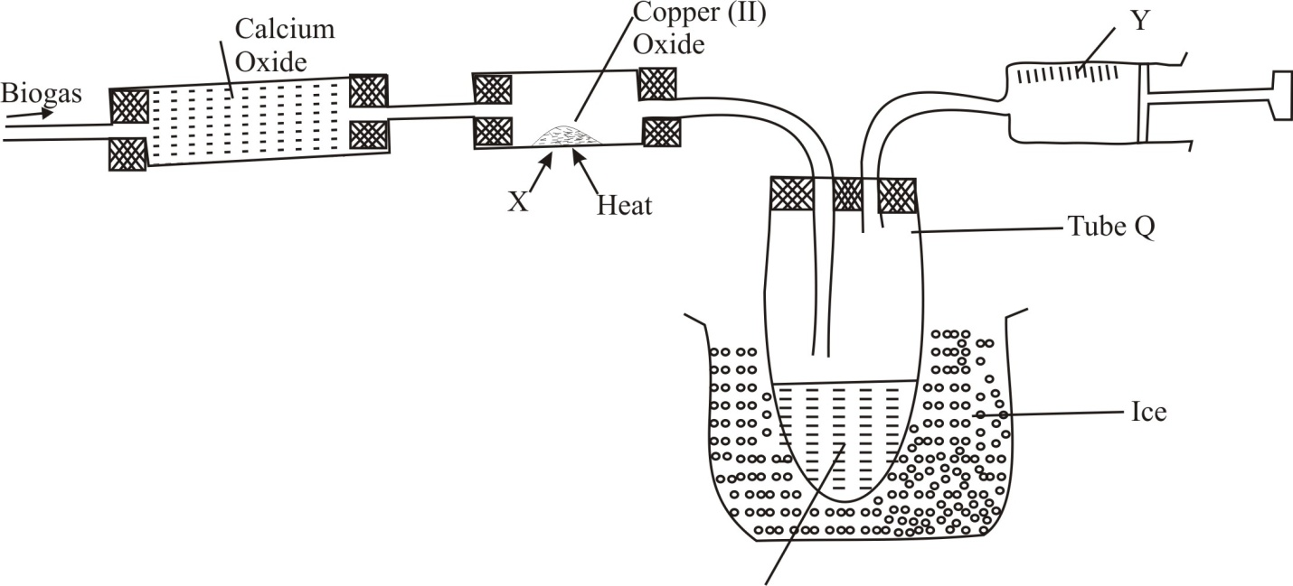
P
a) What is the function of calcium oxide (1 mark)
..............................................................................................................................................................

..............................................................................................................................................................

- Name products

i) P................................................................................................................................................

ii) Y.................................................................................................................................. (2marks)

- Give the two observations made in tube X (2 marks)

..................................................................................................................................................................

................................................................................................................................................................

(d) (i) Name the type of reaction taking place in tube X (1 mark)
..............................................................................................................................................................

ii) Write the equation for the reaction above in (d)(i) (1 mark)

.............................................................................................................................................................
(e) What elements are present in biogas (2 marks)
..............................................................................................................................................................

.................................................................................................................................................................
(f) Explain why one tube in boiling tube Q is longer than the other (2 marks)
..............................................................................................................................................................

..............................................................................................................................................................

................................................................................................................................................................
- Iron is obtained using the blast furnace below.

200ºC
800ºC
1800ºC
Limestone coke ore
A
B
Hot Air

D

Hot air

C

(a) Name one ore of iron………………………………………………………. (1 mark)
(b) Name what comes out through points

A..................................................................... B................................................................

C................................................................... (3 marks)

(c) Limestone is one of the raw materials in extraction of iron. State its two functions.
(2 marks)
..................................................................................................................................................................

................................................................................................................................................................

(d) Write an equation for the reaction taking place at point D (1 mark)

..................................................................................................................................................................

.................................................................................................................................................................

- Iron reacts with chlorine gas to form iron (III) chloride as shown in the equation.
2Fe_{(s)} + 3Cl_{2(g)} 2FeCl_{3(s)}
Given that total mass of product is 0.5 g. Calculate the volume chlorine gas that reacted with iron. (Fe = 56, Cl = 35.5, Molar gas volume is 24000 cm³) (3 marks)

................................................................................................................................................................

..................................................................................................................................................................

..................................................................................................................................................................

..............................................................................................................................................................

(f) Give one industrial use of iron (1 mark)

....................................................................................................................................................

- (a) Production of Nitrogen(II) oxide follows the equation below represented by the equation
N_{2(g)} + O_{2(g)} 2NO_{(g)} ∆H= +180 kJ /mol.

- What is meant by the word equilibrium

..............................................................................................................................................................

..............................................................................................................................................................
- With reasons explain what would happen when
(i) Pressure is increased in the system in (a) above (2 marks)
................................................................................................................................................................

...............................................................................................................................................................

.................................................................................................................................................................

..................................................................................................................................................................

(ii) Temperature is increased (2 marks)

....................................................................................................................................................

....................................................................................................................................................

(iii) Nitrogen (II) Oxide is removed (2 marks)

..............................................................................................................................................................
............................................................................................................................................................

- An equilibrium exists between

2NO_{2(g)} N₂O_{4(g)}

On the grid below sketch how the concentration of NO₂ varies with t he reaction path
(3 marks)

Concentration
of NO₃

Reaction path

- An organic compound was subjected to combustion. 1.0 g of it formed 1.37 g of carbon (IV) oxide, 1.12 g of water as the only products. (C = 12, H = 1 , 0 = 16)
(a) Calculate the mass of carbon and hydrogen in the compound (3 marks)

................................................................................................................................................................
................................................................................................................................................................
................................................................................................................................................................

.................................................................................................................................................................

- What other element must be present ...................................................................................(1 mark)

- Calculate the empirical formula of the compound (2 marks)
...............................................................................................................................................................
................................................................................................................................................................

................................................................................................................................................................

...............................................................................................................................................................

- What is meant by the term positional isomerism, give an example (2 marks)

..............................................................................................................................................................
...............................................................................................................................................................

- Draw the structural formulae of the following
(i) ethanoic acid 1 mark)

(ii) butane (1 mark)

- I Ethene can be converted to ethane industrially. Name the reagent and conditions
necessary for this reaction to occur.
(i) Reagent............................................................................................ (1mark)
(ii) conditions..................................................................................... (1 mark)

II What is the importance of the reaction above in I (1 mark)
.................................................................................................................................................
........................................................................................................................................ ……

