NAME: …………………………………………………………………………

INDEX NO: …………………………

CANDIDATES SIGNATURE………

DATE:…………………………………
121/2
MATHEMATICS ALT A.
PAPER 2
JULY /AUGUST 2014
2 ½ HOURS

Nakuru District Kenya Certificate of Secondary Education Trial Examination 2014
MATHEMATICS ALT. A.
PAPER 2
2½ HOURS

INSTRUCTIONS TO CANDIDATES
- Write your name and index number in the spaces provided above.
- Sign and write the date of examination in the spaces provided
- This paper consists of two sections: Section I and Section II.
- Answer all the questions in Section I and only five from section II.
- Show all the steps in your calculations, giving your answers at each stage in the spaces below each question.
- Marks may be given for correct working even if the answer is wrong.
- Non- programmable silent electronic calculators and KNEC Mathematical tables may be used except where stated otherwise.
- Candidates should check the question paper to ascertain that all the pages are printed as
- Candidates should answer the questions in English .
For Examiner’s Use Only
SECTION I
1 | 2 | 3 | 4 | 5 | 6 | 7 | 8 | 9 | 10 | 11 | 12 | 13 | 14 | 15 | 16 | Total

SECTION II
17 | 18 | 19 | 20 | 21 | 22 | 23 | 24 | Total
Grand
Total

SECTION 1 (50 MARKS)
ANSWER ALL THE QUESTIONS IN THIS SECTION

1. Use logarithms to evaluate $\frac{{\left(0.06824\right)}^{3}}{\sqrt[4]{0.05235}}$ (4 marks)

2. A bath tub has two inlet pipes P₁ and P₂ and an outlet pipe P₃. Pipe P₁ can fill an empty bath
tub in 15 minutes while pipes P₁ and P₂ , when opened at the same time can fill the same empty bath tub in 6 minutes. P₃ can empty the tub in 12 minutes. Find the fraction of the tub filled if P₂ and P₃ are opened for 25 minutes. (3 marks)

3. To obtain the estimate value of 1056 $÷$ 22, the numbers were first rounded off to the
nearest ten. Calculate the percentage error arising from this rounding – off. (3 marks)

4. Make R the subject of the formular (3 marks)

P =$\frac{C R }{\sqrt{{K - C R }^{2}}}$

5. Without using mathematical tables or a calculator simplify

²/₃ $\log_{3}{27 }$ - $\log_{3}{5 }$ + $\log_{3}{45}$ (3 marks)

6 (a) Expand and simplify ${\left(1+\frac{1}{4} x\right)}^{6}$ ( 2 marks)

(b) Use t he expansion in (a) above up to the fourth term to estimate the value of ${\left(1.025\right)}^{6}$
(2 marks)

7. In the diagram below ( not drawn to scale,) PR and QT are chords of a circle intersecting at
S. OT is a tangent to the circle at T. Chord QP produced meets the tangent at O.
(a) Given that O T = 10.5 cm and O P = 8 cm.
R
Q
T
P
S
O
4.3cm
2.3cm
10.5cm
8 cm
Calculate the length of P Q
(2 marks)

(b)Hence determine, to 1 decimal place the length of TR if PS = 4.3 and TS = 2.3 cm. (2 marks)

8. A mixture P contains sorghum and millet in the ration 2: 3. Another mixture Q contains
sorghum and millet in the ration 3:1. 15kg of P is mixed with 24kg of Q, determine the ratio
of sorghum and millet in the new mixture. (3 marks)

9. Rationalize the denominator leaving your answer in the form a + b$\sqrt{c}$ where a, b and c are
constants (2 marks)
$\frac{5 - 2\sqrt{3}}{2 + 3\sqrt{3}}$

10. The figure below is a regular tetrahedron VPQR with edges of length 6cm. Calculate the
V
P
Q
angle between the planes VQR and PQR (3 marks)

R

11. Solve for x: tan ² x – 2 tan x = 3 for the interval (3 marks)
0 $≤$ x $≤$ 180º

12. A quantity P varies partly as the square root of Q and partly as the inverse of Q. Given that
P = 14.5 when q = 4 and P = 17 when Q = 9 determine the equation connecting P and Q. (4 marks)

13. A car travelling at 94 km/hr is 5 m behind a truck travelling at 80 km/hr. If the truck is 13 m
long and the car is 3 m long, deter mine the time taken in seconds for the car to completely
overtake the truck. ( 3 marks)

14. The figure below shows a sketch of a graph of a quadratic function
Y = 3 c (x – 2) (x – 5)
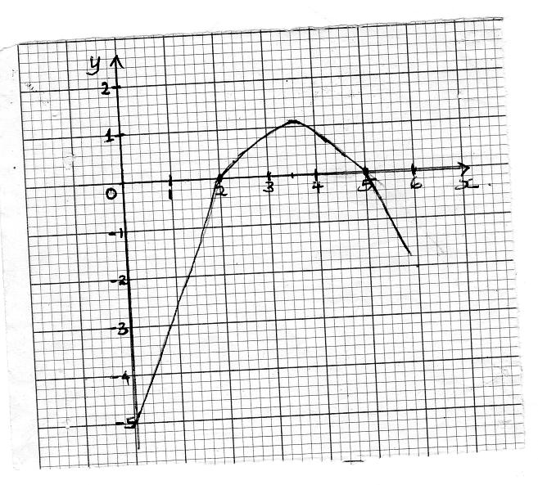
Find the value of C (2 marks)

15. Given that $\left(\begin{matrix}x & 2 \\ 4 & 2x\end{matrix}\right)$ is a singular matrix
Determine the value of x, hence state the two possible matrices. (3 marks)

16. The equation of a circle is given by 5x² + 20 x + 5y² – 25 = O. Find the radius and the centre
of the circle (3 marks)

SECTION II (50 MARKS) ANSWER ANY FIVE QUESTIONS ONLY FROM THIS SECTION.

17 The table below shows the income tax rates in 2012

Income (K £ per annum) | Tax rate (Kshs. Per K £)
1-5808 | 2
5809-11280 | 3
11281 – 16752 | 4
16753 - 22224 | 5
22225 - 27696 | 6
Over 27896 | 6.5
In June 2012 Mrs Sudi earned the following per month: a basic salary of Kshs.23530, a house allowance of Kshs.8000, a medical allowance of Kshs.2844 and a commuter allowance of Kshs.2031.
She was entitled to a personal relief of Kshs.1056 per month.
(a) Calculate:
(i) Her taxable income in K£ per annum (1 mark)

(ii) The net tax paid by Mrs. Sudi in Kshs per annum (5 marks)

(b) In July 2012, Mrs. Sudi’s Basic salary was increased in the ration 11:10 and received a hardship
allowance that is 30% of her basic salary. Find the additional net tax per annum as a
percentage (significant figures,) of the net tax obtained in (a)(ii) above ( to 4) (sig.fig) (4 marks)

18. In a mathematics test, the probability of 3 students, Kamau, Otieno and Mwala passing are
⅔, ¾ and ⅚ respectively
(a) Draw a tree diagram to represent this information (3 marks)

(b) Use the tree diagram to find the probability that:
(i) All the three students will fail (2 marks)

(ii) At least two students will pass. (3 marks)

(iii) Only one student will pass (2 marks)

19. The position of two towns A and B are given to the nearest degree as A (40ºN, 110ºE) and
B (50ºN, 70ºW).
(a) Find the shortest distance between the two towns in kilometers. (Take the radius of
the earth as 6370 km). (3 marks)

(b) An aircraft flew through the shortest route from town A to town B and then proceeded
to town C, 6000 nm due south of B at an average speed of 850 km/h.
(i) Find the position of C

(ii) Find the time taken by the aircraft to fly from town A to town C. ( 2 marks)

(iii) Determine the local time at A when the local time at C is 5.30 p.m. (2 marks)

20. In triangle OPQ below, R and S are points on OQ and PQ respectively, such that the ratio
PS: SQ= 2:1 and OR = ½ OQ. T is a point on OS such that OT: TS= 3:2.
P
~

R

q
~

O Q

T
S

P
q
~

Given that = and =
OQ
~

P
~

OP
~

q
~

P
~

(a) Express the following vectors in terms of and
PQ
~

(i) (1 mark)

(ii) (1 mark)
OS
~

PR
~

(iii) (1 mark)

PT
~

(iv) (1 mark)

(b) Show that P, T and R are collinear (4 marks)

(c) Determine the ratio PT:TR (1 mark)

21 (a) Using a pair of compasses and a ruler only. Construct triangle ABC such that AB=7cm
BC= 6cm and angle ABC = 60º. Measure AC (3marks)

b) On the same side of AB as C.
(i) Determine the locus of points P such that angle APB =60º (2 marks)

(ii) Construct the locus of R such that AR= 4.5cm (1 mark)

(iii) By shading the unwanted region identify the region T such that AR $≥$ 4.5. Angle APB $≥$ 60º and angle ACB $≤$ angle BCA . (4 marks)

22. Laptech company is considering installing two types of machines, Type A and type B, for
assembly of spare parts of laptops. Type A machine can assemble 5 spare parts per hour
while type B machine can assemble 3 spare parts per hour. Type A machine requires 11
operators while type B machine requires 9 operators. The number of type B machines
must be more than the number of type A machines. The total number of spare parts
assembled per hour must be at least 30 and the number of operators should not exceed 100.
There should be at least 3 type A machines and at least 4 type B machines
.
(a) Taking x to be the number of type A machines and y to be the number of type B machines.
Write down in terms of x and y the linear inequalities representing the information above
(4 marks)

(b) On the grid provided draw the inequalities and shade the unwanted regions. (4 marks)

(c) If the company makes a profit of shs.6 per hour on type A machines and shs.2 per hour on
type B machines, Use the graph in (b) above to determine the number of machines of each
type that should be installed to maximize the profit. (2 marks)



23 A Manson lays bricks in the erecting of a perimeter wall. In consecutive days, he increased
the number of bricks laid by an equal number. On the third day he laid 23 bricks, while on
the seventh day he laid 35 bricks.

(a) Calculate
(i) The number of bricks he laid on the first day (2 marks)

(ii) The constant increase of the number of bricks laid daily (2 marks)

(iii) The number of bricks laid on the eleventh day (2 marks)

(b) If he laid 80 bricks on the last day, find the total number of bricks laid (4 marks)

24. The relationship between the pressure P of a fixed mass of a gas and its volume V at a
constant temperature, is known to be of the form P=$\frac{K}{V}$ where K is a constant. The
table below shows the experimental results for pressure and corresponding values of
volume.
Pressure  (N/cm² ) | 1.1 | 1.8 | 2.2 | 2.6 | 3.4
Volume  (Litres) | 3.03 | 2.12 | 1.65 | 1.4 | 1.07

(a) Using the grid provided, plot the graph of P against $1/V$ ( 5 marks)

(b) From the graph estimate the value of K (3 marks)

(c) Determine the volume of the gas when the pressure is 3.1 N/cm² (2 marks)

