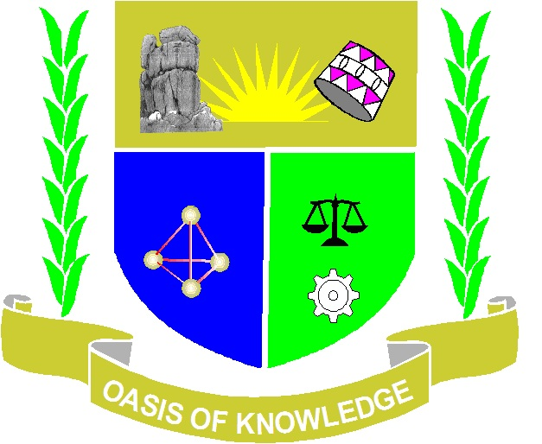

JARAMOGI OGINGA ODINGA UNIVERSITY OF SCIENCE AND TECHNOLOGY
SCHOOL OF HEALTH SCIENCES
UNIVERSITY EXAMINATION FOR BACHELOR OF SCIENCE IN COMMUNITY HEALTH AND DEVELOPMENT
2ND YEAR 1ST SEMESTER 2013/2014 ACADEMIC YEAR
CENTER: BUSIA
__________________________________________________________________

COURSE CODE: HCD 2114
COURSE TITLE: INTRODUCTION TO MEDICAL ENTOMOLOGY AND
PARASITOLOGY
EXAM VENUE:
DATE:
---------------------------------------------------------------------------------------------------------------------:

Instructions:
- Answer ALL questions in Section A and ANY other 2 questions in Section B.
- Candidates are advised not to write on the question paper.
- Candidates must hand in their answer booklets to the invigilator while in the examination room.

Section A: ANSWER ALL QUESTIONS (30 Marks)

- Define the following terms
- Ectoparasite
- Vector
- Obligate parasites (3 marks).

- Insects in the order diptera consist of many insect families that are of medical importance among them mosquitoes. Describe the distinguishing features between Culex and Anopheles mosquitoes (3 marks).

- List at least three benefits and three harmful effects of insects to man (3 marks).

- Define the term Metamorphosis. Name any two insects that undergo complete metamorphosis (3 marks).

- Protozoa are single cell organisms that contain important parasites of humans. There are six phyla of protozoa that contain parasites of medical importance. Name the phyla in which the following parasites are found: Plasmodium falciparum, Giardia lamblia and Entamoeba hystolytica (3 marks)

- Insects’ legs are basically used for locomotion. In some insects the legs have been modified to perform other functions. With examples name at least three other functions that insecs legs have been modified to perform (3 marks).

- Describe the basic differences between class Myriapoda and class Arachnida (3 marks).

- Malaria is a vector born disease that is transmitted from person to person by vectors. Name the genus of the parasite that causes malaria. Name the definitive and intermediate hosts of the malaria parasite (3 marks).

- Name the definitive and alternative hosts of the following parasites: Babesia microti, Taenia solium and Leishmania donvani (3 marks).

- Name at least one parasite that is transmitted by the following vectors: Sand flies, Tsetse flies, and Ixodidae ticks (3 marks).

SECTION B. ANSWER ANY TWO QUESTIONS (30Marks)
- Describe ANY one of the following diseases. Malaria OR Trichomoniasis. Name the causal agent/s and mode of transmission. Describe prevention method and treatment (15 marks).

- Arthropods in the class insecta have their bodies segmented into three distinct regions. List the segments that comprise the insect’s body. List at least two appendages that are found on each segment and their functions (15 marks)

- Name the parasites that cause the following diseases. For each parasite named state the mode of transmission, definitive and alternative host.
- Taeniasis (5 marks)
- Filariasis (5 marks)
- Diphyllobothriasis (5 marks)

- Describe the two forms of Schistosomiasis that infects humans. What are the causal agents of these infections in humans? State mode of transmission and prevention for Schistosomiasis (15 marks)

