Name ................................................................ Index Number ............................................................
School ............................................................... Candidate’s Signature ..............................................
443/2 Date ...............................................................................
AGRICULTURE
Paper 2
2015
2 hours

BRILLIANT KENYA CERTIFICATE OF SECONDARY EDUCATION PREPARATORY EXAMINATION
AGRICULTURE
Paper 2
2 hours

Instructions to candidates
- Write your name and index number in the spaces provided above.
- Sign and write the date of examination in the spaces provided above.
- This paper consists of three sections: A, B and C.
- Answer all the questions in sections A and B.
- Answer any two questions from section C.
- Answers should be written in the spaces provided in this booklet.
- This paper consists of 10 printed pages.
- Candidates should check the question paper to ascertain that all the pages are printed as indicated and that no questions are missing.

For Examiner’s Use Only
Section | Questions | Maximum Score | Candidate’s Score
A | 1-19 | 30
B | 20-23 | 20
C |  | 20
 |  | 20
 |  | 90

Total Score

.

SECTION A (30 marks)
Answer all the questions in this section in the spaces given.
- Name four farm structures used for the control of livestock parasites. (2 marks)
……………………………………………………………………………………………………………………

……………………………………………………………………………………………………………………

……………………………………………………………………………………………………………………

……………………………………………………………………………………………………………………

- Explain the meaning of dry cow therapy as used in livestock production. (1 mark)
……………………………………………………………………………………………………………………

……………………………………………………………………………………………………………………

- State three conditions in a breeding boar which may necessitate culling. (1 mark)
……………………………………………………………………………………………………………………

……………………………………………………………………………………………………………………

……………………………………………………………………………………………………………………

- State two reasons why lactating dairy goats require calcium. (1 mark)
……………………………………………………………………………………………………………………

……………………………………………………………………………………………………………………

- Identify four undesirable characteristics of indigenous cattle that make them unpopular with farmers. (2 marks)
……………………………………………………………………………………………………………………

……………………………………………………………………………………………………………………

……………………………………………………………………………………………………………………

……………………………………………………………………………………………………………………

- Name the intermediate host of liver flukes. (1 mark)
……………………………………………………………………………………………………………………

- Distinguish between stress and vice, as used in livestock production. (1 mark)
……………………………………………………………………………………………………………………

……………………………………………………………………………………………………………………

- Give the reason why eggs are packed with the broad end facing upwards. (1 mark)
……………………………………………………………………………………………………………………

- State four factors affecting milk composition. (2 marks)
……………………………………………………………………………………………………………………

……………………………………………………………………………………………………………………

……………………………………………………………………………………………………………………

……………………………………………………………………………………………………………………

- Outline four advantages of using animal power over tractor power. (2 marks)
………………………………………………………………………………………………………….…………

…………………………………………………………………………………………………………….………

…………………………………………………………………………………………………………….………

………………………………………………………………………………………………………….…………

- State the function of each of the following tools:
  - Pruning saw (½ mark)
……………………………………………………………………………......………………......................
  - Dibber (½ mark)
……………………………………………………………………………......………………......................

- Give four requirements of a produce store. (2 marks)
……………………………………………………………………………………………………………………
……………………………………………………………………………………………………………………
……………………………………………………………………………………………………………………
……………………………………………………………………………………………………………………
- State four control measures of tsetse fly. (2 marks)
……………………………………………………………………………………………………………………
……………………………………………………………………………………………………………………
……………………………………………………………………………………………………………………
……………………………………………………………………………………………………………………
- Name one sheep breed which is resistant to foot rot and worm infestation. (1 mark)
……………………………………………………………………………………………………………………
- State the ratio of cement, sand and aggregate used in preparation of concrete blocks.
(1 mark)
……………………………………………………………………………………………………………………
- State four symptoms of scours in a calf. (2 marks)
……………………………………………………………………………………………………………………
……………………………………………………………………………………………………………………
……………………………………………………………………………………………………………………
……………………………………………………………………………………………………………………
- State four factors that determine the amount of water taken by an animal. (2 marks)
……………………………………………………………………………………………………………………
……………………………………………………………………………………………………………………
……………………………………………………………………………………………………………………
……………………………………………………………………………………………………………………

- Name four equipment used when harvesting honey from Kenya top bar hive. (2 marks)
……………………………………………………………………………………………………………………

……………………………………………………………………………………………………………………

……………………………………………………………………………………………………………………

……………………………………………………………………………………………………………………

- State five advantages of artificial insemination. (2 ½ marks)
………………………………………………………………………………………………….…………………

………………………………………………………………………………………………….…………………

………………………………………………………………………………………………….…………………

………………………………………………………………………………………………….…………………

………………………………………………………………………………………………….…………………
SECTION B (20 marks)
Answer all questions in this section in the spaces provided.
- Study the diagram below and answer the questions that follow.
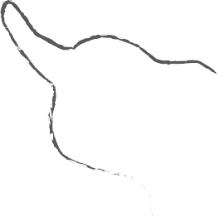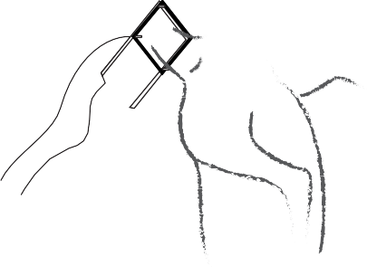
  - Identify the operation shown in the diagram. (1 mark)
……………………………………………………………………………......…………….….....................

……………………………………………………………………………......……………….....................
  - Name the tool and equipment used. (1 mark)
……………………………………………………….……………………......……………….....................

…………………………………………….....……………………………......………………....................

.
  - Give three reasons why the operation is practised in Kenya. (3 marks)
…………………………………………………………………..…………......………………....................

………………………………………………………………..……………......………………....................

………………………………………………………………..……………......………………....................

- 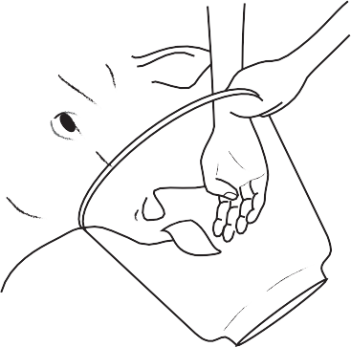The diagram below represents an operation carried out on livestock. Use it to answer the questions that follow.

  - Identify the operation. (1 mark)
…….………………………………………………………………………......……………….....................
  - Outline the procedure for the operation shown in the diagram above. (4 marks)
……………………………………………………………………………......………………......................

……………………………………………………………………………......………………......................

……………………………………………………………………………......………………......................

……………………………………………………………………………......………………......................

……………………………………………………………………………......………………......................

- Below is an illustration of a farm equipment.

A

C B

  - Identify the above equipment. (1 mark)
……………………………………………………………………………......…………..……....................
  - Name the parts labelled A and C. (2 marks) A ……………………………………………………………………………......…….………….................
C ……………………………………………………………………………......…………..……................
  - Give two maintenance practices for the above equipment. (2 marks)
……………………………………………………………………………......………….……....................

……………………………………………………………………………......……….………....................

……………………………………………………………………………......………..………....................

- 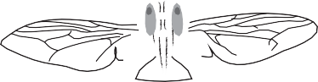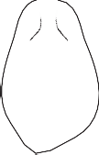Below are illustrations of parasites which transmit disease in livestock. Study them carefully and answer the questions that follow.
K
L

  - Identify specimens K and L. (1 mark)
K……………………………………………………………………………......………………...................

L……………………………………………………………………………........……………….................
  - Name one disease each, transmitted by the parasites K and L. (2 marks) K………………………..……………………………………………………......…………….…................
L………………………………………..……………………………………......……………….................
  - State two mechanical control measures for parasite L. (2 marks)
……………………………………………………………………………......…………..……....................

……………………………………………………………………………......…………..……....................

SECTION C (40 marks)
Answer any two questions.
- (a) Discuss the construction of a dairy shed under the following topics:
- Construction material (4 marks)
…………………………………….…………………………………......………………....................

…………………………………….…………………………………......………………....................

…………………………………….…………………………………......………………....................

…………………………………….…………………………………......………………....................

…………………………………….…………………………………......………………....................
- Six maintenance practices of the structure (6 marks)
…………………………………….…………………………………......………………....................

…………………………………….…………………………………......………………....................

…………………………………….…………………………………......………………....................

…………………………………….…………………………………......………………....................

…………………………………….…………………………………......………………....................

…………………………………….…………………………………......………………....................
(b) Outline five differences between a good layer and a poor layer. (10 marks)
……………………………………………………………….……………......………………....................
……………………………………………………………….……………......………………....................
……………………………………………………………….……………......………………....................
……………………………………………………………….……………......………………....................
……………………………………………………………….……………......………………....................
……………………………………………………………….……………......………………....................
……………………………………………………………….……………......………………....................
……………………………………………………………….……………......………………....................

……………………………………………………………….……………......………………....................
……………………………………………………………….……………......………………....................

- (a) Describe the management of pigs during parturition. (10 marks)
……………………………………………………………….……………......………………....................
……………………………………………………………….……………......………………....................
……………………………………………………………….……………......………………....................
……………………………………………………………….……………......………………....................
……………………………………………………………….……………......………………....................
……………………………………………………………….……………......………………....................
……………………………………………………………….……………......………………....................
……………………………………………………………….……………......………………....................
……………………………………………………………….……………......………………....................
……………………………………………………………….……………......………………....................
(b) Give the differences between a petrol engine and a diesel engine. (10 marks)
……………………………………………………………………….……......………………....................

…………………………………………………………………………….......………………....................
……………………………………………………………….……………......………………....................
……………………………………………………………….……………......………………....................
……………………………………………………………….……………......………………....................
……………………………………………………………….……………......………………....................
……………………………………………………………….……………......………………....................
……………………………………………………………….……………......………………....................
……………………………………………………………….……………......………………....................

……………………………………………………………………………......……..…………....................
……………………………………………………………………………......……..…………....................
- (a) Describe the life cycle of beef tapeworm (Taenia saginata). (10 marks)
……………………………………………………………….……………......………………....................
……………………………………………………………….……………......………………....................
……………………………………………………………….……………......………………....................
……………………………………………………………….……………......………………....................
……………………………………………………………….……………......………………....................
……………………………………………………………….……………......………………....................
……………………………………………………………….……………......………………....................
……………………………………………………………….……………......………………....................
……………………………………………………………….……………......………………....................
……………………………………………………………….……………......………………....................
(b) State and explain five reasons for maintaining farm tools and equipment. (10 marks)
……………………………………………………………….……………......………………....................
……………………………………………………………….……………......………………....................
……………………………………………………………….……………......………………....................
……………………………………………………………….……………......………………....................
……………………………………………………………….……………......………………....................
……………………………………………………………….……………......………………....................
……………………………………………………………….……………......………………....................
……………………………………………………………….……………......………………....................
……………………………………………………………….……………......………………....................
……………………………………………………………….……………......………………....................

