Name ..................................................................... Index Number .................................................................
School .................................................................... Candidate’s Signature ...................................................
232/1 Date ...................................................................................

PHYSICS
Paper 1 (THEORY) 2015
2 hours

BRILLIANT KENYA CERTIFICATE OF SECONDARY EDUCATION PREPARATORY EXAMINATION

Paper 1 (THEORY)
2 hours

Instructions to Candidates
- Write your name and index number in the spaces provided above.
- Sign and write the date of examination in the spaces provided above.
- This paper consists of two sections; A and B.
- Answer all the questions in sections A and B in the spaces provided.
- All working must be clearly shown.
- Silent non programmable electronic calculators may be used.
- This paper consists of 17 printed pages.
- Candidates should check the question paper to ascertain that all the pages are printed as indicated and that no questions are missing.
- Candidates should answer the questions in English.

For Examiner’s Use Only

Section | Question | Maximum Score | Candidate’s Score
A | 1-14 | 25
B | 15 | 13
B | 16 | 12
B | 17 | 12
B | 18 | 10
B | 19 | 18
Total Score |  | 80

TURN OVER

SECTION A (25 MARKS)
Answer all the questions in this section in the spaces provided.
  - The diameter of a ball bearing of mass 0.0045 kg is measured using a micrometer screw gauge as shown in Figure 1 below.
mm
0
5
35

30
Ball bearing
Figure 1

    - Determine the radius of the ball bearing. (1 mark)

    - Determine the density of the ball bearing. (Take pi = 3.142) (2 marks)

  - A body exerts a pressure of 100 N/mm2. Express this in SI units. (1 mark)

……………………………………………………………………………......……………….........................................

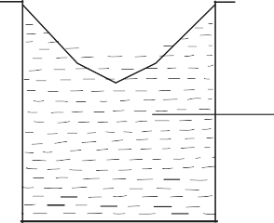
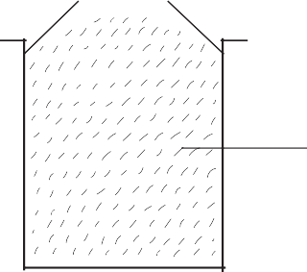
  - The diagram below shows the levels of mercury and water in beakers.

Water Mercury

Figure 2
Explain the difference in the shape of the meniscus. (2 marks)

……………………………………………………………………………......……………….........................................

……………………………………………………………………………......………………..........................................

……………………………………………………………………………......……………….........................................

……………………………………………………………………………......……………….........................................

  - Figure 3 below shows a rod made of wood on one end and metal on the other end. It is suspended freely with a piece of thread so that it is in equilibrium.

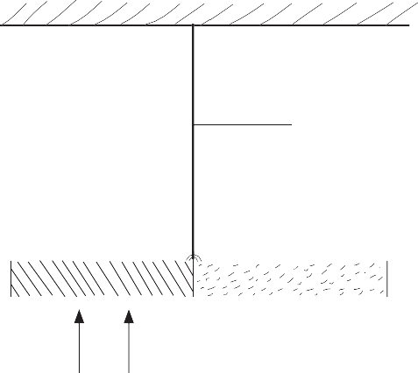Thread

Metal Wood

Figure 3
The side made of metal is heated with a Bunsen flame and the rod tips to the left. Explain.
(1 mark)

……………………………………………………………………………......……………….........................................

……………………………………………………………………………......……………….........................................

……………………………………………………………………………......……………….........................................

  - Convection and diffusion both involve motion of fluid molecules. Distinguish between the two.
(1 mark)

……………………………………………………………………………......………………..........................................

……………………………………………………………………………......………………..........................................

……………………………………………………………………………......………………..........................................

……………………………………………………………………………......………………..........................................

  - Three identical springs each of spring constant 10 N/M and weight 0.5 N are used to support a load as shown. Determine the total extension of the system. (2 marks)
A
C
B
6 N
Figure 4

  - As Mariga was taking a penalty kick, his leg moved through an angular displacement of 90º. If his leg is 1.2 m long, calculate the distance moved through by the end of Mariga’s foot.
(2 marks)

  - A non-uniform plank of wood AB of mass 0.50 kg balances on a point K 0.15 m from the end A when a 0.24 kg mass is suspended from one end as shown.

A B
0.15 m
K

0.24 kg
Figure 5
Determine the distance of the centre of gravity of the plank from end A. (2 marks)

TURN OVER

  - The diagram shows a cross-section of an aeroplane wing when the aeroplane is moving at constant height and constant speed. An upward force equal and opposite to it is exerted on its wing as shown

in Figure 6.
Upward force

Direction of motion

Figure 6
    - What is the cause of the upward force? (1 mark)

……………………………………………………………………………......………………...................................

……………………………………………………………………………......………………...................................

……………………………………………………………………………......………………...................................

……………………………………………………………………………......………………...................................

……………………………………………………………………………......………………...................................
    - Why is the shape of the wing crucial in producing this upward force? (1 mark)
……………………………………………………………………………......………………...................................
……………………………………………………………………………......………………...................................
  - Tracy drew the graph below (Figure 7).

Velocity (m/s)

Time (s)
Figure 7

She then worked out the area of the shaded part. State what she was determining. (1 mark)

………………………………………………………………….…………......……………….........................................

  - It is impossible to reduce the pressure of a gas to zero. Explain. (1 mark)

……………………………………………………………………………......………………..........................................

……………………………………………………………………………......………………..........................................

……………………………………………………………………………......………………..........................................

……………………………………………………………………………......………………..........................................

  - The figure below shows a block of volume 50 cm3 and density 2 000 kg/m3 submerged in a liquid and suspended from a homogeneous horizontal beam by means of a thread. The beam is balanced by a spherical mass of 40 g, which is suspended from it on the other side of the pivot as shown in Figure 8.
10 cm
40 cm
30 cm
20 cm
M

Block
Liquid
40 g
Figure 8
Determine the upthrust force acting on the block. (3 marks)

TURN OVER

  - Figure 9 below shows two stationary trolleys A and B separated by a compressed spring and held together by an inextensible thread. The mass of trolley A is 2.0 kg and that of trolley B is 0.1 kg. When the thread is cut, the trolleys move rapidly apart.
Thread
A = 2 kg
B = 0.1 kg
Figure 9
    - State the energy changes that occur when the string is cut. (1 mark)

……………………………………………………………………………......………………...................................

    - If trolley A moves off with a speed of 0.48 m/s, calculate the speed with which trolley B moves off. (2 marks)

  - A load was raised using the system shown below as in Figure 10 (a). The system was then modified as shown in Figure 10 (b) and used to raise the same load.
L
L

(a)
Figure 10
(b)

Explain the change in efficiency. (1 mark)

………………………….............…………………………………………………......………………............................

……………………………………………………………………………......……..............…………............................

SECTION B (55 MARKS)
Answer all questions in this section in the spaces provided after each question.
  - (a) Define the term relative density. (1 mark)

……………………………………………………………………………......………………...................................

……………………………………………………………………………......………………...................................
- A balloon of negligible weight and a capacity of 80 m3 is filled with helium gas whose density is
0.18 kg/m3. Given that the density of air is 1.1 kg/m3, calculate:
- the upthrust force on the balloon. (2 marks)

- the weight of helium. (2 marks)

- the lifting force of the balloon. (2 marks)

TURN OVER

- Draw a force diagram showing all the forces acting on the balloon as it floats. (2 marks)

- An experiment was carried out to determine the relative density of a liquid by applying Archimedes principle. The table below shows the results that were obtained using various masses.

Table 1
Object | A | B | C
Mass (kg) | 0.2 | 0.3 | 0.4
Weight in air (N) | 2.0 | 3.0 | 4.0
Weight in Liquid X (N) | 1.82 | 2.72 | 3.64
Weight in water | 1.76 | 2.64 | 3.52
Upthrust in water ( N)
Upthrust in Liquid X (N)
  - Complete the table. (2 marks)
  - Determine the average relative density of Liquid X. (2 marks)

  - (a) Define the term latent heat of fusion of a substance. (1 mark)

………………………………………………………………......……………......………………............................

………………………………………………………………......……………......………………............................

………………………………………………………………......……………......………………............................

- Figure 11 below shows an apparatus that could be used to determine the specific latent heat of fusion of ice.
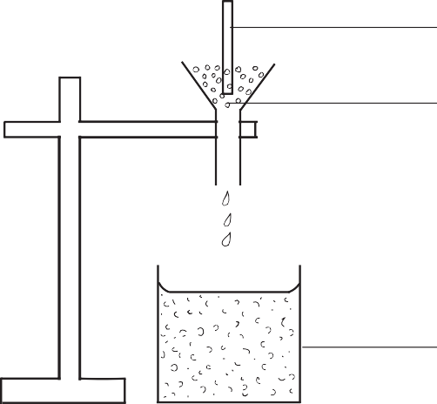
60 W heater Finely crushed ice

Beaker

Figure 11
- In order to obtain results that are as accurate as possible, state why it is important to:
- wait until water is dripping into the beaker at constant rate before taking readings.
(1 mark)

……………………………………………………………………………......………………............................

……………………………………………………………………………......………………............................
- use finely crushed ice rather than larger ones. (1 mark)

……………………………………………………………………………......………………............................

……………………………………………………………………………......………………............................
- The power of the heater and the time for which water is collected are known. Write down all other readings that are needed to obtain a value for a specific latent heat of fusion of ice.
(2 marks)

……………………………………………………………………………......………………............................

……………………………………………………………………………......………………............................
- In an experiment to measure the specific heat capacity of a liquid, a quantity of the liquid was heated in a copper calorimeter. The following measurements were obtained:
Mass of calorimeter = 53.0 g
Mass of calorimeter + liquid = 142.6 g
Initial temperature of calorimeter + liquid = 16ºC Final temperature of calorimeter+ liquid= 21ºC Energy supplied = 1168J

TURN OVER

Using the above measurements, calculate the value of the specific heat capacity of the liquid. (specific heat capacity of copper = 390Jkg–1K–1.) (7 marks)

  - (a) Distinguish between velocity and speed. (2 marks)

……………………………………………………………………………......………………...................................

……………………………………………………………………………......………………...................................

- The velocity-time graph in Figure 12 below illustrates the motion of a ball which has been projected vertically upwards from the surface of a planet. Weight of the ball on Earth is 30 N.
6

5

4
Velocity (m/s)

3

2

1

0
1 2 3 4
Time (s)
Figure 12
Determine the weight of the ball on the planet, if gravitational field strength on Earth is 10 N/kg.
(4 marks)

- The figure below shows a section of a tape from a ten tick timer whose frequency is 50 Hz.
W X Y Z

10 cm

Calculate:

Figure 13

30 cm

- the average velocity of the trolley between points WX. (2 marks)

TURN OVER

- the average velocity of the trolley between YZ. (2 marks)

- the acceleration of the trolley. (2 marks)

  - (a) (i) State the pressure law. (1 mark)

……………………………………………………………………………......………………............................

……………………………………………………………………………......………………............................

……………………………………………………………………………......………………............................
- Define an ideal gas. (1 mark)

……………………………………………………………………………......………………............................

……………………………………………………………………………......………………............................

……………………………………………………………………………......………………............................
- Define the absolute zero temperature. (1 mark)

……………………………………………………………………………......………………............................

……………………………………………………………………………......………………............................

- Using Boyle’s Law, explain the changes in the size of a gas bubble from the bottom of a deep dam to the point that it reaches the surface of the water. (3 marks)
……………………………………………………………………………......………………...................................

……………………………………………………………………………......………………...................................

……………………………………………………………………………......………………...................................

……………………………………………………………………………......………………...................................

……………………………………………………………………………......………………...................................

……………………………………………………………………………......………………...................................

……………………………………………………………………………......………………...................................

……………………………………………………………………………......………………...................................

……………………………………………………………………………......………………...................................
- During the promulgation of the new Constitution, a hydrogen-filled balloon with a volume of
0.027 m3 was released at Uhuru Park from the ground where the pressure was 675 mmHg and the temperature was 25°C. The balloon rose to a height of 2700 m above the ground where the pressure had fallen to 450 mmHg and the temperature to 10°C. Determine the new volume of the balloon. (4 marks)

TURN OVER

  - (a) State the limitation of Hooke’s Law. (1 mark)

……………………………………………………………………………......………………...................................
- An experiment was performed to find out how the length, l, of a spring varies with the compressing force, F. The results were recorded in the graph below.
10
8
6
4
2
0
10
20
Force (N)
30
40
Length (cm)

  - Draw a diagram showing the possible set-up of the apparatus used. (2 marks)

  - Determine the range of force that the spring obeys Hooke’s Law. (1 mark)

……………………………………………………………………………......……………….............................
  - Suggest a reason for the shape of the graph between 20 N and 30 N force. (1 mark)

……………………………………………………………………………......………………............................

……………………………………………………………………………......………………............................
- A spring balance produces an extension of 12 mm when a force of 0.6 N is applied to it. Calculate the spring constant for the system when two such springs are arranged in series. (3 marks)

