Name…………………………………… …………………………..… Index No:………………………….
231/2 Candidate’s Signature …………..……………
BIOLOGY Date: …………………………
PAPER 2
(THEORY)
JULY/AUGUST 2014
TIME: 2 HOURS

Kenya Certificate of Secondary Education (K.C.S.E.)

231/2
Biology
Paper 2
2 ½ Hours

INSTRUCTIONS TO CANDIDATES
- Write your name and index number in the spaces provided above
- Sign and write the date of examination in the spaces provided.
- This paper consists of sections A and B answer all questions in section A
- In section B answer question 6compulsory and either question 7or 8 in spaces provided after question 8
- Answer all the questions in the spaces provided.

For Examiners Use Only
Section | Question | Maximum score | Candidate’s score
A | 1  2  3  4  5 | 9  8  7  8  8
B | 6  7  8 | 20  20  20
TOTAL |  | 80

This paper consists of 11printed pages. Candidates should check to ascertain that all pages are printed as indicated and that no questions are
missing.
1. The diagram below represents a part of thoracic region of a human being;
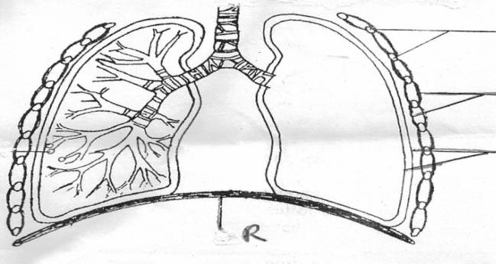
Ribs
L
K
R

(a) Name the structures labeled K and L (2mks)
K………………………………………………
L……………………………………………….
(b) How is structure R bring about inhalation (4mks)
……………………………………………………………………………………………………...
……………………………………………………………………………………………………...
……………………………………………………………………………………………………...
……………………………………………………………………………………………………...
(c) Give the scientific name of the organism that causes whooping cough (1mk)
……………………………………………………………………………………………………...
(d) Name a vertebra that articulates with the ribs to the back of the chest region? (1mk)
……………………………………………………………………………………………………...
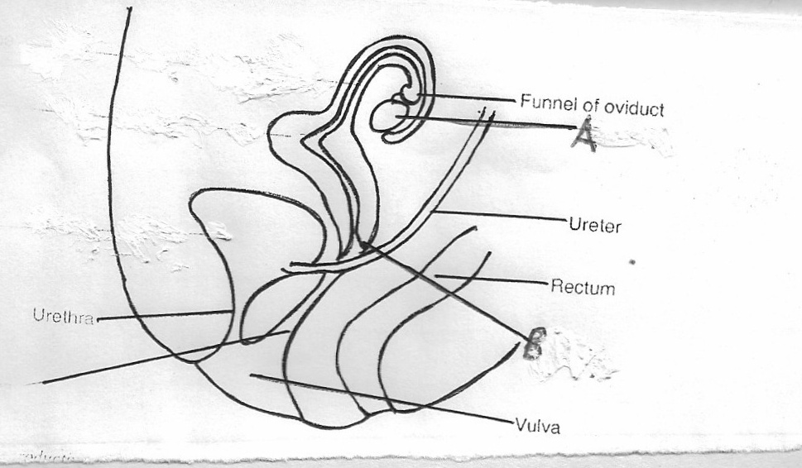
2. The diagram below shows the vertical section of a female reproductive system
Funnel of oviduct
A
Rectum
Ureter
B
Urethra
Vulva
(a) Name the parts labeled A and B (2mks)
A…………………………………..
B………………………………….
(b) Name the gonadotrophic hormone that affects the part labeled A (1mk)
……………………………………………………………………………………………………...
(c) (i) State a hormone(s) produced by each of the following structures in a female (2mks)
Ovary…………………………………………………………………………………………
Placenta ……………………………………………………………………………………
(ii) State one effect of each of the above hormones on uterine wall (2mks)
……………………………………………………………………………………………………...
……………………………………………………………………………………………………...
(d)Name a sub-division in the kingdom plantae that exhibit double fertilization (1mk)
……………………………………………………………………………………………………...
3. (a) Define the following terms as used in animal nutrition
(i)Dentition (1mk)
……………………………………………………………………………………………………...
(ii) Homodont and heterodont teeth (2mks)
……………………………………………………………………………………………………...
……………………………………………………………………………………………………...
(b) State two functions of ileum (2mks)
……………………………………………………………………………………………………...
……………………………………………………………………………………………………...
(c) Explain the importance of the following in the process of photosynthesis; (2mks)
(i) Chlorophyll
……………………………………………………………………………………………………...
(ii) Light
……………………………………………………………………………………………………...
(d) State one use of Potassium in (K⁺) ion the body (1mk)
……………………………………………………………………………………………………...
4. A man who suffers from Haemophilia which is a sex linked gene; marries a woman who is normal for the condition. However, one of their daughters Jane turns to be haemophiliac. Taking ‘H’ for normal trait and ‘h’ for haemophilia
(a) State the genotypes of the parents (2mks)
……………………………………………………………………………………………………...
(b) (i) Work out the genotypes of the offspring show your work (4mks)
……………………………………………………………………………………………………...
……………………………………………………………………………………………………...
……………………………………………………………………………………………………...
……………………………………………………………………………………………………...
(ii) State the genotype of Jane (1mk)
……………………………………………………………………………………………………...
……………………………………………………………………………………………………...
(c) What is polyploidy (1mk)
……………………………………………………………………………………………………...
……………………………………………………………………………………………………...
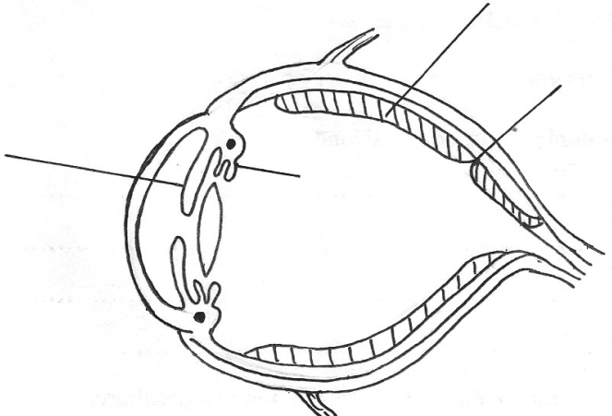
5. The diagram below represents a longitudinal section through the human eye
Eye
Fovea centralis
L
K
N

(a) Name the parts labeled K and L (2mks)
K……………………………………
L……………………………………
(b) A person in totally dark room switches on light. Describe the changes that will occur to
structure N (3mks)
……………………………………………………………………………………………………...
……………………………………………………………………………………………………...
……………………………………………………………………………………………………...
(c) How does the human eye obtain nutrients? (3mks)
……………………………………………………………………………………………………...
……………………………………………………………………………………………………...
……………………………………………………………………………………………………...
SECTION B (40 MKS)
Answer question 6 (Compulsory) and either question 7 or 8 in the spaces provide after question 8
6. The glucose level in mg/100cm³ of blood was determined in two persons Y and Z. Both had stayed for 6 hours without taking food. They were on equal amount of glucose at the start of the experiment. The amount of glucose in their blood was determined at intervals. The results are as shown in the table below:

Time (Mins) | Glucose level in Y | Blood in mg/100cm³
0  20  30  45  60  80  100  120  140 | 85  105  116  130  100  93  90  90  88 | 78  110  130  170  195  190  140  130  120

(a) On the same graph and on the same axis, plot a graph of glucose level in blood against
time (7mks)

(b) What was the concentration of glucose in blood of person Y and Z at 50th minute? (2mks)
Person Y
……………………………………………………………………………………………………...
Person Z
……………………………………………………………………………………………………...
(c) Account for the level of glucose for a person Y
(i) During the first 45 minutes (2mks)
……………………………………………………………………………………………………...
……………………………………………………………………………………………………...
(ii) After 45th minute to the end (4mks)
……………………………………………………………………………………………………...
……………………………………………………………………………………………………...

(d) Discuss the effect of higher glucose level in blood above 90mg/100cm3 (3mks)
……………………………………………………………………………………………………...
……………………………………………………………………………………………………...

(e) State two advantages of homoitherms over paikilotherms (2mks)
……………………………………………………………………………………………………...
……………………………………………………………………………………………………...
7. (a) A dicotyledonous stem offer support to the plant. Give three necessities for this support(3mks)
(b) Describe the adaptation of the stem of a dicotyledonous plant to its function (17mks)
8. (a) Describe the dentition of carnivorous mammals and their adaptation to the mode of
Feeding (10mks)
(b) Explain the different forms of chromosomal mutation (10mks)
……………………………………………………………………………………………………...
……………………………………………………………………………………………………...
……………………………………………………………………………………………………...
……………………………………………………………………………………………………...
……………………………………………………………………………………………………...
……………………………………………………………………………………………………...
……………………………………………………………………………………………………...
……………………………………………………………………………………………………...
……………………………………………………………………………………………………...
……………………………………………………………………………………………………...
……………………………………………………………………………………………………...
……………………………………………………………………………………………………...
……………………………………………………………………………………………………...
……………………………………………………………………………………………………...
……………………………………………………………………………………………………...
……………………………………………………………………………………………………...
……………………………………………………………………………………………………...
……………………………………………………………………………………………………...
……………………………………………………………………………………………………...
……………………………………………………………………………………………………...
……………………………………………………………………………………………………...
……………………………………………………………………………………………………...
……………………………………………………………………………………………………...
……………………………………………………………………………………………………...
……………………………………………………………………………………………………...
……………………………………………………………………………………………………...
……………………………………………………………………………………………………...
……………………………………………………………………………………………………...
……………………………………………………………………………………………………...
……………………………………………………………………………………………………...
……………………………………………………………………………………………………...
……………………………………………………………………………………………………...
……………………………………………………………………………………………………...
……………………………………………………………………………………………………...
……………………………………………………………………………………………………...
……………………………………………………………………………………………………...
……………………………………………………………………………………………………...
……………………………………………………………………………………………………...
……………………………………………………………………………………………………...
……………………………………………………………………………………………………...
……………………………………………………………………………………………………...
……………………………………………………………………………………………………...
……………………………………………………………………………………………………...
……………………………………………………………………………………………………...
……………………………………………………………………………………………………...
……………………………………………………………………………………………………...
……………………………………………………………………………………………………...
……………………………………………………………………………………………………...
……………………………………………………………………………………………………...
……………………………………………………………………………………………………...
……………………………………………………………………………………………………...
……………………………………………………………………………………………………...
……………………………………………………………………………………………………...
……………………………………………………………………………………………………...
……………………………………………………………………………………………………...
……………………………………………………………………………………………………...
……………………………………………………………………………………………………...
……………………………………………………………………………………………………...
……………………………………………………………………………………………………...
……………………………………………………………………………………………………...
……………………………………………………………………………………………………...
……………………………………………………………………………………………………...
……………………………………………………………………………………………………...
……………………………………………………………………………………………………...
……………………………………………………………………………………………………...
……………………………………………………………………………………………………...
……………………………………………………………………………………………………...
……………………………………………………………………………………………………...
……………………………………………………………………………………………………...
……………………………………………………………………………………………………...
……………………………………………………………………………………………………...
……………………………………………………………………………………………………...
……………………………………………………………………………………………………...
……………………………………………………………………………………………………...
……………………………………………………………………………………………………...
……………………………………………………………………………………………………...
……………………………………………………………………………………………………...
……………………………………………………………………………………………………...
……………………………………………………………………………………………………...
……………………………………………………………………………………………………...
……………………………………………………………………………………………………...
……………………………………………………………………………………………………...
……………………………………………………………………………………………………...
……………………………………………………………………………………………………...
……………………………………………………………………………………………………...
……………………………………………………………………………………………………...
……………………………………………………………………………………………………...
……………………………………………………………………………………………………...
……………………………………………………………………………………………………...

