Name…………………………………… …………………………..………… Index No:………………………….

233/2 Candidate’s Signature …………..……………
CHEMISTRY Date: …………………………
PAPER 2
THEORY
JULY/AUGUST 2014
TIME: 2 HOURS

Kenya Certificate of Secondary Education (K.C.S.E.)

233/2
Chemistry
Paper 2
2 Hours

INSTRUCTIONS TO CANDIDATES

- Write your name and Index number in spaces provided above.
- Sign and write the date of examination in the spaces provided above
- Answer all the questions in the spaces provided above.
- KNEC Mathematical tables and silent electronic calculators may be used.
- All working must be clearly shown where necessary.
- Candidates should answer the questions in English.

For Examiners Use Only
Question | Maximum score | Candidate’s score
1 | 13
2 | 11
3 | 12
4 | 09
5 | 11
6 | 10
7 | 14
Total score | 80

This paper consists of 8 printed pages. Candidates should check to ascertain that all pages are printed as indicated and that no questions are missing.
1. (a) The grid given below represents part of the periodic table. Study it and answer the questions that follow. (The letters do not represent the actual symbols of elements )
A |  |  |  | E |  |  | H
 | C |  | D |  | G |  |  | K
B |  |  |  | F |  |  | J
(i) Giving reasons, select the element which is
I. Most reactive non metal (2mks)
………………………………………………………………………………………………………………
………………………………………………………………………………………………………………
II. Most reactive metal (2mks)
………………………………………………………………………………………………………………
………………………………………………………………………………………………………………
(ii) How does reactivity of A compare with that of B. Explain (1mk)
………………………………………………………………………………………………………………
………………………………………………………………………………………………………………
(iii) Explain why the atomic radius of K is smaller than that of G (1mk)
………………………………………………………………………………………………………………
………………………………………………………………………………………………………………
(iv) An element W forms ion W²⁻, if w is in period 3, indicate the position of W on the grid (1mk)
………………………………………………………………………………………………………………
(v) Write the formula of the compound formed when C reacts with H (1mk)
………………………………………………………………………………………………………………
(b) Study the information in the table below and answer the questions that follow
Substance | M.P(ºC) | B.P(ºC) | Electrical conductivity |  | Solubility in water
 |  |  | In solid state | In molten state
P  Q  R  S  U  V  W | 714  -95  1083  -101  -23  -219  1560 | 1418  56  2580  -34  77  -183  2600 | Does not conduct  Does not conduct  Conducts  Does not conduct  Does not conduct  Does not conduct  Does not conduct | Conducts  Conducts  Conducts  Does not conduct  Does not conduct  does not conduct  does not conduct | Very soluble  Insoluble  Insoluble  Very soluble  Soluble  Insoluble  Insoluble
(i) Name two substances which are gaseous at room temperature (1mk)
………………………………………………………………………………………………………………
………………………………………………………………………………………………………………
(ii) Select the substance that could be dissolved in water and be separated from the solution by
Fractional distillation (1mk)
………………………………………………………………………………………………………………
(iii) Which substance could be an electrolyte? (1mk)
………………………………………………………………………………………………………………

(iv) Element U has low M.P and B.P whereas W has high M.P and B.P. Explain (2mks)
………………………………………………………………………………………………………………
2. (a)The diagram below shows part of the processes in the manufacture of Nitric (V) acid
Purifier
Compressor
Heat exchanger
Catalytic chamber
Absorption tower
Reaction chamber
Purified air
65% Nitric (V) acid
65% Nitric (V) acid
Warm water
Unreacted gases
Ammonia
Air

Water

(i) What is the work of the purifier (1mk)
………………………………………………………………………………………………………………
(ii) State the pressure used in the compressor (1mk)
………………………………………………………………………………………………………………
(iii) State two functions of the heat exchanger (1mk)
………………………………………………………………………………………………………………
………………………………………………………………………………………………………………
(iv) Name the catalyst used in the catalytic chamber (1mk)
………………………………………………………………………………………………………………

(v) Write equation of the reaction that takes place in:
(I) Catalytic chamber (1mk)
………………………………………………………………………………………………………………
(II) Reaction chamber (1mk)
………………………………………………………………………………………………………………
(III) Absorption tower (1mk)
………………………………………………………………………………………………………………
(b) (i) Calculate the volume of Oxygen that would be obtained from the decomposition of 21.25g of
Sodium Nitrate at s.t.p (1 mole of a gas occupies 22.4dm3 at stp, N=14, Na=23,O=10) (3mks)

(c) Name two commercial uses of Nitric (V) acid (2mks)
…………………………………………………………………………………………………………
…………………………………………………………………………………………………………
3. (a) The diagram below shows a set-up used to determine the standard electrode potential (E^{θ}) of Zinc
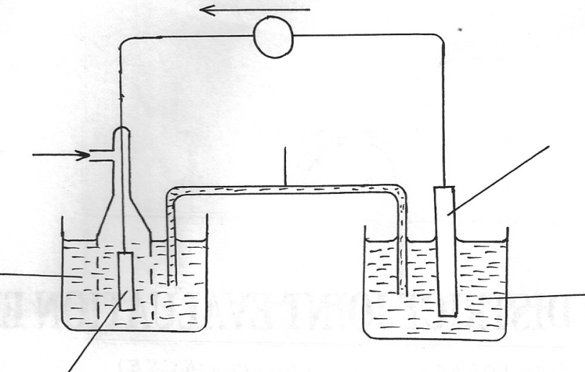
A
C
B
Zinc electrode
1M Zn²⁺_{(aq)}
1M H⁺_{(aq)}
Ions solutions
Flow of elctrons

(i) I. Label parts A and B
A………………………………………….. (1mk)
B………………………………………….. (1mk)
II. Identify substance C
C……………………………………….
(ii) Write the equations of the reactions that take place at the electrodes (2mks)
Anode :
………………………………………………………………………………………………………………
Cathode :
………………………………………………………………………………………………………………
(b) Study the standard electrode potentials given below and answer the questions that follow.
The letters do not represent the actual symbols of the elements

Half reactions | Electrode potential E^{θ} V
P⁺_{(aq)} + e- P_{(s)}  R³⁺_{(aq)} +3e- R_{(s)}  S²⁺_{(aq)}+2e- S_{(s)}  T²⁺_{(aq)} +2e- T_{(s)}  V⁺_{(aq)} + e- V_{(s)}  W_{2(g)}+2e 2W-_{(aq)} | -2.92  -1.35  -0.76  +0.34  +0.80  +1.36
(i) Which is the
I. Strongest reducing agent. Explain (1mk)
………………………………………………………………………………………………………………
II. Strongest oxidizing agent. Explain (1mk)
………………………………………………………………………………………………………………
(ii) Calculate the e.m.f of a cell made by metals S and V (1mk)
………………………………………………………………………………………………………………
(c) During electrolysis of an aqueous solution of a salt of metal Q, a current of 2.0A was passed
for 32 minutes and 10 seconds. The mass of metal Q deposited was 2.24g
(1 Faraday=96500c, RAM of Q=112)
(i) Calculate the quantity of electricity passed (2mks)

(ii) Calculate the charge carried on the ion of metal Q (2mks)

4. (a) In an experiment to study the rate of a reaction,2.0g of Manganese (IV) oxide was added to 100cm³ of hydrogen peroxide solution at 25ºC. The volume of oxygen released was measured at 10 seconds intervals. The results obtained are tabulated below

Time (sec) | 0 | 10 | 20 | 30 | 40 | 50 | 60 | 70 | 80 | 90
Volume (cm³) | 0 | 60 | 90 | 105 | 112 | 116 | 118 | 120 | 120 | 120
(i)Plot a graph of volume of gas (vertical axis) against time and label it X (3mks)

(ii) Use the graph to find:
(I) The volume of gas produced after 25 seconds (1mk)
………………………………………………………………………………………………………………
………………………………………………………………………………………………………………
(II) The time taken to produce 80cm³ of oxygen (1mk)
………………………………………………………………………………………………………………
………………………………………………………………………………………………………………
(iii) Explain why the volume of oxygen produced does not exceed 120cm3 (1mk)
………………………………………………………………………………………………………………
………………………………………………………………………………………………………………
(iv) Sketch a graph Y, on the same grid to show the results if the experiment was repeated
using hydrogen peroxide at 10ºC. Explain (2mks)
………………………………………………………………………………………………………………
………………………………………………………………………………………………………………
(v) The mass of the solid residue after the experiment was found to be 2.0g when dried. Explain (1mk)
………………………………………………………………………………………………………………
………………………………………………………………………………………………………………
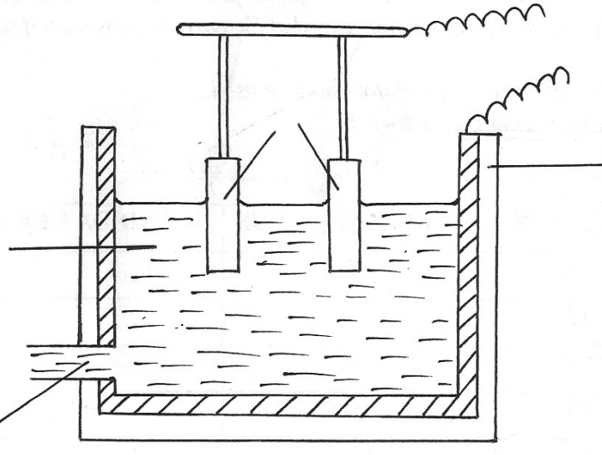
5. (a) The figure shows the extraction of Aluminium from bauxite
+ve
-ve
Steel trough
C
B
A

(i) Write the formula of bauxite (1mk)
………………………………………………………………………………………………………………
(ii) How is the ore (bauxite) concentrated before it is electrolysed (1mk)
………………………………………………………………………………………………………………
………………………………………………………………………………………………………………
(iii) Identify;
(I) Product A (1mk)
………………………………………………………………………………………………………………
(II) Electrolyte B (1mk)
………………………………………………………………………………………………………………
(III) Material used to make electrode C (1mk)
………………………………………………………………………………………………………………
(b) What is the purpose of dissolving electrolyte B in molten cyrolite (Na₃AlF₆) (1mk)
………………………………………………………………………………………………………………
………………………………………………………………………………………………………………
(c) Explain why anode has to be replaced from time to time (1mk)
………………………………………………………………………………………………………………
(d) Write the reaction for the chemical reaction that take place when aluminium reacts with Iron (III)
Oxide (1mk)
………………………………………………………………………………………………………………
(e) State any two uses of Aluminium (2mks)
………………………………………………………………………………………………………………
………………………………………………………………………………………………………………
6. (a) Differentiate between lattice energy and hydration energy (2mks)
………………………………………………………………………………………………………………
………………………………………………………………………………………………………………
(b) Use the values given in the table below to answer the questions that follow

Ion | Enthalpy of hydration ΔH_{hyd}.(KJMol⁻¹)
Mg ²⁺ | -1891
Cl⁻ | -384

Given that lattice energy of MgCl₂ is -2489 KJ/Mol
(i) Draw an energy cycle diagram for dissolving Magnesium in water (3mks)

(ii) Use your energy cycle diagram above to calculate the enthalpy of solution of Magnesium chloride (2mks)

(b) (i) Define fuel (1mk)
………………………………………………………………………………………………………………
………………………………………………………………………………………………………………
(ii) Given that heat of combustion of S is 296.8KJ/Mol, Determine the heating value of S(S=32)
(2mks)

7. (a) Give the systematic names for following compounds;
(i) CH₃CH₂CH₂CH₂OH (1mk)
………………………………………………………………………………………………………………
O
(ii) CH₃CH₂ C – O - CH₂CH₃ (1mk)
………………………………………………………………………………………………………………
(iii) CH₃CH₂CH₃ (1mk)
………………………………………………………………………………………………………………
(b) Study the flow chart below and use it to answer the question that follow
Sugar solution
Crud e ethanol
Pure ethanol
Substance D
Compound E
Substance B + Gas C
Substance A
Process I
Conc. H₂SO₄
180ºC
Polymerization
Sodium
Metal

(i) Name:
Substance A (1mk)
………………………………………………………………………………………………………………
Process I (1mk)
………………………………………………………………………………………………………………
Substance B (1mk)
………………………………………………………………………………………………………………
Gas C (1mk)
………………………………………………………………………………………………………………
Substance D (1mk)
………………………………………………………………………………………………………………
Compound E (1mk)
………………………………………………………………………………………………………………
(ii) Identify the type of Polymerization that results to the formation of compound E (1mk)
………………………………………………………………………………………………………………
(iii)If one mole of sugar, C₆H₁₂O₆ produces two molecules of pure ethanol, C₂H₅OH
and two moles of carbon (IV) oxide gas as the only product;
I. Write an equation for the reaction (1mk)
………………………………………………………………………………………………………………
II. If 144kg of sugar (C₆H₁₂O₆) was used to produce ethanol in this process, calculate the mass
in kg of ethanol produced (C=12,H=1, O=16) (3mks)

