Name………………………………………………………………………………………Index No:……………………………………………..
231/3 Candidate’s Signature:……………………….
BIOLOGY Date:…………………………………………………
Paper 3
(PRACTICAL)
Jul./Aug.2014
KAKAMEGA COUNTY JOINT EVALUATION TEST -2014
BIOLOGY
Paper 3
(PRACTICAL)
1 ¾ hours

Instructions to candidates
- Write your name and index number in the spaces provided above.
- Sign and write the date of the examination in the spaces provided above.
- Answer ALL the three questions in the spaces provided.
- Spend the first 15 min of the 1hr 45min to read through the paper carefully before commencing your work.
- Additional pages must NOT be inserted.
- This paper consists of 5 printed pages.
- Candidates should check the question paper to ensure that all the pages are printed as indicated and no question is missing.

QUESTION | MAXIMUM SCORE | CANDIDATE’S SCORE
1 | 13
2 | 14
3 | 13
TOTAL | 40
For Examiner’s use Only

1(a).You are provided with specimen K which is a plant tissue cut it into two equal halves longitudinally and place one half into solution L₁ and the other into solution L₂ provided. Allow it to stand for 20min and then remove and wipe excess solution using tissue paper.
(i)Observe and draw labeled illustrations showing the results of the two tissues. (2mks)

(ii)How does each piece feel when pressed (1mk)
Piece in solution L₁ ……………………………………………………………………………………………………………………………………
Piece in solution L₂ ……………………………………………………………………………………………………………………………………
(iii)Account for the results of the piece in L _{2.} (3marks)
……………………………………………………………………………………………………………………………………………………………………………………………………………………………………………………………………………………………………………………………………………………………………………………………………………………………………………………………………………………………………….
b)(i).You are provided with solution N which is a food substance, solution H –Benedict’s solution, solution G –Iodine solution, and solution F whose identity is not known. Conduct food tests using the reagents provided to complete the table below: (3marks)
TEST | PROCEDURE | OBSERVATION | CONCLUSION
(ii)Place 3cm³ of solution N in a test tube then add 1cm³ of solution F and warm the mixture in a water bath maintained at 40⁰C for 15 minutes. Repeat Benedicts test and state the observations and conclusions made. (2 marks)
Observations …………………………………………………………………………………………………………………………………………….
Conclusion ………………………………………………………………………………………………………………………………………………..
(iii) State the identity of solution F. (1 mark)
………………………………………………………………………………………………………………………………………………………………….
(iv) Account for the results in b (iii) above. (2 marks)
……………………………………………………………………………………………………………………………………………………………………………………………………………………………………………………………………………………………………………………………………
2. Study the photographs of bones below and answer the questions that follow
PHOTOGRAPH T PHOTOGRAPH R PHOTOGRAPH Q (anterior view)
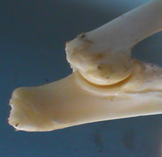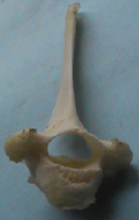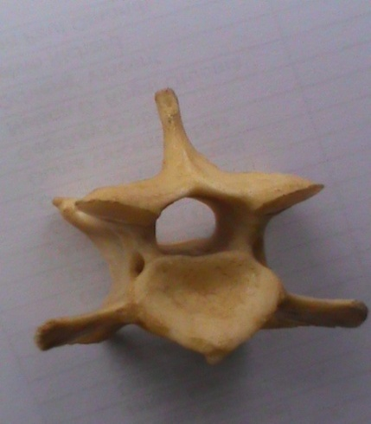
N
PHOTOGRAPH Q (side view) PHOTOGRAPH S (anterior view) PHOTOGRAPH S (side view)
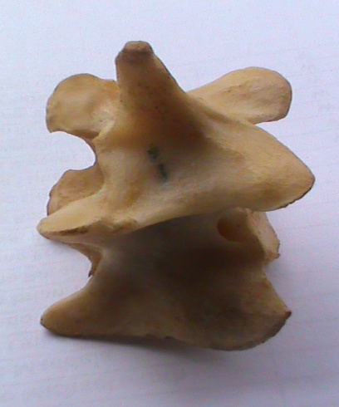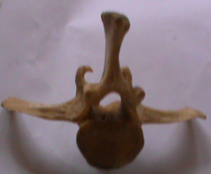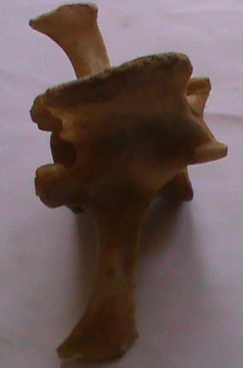

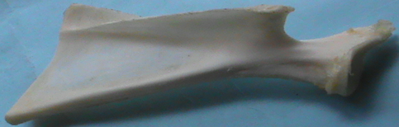
Y X
a (i) Giving reasons in each case identify the bones Q, R and S. (3 marks)
Bone | Name | Reason
Q
R
S
(ii) Using observable features only state two ways in which bone Q Is adapted to its functions. (2 marks)
……………………………………………………………………………………………………………………………………………………………
……………………………………………………………………………………………………………………………………………………………
b (i) Identify the parts labeled X and Y in bone P and in each case name the bone that articulates with the parts identified in bone P. (4 marks)
Part X: ………………………………………………………………………………………………………………………………………….
Bone articulating with: …………………………………………………………………………………………………………………
Part Y: ………………………………………………………………………………………………………………………………………….
Bone articulating with: …………………………………………………………………………………………………………………
c. In photograph T;
(i) Name the joint shown ………………………………………………………………………………………………………………………….
(ii) State two similarities between the joint shown and the joint in formed at part X in photograph P. (2 marks)
………………………………………………………………………………………………………………………………………………………………….………………………………………………………………………………………………………………………………………………………………….
(iii) State two functions of the part labeled N. (2 marks)
………………………………………………………………………………………………………………………………………………………………….………………………………………………………………………………………………………………………………………………………………….

3 study the photographs below and answer the questions that follow:
PHOTOGRAPH J PHOTOGRAPH K
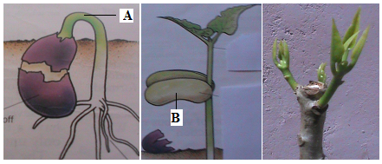
a) Photograph K illustrates the observations made two weeks after the plant was trimmed.
(i)Name the phenomenon that was experienced by the plant before it was trimmed (1mark)
………………………………………………………………………………………………………………………………………………………………….
(ii)Account for the observation made in the shoot after the practice (3marks)
……………………………………………………………………………………………………………………………………………………………………………………………………………………………………………………………………………………………………………………………………………………………………………………………………………………………………………………………………………………………………….(iii)Explain the application of the practice in agriculture (2marks)
……………………………………………………………………………………………………………………………………………………………………………………………………………………………………………………………………………………………………………………………………
b) In photograph J
(i) Name the part labeled A …………………………………………………………………………………………………………. (I mark)
(ii) State thee functions of part B (3marks)
……………………………………………………………………………………………………………………………………………………………………………………………………………………………………………………………………………………………………………………………………………………………………………………………………………………………………………………………………………………………………….
(iii) Account for the change in shape of the seedling shown in the next stage (3marks)
……………………………………………………………………………………………………………………………………………………………………………………………………………………………………………………………………………………………………………………………………………………………………………………………………………………………………………………………………………………………………….

