Name...........................................................Adm. No.................................................................
School............................................................Class.....................................................................
Index No.....................................................................................................................................
233/1
CHEMISTRY
Paper 1
THEORY
July 2014
2 hours
KAKAMEGA COUNTY JOINT EVALUATION TEST
Kenya Certificate of Secondary Education
Instructions to candidates
- Write your name and index number in the spaces provided above.
- Answer all the questions in the spaces provided in the question paper.
- Mathematical tables and silent electronic calculators may be used.
- All workings MUST be shown where necessary.
For Examiner’s Use Only.
Questions | Maximum score | Candidate’s score
1-29 | 80

1. Study the following nuclear reaction and complete it by giving the values of m and n. (2mks)
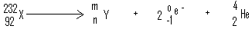
2. For the reaction
Cl_{2 (g)} + 2I⁻_{(aq)} 2Cl⁻ _{(aq)} + I_{2(s)}
Using oxidation numbers determine the reducing agent. (2mks)
........................................................................................................................................................................................................................................................................................................................................................................................................................................................................................................................................................................................................................................
3. When aqueous sodium hydroxide solution was added to freshly prepared acidified iron (II) sulphate solution, a green precipitate was formed. When hydrogen peroxide was first added to iron (II) sulphate solution followed by sodium hydroxide solution, a brown precipitate was formed. Explain these observations. (3mks)
........................................................................................................................................................................................................................................................................................................................................................................................................................................................................................................................................................................................................................................
4. Substances X and Y consist of molecules X₂ and Y₂ respectively. When the two elements react, they form a molecule XY. The X-X bonds are as strong as the Y-Y bonds but X-Y bonds are stronger than either X-X or Y-Y. The equation for the reaction for the reaction is.
X_{2(g)} + Y_{2 (g)} 2XY _{(g)}
- Is the reaction exothermic or endothermic? Give a reason for your answer. (2mks)
..........................................................................................................................................................................................................................................................................................................................................................................................................................................
- Draw an energy level diagram for the reaction in (a) above. (2mks)

5. Pentane is a saturated hydrocarbon.
(a) What does the term saturated hydrocarbon mean? (1mk) ....................................................................................................................................................................................................................................................................................................................
(b) Give the equation for complete combustion of pentane when burnt in plentiful supply of air.
(2mks) .........................................................................................................................................................
6. A solution of potassium chloride was added to a solution containing a lot of lead (II) nitrate. A precipitate that weighed 5.56g was formed. Find the amount of potassium chloride in the solution. (Pb=207, Cl=35.5, K=39) (3mks) ........................................................................................................................................................................................................................................................................................................................................................................................................................................................................................................................................................................................................................................
7. Aluminium chloride vapour combines readily with ammonia gas to form a solid compound of formula (AlCl₃.NH₃). Explain in terms of structure and stability of atoms why this reaction occurs. (2mks) ..............................................................................................................................................................................................................................................................................................................................................................................................................................................................................
8. (a) Give the systematic name of the following monomer and draw the structure of the polymer it forms. (2mks)
CH₂CHCl .........................................................................................................................................
Structure of polymer ....................................................................................................................................................................................................................................................................................................................
(b) State one use of the polymer in (a) (1mk) ....................................................................................................................................................................................................................................................................................................................
9. Gas A is 16 times denser than gas B. 100cm3 of A diffuses through a hole in 20 seconds. Calculate the volume of B that will diffuse through the hole in 30 seconds. (3mks) ........................................................................................................................................................................................................................................................................................................................................................................................................................................................................................................................................................................................................................................
10. Use the following information to answer the questions that follow.
Sn²⁺ _{(aq)} + 2e- Sn_{(s)} E^{Q} = -0.14V
Cu²⁺ (_{aq)} + 2e- Cu_{(s)} E^{Q} =0.34V.
- Write the cell representation for the cell made up of two half cells. (1mk) .............................................................................................................................................
- Write an equation for the cell reaction. (1mk) ..............................................................................................................................................
- Calculate the E^{Q} value for the cell. (1mk) ..........................................................................................................................................................................................................................................................................................................................................................................................................................................
11. A solution of hydrogen bromide in benzene does not react with sodium carbonate while an aqueous solution of hydrogen bromide reacts with carbonates. Explain this observation.
(2mks) ....................................................................................................................................................................................................................................................................................................................
12. A student prepared ammonia gas and led it into a solution of zinc sulphate using the arrangement shown below.
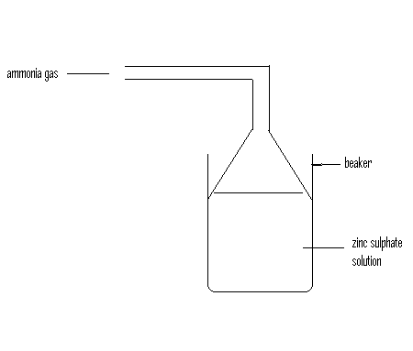
- State and explain the observations that were made in the beaker. (2mks) ..........................................................................................................................................................................................................................................................................................................................................................................................................................................
- Write the ionic equation for the reaction involving zinc ions. (1mk) ..............................................................................................................................................
13.A solid mixture consists of substances Y, Y, and Z whose solubilities at room temperature are shown in the table below.
Substance | Solubility (g/100g water)
Substance | At 25ºC | At 60ºC
X | 0.02 | 0.02
Y | 63 | 82
Z | 48 | 64
Describe how you would separate X Y and Z. (3mks) ........................................................................................................................................................................................................................................................................................................................................................................................................................................................................................................................................................................................................................................
14. When a hydrated sample of calcium sulphate CaSO₄.XH₂O was heated until all the water was lost, the following data was recorded.
Mass of crucible = 30.296g
Mass of crucible + hydrated salt = 33.111g
Mass of crucible + anhydrous salt = 32.781g
Determine the empirical formula of the hydrated salt (RAM: CaSO₄= 136, H₂O= 18) (3mks) ........................................................................................................................................................................................................................................................................................................................................................................................................................................................................................................................................................................................................................................
15. Zinc reacts with both concentrated and dilute sulphuric (VI) acid. Write equations for the two reactions. (2mks) ....................................................................................................................................................................................................................................................................................................................
16. Starting with copper metal, describe how a sample of copper (II) chloride may be prepared in the laboratory. (3mks) ........................................................................................................................................................................................................................................................................................................................................................................................................................................................................................................................................................................................................................................
17. The atomic number of sulphur is 16. Write the electron arrangement of sulphur on the following. (2mks)
- H₂S.......................................................................................................................................
- SO²⁻₃.....................................................................................................................................
18. Using dots (.) and crosses (X) show bonding in:
- The compound formed between phosphorus and hydrogen. (P=15, H= 1) (1mk) ........................................................................................................................................................................................................................................................................................................................................................................................................................................................................................................................................................................................
- carbon(II)oxide.(C=6, O=8) (1mk) ........................................................................................................................................................................................................................................................................................................................................................................................................................................................................................................................................................................................
19. Hydrogen and oxygen can be obtained by electrolysis of acidified water. Using equation for the reaction at the electrodes, explain why the volume of hydrogen obtained is twice that of oxygen. (2mks) ..............................................................................................................................................................................................................................................................................................................................................................................................................................................................................
20. The energy level diagram below shows the effect of catalyst on the reaction path.
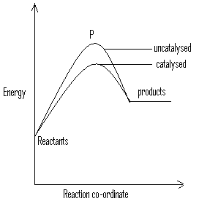

- What does point P represent? (1mk) ............................................................................................................................................
- With reference to the energy level diagram, explain how a catalyst increases the rate of a reaction. (2mks) ..........................................................................................................................................................................................................................................................................................................................................................................................................................................
21. (a) What is meant by a strong acid? (1mk) ....................................................................................................................................................................................................................................................................................................................
(b)In an experiment 40cm³ of 0.5M sulphuric acid was reacted with excess sodium carbonate and the volume of carbon (IV) oxide produced recorded with time. In another experiment, the same volume and concentration of ethanedioic acid was also reacted with excess sodium carbonate and the volume of carbon (IV) oxide produced recorded with time. On the grid below, sketch and label the curves if the volumes of carbon (IV) oxide were plotted against time. (2mks)
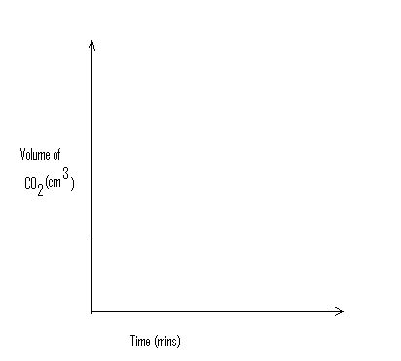
22. (a) State Gay Lussac’s law. (1mk) ..............................................................................................................................................................................................................................................................................................................................................................................................................................................................................
(b) 10cm³ of a gaseous hydrocarbon, CxHy required 30cm³ of oxygen for complete combustion. If steam and 20cm3 of carbon (IV) oxide were produced, what is the value of X? (2mks) ........................................................................................................................................................................................................................................................................................................................................................................................................................................................................................................................................................................................................................................
23. (a) Explain why permanent hardness in water cannot be removed by boiling. (2mks) ....................................................................................................................................................................................................................................................................................................................
(b) Name two methods that can be used to remove permanent hardness from water. (2mks) ..............................................................................................................................................................................................................................................................................................................................................................................................................................................................................
24. (a) Distinguish between nuclear fission and nuclear fusion. (2mks) ..............................................................................................................................................................................................................................................................................................................................................................................................................................................................................
(b) Describe how solid wastes containing radioactive substances should be disposed of.
(2mks) ..............................................................................................................................................................................................................................................................................................................................................................................................................................................................................
25. Study the information below and answer the questions that follow.
Ions | Electronic arrangement | Ionic radius
Na⁺ | 2.8 | 0.095
K⁺ | 2.8.8 | 0.133
Mg²⁺ | 2.8 | 0.65

Explain why ionic radius of:
- K⁺ is greater than that of Na⁺ (1mk) ............................................................................................................................................................................................................................................................................................
- Mg²⁺ is smaller than that of Na⁺ (2mks) ..........................................................................................................................................................................................................................................................................................................................................................................................................................................
26. In the industrial extraction of lead metal, the ore is first roasted in a furnace. The solid mixture obtained is then fed into another furnace together with coke, limestone and scrap iron. State the function of each of the following in this process.
- Coke (1mk) ............................................................................................................................................................................................................................................................................................
- Limestone (1mk) ............................................................................................................................................................................................................................................................................................
- Scrap iron (1mk) ..........................................................................................................................................................................................................................................................................................................................................................................................................................................
27. (a) State Le-Chateliar’s principle. (1mk) ....................................................................................................................................................................................................................................................................................................................
(b) Under certain conditions, carbon (IV) oxide reacts with water to form methanol and oxygen as shown in the equation below.
2CO₂ + 4H₂O 2CH₃OH + 3O₂ H= +1452kJ/mol
What would be the effect on yield of methanol if the temperature of the reaction mixture is decreased? Explain. (2mks) ..............................................................................................................................................................................................................................................................................................................................................................................................................................................................................

28. Some average bond energies are given below.
Bond | Energy(kJ/mol)
C-C | 348
C-H | 414
Cl-Cl | 243
C-Cl | 432
H-Cl | 340

Calculate the energy change for the reaction below:
C₂H₆ _{(g)} + Cl_{2 (g)} CH₃CH₂Cl _{(g)} + HCl _{(g)} (3mks) ........................................................................................................................................................................................................................................................................................................................................................................................................................................................................................................................................................................................................................................
29. Study the flow chart below showing the reaction involved in the preparation of sulphuric acid and answer the questions that follow.
S SO₂

Reagent L
SO₃ H₂S₂O₇ 2H₂SO₄ (l)
Reagent M
- Name the reagents.
L........................................... (1/2mk) M................................................... (1/2)
- Write the equation for the reaction between reagent M and H₂S₂O₇ (1mk) ............................................................................................................................................................................................................................................................................................

