Name...........................................................Adm. No.................................................................
School............................................................Class.....................................................................
Index No.....................................................................................................................................
KAKAMEGA COUNTY JOINT EVALUATION EXAMINATIONS-2014
233/2
CHEMISTRY
Paper 2
THEORY
July 2014
2 hours
KAKAMEGA COUNTY JOINT EVALUATION TEST-2014
Kenya Certificate of Secondary Education
Instructions to candidates
- Write your name and index number in the spaces provided above.
- Answer all the questions in the spaces provided in the question paper.
- Mathematical tables and silent electronic calculators may be used.
- All workings MUST be shown where necessary.

The flow diagram below shows the processes of purification of an aluminium ore and extraction of aluminium from it.
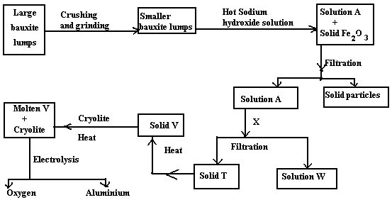
- State why bauxite is first crushed and ground into smaller particles? (½mk)
______________________________________________________________________________________
- Only aluminium oxide and silicon (IV) oxide dissolves chemically in the hot concentrated sodium hydroxide to form solution A, Iron (III) oxide does not.
What property make aluminium oxide and silicon (IV) oxide react with sodium hydroxide solution?
I Silicon (IV) oxide_______________________________________________________________ (1mk)
II Aluminium oxide_______________________________________________________________ (1mk)
- Write ionic equation for the reaction between sodium hydroxide solution and
I Silicon (IV) oxide________________________________________________________________ (1mk)
II Aluminium oxide_______________________________________________________________ (1mk)
- I. Identify solid T___________________________________________________________________(1mk)
II Name substance X that could be used to precipitate out solid T from solution Q. (1mk)
_________________________________________________________________________________
III Write equation for the formation of solid V from solid T (1mk)
_____________________________________________________________________________________
- Why is cryolite added to substance V? (½mk)
_________________________________________________________________________________
- Write half equation for the formation of aluminium at the cathode during electrolysis (1mk)
___________________________________________________________________________________
- Give one advantage of locating aluminium extraction plant near the
- Source of hydroelectricity_________________________________________________
__________________________________________________________________________(1mk)
- Aluminium deposits or sea port._______________________________________________ (1mk)
- Explain why an alloy of aluminium, instead of aluminium is used in overhead electric power cables. (1mk)
______________________________________________________________________________________
- State why the ore for extracting aluminium is known as bauxite and not aluminium oxide (1mk)
_____________________________________________________________________________________
- Study the reaction scheme below and answer the questions that follow.
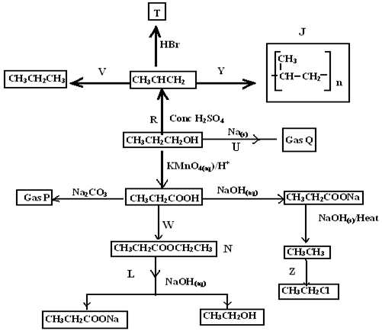
- Name I gas P_______________________________________________________
II gas Q_______________________________________________________
III Substance J________________________________________________ (1½mks)

- Give the most probable structural formula of product T (1mk)
____________________________________________________________________________________________________________________________________________________________________________________________________________________________________________________________________________________________________________________________________________________________________
- I. Name reaction producing substance labeled N (1mk)
_____________________________________________________________________________________
- State the characteristic property of N (1mk)
______________________________________________________________________________
- Complete the table below.
Reaction | Reagents | Condition
W

Z

V

(3mks)
- I. Name the organic product of reaction U (½mk)
________________________________________________________________________________________
II Write the equation for the reaction represented by U (1mk)
________________________________________________________________________________________
- What is the specific name of process Y? (½mk)
_________________________________________________________________________________________
- What is the type of reaction represented by Z? (½mk)
________________________________________________________________________________________
- Give two reasons why ethanoic acid has a higher melting point than ethanol when both of them have two carbon atoms. (2mks)
__________________________________________________________________________________________________________________________________________________________________________________

- I. The following table gives the standard electrode potential for a number of half reactions.
Half equation E℮/volts
Zn²⁺_{(aq)} + 2e⁻ Zn_{(s)} -0.76
Fe²⁺_{(aq)} + 2e⁻ Fe_{(s)} -0.44
I_{2(l)} + 2e⁻ 2I⁻_{(aq)} +0.54
Fe³⁺⁽_{aq)} + e⁻ Fe²⁺_{(aq)} +0.77
Ce⁴⁺⁽aq) + e⁻ Ce³⁺⁽_{aq)} +1.61
- Which half equation is used as the standard for the electrode potentials? (1mk) _______________________________________________________________________________________
- From the table identify:
- Strongest oxidizing agent_________________________________________________________(½mk)
- Strongest reducing agent_________________________________________________________(½mk)
(c) Identify two substances from the table which could be used to convert iodide ions to iodine. (1mks)
________________________________________________________________________________________
d. A half cell (I)is constructed by putting platinum electrode in a solution of 1M with respect to Fe²⁺ and Fe³⁺ ions. The half cell is then connected to another half cell (II) with Fe²⁺ ions.
i. What is the e.m.f of this cell (1mk)
_________________________________________________________________________________________
ii. Write equation for reactions taking place in each cell. (2mks)
(I)_______________________________________________________________________________________ (II) ______________________________________________________________________________________
iii. In which direction do electrons flow in the circuit? (½mk)
_______________________________________________________________________________________ II. When copper (II) sulphate solution is electrolysed using platinum electrodes, the equation for the overall changes can be written as:
2CuSO_{4 (aq)} + 2H₂O _{(l)} 2Cu_{(s)} + O_{2 (g)} + 2H₂SO_{4 (aq)}
- State the observation made at
  - Anode________________________________________________________________________(½mk)
  - Cathode______________________________________________________________________(½mk)
  - In the solution_________________________________________________________________ (½mk)
- Write ionic half equation for the reaction occurring at the anode. (1mk) _________________________________________________________________________________________
- During electrolysis, 1.27g of copper is produced. Calculate
- The volume of oxygen, measured at room temperature that would be produced in the same time. (Cu=63.5, MGV= 24dm³, IF= 96 (2mks) __________________________________________________________________________________________________________________________________________________________________________________________________________________________________________________________________________________________________________________________________________________________________________________________________________________________
- The time for which a current of 0.5A would be maintained to form these products. (1mk)
______________________________________________________________________________________________________________________________________________________________________________________________________________________________________________________
- I. The diagram below summarizes the results of a series of chemical reactions.
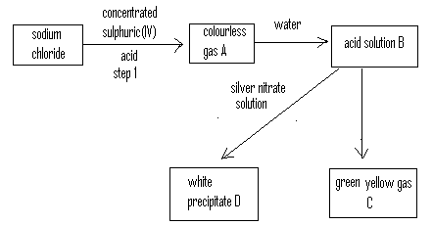
- Name: A___________________________________________________________________________(2mks)
B____________________________________________________________________________
C____________________________________________________________________________
D____________________________________________________________________________
- What reagent would you use to convert B into C? (1mk) _____________________________________________________________________________________
- Write equation for the reaction in step 1 (1mk) _______________________________________________________________________________________
- Chlorine is used as bleaching agent. Name another substance that must be present for bleaching to occur. ___________________________________________________________________________________ (½mk)
- Give one other use of chlorine. (1mk) _______________________________________________________________________________________
- Explain the observation made when white precipitate D is exposed to sunlight. (2mks) ________________________________________________________________________________________
II One stage in the manufacture of nitric acid involves the oxidation of ammonia by the reaction:
4NH_{3 (g)} + 5O_{2 (g)} 4NO _{(g)} + 6H₂O _{(l)}
- State one condition under which this reaction is carried out. (1mk)
__________________________________________________________________________________________________________________________________________________________________________________
- Below is equation for the Haber process for the manufacture of ammonia.
3H_{2 (g)} + N_{2 (g)} ₅₀₀º_{C} 2NH_{3 (g)} ΔH = -92 kJ
  - Name one material which is available in large scale and can be used as a source of hydrogen for this process. _____________________________________________________________________(1mk)
  - Give one reason why the reaction of nitrogen with hydrogen cannot be used to produce ammonia at room temperature and pressure. (1mk)
_________________________________________________________________________________
  - To maintain a constant temperature, the bed of catalyst particles must be cooled. Why would the temperature of the catalyst rise if it were not cooled? (½mk)
__________________________________________________________________________________
  - The iron catalyst used is fed in form of Fe₃O₄, but this is converted to minute crystals of iron when it is exposed to the hot mixture of nitrogen and hydrogen gases. Write an equation for the reaction which converts the iron oxide to iron. (1mk)
__________________________________________________________________________________
  - Suggest one disadvantage of using pure ammonia as fertilizer. (1mk)
__________________________________________________________________________________
- I. The equation below is for the manufacture of ethanol by direct hydration of ethane.
H₂O _{(g)} +C₂H_{4 (g)} C₂H₃OH _{(g)} H= -46kJmol-1
- State the effect an increased in pressure will have on the equilibrium yield of ethanol and give a reason for your answer. (2mks) __________________________________________________________________________________________________________________________________________________________________________________
- At high pressure, addition polymerization of one of the compounds in the reaction mixture may occur. Give the name of the polymer produced and structure of the repeating unit. (2mks) ___________________________________________________________________________________________________________________________________________________________________________________________________________________________________________________________________________
- In an experiment, excess solid calcium carbonate was added to 100cm³ of 0.2M hydrochloric acid at 20ºC . The volume of carbon (IV) oxide produced was measured at regular time interval. The results of the experiment are as shown in the table below.
Time (seconds) | 0 | 10 | 20 | 30 | 40 | 50 | 60 | 70 | 80 | 90 | 100
Volume of carbon(IV)oxide(cm³) | 0 | 18 | 30 | 40 | 48 | 53 | 57 | 58 | 58 | 58 | 58
- Draw a diagram of suitable apparatus for the experiment. (2mks) _____________________________________________________________________________________________________________________________________________________________________________________________________________________________________________________________________________________________________________________________________________________________________________________________________________________________________________________________
- On the grid provided plot of volume of CO₂ produced against time. (3mks)

- On the grid plot a graph you would expect if the acid was kept at 30ºC. (1mk)
- What is the rate of reaction if the volume of hydrogen per minute between 4th and 5th second (1mk) __________________________________________________________________________________________________________________________________________________________________________________
- Other than raising the temperature state two ways by which the rate of reaction would be increased. (2mks) __________________________________________________________________________________________________________________________________________________________________________________
- Below is a section of the periodic table. Use it for the questions below.
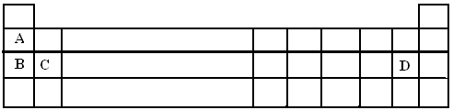
    - In the grid, place
- M in the space with the most reactive non metal. (1mk).
ii R in the space which could be occupied by an element capable of forming a covalent compound RD₃ (1mk)
b). Explain how the reducing power changes from A to B (2mks)
__________________________________________________________________________________________________________________________________________________________________________________
c). How many protons are there in the atom of element C? __________________________________ (1mk)
d. Element B reacts with water.
i. State two observations you would expect to make when a small piece of B is added to water. (2mks)
__________________________________________________________________________________________________________________________________________________________________________________
ii. Name the aqueous product formed in the above reaction and write chemical equation for the reaction. (2mks)
Product__________________________________________________________________________________
Equation_________________________________________________________________________________

- a. I. Aluminium chloride exists as a dimeric molecule Al₂Cl₆. Draw its dimeric structure. (2mks)
_____________________________________________________________________________________________________________________________________________________________________________________________________________________________________________________________________________________________________________________________________________________________________________________________________________________________________________________________
II. State why aluminium chloride exist as a dimer. (1mk)
_________________________________________________________________________________________
b. The table below gives some properties of four substances. Use it to answer the questions that follow.
 |  |  | Electrical conductivity
Substance | M.P. (ºC) | B.P. (ºC) | Solid | Solid
V | 1128 | 2657 | Good | Good
X | -166 | -95 | Poor | Poor
Y | 854 | 1790 | Poor | Poor
Z | 2230 | 3714 | Poor | Poor
i. Which substance has
Giant atomic structure ______________________________________________________________(1mk)
Giant metallic structure______________________________________________________________(1mk)
ii. The structure of water molecule can be represented as shown below.
H H H
O B O O A
H H H
Name the type of bonds represented by letters A_____________________________________(½mk)
B_____________________________________(½mk)
C Explain why sodium chloride conducts electricity when molten but not when solid. (2mks)
__________________________________________________________________________________
__________________________________________________________________________________

