Form 1 end term 3 2017

- Define physics (1mk)

- State two branches of physics (2mks)

- A block measuring 20cm by 10cm by 4cm rests on a flat surface. The block has a weight of 6N. Determine:
    - The minimum pressure it exerts on the surface. (2 marks)

    - The density of the block in kg/m³ (3 mark)

- Figure below shows apparatus used to observe the behaviour of smoke particles in a smoke cell.
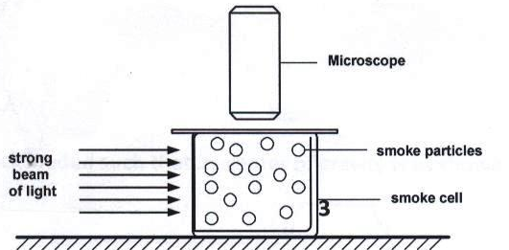
a) Explain what was observed (1mark)

b) Explain what would happen if the temperature was raised. (1mark)

- Two samples of bromine vapour are allowed to diffuse separately under different conditions, one in a vacuum and the other in air. State with reasons the conditions in which bromine diffuse slower. (2 mrks)

- Define atmospheric pressure (1mk)

- Figure 14 below shows a manometer used to measure gas pressure.

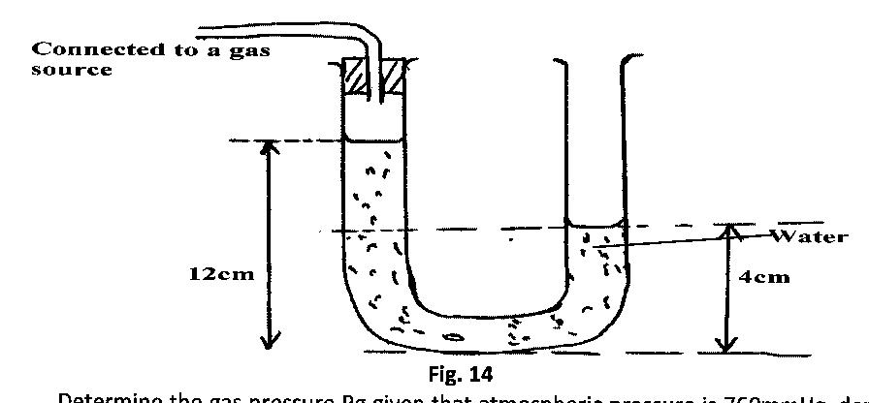
Determine the gas pressure Pg given that atmospheric pressure is 760mmHg, density of
water is l000kgm⁻³ and that of mercury 13,600kgm⁻³ (3mks)

c) The barometric height in a town is 65cmHg. Given that the standard atmospheric
pressure is 76cmHg and the density of mercury is 13600kg/m³, determine the altitude of
the town. (Take density of air = 1.25kg/m³) (3mks)

- . a) Figure 13 below represents a car hydraulic braking system.

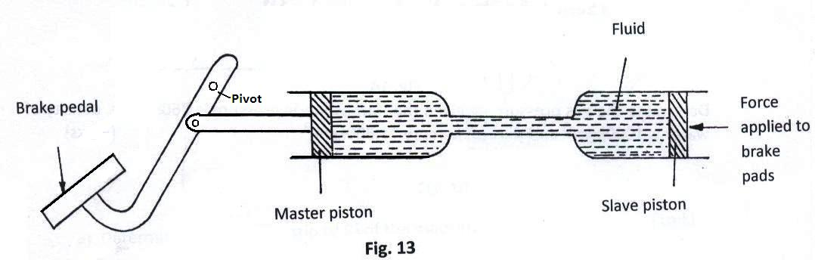
Use the information given in the diagram above to answer questions 3(a) and 3(b).
(i) State one property the fluid should have. (1mk)

(ii) Explain briefly how the system operates. (3mks)

- Using kinetic theory of matter, explain why solids expand when heated. ( 1 mark )

- State three modes of heat transfer (3mks)

- Two l0g masses are fixed onto two similar aluminum plates, one polished and the other painted black, using wax as shown in the figure below. A Bunsen flame is placed mid-way between the plates.
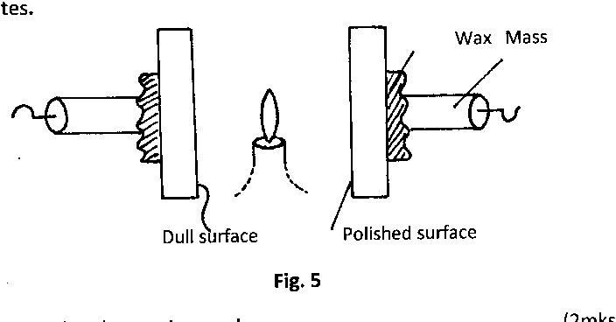
Give and explain the observation made (2mks)

- Ten glass marbles, each of mass 6.0 g, were gently lowered into a 100cm³ measuring cylinder containing water to the level marked A. The water level rose to the level marked B as shown in Fig. 1 below
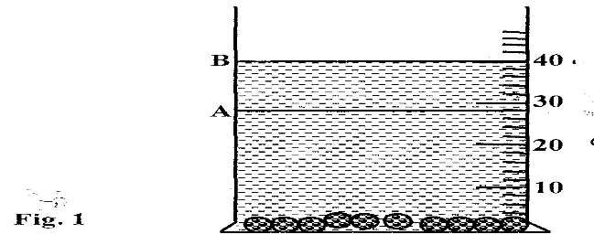
Determine the density of the glass. (3mks)

- State two experiment to show that light travels in a straight line (2mks)

- Define reflection (1mk)

- Define the following terms (2mks)
    - Angle of incident

    - Angle of reflection

- A pinhole camera forms an image of size 10cm. The object is 5m tall and 20m away from the pinhole. Find the length of the pinhole camera. ( 3marks )

- State four characteristics of images formed by plane mirrors (4mks)

- Figure 1 below shows an incident ray and reflected ray on a plane mirror
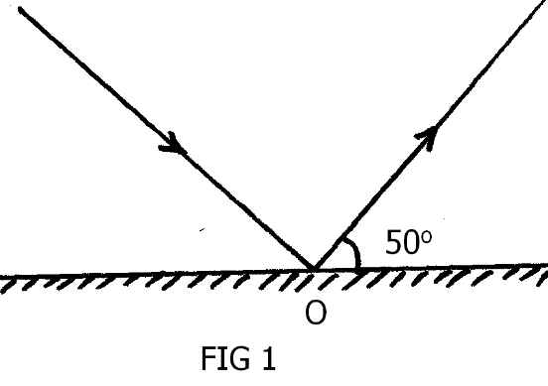

    - Label incident ray and reflected ray in the diagram below (2mks)
    - Calculate angle of incident and angle of reflection (2mks)
    - The mirror is rotated clockwise through an angle of 15⁰ about point O. What will be the angle between the two rays? (2mks)

