Name: …………………………………………………………… Index no ……..…................................... School: ……………………………………………………....…. Candidate’s sign …………………….... Date: ……………………………………………………………
443/1
AGRICULTURE FORM IV PAPER 1
PRE-MOCKS TIME: 2 HOURS
FULL PAPER

Kenya Certificate of Secondary Education,(KCSE)

FORM IV
Paper 443/1
AGRICULTURE

INSTRUCTIONS TO CANDIDATES:
 Write your name and index number and school in the spaces provided. Sign and write the date of the examination in the spaces provided above. This paper consists of three section A,B and C
Answer all the questions in section A and B
Answer any two questions in section C.
All answers should be written in the spaces provided in this booklet.

SECTION 30 Marks
Answer all questions in the spaces provided

- (a) Define the term land tenure.(½ mark)
……………………………………………………………………………………………………………
……………………………………………………………………………………………………………
  - List down four disadvantages of plastic water tanks for water storage on the farm.(2 marks)
……………………………………………………………………………………………………………
…………………………………………………………………………………………………………… (c)State four conditions that can lead to land fragmentation and subdivision of Agricultural land in
Kenya2 marks)
……………………………………………………………………………………………………………
……………………………………………………………………………………………………………
……………………………………………………………………………………………………………
……………………………………………………………………………………………………………
……………………………………………………………………………………………………………
……………………………………………………………………………………………………………
- (a )State the difference between soil structure and texture. (2 marks)
……………………………………………………………………………………………………………
…………………………………………………………………………………………………………… (b)Give three examples of compound fertilizers. (1½ marks)
……………………………………………………………………………………………………………
……………………………………………………………………………………………………………
……………………………………………………………………………………………………………
…………………………………………………………………………………………………………… (c)Outline two ways through which ridging reduces soil erosion. (2 marks)
……………………………………………………………………………………………………………

……………………………………………………………………………………………………………
- (a)Outline two ways through which raindrop or splash erosion initiates the process of soil erosion.
(2 marks)
……………………………………………………………………………………………………………

……………………………………………………………………………………………………………

  - Whatare the advantages of using seeds in crop propagation? Give four reasons.(2 marks)
……………………………………………………………………………………………………………
……………………………………………………………………………………………………………
……………………………………………………………………………………………………………
……………………………………………………………………………………………………………

- (a) State four factors that may limit a farmer from keeping proper farm records.(2 marks)
……………………………………………………………………………………………………………
……………………………………………………………………………………………………………
……………………………………………………………………………………………………………
……………………………………………………………………………………………………………

  - Why is burning of fields during land clearing discouraged in crop production? Give four reasons. (2marks)
……………………………………………………………………………………………………………
……………………………………………………………………………………………………………
……………………………………………………………………………………………………………
……………………………………………………………………………………………………………

  - State three roles of disc harrowing in land preparation.(1½ marks)
……………………………………………………………………………………………………………
……………………………………………………………………………………………………………
……………………………………………………………………………………………………………
……………………………………………………………………………………………………………

- State three ways through which biological agents help in soil formation. (1½ marks)
……………………………………………………………………………………………………………
……………………………………………………………………………………………………………
……………………………………………………………………………………………………………
……………………………………………………………………………………………………………

- State four desirable characteristics of phosphatic fertilizers. (2 marks)
……………………………………………………………………………………………………………
……………………………………………………………………………………………………………
……………………………………………………………………………………………………………
……………………………………………………………………………………………………………

- State four advantages of intercropping maize with beans. (2 marks)
……………………………………………………………………………………………………………
……………………………………………………………………………………………………………
……………………………………………………………………………………………………………
……………………………………………………………………………………………………………

- Name two filed pests of tomatoes. (2 marks)
……………………………………………………………………………………………………………
……………………………………………………………………………………………………………
……………………………………………………………………………………………………………
……………………………………………………………………………………………………………

- List down four advantages of minimum soil tillage operation? (2 marks)
……………………………………………………………………………………………………………
……………………………………………………………………………………………………………
……………………………………………………………………………………………………………
……………………………………………………………………………………………………………

- State two conditions under which opportunity cost exists. (1 mark)
……………………………………………………………………………………………………………
……………………………………………………………………………………………………………
……………………………………………………………………………………………………………
……………………………………………………………………………………………………………

SECTION B (20 MARKS)

- The diagrams labeled T and U below illustrate some Arabic weeds. Study the diagrams and answer the questions that follow.
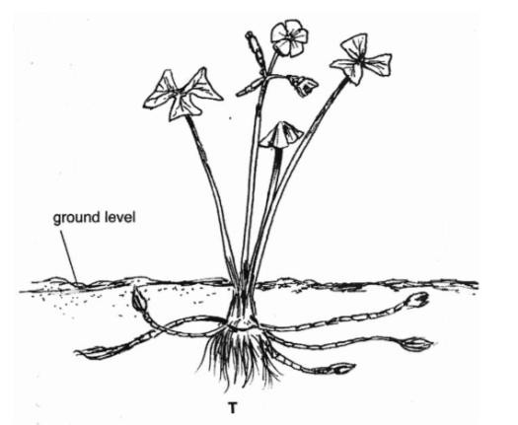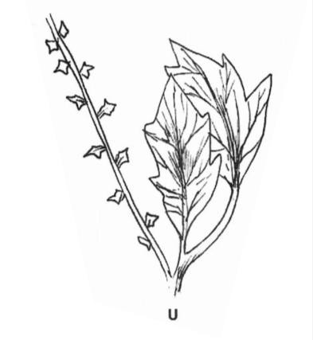

  - Identify the weeds T and U. (2 marks)

……………………………………………………………………………………………………………
……………………………………………………………………………………………………………

  - Why is weed T difficult to Control in the field? (1 mark)
……………………………………………………………………………………………………………
……………………………………………………………………………………………………………

  - State two harmful effects of weed U in crop production. (2 marks)
……………………………………………………………………………………………………………
……………………………………………………………………………………………………………

- The diagram below illustrates one of the routine field practices carried out on some crops. Study the diagram and answer the questions that follow: -
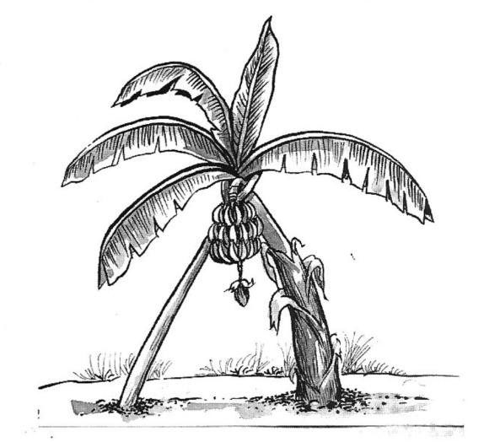

- Identify the field practice. (1 mark)

……………………………………………………………………………………………………………
……………………………………………………………………………………………………………

- State two conditions which necessitate the practice. (2 marks)
……………………………………………………………………………………………………………
……………………………………………………………………………………………………………

- Name other two crops where the practice is carried out. (2 marks)
……………………………………………………………………………………………………………
……………………………………………………………………………………………………………

- Samples of fertilizers were labeled D, F and E. The properties of each sample were given as explained below.
D: It is crystalline white and acidic in reaction. B: It is granular grey and neutral in reaction.
F: Ii is powder grey and highly basic in reaction. Use the above information to answer the following questions:
  - Identify the samples of fertilizers labeled D, E and F. (3 marks)
……………………………………………………………………………………………………………
……………………………………………………………………………………………………………

  - Which fertilizer sample is good for soils with high pH? (1 mark)
……………………………………………………………………………………………………………
……………………………………………………………………………………………………………

  - Which fertilizer sample is good for soils with low pH? (1 mark)
……………………………………………………………………………………………………………
……………………………………………………………………………………………………………

- Study the illustration below of a tomato fruit and answer the questions that follow:
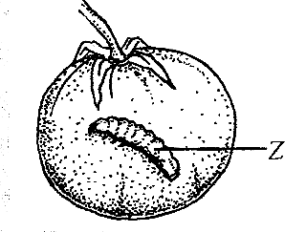
- Name the pest labeled Z. (1 mark)
……………………………………………………………………………………………………………
……………………………………………………………………………………………………………

- State two control measures of the pest named in (a) above. (2 mark)
……………………………………………………………………………………………………………
……………………………………………………………………………………………………………

- Apart from pest Z identified above, name two other insect pests oftomatoes. (2 marks)
……………………………………………………………………………………………………………
……………………………………………………………………………………………………………

SECTION C (4O Marks)
Answer any two questions.

- Describe the field production of onions under the following sub-headings:
-Ecological requirements.
-Land preparation.
-Transplanting.
- Field operations.
- Harvesting. (20 marks)

- Discuss the following land reforms:
  - Land consolidation.
  - Land adjudication and registration.
  - Land subdivision. (20 marks)

17.(a) Outline the effects of wind on agricultural production. (11 marks)
(b) Briefly mention the importance of the soil organic matter. (9 marks)

……………………………………………………………………………………………………………
……………………………………………………………………………………………………………
……………………………………………………………………………………………………………
……………………………………………………………………………………………………………
……………………………………………………………………………………………………………
……………………………………………………………………………………………………………
……………………………………………………………………………………………………………
……………………………………………………………………………………………………………
……………………………………………………………………………………………………………
……………………………………………………………………………………………………………
……………………………………………………………………………………………………………
……………………………………………………………………………………………………………

