Name: …………………………………………………………… Index no ……..…................................... School: ……………………………………………………....…. Candidate’s sign …………………….... Date: ……………………………………………………………
443/2
AGRICULTURE FORM IV PAPER 2
Pre-mocks TIME: 2 HOURS

FULL PAPER
Paper 443/2
AGRICULTURE

INSTRUCTIONS TO CANDIDATES:
 Write your name and index number and school in the spaces provided. Sign and write the date of the examination in the spaces provided above. This paper consists of three section A, B and C
Answer all the questions in section A and B
Answer any two questions in section C.
All answers should be written in the spaces provided in this booklet.

SECTION A (30 Marks)
Answer all questions in the spaces provided

- What are the symptoms of attack by Taenia saginata? (2 marks)
……………………………………………………………………………………………………………
……………………………………………………………………………………………………………
……………………………………………………………………………………………………………
……………………………………………………………………………………………………………

- List the factors that may predispose an animal to a certain disease. (5 marks)
……………………………………………………………………………………………………………
……………………………………………………………………………………………………………
……………………………………………………………………………………………………………
……………………………………………………………………………………………………………

- State the functions of the tools and equipment listed below: (3 marks)
  - Strip cup.
……………………………………………………………………………………………………………
……………………………………………………………………………………………………………

  - Bolus gun.
……………………………………………………………………………………………………………
……………………………………………………………………………………………………………

  - Mortise gauge.
……………………………………………………………………………………………………………
……………………………………………………………………………………………………………

- Distinguish between cross breeding and upgrading. (2 marks)
……………………………………………………………………………………………………………
……………………………………………………………………………………………………………
……………………………………………………………………………………………………………
……………………………………………………………………………………………………………

- Why do farmers keep livestock healthy? (4 marks)
……………………………………………………………………………………………………………
……………………………………………………………………………………………………………
……………………………………………………………………………………………………………
……………………………………………………………………………………………………………

- Give two distinguishing features in each case between the following:
Compiled and distributed online by Schools Net Kenya / P.O. Box 85726 – 00200, Nairobi Mob. 0711 88 22 27 / Email: infosnkenya@gmail.com / Order Answers at: www.schoolsnetkenya.com
  - Kenya white and Californian white. (2 marks)
……………………………………………………………………………………………………………
……………………………………………………………………………………………………………

  - Large white and Land race. (2 marks)
……………………………………………………………………………………………………………
……………………………………………………………………………………………………………

- Give two signs of heat in rabbits. (2 marks)
……………………………………………………………………………………………………………
……………………………………………………………………………………………………………

- State two reasons why breeding stock should be selected. (2 marks)
……………………………………………………………………………………………………………
…………………………………………………………………………………………………………… 9 State two signs of attack by external parasites in livestock. (2 marks)
10 Give two instances when sheep shearing should be done. (2 marks)
……………………………………………………………………………………………………………
…………………………………………………………………………………………………………… 11 State the intermediate hosts in the following classes of parasites:
- Tape worms. (1 mark)
……………………………………………………………………………………………………………

- Liver flukes. (1 mark)
……………………………………………………………………………………………………………
……………………………………………………………………………………………………………

SECTION B ( 20 Marks)
Answer all questions in the spaces provided

- Diagrams G, H and J illustrate some livestock parasites.
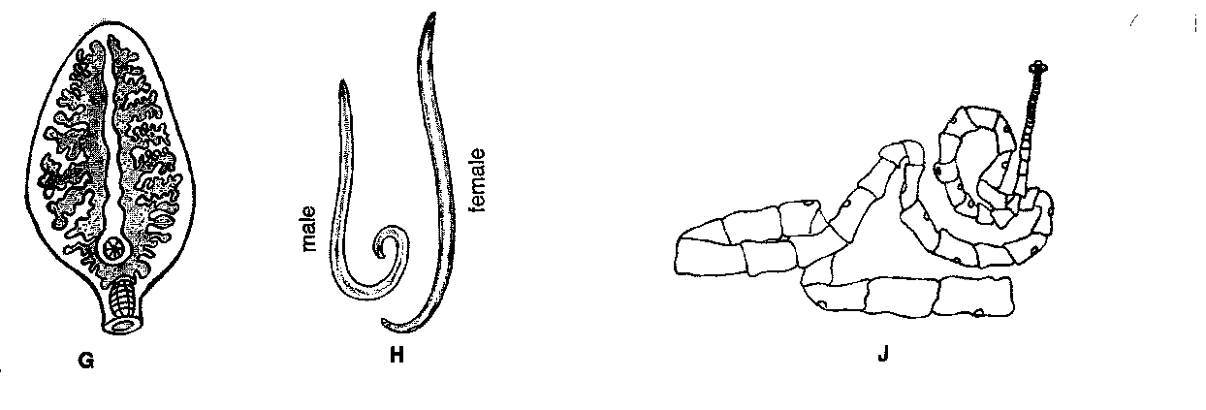

- Identify parasites G, H and J. (1½ marks)
……………………………………………………………………………………………………………
……………………………………………………………………………………………………………

- State the category of parasites G, H and J. (1½ mark)
……………………………………………………………………………………………………………
……………………………………………………………………………………………………………

c) Name the parts of the hosts body where parasites G and J are found. (1 mark)
……………………………………………………………………………………………………………
……………………………………………………………………………………………………………

- Name the intermediate hosts of parasite G and H. (1 mark)

……………………………………………………………………………………………………………
……………………………………………………………………………………………………………

- Diagrams Q and R below illustrate a practice carried out on livestock. Study the diagrams and answer the questions that follow.
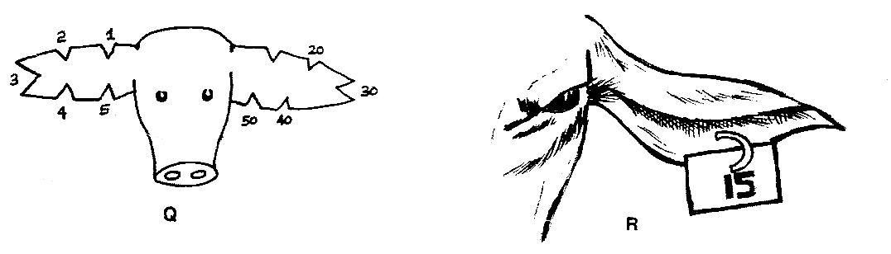
(a)(i) Identify the practice in Q and R. (1 mark)
……………………………………………………………………………………………………………
……………………………………………………………………………………………………………

(ii) Name the method carried out in Q and R. (1 mark)
……………………………………………………………………………………………………………
……………………………………………………………………………………………………………

(b)(i)State one advantage practice R over Q. (1 mark)
……………………………………………………………………………………………………………
……………………………………………………………………………………………………………

- By using method of practice in Q, draw the animal whose Number is 100. (1 mark)
……………………………………………………………………………………………………………
……………………………………………………………………………………………………………

- Give two reasons of carrying out the practice Q and R. (1 mark)
……………………………………………………………………………………………………………
……………………………………………………………………………………………………………

- (a) Name three tools used in constructing a barbed wire fence. (3 marks)
……………………………………………………………………………………………………………
……………………………………………………………………………………………………………

  - Outline the procedure of putting up a barbed wire fence (7 marks)
……………………………………………………………………………………………………………
……………………………………………………………………………………………………………
……………………………………………………………………………………………………………
……………………………………………………………………………………………………………

……………………………………………………………………………………………………………
……………………………………………………………………………………………………………
……………………………………………………………………………………………………………
……………………………………………………………………………………………………………

……………………………………………………………………………………………………………
……………………………………………………………………………………………………………
……………………………………………………………………………………………………………
……………………………………………………………………………………………………………

……………………………………………………………………………………………………………
……………………………………………………………………………………………………………
……………………………………………………………………………………………………………
……………………………………………………………………………………………………………

SECTION C ( 40 Marks)
Answer any two questions in the spaces provided

- Describe the process of constructing a fish pond. (20 marks)

- Explain the factors considered in siting farm structures. (20 marks)

- (a) Describe the procedure of harvesting honey. (10 marks) (b)Describe extraction of honey from combs using the heat method. (7 marks)
  - State three factors affecting the quality of honey. (3 marks)

……………………………………………………………………………………………………………
……………………………………………………………………………………………………………
……………………………………………………………………………………………………………
……………………………………………………………………………………………………………
……………………………………………………………………………………………………………
……………………………………………………………………………………………………………
……………………………………………………………………………………………………………
……………………………………………………………………………………………………………
……………………………………………………………………………………………………………
……………………………………………………………………………………………………………
……………………………………………………………………………………………………………
……………………………………………………………………………………………………………
……………………………………………………………………………………………………………
……………………………………………………………………………………………………………
……………………………………………………………………………………………………………
……………………………………………………………………………………………………………
……………………………………………………………………………………………………………
……………………………………………………………………………………………………………
……………………………………………………………………………………………………………
……………………………………………………………………………………………………………
……………………………………………………………………………………………………………
……………………………………………………………………………………………………………

