Name: …………………………………………………………… Index no ……..…................................... School: ……………………………………………………....…. Candidate’s sign …………………….... Date: ……………………………………………………………
FORM IV 231/1
BIOLOGY PAPER 1 PRE-MOCKS
TIME: 2 hours
FULL PAPER

Kenya Certificate of Secondary Education (K.C.S.E.)

231/1
BIOLOGY
PAPER 1

INSTRUCTIONS TO CANDIDATES:
Write your name and index number in the spaces provided.
Sign and write date of examination in the spaces provided above. Answer all the questions in the spaces provided.

Answer all the questions in this section in the spaces provided.
- A process that occurs in plants is represented by the equation below.
C₆H₁₂O₆ 2C₂H₅OH + 2CO₂ + Energy

- Name the process. (2 marks)
…………………………………………………………………………………………………………
…………………………………………………………………………………………………………

- State the economic importance of this process. (1 mark)
…………………………………………………………………………………………………………
- Name the
- materials that strengthens the xylem tissues. (1 mark)
…………………………………………………………………………………………………………

- tissue that is removed when the back of a dicotyledonous plant is ringed. (1 mark)
…………………………………………………………………………………………………………

- State the function of each of the following parts in a microscope.
- the eye piece lens (1 mark)
…………………………………………………………………………………………………………

- the objective lens (1 mark)
…………………………………………………………………………………………………………

- What is the importance of osmosis in plants? (3 marks)
…………………………………………………………………………………………………………
…………………………………………………………………………………………………………
…………………………………………………………………………………………………………
- (a) Give two ways in which red blood cells are adapted to carrying out their functions. (2 marks)
…………………………………………………………………………………………………………
…………………………………………………………………………………………………………

(b) Explain how carbon (II) oxide affects the way is which red blood cells function. (2 marks)
…………………………………………………………………………………………………………
…………………………………………………………………………………………………………

- (a) Suggest two ways in which gaseous exchange systems contribute to problems of dehydration and hypothermia (low body temperature) in mountaineers. (2 marks)
…………………………………………………………………………………………………………
…………………………………………………………………………………………………………
(b) State the importance of the thin film of water on the skin of frogs. (1 mark)

…………………………………………………………………………………………………………

- 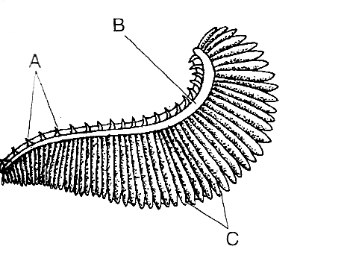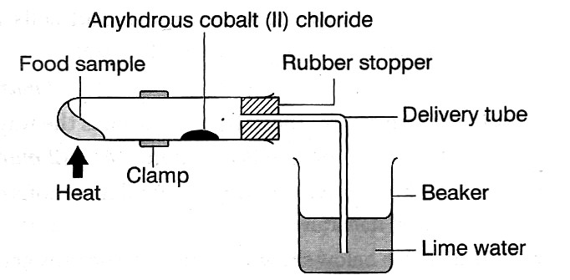State the adaptations of seeds to dispersal by wind. (3 marks)

…………………………………………………………………………………………………………
…………………………………………………………………………………………………………………

………………………………………………………………………………………

- Study the diagram below and answer the questions that follow.

- Identify the structure. (1 mark)
…………………………………………………………………………………………………………

- Name the parts labelled A, B and C and state their functions. (2 marks)
…………………………………………………………………………………………………………………

………………………………………………………………………………………………

- The diagram below shows an experimental set-up.

- Suggest one aim of carrying out the experiment. (1 mark)
…………………………………………………………………………………………………………

- Account for the result(s) that would be observed at the end of the experiment. (3 marks)
…………………………………………………………………………………………………………
…………………………………………………………………………………………………………
…………………………………………………………………………………………………………

- State the functions of each of the following cell organelles. (1 mark)
- Smooth endoplasmic reticulum
…………………………………………………………………………………………………………

- 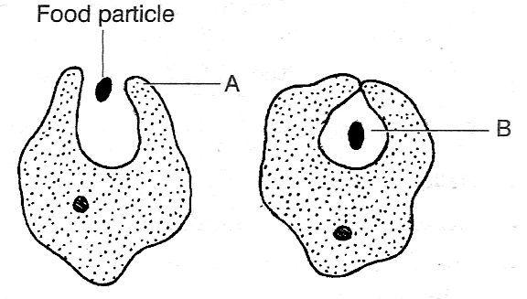Nucleus (2 marks)
…………………………………………………………………………………………………………
…………………………………………………………………………………………………………

- The diagrams below show stages in a feeding process exhibited by amoebae.

- Name the parts labelled A and 8. (2 marks)
…………………………………………………………………………………………………………
…………………………………………………………………………………………………………

- Name the process illustrated. (1 mark)
…………………………………………………………………………………………………………

- Name a type of cell inhuman beings that exhibits the process shown above. (1 mark)
…………………………………………………………………………………………………………

- (a) State two differences between mitosis and meiosis. (2 marks)
……………………………………………………………………………………………………………
………………………………………………………………………………………………………

(b) State two processes that take place during interphase. (2 marks)
…………………………………………………………………………………………………………
…………………………………………………………………………………………………………

- A rhinoceros in a national park was found to be infected with ticks. State the trophic level occupied by the:
- rhinoceros. (1 mark)
…………………………………………………………………………………………………………

- ticks (1 mark)

…………………………………………………………………………………………………………

- State one difference between the circulatory systems of organisms in Class Mammalia and Class Insecta.
(1 mark)
…………………………………………………………………………………………………………

- 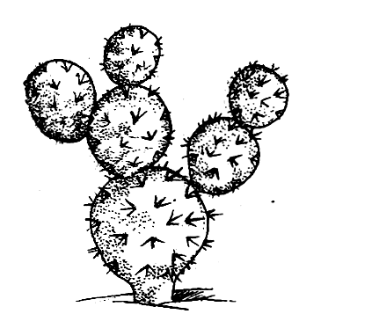State three advantages of cross-pollination. (3 marks)
…………………………………………………………………………………………………………
…………………………………………………………………………………………………………
…………………………………………………………………………………………………………

- State the cause of:
- marasmus in children. (1 mark)

…………………………………………………………………………………………………………

- scurvy (1 mark)

…………………………………………………………………………………………………………

- List three adaptation of fruits that are dispersed by animals. (3 marks)
…………………………………………………………………………………………………………
…………………………………………………………………………………………………………
…………………………………………………………………………………………………………

- Two students were observing bacteria using two identical microscopes and identical slides. Student A saw 10 bacteria while student B saw 50 bacteria.
- Suggest a reason why they observed different numbers of bacteria. (1 mark)
…………………………………………………………………………………………………………

- Which of the following combinations would give a wider field of view: eyepiece xl0 and objective x20 or eyepiece x10 and objective x40? (1 mark)
…………………………………………………………………………………………………………

- Study the diagram below and answer the questions that follow.

- Name the habitat of the plant. (1 mark)
…………………………………………………………………………………………………………

- State two adaptations of the plant to its habitat. (2 marks)
…………………………………………………………………………………………………………
…………………………………………………………………………………………………………

- 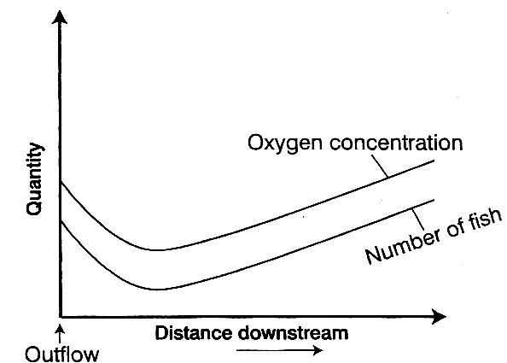Name three classes in Phylum Chordata that have a double circulatory system. (3 marks)
………………………………………………………………………………………………………………
……………………………………………………………………………………………………

- (a) Name two methods of estimating the population of organisms in a habitat. (2 marks)
…………………………………………………………………………………………………………
…………………………………………………………………………………………………………

(b) Organisms A and B were found to have the following features. A — Thick fur on the body and a lot of fat under the skin.
B — Long loops of Henle, few glomeruli and reduced fur on the body.
Identify the habitats of organisms A and B. (2 marks)
…………………………………………………………………………………………………………
…………………………………………………………………………………………………………

22.(a) State the importance of an enzyme in a chemical reaction. (1 mark)
…………………………………………………………………………………………………………

(b) Explain the effect of temperature and pH on reactions controlled by enzymes. (2 marks)
…………………………………………………………………………………………………………

- What is the importance of respiration in organisms? (1 mark)
…………………………………………………………………………………………………………

(b) Name the process by which glucose is broken down to pyruvic acid. (1 mark)
…………………………………………………………………………………………………………
- The graph below shows the changes in oxygen concentration and the number of fish downstream from an outflow.

- Explain why the curve of the number of fish is the same shape as that of the oxygen concentration.
…………………………………………………………………………………………………………
…………………………………………………………………………………………………………
(2 marks)

- Suggest two ways by which oxygen can enter water. (2 marks)
…………………………………………………………………………………………………………

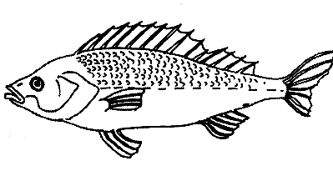…………………………………………………………………………………………………………

- The diagram below shows a certain organism.

State the phylum and the class to which it belongs. (2 marks)
…………………………………………………………………………………………………………

…………………………………………………………………………………………………………

- The equation below shows a process that takes place in mammals.
Amino acids Organic Compound + Urea
- Identify the process. (1 mark)
…………………………………………………………………………………………………………

- State the significance of this process to a mammal. (1 mark)
…………………………………………………………………………………………………………

- Name the hormone responsible for
- conversion of glucogen to glucose (1 mark)
…………………………………………………………………………………………………………

- regulation of the amount of water in blood. (1 mark)
…………………………………………………………………………………………………………

- State two methods of preventing malaria. (2 marks
…………………………………………………………………………………………………………
…………………………………………………………………………………………………………

