Name: …………………………………………………………… Index no ……..…................................... School: ……………………………………………………....…. Candidate’s sign …………………….... Date: ……………………………………………………………
FORM IV 231/2
BIOLOGY PAPER 2 PRE-MOCKS
TIME: 2 hours
FULL PAPER

Kenya Certificate of Secondary Education (K.C.S.E.)

FORM IV 231/2
BIOLOGY
PAPER 2

INSTRUCTIONS TO CANDIDATES:
Write your name and index number in the spaces provided.
Sign and write date of examination in the spaces provided above.

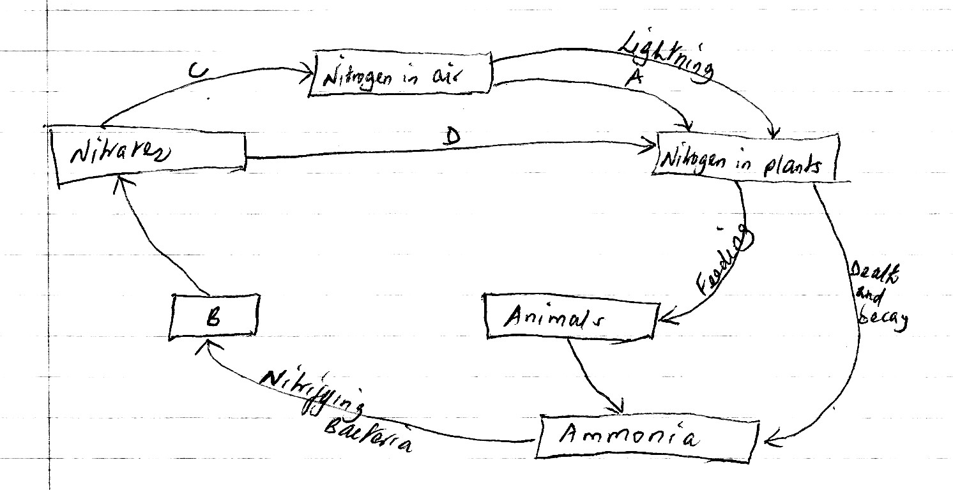Answer all the questions in this section in the spaces provided.

Answer all the questions in this section.

- Study the diagrambelow and answer the questions thatfollow. Parental phenotypeRedflowers X White flowers

F1 All pinkflowers

(a)State the type of dominance displayed in the above cross (1 mark)
………………………………………………………………………………………………………………….. (b)Usingletter R to represent the gene for redcolour and W for the white colour, state the parental genotype
(2 marks)
…………………………………………………………………………………………………………………..
…………………………………………………………………………………………………………………..

- If the F1 wasselfed, work out the phenotypic ratio of F2 generation
…………………………………………………………………………………………………………………..
…………………………………………………………………………………………………………………..
…………………………………………………………………………………………………………………..

- 480 redflowered plants wereobtained in the second filial generationwhen F1 wasselfed, how many F2 plants werepink? Show yourworking (2 marks)
…………………………………………………………………………………………………………………..
…………………………………………………………………………………………………………………..
…………………………………………………………………………………………………………………..

- The diagrambelowrepresents the nitrogen cycle

- State the processlabeled A………………………………………………………………………………………………… (1 mark)
B…………………………………………………………………………………………………… (1 mark)
- Name the component represented by B (1 mark)
…………………………………………………………………………………………………………………..

- Name the group of organismslabeled C (1 mark)
…………………………………………………………………………………………………………………..

- i) Name the group of plants whichpromoteprocess A (1 mark)
…………………………………………………………………………………………………………………..

ii) State the part of the plant whereprocess A takes place (1 mark)

- How wouldexcess pesticide in the soilinterferewithprocess A? (2 marks)
…………………………………………………………………………………………………………………..
…………………………………………………………………………………………………………………..

- The equationbelowrepresents a metabolicprocessthatoccurs in a certain organ in the mammalian body.

Ammonia + Carbon IV oxideenzymeOrganic compound Q + water

- Name the processrepresented in the equationabove (1 mark)
………………………………………………………………………………………………………………

- Name the organ in which the processoccurs (1 mark)
……………………………………………………………………………………………………………..

- Whyis the process important to mammals? (1 mark)
………………………………………………………………………………………………………

- Identify the organic compound Q (1 mark)
………………………………………………………………………………………………
- Explain the source of ammonia in the organnamed in (b) above (2 marks)
…………………………………………………………………………………………………..
- Whathappens to organic compound Q? (2 marks)
………………………………………………………………………………………………………………
……………………………………………………………………………………………………

- (a) Define the termbalanceddiet (2 marks)
……………………………………………………………………………………………………
……………………………………………………………………………………………………

- Explain the importance of each of the followingduring digestion in humanbeings
  - Teeth (1 mark)
………………………………………………………………………………………………………………

  - Saliva (1 mark)
………………………………………………………………………………………………………………

- State the role of each of the following in photosynthesis
  - Light (1 mark)
……………………………………………………………………………………………..

  - 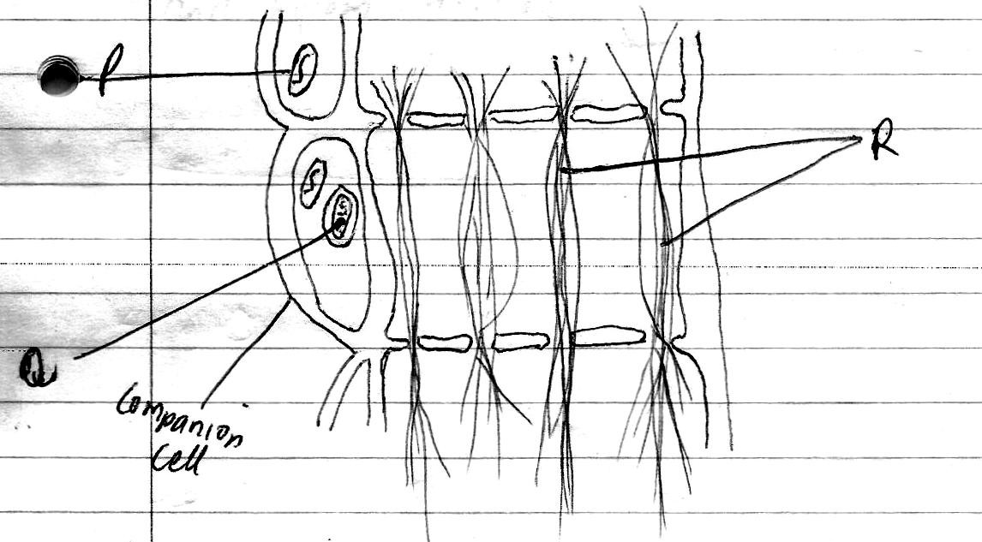Chlorophyll (1 mark)
…………………………………………………………………………………………………

  - Carbon IV oxide (1 mark)
……………………………………………………………………………………………………

- State the function of sodium glycochlate in humanbeings (1 mark)
………………………………………………………………………………………………………

- Thediagrambelowrepresents part of aphloem tissue

  - Name the structure labeled P, Q & R (3 marks)
P…………………………………………………………………………………………………… Q………………………………………………………………………………………………….. R………………………………………………………………………………………………..

  - State the function of the phloem tissue ( 1 mark)
…………………………………………………………………………………………………….. c). State how the functioning of the phloem tissue isaffected if the companioncellisdestroyed
(1 mark)
………………………………………………………………………………………………………… Give a reason for youranswer in C (i) above (1 mark)
………………………………………………………………………………………………………..

d).State two structural differencesbetweenphloem and xylem tissue (2 marks)
…………………………………………………………………………………………………………
………………………………………………………………………………………………………….

SECTION B (40 MARKS)
Answer question 6 (compulsory) and either7 or 8

- Aform four carried out an experiment to investigate the rate of growth of pollen tube against time. The resultsweretabulated in a table shownbelow

Time in minutes | Length of pollen tube (mm)
0  20  40  60  80  100  120 | 0  4  9  15  20  21  22

- Plot a graph of pollen tube lengthagainst time on the graph paperprovided (6 marks)

- Determine the growth rate between 80th and 34th minute (2 marks)
………………………………………………………………………………………………………………
…………………………………………………………………………………………………….

Whatwas the length of the pollen tube at the 90th minute? (1 mark)
………………………………………………………………………………………………………………
…………………………………………………………………………………..………………………….

Atwhat time was the length of the pollen tube 18mm? (1 mark)
………………………………………………………………………………………………………………
…………………………………………………………………..………………………………………….

c).Withreasonsdescribe the growth pattern of the pollen tube between
  - 0-80 minutes (2 marks)
………………………………………………………………………………………………………………
…………………………………………………………………………………………………..………….

  - 80-120 minutes (2 marks)
………………………………………………………………………………………………………………
………………………………………………………………………………………………………………

- Give the importance of the growth of pollen tube to the plant (2 marks)
………………………………………………………………………………………………………………
………………………………………………………………………………………………………..…….

- Mention the changes thattake place in a flowerafterfertilization (2 marks)
……………………………………………………………………………………………………………
……………………………………………………………………………………………………………

- Describe how water moves from the soil to the leaves in a tree (20 marks)
………………………………………………………………………………………………………………
………………………………………………………………………………………………………………
………………………………………………………………………………………………………………
- How are flowersadopted to wind and insectpollination (20 marks)
………………………………………………………………………………………………………………
………………………………………………………………………………………………………………
………………………………………………………………………………………………………………
………………………………………………………………………………………………………………
………………………………………………………………………………………………………………
………………………………………………………………………………………………………………
………………………………………………………………………………………………………………
………………………………………………………………………………………………………………
………………………………………………………………………………………………………………
………………………………………………………………………………………………………………
………………………………………………………………………………………………………………
………………………………………………………………………………………………………………
………………………………………………………………………………………………………………
………………………………………………………………………………………………………………
………………………………………………………………………………………………………………
………………………………………………………………………………………………………………
………………………………………………………………………………………………………………
………………………………………………………………………………………………………………
………………………………………………………………………………………………………………
………………………………………………………………………………………………………………
………………………………………………………………………………………………………………
………………………………………………………………………………………………………………
………………………………………………………………………………………………………………
………………………………………………………………………………………………………………
………………………………………………………………………………………………………………
………………………………………………………………………………………………………………
………………………………………………………………………………………………………………
………………………………………………………………………………………………………………
………………………………………………………………………………………………………………
………………………………………………………………………………………………………………
………………………………………………………………………………………………………………
………………………………………………………………………………………………………………
………………………………………………………………………………………………………………
………………………………………………………………………………………………………………
………………………………………………………………………………………………………………
………………………………………………………………………………………………………………
………………………………………………………………………………………………………………
………………………………………………………………………………………………………………

