NAME:………………………………………………… DATE……..……………………………. SCHOOL:………………………………………………SIGNATURE…………………………
565/2
BUSINESS STUDIES

FORM IV PRE-MOCKS
2 hours

FULL PAPER BUSINESS STUDIES

INSTRUCTIONS TO CANDIDATES
Answer all questions in the spaces provided in the question paper

Questions | 1 | 2 | 3 | 4 | 5 | 6 | 7 | 8 | 9 | 10 | 11 | 12 | 13 | 14 | 15
Marks

Questions | 16 | 17 | 18 | 19 | 20 | 21 | 22 | 23 | 24 | 25
Marks

- 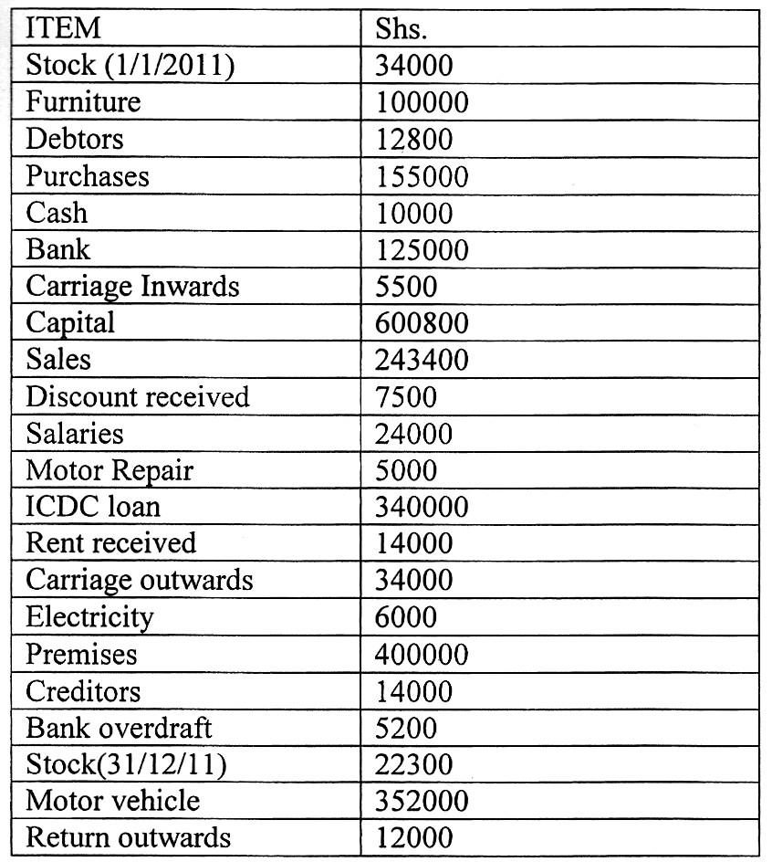(a) Describe five factors considered when choosing a means of communication. (l0mks)

(b) Explain five problems associated with the output approach in computation of National income. (10 mks)

- (a) Describe five principles of public expenditure. (l0mks)

(b) Explain five advantages of open office layout to an organization. (l0mks)

- (a) Highlight five circumstances under which an insurance company would compensate in event of loss.
(10 mks)

(b) Explain five reasons for taxation in an economy (10 mks)

- (a) Explain four benefits that accrue to a seller who uses personal selling. (8 mks)

(b) The following information was extracted from the books of Karanja Stores on 3l^{st} December 2011.

Prepare:
- Trading, profit and loss account for the year ended 31st December, 2009
- Balance Sheet as at 31st December 2011 (l2 mks)

- Explain five negative effects of over population to a country. (l0mks)
- Give five differences between private and public limited companies. (l0mks)

6. (a)Explain five benefits a consumer who buys goods from a departmental store would enjoy. (l0mks) (bJagongo enterprises had the following balances as at 3l^{st} December 2012:

Shs.
Stock 15000 Cash at bank 20000
Cash in hand | 6500
Debtors | 3400
Creditors | 2500
The following transactions took place during the first week of January 2013:- Jan 2: Bought stock by cash Kshs. 2000
3: Sold goods on credit Kshs. 3000
4: Received a cheque of Kshs. 1800 from a debtor.
4: Deposited Kshs. 600 into the bank account from the cash till. 5: A debtor returned goods worth Kshs. 500
5: Sold goods for cash Kshs. 1200
6: Bought goods Kshs. 4500 on credit
6: The owner took cash Kshs, 1000 to pay his child school fees Required:-Prepare the ledger accounts to record the above transactions.

