

**JARAMOGI OGINGA ODINGA UNIVERSITY OF SCIENCE AND TECHNOLOGY**

**UNIVERSITY EXAMINATIONS 2013/14 ACADEMIC YEAR**

**1ST YEAR 1ST SEMESTER EXAMINATION FOR THE DEGREE OF BACHELOR OF SCIENCE IN RENEWABLE ENERGY, TECHNOLOGY AND MANAGEMENT**

**COURSE CODE: TET 3112**

**COURSE TITLE: ENGINEERING DRAWING I**

**DATE: 22/4/2013 TIME: 14.00-16.00PM**

**DURATION: 3 HOURS**

**INSTRUCTIONS TO CANDIDATES**

1. **This paper consists of 5 questions; answer question ONE and any other two questions**
2. **Draw the margin and title block on at least one of the drawing papers (answer sheet)**
3. **Answer question one in the answer sheet provided**

**QUESTION ONE (20 MARKS)**

1. Explain what you understand by the term engineering drawing?

(2MARKS)

1. Name any four branches of engineering drawing (4 MARKS)
2. Do you think engineering drawing is relevant to you as far as your line of training is concerned? Discuss (4 MARKS)
3. In this course, you have been exposed to both pictorial and orthographic projections. Discuss each giving advantages, disadvantages and areas of application in Engineering (6 MARKS)
4. If you are restricted to use only three grades (types i.e. HB, H, 2H, etc) of pencils in a drawing exercise
5. Which grades will you choose? (2 MARKS)
6. How will you use each of the chosen grades? (2 MARKS)

**QUESTION TWO (15MARKS)**

1. Draw a straight line AB of any suitable length. Mark a point P on line AB very close to point B (10mm from B). Construct a perpendicular bisector to line AB passing through point P without extending line AB

(5 MARKS)

1. Construct a chord scale using a radius of any suitable length (3 MARKS)
2. Using the chord scale constructed in (ii) above, construct an angle of 50o

(3 MARKS)

1. Construct a right angled triangle given the length of the hypotenuse is 5m and one of the sides is 3m (4 MARKS)

**QUESTION THREE (15 MARKS)**

Draw orthographic views using first angle method of projection from the pictorial view given below. Set the side with the longer dimension as the front

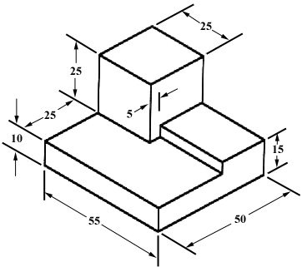

**QUESTION FOUR (15 MARKS)**

Draw orthographic views using first angle method of projection from the pictorial view given below. Give only the views required to completely describe the object

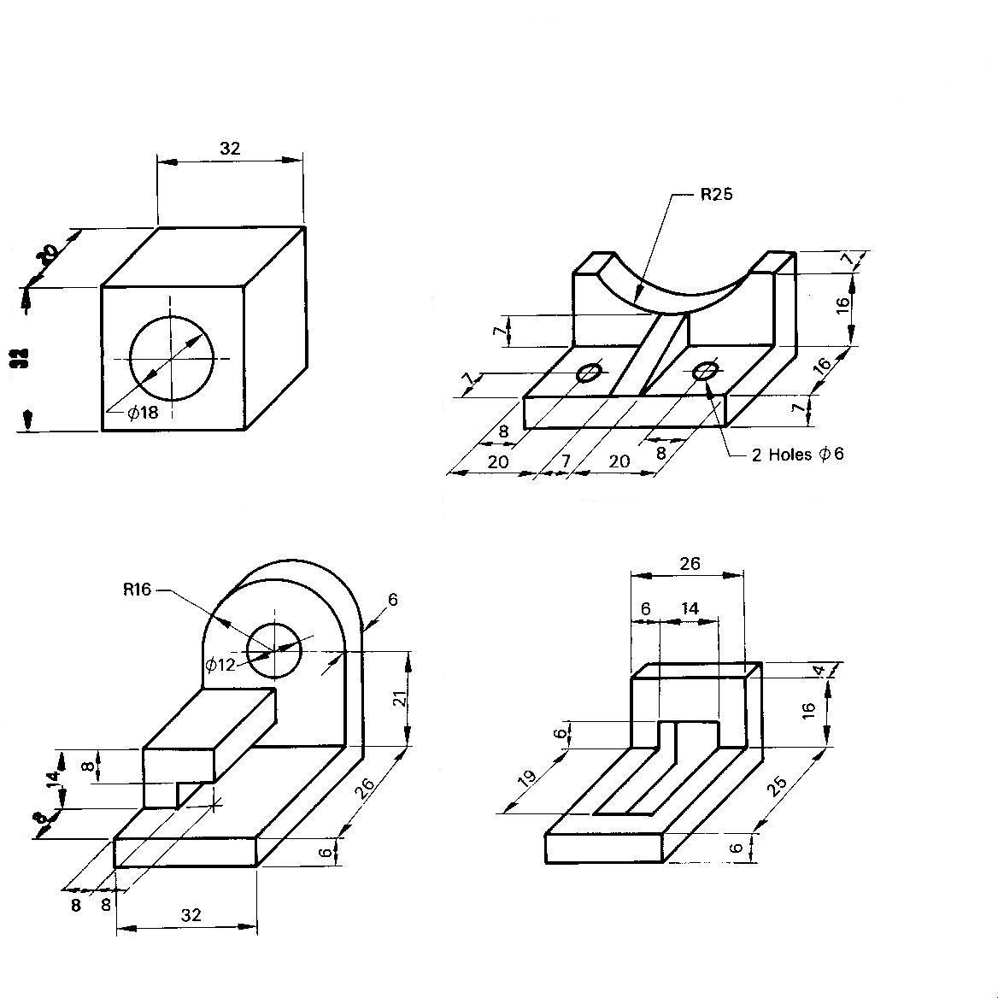

**QUESTION FIVE (15 MARKS)**

Below is given the orthographic multi-views of an object. Develop the pictorial view using the isometric method. The dimensions are in centimeters

