NAME: …………………………………………………..…………… INDEX NO:……….…………….. SCHOOL………………………………….……………………..…… DATE……………..………………
CANDIDATE’SIGN…………………………..…………………….

231/2
BIOLOGY
PAPER 2 (THEORY)
JULY/AUGUST 2014
TIME: 2 HOURS

KISUMU WEST SUB-COUNTY JOINT EVALIATION-2014
Kenya Certificate of Secondary Education (K C.S.E)

BIOLOGY
PAPER 2

INSTRUCTIONS TO THE CANDIDATES
- Write your name, school and index number in the spaces provided above.
- Sign and write the date of examination in the spaces provided above.
- This paper consists of two sections; A and B.
- Answer all the questions in Section A in the spaces provided.
- In section B, answer question 6(compulsory) and either question 7 or 8 in the spaces provided after question 8.

For Examiner’s Use only:-
SECTION | QUESTION | MAXIMUM SCORE | CANDIDATE’S SCORE
A | 1  2  3  4  5 | 8  8  8  8  8
B | 6  7  8 | 20  20  20
TOTAL SCORE |  | 80

This paper consists of 8 printed pages. Candidates should check to ascertain that all pages are printed
as indicated and that no questions are missing.

SECTION A (40MRKS)
Answer all question in the spaces provided
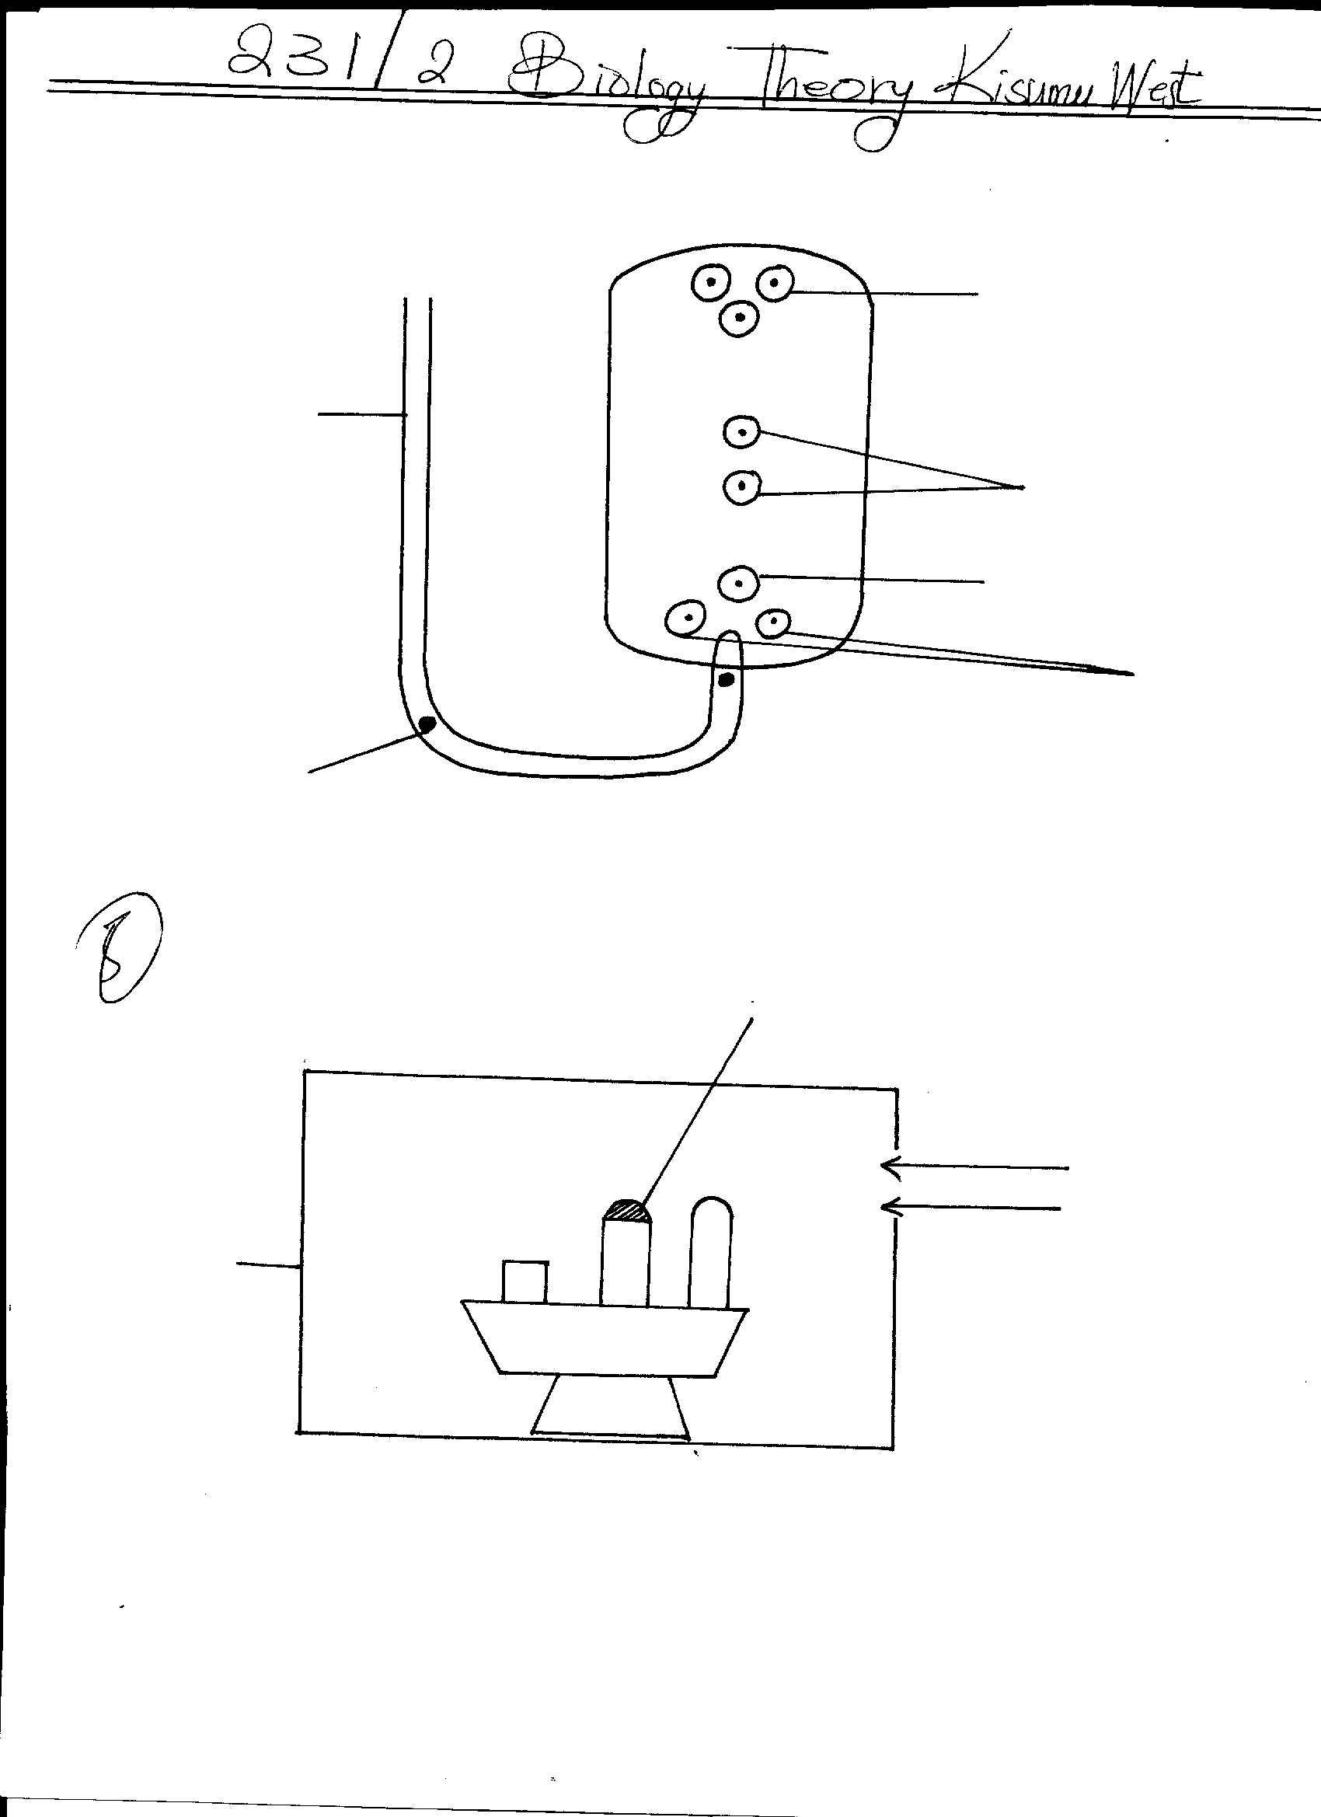1. The figure below shows the embryo-sac before fertilization.
E
D
B
C
A
Generative nucleus

(a) Identify the structures labelled A and B . (2mrks)
A ………………………………………………….………..…….……………………………
B ………………………………………………………………………………………………
(b) Identify the structures labelled in the diagram that will develop into the following after
fertilization.
i) Embryo…………………………………………………….……………………… (1mrk)
ii) Endosperm.…………………………………………………………….……………. (1mrk)
(c) State the ploidy of each the following nuclei after fertilization.
i) C ……………………………………………………………………………… (1mrk)
ii) D ……………………………………………………………………………… (1mrk)
(d) Briefly outline the process of “double” fertilization in flowering plants. (2mrks)
………………………………………………………………………………………………………….
…………………………………………………………………………………………………………..
2. (a) Name two substances which are found in the intercellular air spaces in a green leaf during a hot
sunny day. (2mrks)
……………………….………………………………………………………………………………….
……………………….………………………………………………………………………………….
(b) Name the gaseous exchange structure found in the:
i) Stem of a mesophyte plant……………………………………………..………………(1mrk)
- Root of aquatic halophytes………………………………………………………………(1mrk)
- Terrestrial insects………………………………………………………………………..(1mrk)
(c) State three ways in which the gill filaments are adapted to their functions. (3mrks)
…………………………………………………………………………………………………………..
…………………………………………………………………………………………………………..
…………………………………………………………………………………………………………..

3. In cats, sex is determined by X and Y chromosomes in the same way as humans. One gene for coat colour in cats is present on the X chromosome but not on the Y chromosome. The gene has two alleles orange (B) and black (b). Female cats that are homozygous for the X^{b} allele have black coats; female cats that are heterozygous have tortoise-shell coats (orange with dark patches).
(a) Give the genotype of:
(i) A female cat with tortoise shell coat. (1mrk)
…………………………………………………………………………………………………………..
…………………………………………………………………………………………………………..
(ii) A male cat with an orange coat. (1mrk)
…………………………………………………………………………………………………………..
…………………………………………………………………………………………………………..
(iii) A male cat with a black coat. (1mrk)
…………………………………………………………………………………………………………..
…………………………………………………………………………………………………………..
(b) A black coated male cat is mated with a tortoise- shell coated female cat. Use a punnet
square to determine the genotypic and phenotypic ratios of the kittens that could be produced by
this cross . (5mrks)

4. In a Savanna grassland ecosystem, the following organisms were identified; grasses, squirrels,
gazelles, lizards, insect larvae, wild dogs, snakes, hawks, vultures and lions, Energy flow in the
ecosystem was also determined as follows.
HEAT LOSS TO THE
ENVIRONMENT
1500kJ
320kJ
Producers
Primary
Consumer
Secondary
Consumer
Tertiary
Consumers
A
500kJ
B
X
C
100kJ
1000kJ
1500kJ
2000kJ

a) Define the term ecosystem (1mrk)
…………………………………………………………………………………………………………..
b) Name the process through which:
i) Producers convert sun’s energy into chemical energy (1mrk)
………………………………………..………………………….………………………………………..
ii) Living organisms convert chemical energy into heat energy lost to the environment (1mrk)
…………………………………………………………………………………………………….
c) Identify organism X (1mrk)
…………………………………………………………………………………………………………….
d) Determine the amount of energy represented by A and B (2mrks) A …………………………………………………………………………………… B …………………………………………………………………………………….
e) If 75% of the energy in the tertiary consumers is lost as heat. Calculate the amount of energy represented by C (2mrks)

5. Three potted seedlings labelled R, Sand T were treated as follows:
R- Tip of seedling was cut off.
S- Tip was covered with aluminium foil cap.
T- Tip was left intact
The seedlings were placed in, a box which had a hole on one side and painted black on the inside.
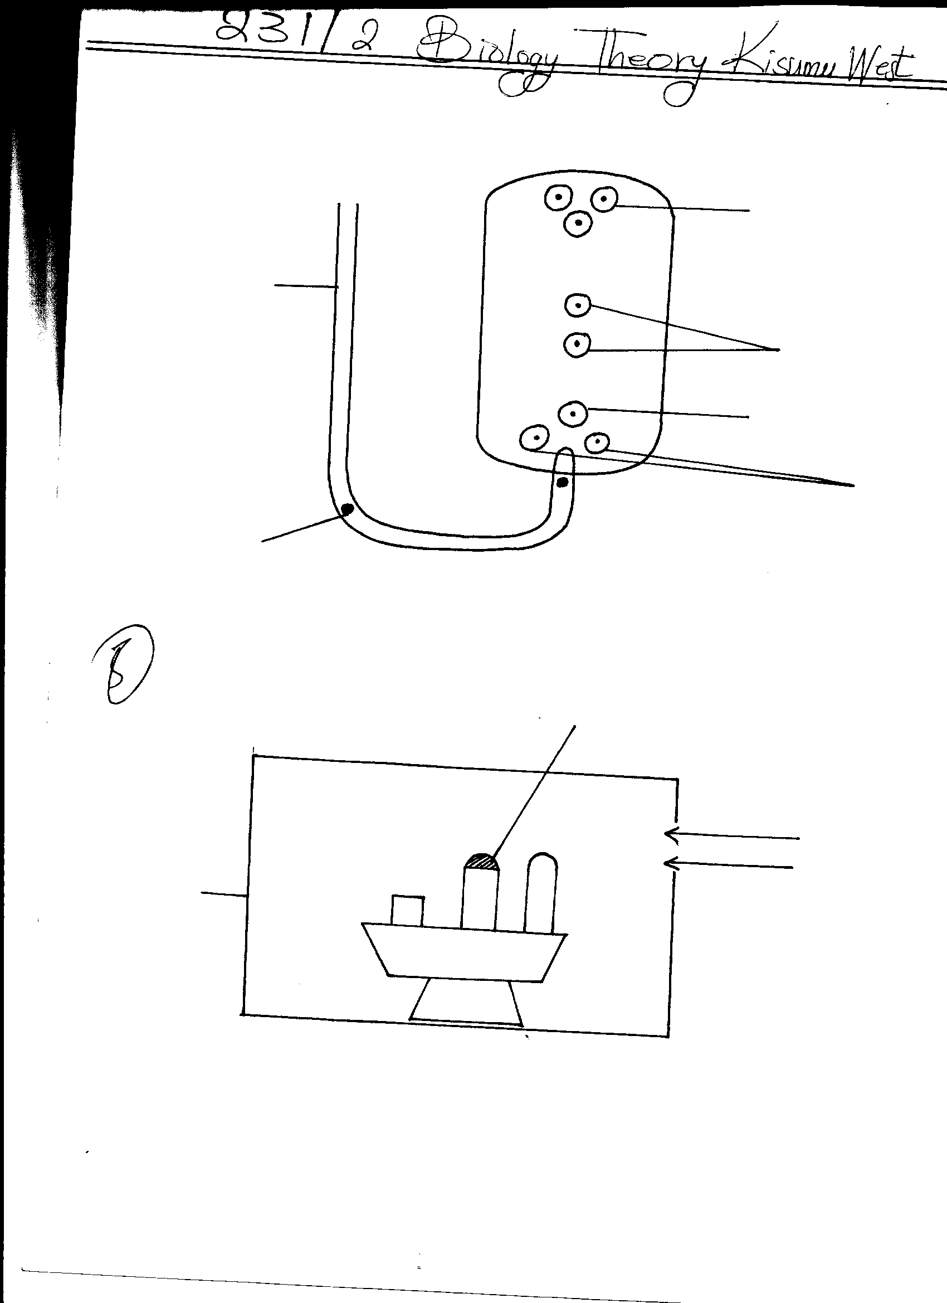
Light
Aluminium foil cap
Box
R
S
T

The experiment was left for four days.
a) (i) State the expected observations (3mrks)
R ………………………………………………………………………………….
S ………………………………………………………………………………..
T …………………………………………………………………………………..
ii) Explain the observations in a (i) above
R ………………………………………………………………………………………………(1mrk) S ………………………………………………………………………………………………(2mrks)
T ………………………………………………………………………………………………(2mrks)
SECTION B- (40MRKS)
Answer questions 6(compulsory) and either 7 or 8 in the spaces after question 8.
6. An experiment was set up to investigate the effect of light on the rate of photosynthesis in the shoot of a water weed. The shoot was immersed in a 2% sodium hydrogen carbonate solution. The gas given off by the shoot was collected for five minutes at different light intensities and the volume measured. The results obtained are shown in the table below.
Light intensity(arb units) | 1 | 2 | 3 | 5 | 10 | 20 | 30 | 40 | 50
Gas collected (cm³/5minutes) | 0.35 | 0.6 | 0.85 | 1.20 | 1.55 | 1.70 | 1.80 | 1.79 | 1.79

Using the data given in the table, plot a graph of volume of the gas collected against the light intensity (6mrks)

b) Account for the rate of gas production in the following intervals of light intensity.
i) 1 - 10 (2mrks)
…………………………………………………………………………………………………………..
…………………………………………………………………………………………………………..
…………………………………………………………………………………………………………..
…………………………………………………………………………………………………………..
ii) 30 - 50 (2mrks)
…………………………………………………………………………………………………………..
…………………………………………………………………………………………………………..
…………………………………………………………………………………………………………..
…………………………………………………………………………………………………………..
c) What is the use of sodium hydrogen carbonate in this experiment. (1mrk)
…………………………………………………………..………………………………………………
…………………………………………………………………………………………………………..
…………………………………………………………………………………………………………..
d) State the products of light stage of photosynthesis. (2mrks)
…………………………………………………………..………………………………………………
…………………………………………………………..………………………………………………
e) State the functions of each of the products of the dark stage of photosynthesis in man. (3mrks) …………………………………………………………..………………………………………………
…………………………………………………………..………………………………………………
…………………………………………………………..………………………………………………
…………………………………………………………………………………………………………..
…………………………………………………………………………………………………………..
f) Why are plants referred to as producers in an ecosystem. (2mrks)
…………………………………………………………..………………………………………………
…………………………………………………………..………………………………………………
(g) Other than light intensity, name two other factors that affect the rate of photosynthesis . (2mrks)
…………………………………………………………..………………………………………………
………………………………………………….………..……………………………………………
7. a) Define the term secondary thickening (2mrks)
b) Briefly describe how secondary thickening occurs in woody plants (14mrks)
c) i) State two ways in which growth in plants is different from that in animals (2mrks)
ii) State how ecdysis affects the growth of insects (2mrks)
8. a) State five differences between aerobic and anaerobic respiration. (5mrks)
b) Discuss the application of anaerobic respiration in industry and at home (15mks)
…………………………………………………………………………………………………………………..
…………………………………………………………………………………………………………………..
…………………………………………………………………………………………………………………..
…………………………………………………………………………………………………………………..
…………………………………………………………………………………………………………………..
…………………………………………………………………………………………………………………..
…………………………………………………………………………………………………………………..
…………………………………………………………………………………………………………………..
…………………………………………………………………………………………………………………..
…………………………………………………………………………………………………………………..
…………………………………………………………………………………………………………………..
…………………………………………………………………………………………………………………..
…………………………………………………………………………………………………………………..
…………………………………………………………………………………………………………………..
…………………………………………………………………………………………………………………..
…………………………………………………………………………………………………………………..
…………………………………………………………………………………………………………………..
…………………………………………………………………………………………………………………..
…………………………………………………………………………………………………………………..
…………………………………………………………………………………………………………………..
…………………………………………………………………………………………………………………..
…………………………………………………………………………………………………………………..
…………………………………………………………………………………………………………………..
…………………………………………………………………………………………………………………..
…………………………………………………………………………………………………………………..
…………………………………………………………………………………………………………………..
…………………………………………………………………………………………………………………..
…………………………………………………………………………………………………………………..
…………………………………………………………………………………………………………………..
…………………………………………………………………………………………………………………..
…………………………………………………………………………………………………………………..
…………………………………………………………………………………………………………………..
…………………………………………………………………………………………………………………..
…………………………………………………………………………………………………………………..
…………………………………………………………………………………………………………………..
…………………………………………………………………………………………………………………..
…………………………………………………………………………………………………………………..
…………………………………………………………………………………………………………………..
…………………………………………………………………………………………………………………..
…………………………………………………………………………………………………………………..
…………………………………………………………………………………………………………………..
…………………………………………………………………………………………………………………..
…………………………………………………………………………………………………………………..
…………………………………………………………………………………………………………………..
…………………………………………………………………………………………………………………..
…………………………………………………………………………………………………………………..
…………………………………………………………………………………………………………………..
…………………………………………………………………………………………………………………..
…………………………………………………………………………………………………………………..
…………………………………………………………………………………………………………………..
…………………………………………………………………………………………………………………..
…………………………………………………………………………………………………………………..
…………………………………………………………………………………………………………………..
…………………………………………………………………………………………………………………..
…………………………………………………………………………………………………………………..
…………………………………………………………………………………………………………………..
…………………………………………………………………………………………………………………..
…………………………………………………………………………………………………………………..
…………………………………………………………………………………………………………………..
…………………………………………………………………………………………………………………..
…………………………………………………………………………………………………………………..
…………………………………………………………………………………………………………………..
…………………………………………………………………………………………………………………..
…………………………………………………………………………………………………………………..
…………………………………………………………………………………………………………………..
…………………………………………………………………………………………………………………..
…………………………………………………………………………………………………………………..
…………………………………………………………………………………………………………………..
…………………………………………………………………………………………………………………..
…………………………………………………………………………………………………………………..
…………………………………………………………………………………………………………………..
…………………………………………………………………………………………………………………..

