Name: …………………………………………………………Index No: ……………………..……………
Candidate’s Signature:……………………………….
Date: ……………….……………….…

443/1
AGRICULTURE
PAPER 1
JULY/AUGUST 2014
TIME: 2 HOURS

Kenya Certificate of Secondary Education

443/1
Agriculture
Paper 1
2 hours

INSTRUCTIONS TO CANDIDATES:
- This paper contains three sections A, B and C
- Answer ALL the questions in section A and B
- Answer any Two questions from section C
- All answers should be written in the spaces provided.

FOR EXAMINERS USE ONLY
SECTION | QUESTIONS | MAX SCORE | CANDIDATES SCORE
A | 1-14 | 30
B | 15-18 | 20
C |  | 20
C |  | 20
TOTAL |  | 90

This paper consists of 8 printed pages. Candidates should check to ascertain that all pages are printed as indicated and that no questions are missing.
SECTION A (30MKS)
Answer ALL the questions in this section in the spaces provided
1. State two reasons why farmers should be encouraged to practice organic farming (1mk)
…………………………………………………………………………………………………….
…………………………………………………………………………………………………….
2. State two ways in which crop rotation controls weeds (1mk)
…………………………………………………………………………………………………….
…………………………………………………………………………………………………….
3. List two market forces which help to determine the price of a commodity in a free market (1mk)
…………………………………………………………………………………………………….
…………………………………………………………………………………………………….
4. State four qualities considered when selecting seeds for planting (2mks)
…………………………………………………………………………………………………….
…………………………………………………………………………………………………….
…………………………………………………………………………………………………….
…………………………………………………………………………………………………….
5. State four advantages of crop rotation (2mks)
…………………………………………………………………………………………………….
…………………………………………………………………………………………………….
…………………………………………………………………………………………………….
…………………………………………………………………………………………………….
6. State three physical agents of weathering in soil formation (1 ½ mks)
…………………………………………………………………………………………………….
…………………………………………………………………………………………………….
…………………………………………………………………………………………………….
7. Give three properties of a foliar fertilizer which makes it possible to be used as a foliar
Feed (1 ½ mks)
…………………………………………………………………………………………………….
…………………………………………………………………………………………………….
8. Give three reasons why Banana should be pruned (1 ½ mks)
…………………………………………………………………………………………………….
…………………………………………………………………………………………………….
…………………………………………………………………………………………………….
9. State four factors considered when classifying crop pests (2mks)
…………………………………………………………………………………………………….
…………………………………………………………………………………………………….
…………………………………………………………………………………………………….
…………………………………………………………………………………………………….
10. Give four reasons for land fragmentation (2mks)
…………………………………………………………………………………………………….
…………………………………………………………………………………………………….
…………………………………………………………………………………………………….
…………………………………………………………………………………………………….
11. State two mechanical methods used in separating soil in soil analysis (1mk)
…………………………………………………………………………………………………….
…………………………………………………………………………………………………….
12. State three ways in which inorganic fertilizers are classified (1 ½ mks)
…………………………………………………………………………………………………….
…………………………………………………………………………………………………….
…………………………………………………………………………………………………….
13. State three effects of raindrops on bare soil ( 1 ½ mks)
…………………………………………………………………………………………………….
…………………………………………………………………………………………………….
…………………………………………………………………………………………………….
14. Give three reasons why layering would be preferred to the use of cutting as a method of raising planting materials ( 1 ½ mks)
…………………………………………………………………………………………………….
…………………………………………………………………………………………………….
…………………………………………………………………………………………………….
15. State the forms in which nitrogen is absorbed by plants (1mk)
…………………………………………………………………………………………………….
16. Outline four factors which effect herbraidal selectivity (2mks)
…………………………………………………………………………………………………….
…………………………………………………………………………………………………….
…………………………………………………………………………………………………….
…………………………………………………………………………………………………….
17. State four natural factors that may influence soil erosion (2mks)
…………………………………………………………………………………………………….
…………………………………………………………………………………………………….
…………………………………………………………………………………………………….
…………………………………………………………………………………………………….

18. Give four advantages of liberalization in marketing agricultural products (2mks)
…………………………………………………………………………………………………….
…………………………………………………………………………………………………….
…………………………………………………………………………………………………….
…………………………………………………………………………………………………….
19. Outline four factors which encourage soil erosion (2mks)
…………………………………………………………………………………………………….
…………………………………………………………………………………………………….
…………………………………………………………………………………………………….
…………………………………………………………………………………………………….
SECTION B (20 MKS)
Answer ALL Questions in this section
20. Below are illustrations of common weeds. Study them and answer the questions that follow

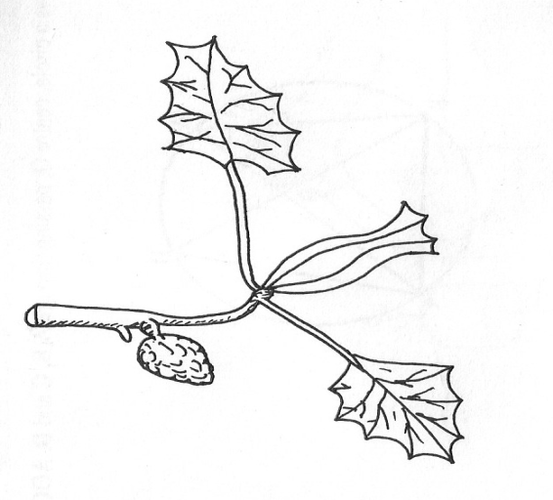
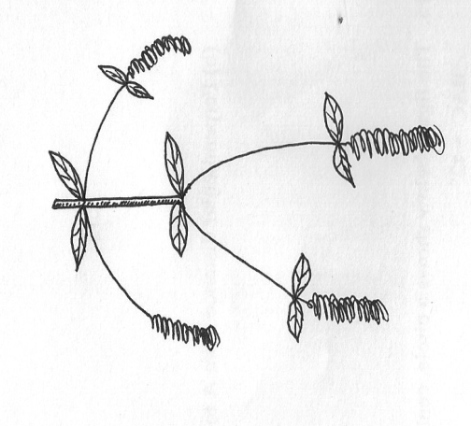

B
A

(a) Identify the weeds (2mks)
A…………………………………………….
B…………………………………………….
(b) State the harmful effects of the weed B above (1mk)
…………………………………………………………………………………………………….
(c) Give four advantages of leasehold tenure systems (2mks)
…………………………………………………………………………………………………….
…………………………………………………………………………………………………….
…………………………………………………………………………………………………….
…………………………………………………………………………………………………….

21. Describe the procedure which should be followed when spraying a crop of onions using a
fungicide in powder form, water and a knapsack sprayer (5mks)
…………………………………………………………………………………………………….
…………………………………………………………………………………………………….
…………………………………………………………………………………………………….
…………………………………………………………………………………………………….
…………………………………………………………………………………………………….
22. The diagram below illustrates a nursery practice carried out on tree seedlings before transplanting. Study it carefully and then answer the questions below
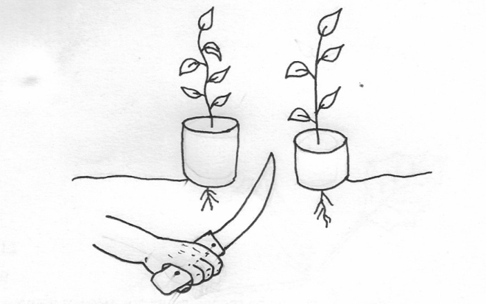

Polythene sleeves
Ground level

(a) Identify the practice being carried out on the diagram (1mk)
…………………………………………………………………………………………………….
(b) Give three reasons why the practice is encouraged when raising tree seedlings (3mks)
…………………………………………………………………………………………………….
…………………………………………………………………………………………………….
…………………………………………………………………………………………………….
(c) Give two reasons why the polythene sleeves are used in the nursery bed as shown in the diagram (2mks)
…………………………………………………………………………………………………….
…………………………………………………………………………………………………….
23. (a) Calculate the elasticity of demand when 20 bags of potatoes are demanded at a price of Kshs.1000 while 22 bags were demanded at Kshs.800. (4mks)

(b) Identify the type of elasticity of demand resulting from the situation above (1mk)
…………………………………………………………………………………………………….

SECTION C (40MKS)
Answer any two Questions in this section
24. (a) Describe harvesting of pyrethrum under the following sub-headings
(i) Procedure (4mks)
(ii) Precautions (6mks)
(b) Describe the safety measures observed when handling farm herbicides (10mks)
25. Describe the production of Rhodes grass (Chloris gayana) under the following sub-headings
(a) Land preparation (5mks)
(b) Pasture establishment (8mks)
(c) Maintenance (7mks)
26. (a) State four major questions a farm manager needs to ask and answer while preparing a partial budget (4mks)
(b) Under what conditions is partial budget an appropriate tool for planning (4mks)
(c) A farmer has 160 ha of land, 60 ha of which is under wheat, 32 ha under maize, 12ha
under fodder crops and the rest under pastures. She wishes to know whether replacing 12 ha
of maize with irish potatoes the following year would be worthwhile. The fertilizer would have
to be increased from 5 bags per ha for maize to 7 bags per ha for irish potatoes and an extra
100 man –days of casual labour per ha will be necessary as a result of the change. The
average yield of maize and irish potatoes is 45 and 115 bags/ha respectively. The prices are
Shs. 1400 per bag for maize and Ksh.1200 per bag for irish potatoes seed costs are Sh.2500
per ha for maize and Shs. 30,000 per ha for irish potatoes. Fertilizer costs are Shs.1300 per
bag. Labour is paid at Shs. 150 per man-day.
Draw up a partial budget and indicate the effects of the change (12mks)
…………………………………………………………………………………………………….
…………………………………………………………………………………………………….
…………………………………………………………………………………………………….
…………………………………………………………………………………………………….
…………………………………………………………………………………………………….
…………………………………………………………………………………………………….
…………………………………………………………………………………………………….
…………………………………………………………………………………………………….
…………………………………………………………………………………………………….
…………………………………………………………………………………………………….
…………………………………………………………………………………………………….
…………………………………………………………………………………………………….
…………………………………………………………………………………………………….
…………………………………………………………………………………………………….
…………………………………………………………………………………………………….
…………………………………………………………………………………………………….
…………………………………………………………………………………………………….
…………………………………………………………………………………………………….
…………………………………………………………………………………………………….
…………………………………………………………………………………………………….
…………………………………………………………………………………………………….
…………………………………………………………………………………………………….
…………………………………………………………………………………………………….
…………………………………………………………………………………………………….
…………………………………………………………………………………………………….
…………………………………………………………………………………………………….
…………………………………………………………………………………………………….
…………………………………………………………………………………………………….
…………………………………………………………………………………………………….
…………………………………………………………………………………………………….
…………………………………………………………………………………………………….
…………………………………………………………………………………………………….
…………………………………………………………………………………………………….
…………………………………………………………………………………………………….
…………………………………………………………………………………………………….
…………………………………………………………………………………………………….
…………………………………………………………………………………………………….
…………………………………………………………………………………………………….
…………………………………………………………………………………………………….
…………………………………………………………………………………………………….
…………………………………………………………………………………………………….
…………………………………………………………………………………………………….
…………………………………………………………………………………………………….
…………………………………………………………………………………………………….
…………………………………………………………………………………………………….
…………………………………………………………………………………………………….
…………………………………………………………………………………………………….
…………………………………………………………………………………………………….
…………………………………………………………………………………………………….
…………………………………………………………………………………………………….
…………………………………………………………………………………………………….
…………………………………………………………………………………………………….
…………………………………………………………………………………………………….
…………………………………………………………………………………………………….
…………………………………………………………………………………………………….
…………………………………………………………………………………………………….
…………………………………………………………………………………………………….
…………………………………………………………………………………………………….
…………………………………………………………………………………………………….
…………………………………………………………………………………………………….
…………………………………………………………………………………………………….
…………………………………………………………………………………………………….
…………………………………………………………………………………………………….
…………………………………………………………………………………………………….
…………………………………………………………………………………………………….
…………………………………………………………………………………………………….
…………………………………………………………………………………………………….
…………………………………………………………………………………………………….
…………………………………………………………………………………………………….
…………………………………………………………………………………………………….
…………………………………………………………………………………………………….
…………………………………………………………………………………………………….
…………………………………………………………………………………………………….
…………………………………………………………………………………………………….
…………………………………………………………………………………………………….
…………………………………………………………………………………………………….
…………………………………………………………………………………………………….
…………………………………………………………………………………………………….
…………………………………………………………………………………………………….
…………………………………………………………………………………………………….
…………………………………………………………………………………………………….
…………………………………………………………………………………………………….

