NAME ………………………………………………………………………..……… Index No ……….…………….………/.………….

Candidate’s Signature………………….…….

Date………………………………………………….

232/3
PHYSICS
(Practical)
Paper 3

July/August 2016

2 ½ Hours

NAKURU NORTH JOINT EVALUATION

Instructions to Candidates

- Write your name and index number in the spaces provided above.
- Sign and write the date of examination in the spaces provided above.
- Answer ALL QUESTIONS in the spaces provided in the question paper.
- You are supposed to spend the first 15 minutes of the 2 ½ hours allowed for this paper reading the whole paper carefully before commencing your work.
- Marks are awarded for clear record of the observations actually made, their suitability, accuracy and the use made of them.
- Candidates are advised to record their observations as soon as they are made.
- Non-programmable silent electronic calculators and KNEC Mathematical tables may be used.
- Candidates should check the question paper to ascertain that all pages are printed as indicated and that no questions are missing

For Examiner’s Use Only

Question 1 | a | c | f |  | g |  | h |  | g(i) |  | g (ii) |  | g (iii) | Total
Maximum Score | 1 | 1 | 5 |  | 5 |  | 3 |  | 1 |  | 2 |  | 2 | 20
Candidate’s Score
Question 2 | a(i) | a(ii) |  | d |  | e |  | f |  | g |  |  |  | Total
Maximum Score | 2 | 1 |  | 6 |  | 5 |  | 3 |  | 3 |  |  |  | 20
Candidate’s Score

This paper consists of xxxx printed pages
Question 1
You are provided with the following;
- A plastic can
- Some sand
- A half metre rule
- A boiling tube
- A vernier calipers (to be shared)
- Some water
- A spatula
- 10 steel balls
Proceed as follows:
- Determine the average external diameter d, of the boiling tube using a vernier caliper provided.
d …………………………………………………..cm (1mk)
- Fill the plastic can with water to a height of 17cm. Place the clean dry boiling tube in the can and add some sand to it until the tube just float upright in water. See figure 1(a)below
Figure 1(a)
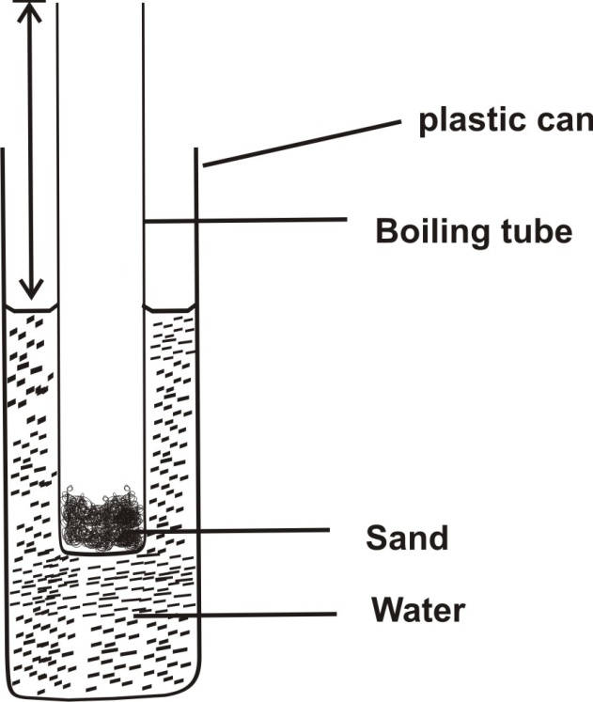
- Remove the boiling tube from the water and measure the height, H of the boiling tube above the level of the sand using the half metre rule provided. See figure 1(b) below
Figure 1(b)
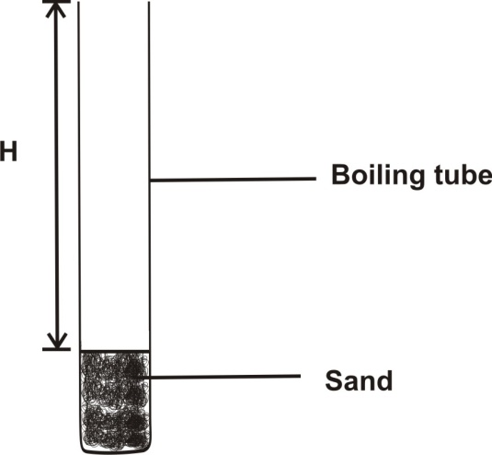
H …………………………………………………..cm (1mk)
- Return the boiling tube with sand into water in the can so that it float freely as in figure 1(a). measure the height h, of the boiling tube above the level of water in the can and record it in the table 1. Determine the height of the boiling tube submerged in water, (H – h)
- Carefully place two steel balls into the boiling tube containing sand. Measure the new height, h of the boiling tube above the water level.
- Repeat step (e) for the number of steel balls, N in the table 1. Complete the table
Table 1
Number of steel balls N | 0 | 2 | 4 | 6 | 8 | 10
Height, h(cm)
H – h(cm)
(5mks)
- On the grid provided, plot a graph of H – h (y-axis) against N (5mks)

- Determine the slope, m, of the graph (3mks)
………………………………………………………………………………………………………………………………………………………………………………………………………………………………………………………………………………………………………………………………………………………………………………………………………………………………………………………………………………………………………………………………………………………………………………………………………………………………………………………………………………………………………………………………………………………………………………………………………………………………………………………………………………………………………………………………………………………………………………………………………………
- (i) From the graph, determine the constant P, the y-intercept of the graph
P …………………………………………………………………………………… (1mk)
(ii) Determine the constant r, given that
(2mks)
………………………………………………………………………………………………………………………………………………………………………………………………………………………………………………………………………………………………………………………………………………………………………………………………………………………………………………………………………………………………………………………………………………………………………………………………………………………………………………………………………………………………………………………………………………………………………………………………………………………………………………………………………………………………………………………………………………………………………………………………………………
(iii) Determine the constant t, given that
(2mks)
……………………………………………………………………………………………………………………………………………………………………………………………………………………………………………………………………………………………………………………………………………………………………………………………………………………………………………………………………………………………………………………………………………………………………………………………………………………………………………………………………………………………………………………………………………………………………………………………………………………………………………………………………………………………………………………………………………………………………………………………………………………………………………………………………………………………………………………………………………………………………………………………………………………………………………………………………………………………………………………………………………………

Question 2
You are provided with the following
- A centre zero galvanometer
- Seven connecting wires each with a crocodile clip at one end
- Two wires, one labeled W and the other labeled Q each mounted on a millimeter scale
- A dry cell and cell holder
- A jockey
- A carbon resistor labeled R
- A micrometer screw gauge (to be shared)
- A switch
Proceed as follows;
- (i) Determine the average diameter D of the wire labeled W and the average diameter d, of the wire labeled Q using the micrometer screw gauge provided
D …………………………………………………………………………………………mm (1mk)
d …………………………………………………………………………………………mm (1mk)
(ii) Determine the ratio (1mk)
………………………………………………………………………………………………………………………………………………………………………………………………………………………………………………………………………………………………………………………………………………………………………………………………………………………………………………………………………………………………………………………………………………………………………………………………………………………………………………………………………………………………………………………………………………………………………………………………………………………………………………………………………………………………………………………………………………………………………………………………………………
- Set up the circuit as shown in the figure 2 below. Use the crocodile clip to fix the length, L of W at 80cm
Figure 2
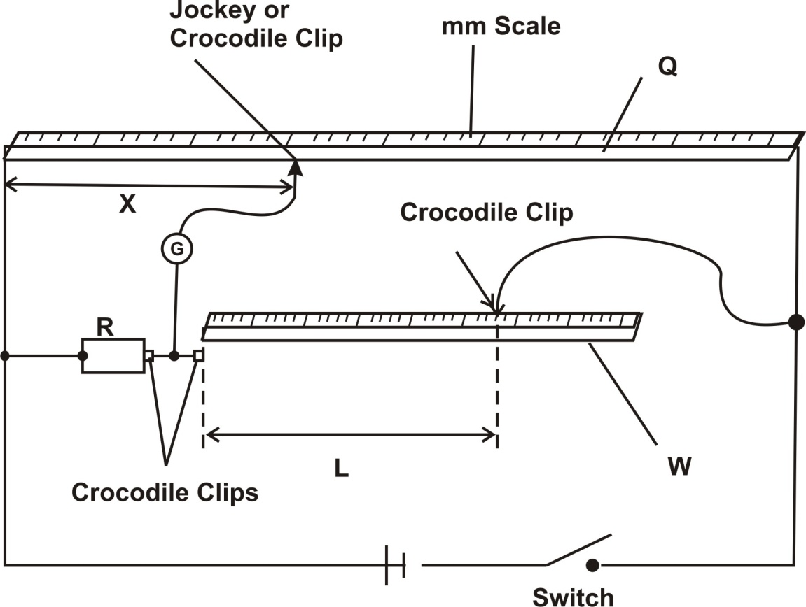
- Close the switch. Use the jockey to touch one end of the wire Q and the other end. The galvanometer deflection should be in the opposite directions otherwise check the circuit.
Adjust the position of the jockey along the wire Q until there is no defection in the galvanometer. This is the balance point.
Record the value of X in cm in table 2 below
- Adjust the length L of wire, W, to 70cm, then find the balance point and record the new value of X in the table.
Repeat this for the other values of L in table 2. Complete the table
L(cm) | 80 | 70 | 60 | 50 | 40 | 30 | 20
X(cm)
(6mks)
- On the grid provided, plot a graph of (y-axis) against L (5mks)
- Determine the slope, S, of the graph (3mks)
……………………………………………………………………………………………………………………………………………………………………………………………………………………………………………………………………………………………………………………………………………………………………………………………………………………………………………………………………………………………………………………………………………………………………………………………………………………………………………………………………………………………………………………………………………………………………………………………………………………………………………………………………………………………………………………………………………………………………………………………………………………………………………………………………………………………………………………………………………………………………………………………………………………………………………………………………………………………………………………………………………………
- Determine the ratio that (3mks)
……………………………………………………………………………………………………………………………………………………………………………………………………………………………………………………………………………………………………………………………………………………………………………………………………………………………………………………………………………………………………………………………………………………………………………………………………………………………………………………………………………………………………………………………………………………………………………………………………………………………………………………………………………………………………………………………………………………………………………………………………………………………………………………………………………………………………………………………………………………………………………………………………………………………………………………………………………………………………………………………………………………

