NAME ……………………………………………………………..………………..… Index No …………………/….……
Candidate’s Signature ..……….
Date …..………………………..…….

232/2
PHYSICS
PAPER 2
(THEORY)

2017

2 Hours
NAIRTOBI JOINT EVALUATION - 2017

Instructions to Candidates

- Write your name and index number in the spaces provided above
- Sign and write the date of examination in the spaces provided above.
- This paper consists of TWO sections; A and B.
- Answer ALL QUESTIONS in section A and B in the spaces provided below each question.
- All working MUST be clearly seen.
- Silent Non-programmable electronic calculators may be used.
- Candidates should check the question paper to ascertain that all the pages are printed as indicated and that no question is missing.

For Examiner’s Use Only

SECTION | Question | Maximum Score | Candidate’s Score
A | 1 – 12 | 25
B | 13 | 10
B | 14 | 12
B | 15 | 12
B | 16 | 11
B | 17 | 10
Total Score |  | 80

This paper consists of 16 pages with xxxxx Printed pages

SECTION A (25 MARKS)

- Give two reasons why prisms may be preferred over plane mirrors in the construction of a periscope
(2mks)
………………………………………………………………………………………………………………………………………………………………………………………………………………………………………………………………………………………………………………………………………………………………………………………………………………………………………………………………………………………………………
- Two spherical conductors are placed close together without touching as shown below
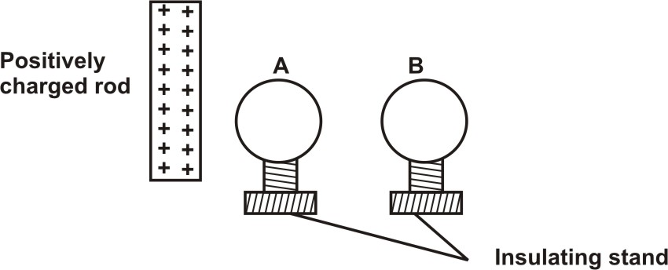
Show the distribution of charges in the sphere when a highly positively charged rod is brought near A
(2mks)
………………………………………………………………………………………………………………………………………………………………………………………………………………………………………………………………………………………………………………………………………………………………………………………………………………………………………………………………………………………………………
- Give two similarities between cathode rays and x-rays. (2mks)
………………………………………………………………………………………………………………………………………………………………………………………………………………………………………………………………………………………………………………………………………………………………………………………………………………………………………………………………………………………………………
- Give a reason why it is not advisable to smoke a cigarette near a charging battery. (1mk)
……………………………………………………………………………………………………………………………………………………………………………………………………………………………………………………………………………………………………………………………………
- A radio station broadcast on a wavelength 150m at a frequency of 200kHz. Calculate the velocity of the radio waves (2mks)
………………………………………………………………………………………………………………………………………………………………………………………………………………………………………………………………………………………………………………………………………………………………………………………………………………………………………………………………………………………………………………………………………………………………………………………………………………………………………………………………………………………………………………………………………………………………………………………………………………………………………………………………………………………………………………………………………………………………………………………………………………
- The diagram below shows part of the electromagnetic spectrum

a | b | c | d | e | f
Increasing wave length
Radiation of frequency corresponding to each of the above regions is allowed strike a metal plate and in some cases electrons wave ejected from the metal surface.
- From which of the above regions is the radiation most likely to eject electrons from metal plate? (3mks)
………………………………………………………………………………………………………………………………………………………………………………………………………………………………………………………………………………………………………………………………………………………………………………………………………………………………………………………………………………………………………………………………………………………………………………………………………………………………………………………………………………………………………………………………………………………………………………………………………………………………………………………………………………………………………………………………………………………………………………………………………………
- Give a reason for your answer in (i) above (1mk)
……………………………………………………………………………………………………………………………………………………………………………………………………………………………………………………………………………………………………………………………………
- On the space provided below, draw a ray diagram to show how a doctor can use a curved mirror to examine a patient tooth (3mks)
………………………………………………………………………………………………………………………………………………………………………………………………………………………………………………………………………………………………………………………………………………………………………………………………………………………………………………………………………………………………………………………………………………………………………………………………………………………………………………………………………………………………………………………………………………………………………………………………………………………………………………………………………………………………………………………………………………………………………………………………………………
- A girl places her ear at one end of a long metal rod. The slightest tap at the other end of the rod is clearly heard. Although it may be inaudible when her ear is removed from the rod. Explain this observation (1mk)
……………………………………………………………………………………………………………………………………………………………………………………………………………………………………………………………………………………………………………………………………
- Explain what happens to the depletion layer when a diode is in forward blasted (1mk)
……………………………………………………………………………………………………………………………………………………………………………………………………………………………………………………………………………………………………………………………………
- The experiment below is an equation for a radioactive element A. element B and C are daughter nuclide
- Identify the element C (1mk)
……………………………………………………………………………………………………………………………………………………………………………………………………………………………………………………………………………………………………………………………………
- State one characteristics of the element C (1mk)
……………………………………………………………………………………………………………………………………………………………………………………………………………………………………………………………………………………………………………………………………
- The figure below shows a u-shaped magnet stored with a keeper.
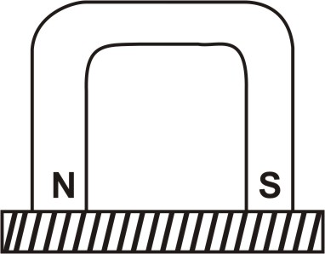
Explain how this method helps to retain magnetism longer. (1mk)
……………………………………………………………………………………………………………………………………………………………………………………………………………………………………………………………………………………………………………………………………
- The figure below shows a setup for observing interference of waves from two sources S₁ and S₂. The points C and D represents positions of the constructive and destructive interference respectively as observed on the screen
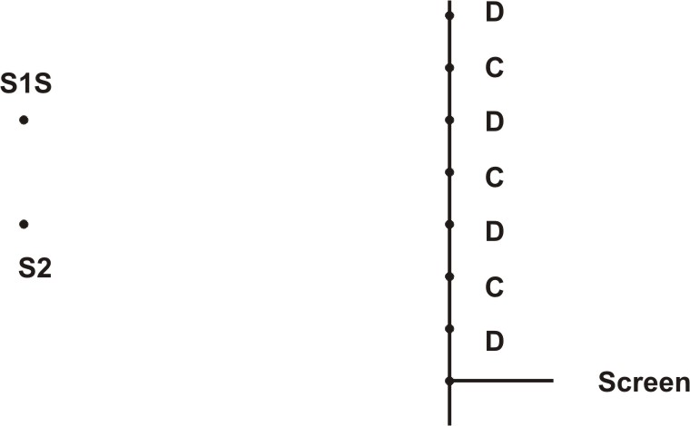
If the observation was made in a nipple tank
- Explain how the constructive and destructive interference patterns are produced (2mks)
…………………………………………………………………………………………………………………………………………………………………………………………………………………………………………………………………………………………………………………………………………………………………………………………………………………………………………………………………………………………………………………………………………………………………………………………………………………………………………………………………………
- Draw a line joining all points where waves from S₂ have travelled one wavelength further than the waves from S₁ (1mk)
……………………………………………………………………………………………………………………………………………………………………………………………………………………………………………………………………………………………………………………………………
Section b (55 marks)
- a) State the conditions to be satisfied for total internal reflection to occur (2mks)
…………………………………………………………………………………………………………………………………………………………………………………………………………………………………………………………………………………………………………………………………………………………………………………………………………………………………………………………………………………………………………………………………………………………………………………………………………………………………………………………………………
- A ray of light travelling in the air enters a rectangular glass block at an angle of 30º face AB.
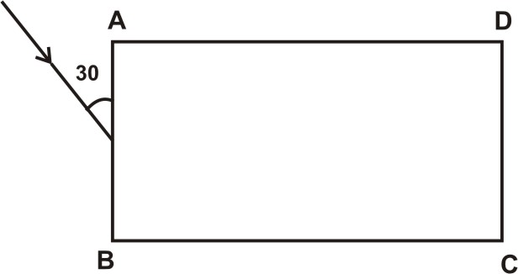
If the refractive index of the glass is 1.5, find;
- The angle of refraction in the glass block (2mks)
…………………………………………………………………………………………………………………………………………………………………………………………………………………………………………………………………………………………………………………………………………………………………………………………………………………………………………………………………………………………………………………………………………………………………………………………………………………………………………………………………………
- The critical angle of the glass block (2mks)
…………………………………………………………………………………………………………………………………………………………………………………………………………………………………………………………………………………………………………………………………………………………………………………………………………………………………………………………………………………………………………………………………………………………………………………………………………………………………………………………………………
- In the same diagram, complete the diagram to show the path of light through and out of the glass block
(2mks)
…………………………………………………………………………………………………………………………………………………………………………………………………………………………………………………………………………………………………………………………………………………………………………………………………………………………………………………………………………………………………………………………………………………………………………………………………………………………………………………………………………
- In the spaces provided below, draw a diagram to illustrate the correction of myopia (short sight) (2mks)
…………………………………………………………………………………………………………………………………………………………………………………………………………………………………………………………………………………………………………………………………………………………………………………………………………………………………………………………………………………………………………………………………………………………………………………………………………………………………………………………………………
- a) Study the circuit diagram below and answers the question that follows.
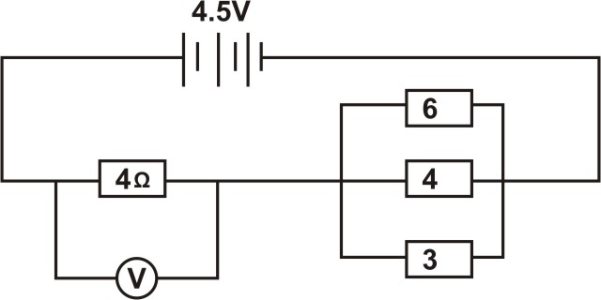
- Calculate the effective resistance of the circuit (3mks)
……………………………………………………………………………………………………………………………………………………………………………………………………………………………………………………………………………………………………………………………………
- Find the voltmeter reading (2mks)
……………………………………………………………………………………………………………………………………………………………………………………………………………………………………………………………………………………………………………………………………
- A cell drives a current of 3.2A through a 2.8Ω resistor. When it is connected to 1.6Ω resistor, the current that flows is 5A.
Find the Emf and the internal resistance of the cell (3mks)
………………………………………………………………………………………………………………………………………………………………………………………………………………………………………………………………………………………………………………………………………………………………………………………………………………………………………………………………………………………………………………………………………………………………………………………………………………………………………………………………………………………………………………………………………………………………………………………………………………………………………………………………………………………………………………………………………………………………………………………………………………
- A house has five rooms with 240V, 60W bulbs. If the bulbs are switched on from 7.00pm to 10.30pm. Find the cost per week for the lighting this rooms at Ksh. 14.20 per unit (3mks)
………………………………………………………………………………………………………………………………………………………………………………………………………………………………………………………………………………………………………………………………………………………………………………………………………………………………………………………………………………………………………………………………………………………………………………………………………………………………………………………………………………………………………………………………………………………………………………………………………………………………………………………………………………………………………………………………………………………………………………………………………………
- a) The figure below shows two circuit close to each other as shown
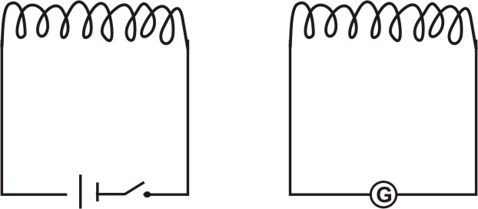
when the switch is closed, the galvanometer shows a reading and then returns to zero. When the switch is then opened the galvanometer shows a reading in the opposite direction and then returns to zero.
Explain this observations (3mks)
………………………………………………………………………………………………………………………………………………………………………………………………………………………………………………………………………………………………………………………………………………………………………………………………………………………………………………………………………………………………………………………………………………………………………………………………………………………………………………………………………………………………………………………………………………………………………………………………………………………………………………………………………………………………………………………………………………………………………………………………………………
- A step-down transformer has 2000 turns in the primary circuit and 200turns in the secondary circuit. When the primary circuit is connected to a 240v a.c source, the power delivered to a resistor in the secondary circuit is found to be 800w.
- What is meant by a step-down transformer (1mk)
……………………………………………………………………………………………………………………………………………………………………………………………………………………………………………………………………………………………………………………………………
- Explain how energy losses in this transformer can be reduced by having a soft iron core in it (2mks)
…………………………………………………………………………………………………………………………………………………………………………………………………………………………………………………………………………………………………………………………………………………………………………………………………………………………………………………………………………………………………………………………………………………………………………………………………………………………………………………………………………
- Determine the current in the secondary circuit if the transformer is 100% efficient (3mks)
………………………………………………………………………………………………………………………………………………………………………………………………………………………………………………………………………………………………………………………………………………………………………………………………………………………………………………………………………………………………………………………………………………………………………………………………………………………………………………………………………………………………………………………………………………………………………………………………………………………………………………………………………………………………………………………………………………………………………………………………………………
- A student wanted to lift a magnetic piece of metal using an electromagnet. He connected the circuit as shown below.
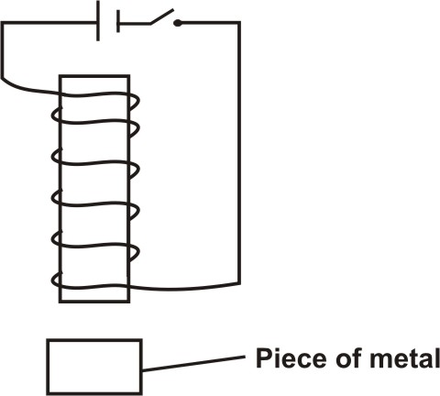
Suggest three adjustment he can make to his set up so that it can perform the intended function (3mks)
………………………………………………………………………………………………………………………………………………………………………………………………………………………………………………………………………………………………………………………………………………………………………………………………………………………………………………………………………………………………………………………………………………………………………………………………………………………………………………………………………………………………………………………………………………………………………………………………………………………………………………………………………………………………………………………………………………………………………………………………………………
- The figure below shows a cathode ray oscilloscope (C.R.O)
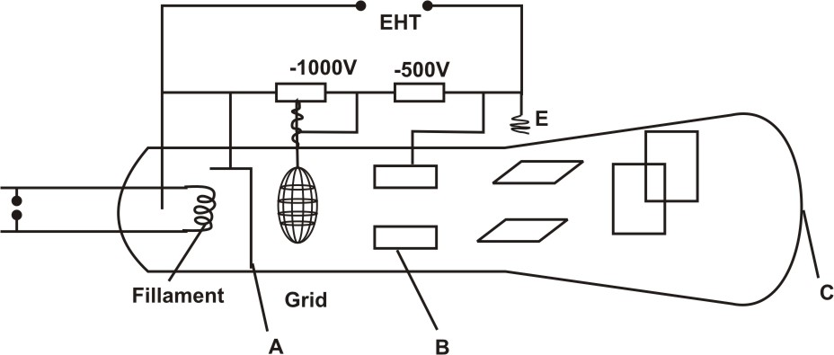
- (i) State the function of the components labeled A, B and C (3mks)
A ……………………………………………………………………………………………………………………………………………………………
……………………………………………………………………………………………………………………………………………………………
B ……………………………………………………………………………………………………………………………………………………………
……………………………………………………………………………………………………………………………………………………………
C ……………………………………………………………………………………………………………………………………………………………
……………………………………………………………………………………………………………………………………………………………
- What would be the effect on the C.R.O if the temperature of the filament of the electron gun was raised? (1mk)
……………………………………………………………………………………………………………………………………………………………………………………………………………………………………………………………………………………………………………………………………
- A T.V tube uses a voltage of 4550V to accelerate electrons released from its cathode by thermionic emission.
- What is meant by thermionic emission (1mk)
……………………………………………………………………………………………………………………………………………………………………………………………………………………………………………………………………………………………………………………………………
- If an electron has a charge of 1.6 x 10⁻¹⁹C and a mass of 9.11 x 10⁻³⁴kg. find the speed of the electron as it strikes the screen (3mks)
………………………………………………………………………………………………………………………………………………………………………………………………………………………………………………………………………………………………………………………………………………………………………………………………………………………………………………………………………………………………………………………………………………………………………………………………………………………………………………………………………………………………………………………………………………………………………………………………………………………………………………………………………………………………………………………………………………………………………………………………………………
- Give a reason why it is possible to have a wider screen in the television set than on a cathode ray oscilloscope (C.R.O) (1mks)
………………………………………………………………………………………………………………………………………………………………………………………………………………………………………………………………………………………………………………………………………………………………………………………………………………………………………………………………………………………………………
- The figure below represent two parallel plates of a capacitor separated by a distance d, each plate has an area of A square units
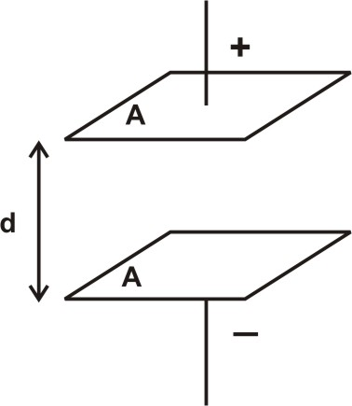
Suggest two adjustments that can be made so as to reduce the effective capacitance (2mks)
…………………………………………………………………………………………………………………………………………………………………………………………………………………………………………………………………………………………………………………………………………………………………………………………………………………………………………………………………………………………………………………………………………………………………………………………………………………………………………………………………………
- a) State two factors which determine the speed of photoelectrons emitted by a metal surface (2mks)
…………………………………………………………………………………………………………………………………………………………………………………………………………………………………………………………………………………………………………………………………………………………………………………………………………………………………………………………………………………………………………………………………………………………………………………………………………………………………………………………………………
- The figure below is a graph of the stopping potential, Vs, against frequency f in an experiment on photoelectric effect
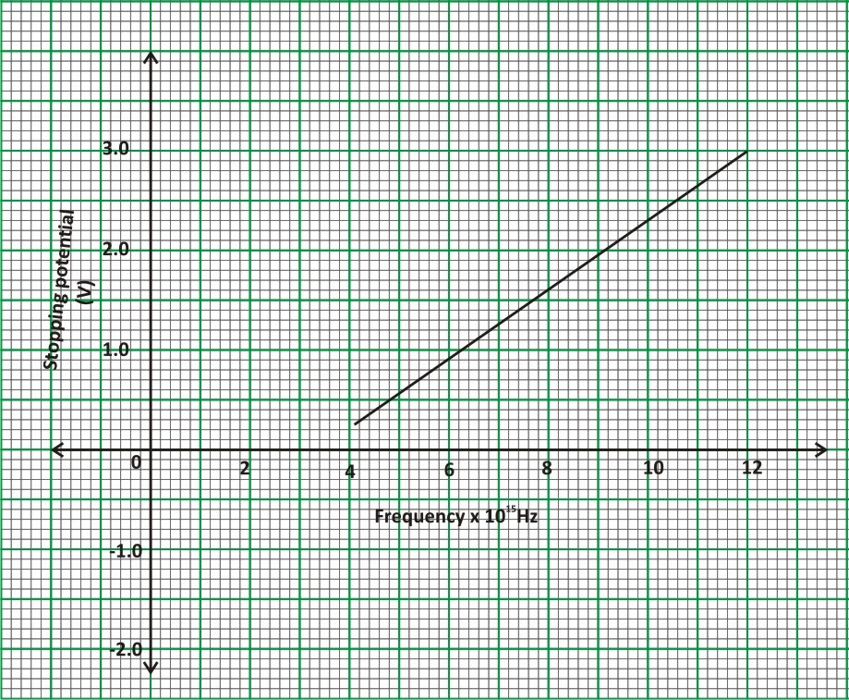
- What is meant by stopping potential (1mk)
……………………………………………………………………………………………………………………………………………………………………………………………………………………………………………………………………………………………………………………………………
- Given that the stopping potential, Vs is related to the frequency f, by the equation
where e is the charge of an electron
Determine from the graph
- Planks constant, h, (4mks)
………………………………………………………………………………………………………………………………………………………………………………………………………………………………………………………………………………………………………………………………………………………………………………………………………………………………………………………………………………………………………………………………………………………………………………………………………………………………………………………………………………………………………………………………………………………………………………………………………………………………………………………………………………………………………………………………………………………………………………………………………………………………………………………………………………………………………………………………………………………………………………………………………………………………………………………………………………………………………………………………………………………………………………………………………………………………………………………………………………………………………………………………………………………………………
- The work function, Wo for the metal in electron volts (eV) (3mks)
………………………………………………………………………………………………………………………………………………………………………………………………………………………………………………………………………………………………………………………………………………………………………………………………………………………………………………………………………………………………………………………………………………………………………………………………………………………………………………………………………………………………………………………………………………………………………………………………………………………………………………………………………………………………………………………………………………………………………………………………………………………………………………………………………………………………………………………………………………………………………………………………………………………………………………………………………………………………………………………………………………………………………………………………………………………………………………………………………………………………………………………………………………………………………

