Name…………………………………… …………………………..………… Index No:………………………….

231/1 Candidate’s Signature …………..……………
BIOLOGY Date: …………………………
Paper 1
(Theory)
March/April 2014
Time: 2 Hours

Kenya Certificate of Secondary Education (K.C.S.E.)

Biology
Paper 1
(Theory)

INSTRUCTIONS TO CANDIDATES

- Write your name and index number in the spaces provided above
- Sign and write the date of examination in the spaces provided.
- Answer all the questions in the spaces provided.

For Examiners Use Only
Question | Maximum score | Candidate’s score
1- 31 | 80

This paper consists of 7printed pages. Candidates should check to ascertain that all pages are printed as indicated and that no questions are missing.

1. State the functions of the following organelles
a) Lysosomes (1 Mark)
……………………………………………………………………………………………………….
……………………………………………………………………………………………………….
b) Golgi apparatus (1 Mark)
……………………………………………………………………………………………………….
……………………………………………………………………………………………………….
2. Distinguish between osmosis and active transport (2Marks)
……………………………………………………………………………………………………….
……………………………………………………………………………………………………….
3. Name two respiratory diseases in humans (2Marks)
……………………………………………………………………………………………………….
……………………………………………………………………………………………………….
4. a) State two main differences between a millipede and a centipede (2Marks)
……………………………………………………………………………………………………….
……………………………………………………………………………………………………….
b) Define the term species (1Mark)
……………………………………………………………………………………………………….
……………………………………………………………………………………………………….
5. State two benefits that a parasite derives from the host (2Marks)
……………………………………………………………………………………………………….
……………………………………………………………………………………………………….
6. State two physiological changes that take place in the human skin when bathed in cold water (2Marks)
……………………………………………………………………………………………………….
……………………………………………………………………………………………………….
7. Distinguish between aerobic and anaerobic respiration (2Marks)
……………………………………………………………………………………………………….
……………………………………………………………………………………………………….
8. a) What is single circulatory system (1Mark)
……………………………………………………………………………………………………….
……………………………………………………………………………………………………….
b) Name an organism which has single circulatory system (1Mark)
……………………………………………………………………………………………………….
……………………………………………………………………………………………………….
c) Name the openings to the chambers of the heart of an insect (1Mark)
……………………………………………………………………………………………………….
……………………………………………………………………………………………………….

9. The equation below represent a metabolic process that occurs in the mammalian liver
Enzymes
Amino acids organic compounds + urea

a) Name the process - (1Mark)
……………………………………………………………………………………………………….
……………………………………………………………………………………………………….
b) What is the importance of the process to the mamal (2 Marks)
……………………………………………………………………………………………………….
……………………………………………………………………………………………………….
10. State three adaptations of the proximal convoluted tubule to its functions (3 Marks)
……………………………………………………………………………………………………….
……………………………………………………………………………………………………….
……………………………………………………………………………………………………….
……………………………………………………………………………………………………….
11. Below is the general formula of an amino acid
COOH

R C NH₂

H

What do the following refer to
- COOH …………………………………………………………..

(b) NH₂ …………………………………………………………..

12. The figure bellow represent a transverse section of a young root
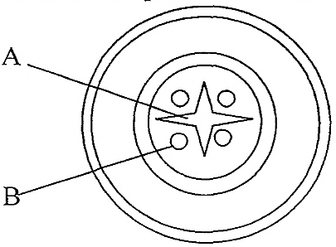

State the function of each of the parts labeled A and B (2 Marks)
……………………………………………………………………………………………………….
……………………………………………………………………………………………………….

13. State two roles of the secretions from sebaceous glands of the mammalian skin. (2 Marks)

……………………………………………………………………………………………………….
……………………………………………………………………………………………………….

14. State how the tracheole system of insects is adapted for gaseous exchange (3 Marks)
……………………………………………………………………………………………………….
……………………………………………………………………………………………………….
……………………………………………………………………………………………………….
……………………………………………………………………………………………………….

15. The diagram below represent a simple nitrogen cycle

Nitrogen in air
Nitrates
Animal
Ammonia
G
Nitrates
H
J
F
E

- Name the organisms that cause process E and J (2 Marks)
E………………………………………
J………………………………………
(b) Name the process represented by F and H (2 Marks)
F …………………………………………………………………………………
H …………………………………………………………………………………
16. State two effects of drug abuse (2 Marks)
……………………………………………………………………………………………………….
……………………………………………………………………………………………………….
17. Name the material that strengthens the following tissues (2 Marks)
a) Xylem ………………………………………………………………..……………
b) Collenchyma ………………………………………………………………………
18. State three adaptations of aquatic plants to photosynthesis (3 Marks)
……………………………………………………………………………………………………….
……………………………………………………………………………………………………….
……………………………………………………………………………………………………….
……………………………………………………………………………………………………….

19. i) State two functions of DNA molecule (2 Marks)
……………………………………………………………………………………………………….
……………………………………………………………………………………………………….
ii) What is DNA replication (1Mark)
……………………………………………………………………………………………………….
……………………………………………………………………………………………………….
iii) A DNA strand had the following base sequence
-T-A-C-G-C-T
What is the sequence of the M-RNA strand copied from this DNA portion (1 Mark)
……………………………………………………………………………………………………….
……………………………………………………………………………………………………….
20. The diagram bellow represent a stage in the development of a human foetus
P

Q

State the two functions of each of the structures labeled P and Q (4 Marks)
……………………………………………………………………………………………………….
……………………………………………………………………………………………………….
……………………………………………………………………………………………………….
……………………………………………………………………………………………………….
21. How is aerenchvma tissues adapted to its functions (2 Marks)
……………………………………………………………………………………………………….
……………………………………………………………………………………………………….

22. The diagram below shows a mature pollen grain
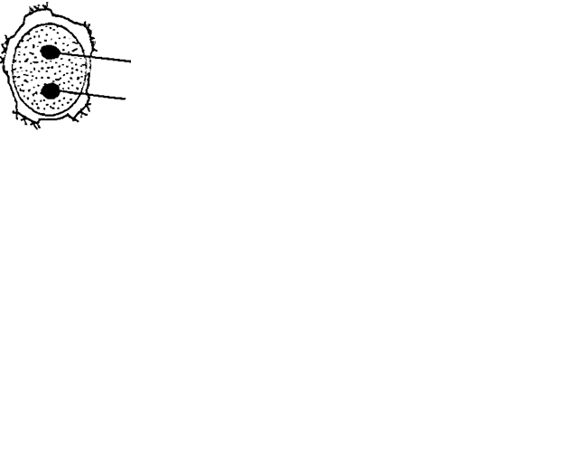

X

Y

State the function of the structures labeled X and Y (2 Marks)
X: ………………………………………
Y: ………………………………………
23. (a) What is homeostasis? (2 Marks)
……………………………………………………………………………………………………….
……………………………………………………………………………………………………….
(b) Name one process in the human body in which homeostasis is involved (1 Mark)
……………………………………………………………………………………………………….
……………………………………………………………………………………………………….
24. What is meant by the terms?
a) Epigenous flower (1 Mark)
……………………………………………………………………………………………………….
……………………………………………………………………………………………………….
b) Staminate flower (2 Marks)
……………………………………………………………………………………………………….
……………………………………………………………………………………………………….
25. (a) Name two groups of organisms that cause food spoilage. (2 Marks)
……………………………………………………………………………………………………….
……………………………………………………………………………………………………….
(b) Name two water –boron disease (2 Marks)
……………………………………………………………………………………………………….
……………………………………………………………………………………………………….
26. Name the deficiency disease caused by lack of the following mineral elements in a human diet
i) Iodine (1 Mark)
……………………………………………………………………………………………………….
……………………………………………………………………………………………………….
ii) Iron (1 Mark)
……………………………………………………………………………………………………….
……………………………………………………………………………………………………….
27. Name two types of chromosomal mutation (1Mark)
……………………………………………………………………………………………………….
……………………………………………………………………………………………………….
28. State three structural differences between arteries and veins (3 Marks)
……………………………………………………………………………………………………….
……………………………………………………………………………………………………….
……………………………………………………………………………………………………….
……………………………………………………………………………………………………….
29. State two Nutritional similarities between Askaris Lumbricoid and Rhizopus. (2 Marks)
……………………………………………………………………………………………………….
……………………………………………………………………………………………………….

30 (a) State two adaptation of the villus to tis function. (2 Marks)
……………………………………………………………………………………………………….
……………………………………………………………………………………………………….
- What is the end product of digestion of lipids. (1 Mark)
……………………………………………………………………………………………………….
……………………………………………………………………………………………………….
31. Name one example of the specialized cells in plants and one example in animals.
(i)Plants (1 Mark)
……………………………………………………………………………………………………….
……………………………………………………………………………………………………….
(ii) Animals (1 Mark)
……………………………………………………………………………………………………….
……………………………………………………………………………………………………….

