Name…………………………………… …………………………..………… Index No:………………………….

231/3 Candidate’s Signature …………..……………
BIOLOGY Date: …………………………
Paper 3
(Theory)
March/April 2014
Time: 2 Hours

Kenya Certificate of Secondary Education (K.C.S.E.)

Biology
Paper 3
(Theory)

INSTRUCTIONS TO CANDIDATES

- Write your name and index number in the spaces provided above
- Sign and write the date of examination in the spaces provided.
- Answer all the questions in the spaces provided.
- You are require dto spend the first 15 minutes of the 1 ¾ hours allowed for this paper reading the whole paper carefully before commencing your work.
- Additional pages must not be inserted.
- candidates must answer all questions in English

For Examiners Use Only
Question | Maximum score | Candidate’s score
1 | 11
2 | 16
3 | 13
Total | 40

This paper consists of 4 printed pages. Candidates should check to ascertain that all pages are printed as indicated and that no questions are missing.
1. You are provided with the following.
- 25 ml Bromothymol blue
- Solution X
- A drinking straw
- 2 test tubes
- 10 ml measuring cylinder
- A boiling tube
- Dilute hydrochloric acid
- Dilute sodium hydroxide
- Place 2ml of Bromothymol Blue (B.T.B) in a clean test tube. Add dilute hydrochloric acid drop
by drop and shake after each drop till there is a permanent colour change.
- State the resulting colour. (1mark)
……………………………………………………………………………………………..
- To the mixture obtained above, now add sodium hydroxide solution drop by drop
until there is a colour change. Record your observation. (1mark)
……………………………………………………………………………………………..
- From your observations in (a) (i) and (a) (ii) above what is the nature of Bromothymol blue
(1 mark)
……………………………………………………………………………………………..
- Place 10ml of fresh bromothymol blue in a boiling tube. Using the drinking straw, bubble air through the bromothlmol blue until there occur colour change.
- Record your observation (1mark)
……………………………………………………………………………………………..
- What does the colour obtained in (b) (i) above suggest about the nature of the gas breathed out? ( 1 mark)
……………………………………………………………………………………………..
- Rinse the measuring cylinder and use it to place 2ml of solution in a clean test tube. Rinse the drinking straw used in (b) above and use it to bubble air through solution X.
(i) Record your observation (1 mark)
……………………………………………………………………………………………..
(ii) Suggest the identity of solution X (1 mark)
……………………………………………………………………………………………..
- Suggest the identity of the gas that gave rise to the observation above. (1 mark)
……………………………………………………………………………………………..
……………………………………………………………………………………………..
(d) (i) Name the physiological process in cells that leads to formation of the gas named in C (iii)
above. (1 mark)
……………………………………………………………………………………………..
(ii) Write down a word equation for the process named in d (1) above. (2 marks)
……………………………………………………………………………………………..
……………………………………………………………………………………………..
2. You are provided with two specimens labeled R₁ and R₂The specimens were soaked overnight.
Examine them.
- With reasons, state the parts of a plant represented by the two specimens
R₁………………………………………………………………………………………... (1 mark)
Reasons …………………………………………………………………………………. (1 mark)
R₂………………………………………………………………………………..…….... (1 mark)
Reasons …………………………………………………………………………………. (1 mark)

- Carefully open specimen R1 from the dorsal side using a razer blade to expose the internal structures. Leave the two halves joined at one point. Observe the inner structures carefully using a hand lens. Draw and label the parts. (3marks)

State the magnification of your drawing. (1 mark)
……………………..…………………………………………………………………………..

- Flood the inner surfaces of the two halves with iodine solution. Record your observation. (1 mark)
…………………………………………………………………………………………………..
- Hold R₂ with the narrow side facing you. Make a longitudinal section through it into halves.
Add two drops of iodine solution onto the cut surfaces of the two halves. Examine using a hand
Lens. Draw and label the parts (3 marks)

State the magnification of your drawing. ( 1mark)
…………………………………..…………………………………………………………………..
- On the diagram, shade the parts that are stained blue –black.
- Identify three observable differences between R₁ and R₂ ( 3marks)
R1 | R2

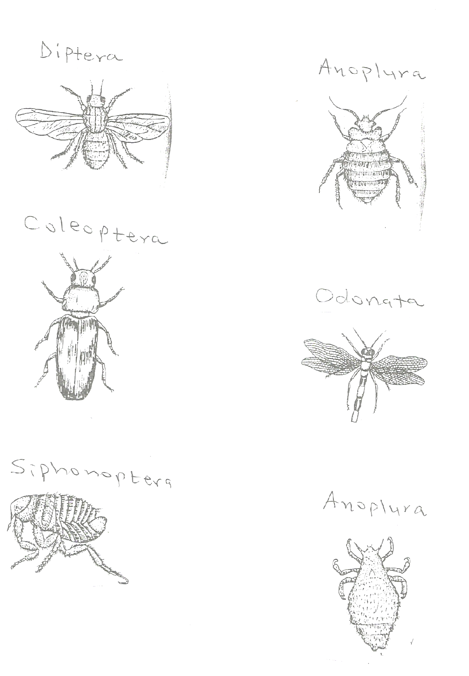
3. Below are drawings of some organisms belonging to the same phylum.Examine them carefully.
Anoplura
Siphonoptera
Odonata
Diptera
Coleoptera
Anoplura

(a) (i) Name the phylum to which the organisms represented by the drawings belong. (1 mark)
…………….………………………………………………………………………………………..
(ii) Give two reasons for answer in (a) (i) above (2 marks)
…………….………………………………………………………………………………………..
…………….………………………………………………………………………………………..

(b) Using the features in the order given below, construct a dichotomous key that can be used to identify
the specimens. (10 marks)
- Presence or absence of wings
- Shape of the body
- Length of antennae
- Type of wings
- Number of wings
…………….………………………………………………………………………………………..
…………….………………………………………………………………………………………..
…………….………………………………………………………………………………………..
…………….………………………………………………………………………………………..
…………….………………………………………………………………………………………..
…………….………………………………………………………………………………………..
…………….………………………………………………………………………………………..
…………….………………………………………………………………………………………..
…………….………………………………………………………………………………………..
…………….………………………………………………………………………………………..
…………….………………………………………………………………………………………..

