NAME: ………………………………………………………………… INDEX NO: ……………………
CANDIDATE’S SIGN………………………………………………. DATE: ……………………..…
SCHOOL……………………………………………………………..

231/1
BIOLOGY
PAPER 1
JULY/AUGUST 2014
TIME: 2 HOURS

Kenya Certificate of Secondary Education (K.C.S.E)
Biology
Paper 1

INSTRUCTIONS TO CANDIDATES:
- This paper consists of twenty nine (29)Questions
- Write your name and Index Number and School in the spaces provided above.
- Answer all the questions
- All answers must be written in the spaces provided in this booklet.
- Sign and write the date of examination in the spaces provided above.
- Additional pages must not be inserted

EXAMINER’S USE ONLY
Question | Maximum score | Candidates score
1-29 | 80

This paper consists of 7 printed pages. Candidates should check to ascertain that all papers are printed as indicated and that no questions are missing

1. Name one factor in nature that increases the process of evolution. (1mk)
…………………………………………………………………………………………………………..
2. What is meant by the term “oxygen debt”? (2mks)
…………………………………………………………………………………………………………
…………………………………………………………………………………………………………
3. Differentiate between characteristics of members of Monera and those of Protoctista. (2mks)
…………………………………………………………………………………………………………..
…………………………………………………………………………………………………………..
4. Study the structure drawn below and answer the question that follows.
A
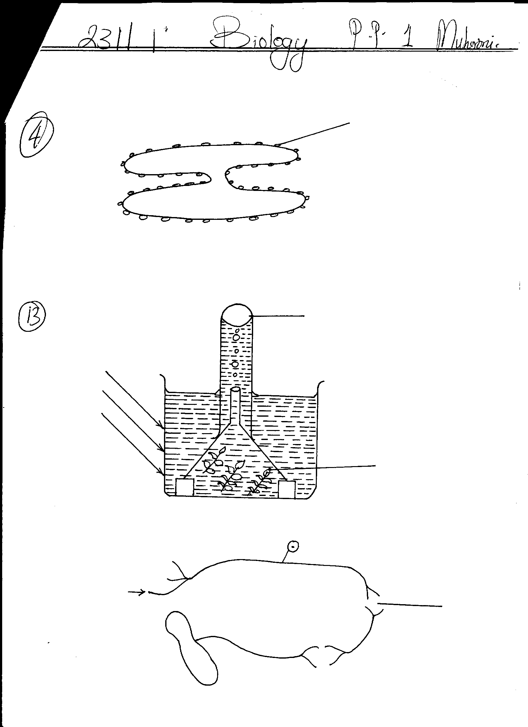

(a) Name the organelle drawn above. (1mk)
………………………………………………………………………………………………………….
(b) State the function of the structure labelled A. (1mk)
…………………………………………………………………………………………………………..
…………………………………………………………………………………………………………..
5. In an experiment, the pituitary gland of a rat was removed.
(a) State the effect that will have on the quality of urine produced by the rat. (1mk)
…………………………………………………………………………………………………………..
…………………………………………………………………………………………………………..
(b) Give a reason for your answer in (a) above. (2mks)
……………………………………………………………………………………………………….…………………………………………………………………………………………………………….
6. State the function of the diaphragm in the microscope. (1mk)
…………………………………………………………………………………………………………..
7. The lungs and ileum are adapted for absorption. State three features they have in common which facilitates absorption. (3mks)
………………………………………………………………………………………………………….
………………………………………………………………………………………………………....
…………………………………………………………………………………………………………

8. Explain why food is stored in an insoluble form in the cells of living organisms. (1mk)
…………………………………………………………………………………………………………
9. (a) State the importance of the following features in gaseous exchange : (1mk)
…………………………………………………………………………………………………………..
(i) Cartilages in gaseous exchange. (1mk)
…………………………………………………………………………………………………………..
(ii) Moisture on the surface of alveoli. (1mk)
…………………………………………………………………………………………………………..
(b) Name the site where gaseous exchange takes place in terrestrial plants. (2mks)
…………………………………………………………………………………………………………..
…………………………………………………………………………………………………………..
10. (a) Explain how the following adaptations minimize the rate of transpiration :
(i) Sunken stomata (1mk)
…………………………………………………………………………………………………………..
………………………………………………………………………………………………………….
(ii) Leaf drooping (1mk)
…………………………………………………………………………………………………………..
………………………………………………………………………………………………………….
(b) State two environmental factors that influence the rate of transpiration. (2mks)
…………………………………………………………………………………………………………………………………………………………………………………………………………………….
11. State the role of decomposition in an ecosystem. (2mks)
…………………………………………………………………………………………………………………………………………………………………………………………………………………….
12. An animal was found to have a large glomeruli and short loop of henles.
Account for the presence of:
- Large glomeruli. (1mk)
…………………………………………………………………………………………………………..
- Short loop of henle. (1mk)
………………………………………………………………………………………………………….
- State the possible habitat for the organism. (1mk)
…………………………………………………………………………………………………………..

13. The diagram below represents a set-up that was used to investigate a certain process in a plant.
Sunlight
Gas
Elodea
Test tube

(a) What was the aim of the experiment? (1mk)
…………………………………………………………………………………………………………..
(b) Name the gas collected in the gas jar. (1mk)
………………………………………………………………………………………………………….
(c) What is the confirmation test for the gas in (b) above? (1mk)
…………………………………………………………………………………………………………..
(d) State two factors that would affect the process. (2mks)
……………………………………………………………………………………………………………………………………………………………………………………………………………………
14. Name the region in plants where the following take place: (2mks)
(i) Primary growth.
………………………………………………………………………………………………………….
(ii) Secondary growth .
…………………………….……………………………………………………………………………
15. (a) Explain why pepsin in stomach of man is secreted in inactive form. (1mk)
…………………………………………………………………………………………………………..
(b) Which gland secretes pepsinogen. (1mk)
………………………………………………………………………………………………………….
16. The figure below illustrate a portion of chromosome with genes A, B, C, D, E and F

A | B | C | D | E | F

Using diagram similar to the one above, illustrate the changes that the above chromosome would undergo if the following mutation occurred on gene C and D
- Deletion (1mk)
………………………………………………………………………………………………………….

- Inversion (1mk)
…………………………………………………………………………………………………………..
- Duplication (1mk)
…………………………………………………………………………………………………………..
State two ways in which genetic engineering is applied in the field of medicine. (2mks)
…………………………………………………………………………………………………………..
…………………………………………………………………………………………………………..

17. The diagram below represents a reflex arc in human beings

P
Q
R

(a) Name the parts labelled Q and R (2mks)
Q
..................................................................................................................................................................
R
.................................................................................................................................................................
(b) What is the function of the part labelled P? (1mk)
…………………………………………………………………………………………………………..
18. State two features of petals that enhances insect pollination. (2mks)
……………………………………………………………………………………………………………………………………………………………………………………………………………………
19. Give two adaptations of halophytes to survival in their habitats. (2mks)
……………………………………………………………………………………………………………………………………………………………………………………………………………………

20. State two functions of chloroplasts. (2mks)
……………………………………………………………………………………………………………………………………………………………………………………………………………………
21. (a) State two functions of an ovary in human female. (2mks)
………………………………………………………………………………………………………….. …………………………………………………………………………………………………………..
(b) State two advantages of internal fertilization in mammals. (2mks)
…………………………………………………………………………………………………………
………………………………………………………………………………………………………..

22. (a) State the part of the eye involved in : (3mks)
- Colour vision.
…………………………………………………………………………………………………………
- Maintaining the shape of the eyeball.
…………………………………………………………………………………………………………
- Change in diameter of the lens.
………………………………………………………………………………………………………..
(b) A person was not able to see far objects clearly but could view near objects clearly. Name the eye defect the person had. (1mk)
…………………………………………………………………………………………………………..
(c) How could the defect in 22(b) above be corrected? (1mk)
…………………………………………………………………………………………………………..
23. State three differences between Osmosis and Active transport. (3mks)
Osmosis | Active transport
1.
2.
3.

24. Explain why cells of an endosperm are triploid and not diploid. (3mks)
………………………………………………………………………………………………………………………………………………………………………………………………………………………………………………………………………………………………………………………………
25. State the functions of the following hormones:
(i) Luteinising hormone. (1mk)
…………………………………………………………………………………………………………
(ii) Oxytocin. (1mk)
………………………………………………………………………………………………………….

(iii) Progesterone. (1mk)
…………………………………………………………………………………………………………..
26. A response exhibited by a certain plant tendril is illustrated below:-
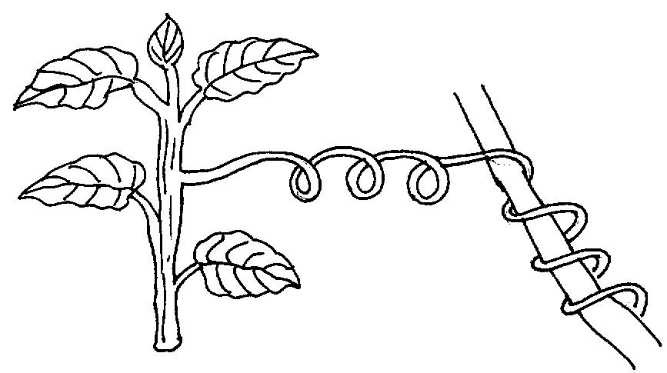

- Name the type of response. (1mk)
…………………………………………………………………………………………………………..
- Explain how the response named in (i)above occurs . (3mks)
…………………………………………………………………………………………………………..
27. An organelle was magnified 800 times by an electron microscope. Its diameter was 2 millimeters. Calculate the actual diameter in micrometers. (2mks)
…………………………………………………………………………………………………………..
………………………………………………………………………………………………………….
28. Name the antigens that determine human blood group. (1mk)
…………………………………………………………………………………………………………..
29. The scientific name for a domestic cat is felis Catus. Outline the rule that were never followed in writing the name. (3mks)
………………………………………………………………………………………………………………………………………………………………………………………………………………………………………………………………………………………………………………………………

