NAME: ………………………………………………………………… INDEX NO: ……………………
CANDIDATE’S SIGN………………………………………………. DATE: ……………………..…
SCHOOL……………………………………………………………..

231/2
BIOLOGY
PAPER 2
JULY/AUGUST 2014
TIME: 2 HOURS

Kenya Certificate of Secondary Education (K.C.S.E)
BIOLOGY
Paper 2

INSTRUCTIONS TO THE CANDIDATES
- Write your name and index number in the spaces provided above.
- Sign and write the date of examination in the spaces provided above.
- This paper consists of two sections; A and B.
- Answer all the questions in Section A in the spaces provided.
- In section B, answer question 6(compulsory) and either question 7 or 8 in the spaces provided after question 8.

For Examiner’s Use Only:-

SECTION | QUESTION | MAXIMUM SCORE | CANDIDATES SCORE
A | 1  2  3  4  5 | 8  8  8  8  8
B | 6  7  8 | 20  20  20
TOTAL SCORE |  | 80

This paper consists of 8 printed pages. Candidates should check to ascertain that all pages are printed as indicated and that no questions are missing.
1. (a) A couple with normal skin pigmentation had three children, but their second born was an albino.
(i) Using letter A to represent the gene for normal skin colour, work out the genotypes of the children. (4mks)
…………………………………………………………………………………………………………………………………………………………………………………………………………………………………………………………………………………………………………………………………………………………………………………………………………………………………………
(ii) What are the chances that their fourth born child being an albino? (1mk)
………………………………………………………………………………………………………….
(iii) Other than albinism, state three disorders in humans caused by gene mutation. (3mks)
…………………………………………………………………………………………………………………
…………………………………………………………………………………………………………………
…………………………………………………………………………………………………………………
2. A set up used to investigate a certain process in plants is shown in the diagram below. Use it to answer questions that follow.
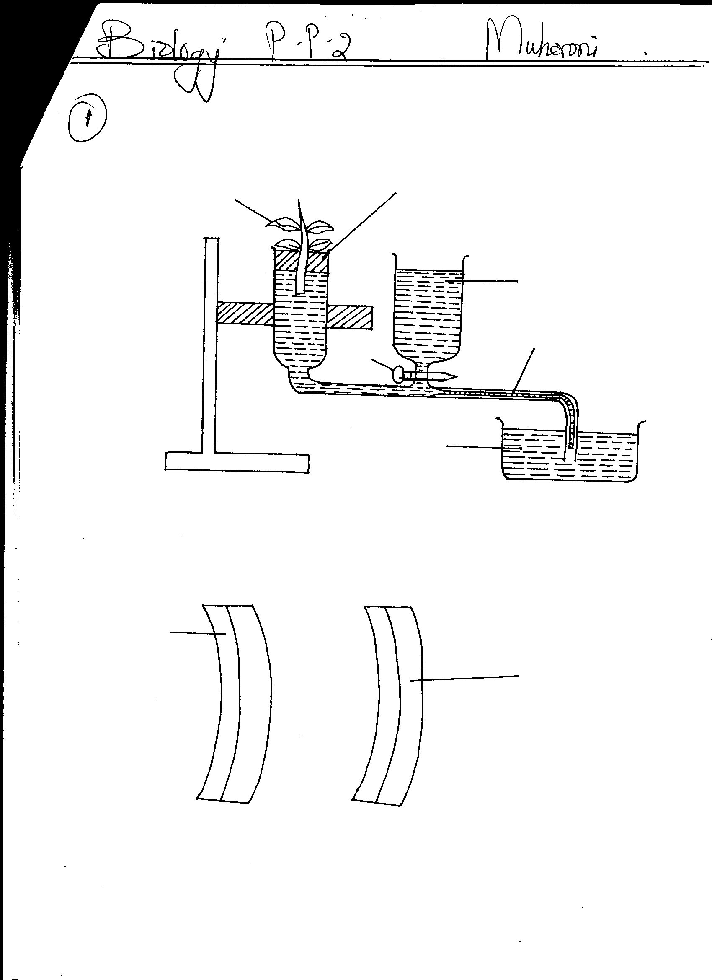
Leaf shoot
Rubber bung
Capillary tubing
Tap
Reservior
Water

- What was the aim of the experiment? (1mk)
………………………………………………………………………………………………………….
- Giving reasons, state two precautions that should be taken when setting up the experiment. (2mks)
………………………………………………………………………………………………………….
………………………………………………………………………………………………………….
- State three environmental factors that affect the process under investigation. (3mks)
………………………………………………………………………………………………………….………………………………………………………………………………………………………….………………………………………………………………………………………………………….
- State two forms by which carbon(IV) oxide is transported in plasma and in red blood cells.
(2mks)
……………………………………………………………………………………………………….…………………………………………………………………………………………………………….
3. A 4cm straight piece of stem from a herbaceous plant was split lengthwise into two similar pieces. The pieces were placed in sugar solutions of different concentrations for 30 minutes. Their appearance after 30 minutes is as shown below:
Epidermis
Epidermis

A
B

- Which biological process is being investigated? (1mk)
…………………………………………………………………………………………………………..
- Account for the appearance of the pieces in solutions: (2mks)
A ………………………………………………………………………………………………..
B………………………………………......................................................................................
- State two functions of the large intestines in humans. (2mks)
……………………………………………………………………………………………………….…………………………………………………………………………………………………………….
- Name the part of the cell that is useful in maintaining support in the herbaceous plants.(1mk)
…………………………………………………………………………………………………………

4. After an ecological study on feeding relationships, students constructed the food web below. Use it to answer questions that follow:
Algae
Mussels
Zooplanktons
Bird L
Green plants
Small fish
Bird J
Bird K
Large birds
Bird M
Bird N
Snail
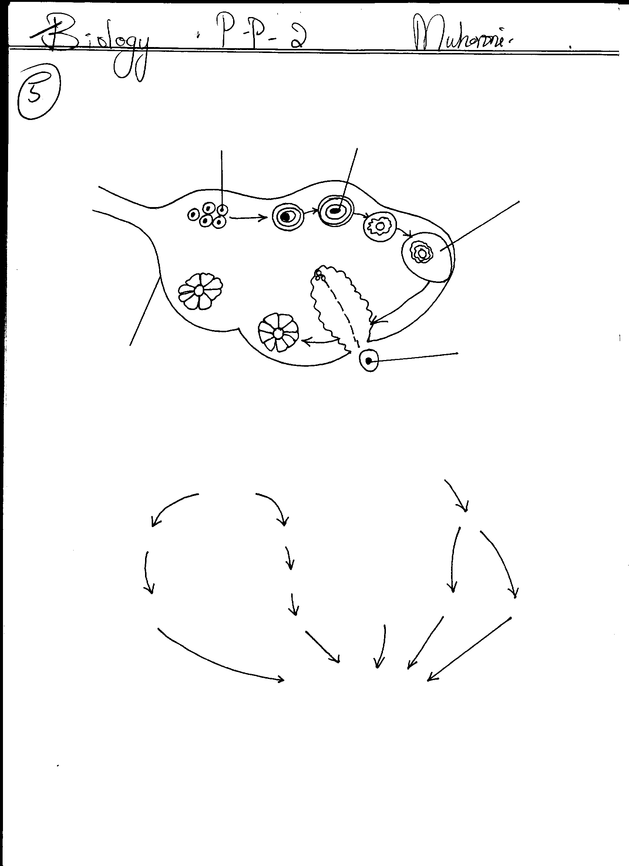

- Name the process through which energy from the sun is incorporated into the food web. (1mk)
…………………………………………………………………………………………………………..
- State the mode of feeding of the birds in the food web. (1mk)
…………………………………………………………………………………………………………..
- Name two ecosystems in which the organisms in the food web live. (2mks)
…………………………………………………………………………………………………………..…………………………………………………………………………………………………………..
- From the information in the food web, construct a food chain with the large birds as quaternary consumers. (1mk)
…………………………………………………………………………………………………………..
- What would happen to the organisms in the food web if bird N migrated? (1mk)
…………………………………………………………………………………………………………..
- Not all energy from one trophic level is available to the next level. Explain. (1mk)
………………………………………………………………………………………………………….
- State one human activity that would affect the ecosystem represented by the food web above. (1mk)
…………………………………………………………………………………………………………..
5. The diagram below shows a section through the human ovary. Study it and answer the questions that follow.
Primary follicle
A
Graafian follicle
Germinal epithelium
B
C

- Name part labelled A (1mk)
………………………………………………………………………………………………
(b) (i) Which part of the ovary divides to form the primary follicle? (1mk)
………………………………………………………………………………………………………….
(ii) Which type of cell division is responsible for the production of primary follicles? (1mk)
…………………………………………………………………………………………………………..………………………………………………………………………………………………………….
(c) Follicle stimulating hormone reaches the ovary so that part A begins to mature.
(i) Name the first hormone, which is secreted by the ovary as a result of arrival of FSH. (1mk)
…………………………………………………………………………………………………………
(ii) What is the role of this hormone in the menstrual cycle? (1mk)
…………………………………………………………………………………………………………
(d) Structure B leaves the ovary.
(i) Where does structure B enter immediately after leaving the ovary? (1mk)
…………………………………………………………………………………………………………..
(ii) Which hormone level peaks just before structure B leaves the ovary? (1mk)
………………………………………………………………………………………………………….
- State the role of structure C. (1mk)
………………………………………………………………………………………………………….
SECTION B (40MARKS)
Answer question 6 (compulsory) and any other one question in the spaces provided after question 8.
6. An experiment was carried out to investigate the effect of temperature on the rate of reaction catalyzed by salivary amylase. The pH was maintained slightly alkaline. The results are shown in the table below:
Temperature (ºC) | Rate of reaction(Arbitrary units)
5 | 0.3
10 | 0.5
20 | 1.25
25 | 2.0
30 | 3.5
35 | 4.8
38 | 4.8
45 | 2.5
50 | 0.8
- On the grid, draw a graph of rate of reaction against temperature (6mks)

- What is the optimum temperature of this enzyme? (1mk)
…………………………………………………………………………………………………………..
- At what temperature was the rate of reaction1.4? (1mk)
………………………………………………………………………………………………………...
- Account for the shape of the graph between:
(i) 5⁰C and 35⁰C (2mks)
………………………………………………………………………………………………………….
………………………………………………………………………………………………………….

(ii) 38⁰C and 50^{o0}C (3mks)
…………………………………………………………………………………………………………..
…………………………………………………………………………………………………………..
…………………………………………………………………………………………………………..

- How is the hydrochloric acid from the stomach neutralized and where does this occur?
(2mks)
……………………………………………………………………………………………………………………………………………………………………………………………………………………
- Name one digestive enzyme in humans that works best in acidic conditions. (1mk)
…………………………………………………………………………………………………………..
- State factors that causes enzymes denaturation. (2mks)
……………………………………………………………………………………………………………………………………………………………………………………………………………………
- Name two factors that determine the amount of energy a human being requires in a day.
(2mks)
……………………………………………………………………………… …………………………
…………………………………………………………………………………………………………..
7. Discuss evidences of organic evolution. (20mks)
8. (a) Explain each of the following biological phenomena:-
(i) The root of a horizontally placed seedling usually curves downwards. (3mks)
(ii) The shoot of a horizontally placed seedling curves upwards. (3mks)
(b) A student sitting under a shade of a tree on a hot sunny day shifted her eyes from the shade to the sunlit jet in the sky and then looked back at a page on her book. Describe the changes that occurred in her eyes. (14mks)
…………………………………………………………………………………………………………………
…………………………………………………………………………………………………………………
…………………………………………………………………………………………………………………
…………………………………………………………………………………………………………………
…………………………………………………………………………………………………………………
…………………………………………………………………………………………………………………
…………………………………………………………………………………………………………………
…………………………………………………………………………………………………………………
…………………………………………………………………………………………………………………
…………………………………………………………………………………………………………………
…………………………………………………………………………………………………………………
…………………………………………………………………………………………………………………
…………………………………………………………………………………………………………………
…………………………………………………………………………………………………………………
…………………………………………………………………………………………………………………
…………………………………………………………………………………………………………………
…………………………………………………………………………………………………………………
…………………………………………………………………………………………………………………
…………………………………………………………………………………………………………………
…………………………………………………………………………………………………………………
…………………………………………………………………………………………………………………
…………………………………………………………………………………………………………………
…………………………………………………………………………………………………………………
…………………………………………………………………………………………………………………
…………………………………………………………………………………………………………………
…………………………………………………………………………………………………………………
…………………………………………………………………………………………………………………
…………………………………………………………………………………………………………………
…………………………………………………………………………………………………………………
…………………………………………………………………………………………………………………
…………………………………………………………………………………………………………………
…………………………………………………………………………………………………………………
…………………………………………………………………………………………………………………
…………………………………………………………………………………………………………………
…………………………………………………………………………………………………………………
…………………………………………………………………………………………………………………
…………………………………………………………………………………………………………………
…………………………………………………………………………………………………………………
…………………………………………………………………………………………………………………
…………………………………………………………………………………………………………………
…………………………………………………………………………………………………………………
…………………………………………………………………………………………………………………

