Name:………………………………………………. Index no …………….. Candidate’s sign ……………………....
Date: ………………………………………………

231/1

CHEMISTRY

Paper 1

July/August 2014

Time: 2 Hours

Kenya Certificate of Secondary Education (K.C.S.E.)

CHEMISTRY

Paper 1

July/August 2013

Time: 2 Hours

INSTRUCTIONS TO CANDIDATES:
- Write you name and index number in the spaces provided above.
- Sign and write the date of examination..
- Answer All the questions in the spaces provided in the question paper.
- Mathematical tables and silent electronic calculators may be used
- All working MUST be clearly shown where necessary.

For Examiner’s Use Only
Question | Maximum score | Candidate’s score
1-28 | 80

This paper consists of 9 printed pages. Candidates should check to ascertain that all pages are printed as indicated and that no questions are missing

- Diamond and graphite are allotropes of carbon.
- What are allotropes? (1mk)
………………………………………………………………………………………………………………………………………………………………………………………………
- In terms of structure and bonding explain why diamond is used in drilling through hard rocks while graphite is a lubricant (2mks)
……………………………………………………………………………………………..
……………………………………………………………………………………………..
………………………………………………………………………………………………
- Differentiate between fractional crystallization and fractional distillation. (2mks)
………………………………………………………………………………………………………………………………………………………………………………………………
………………………………………………………………………………………………
- Study the flow chart below and answer the questions that follow:

Solution K
NaOH_{(aq)}
Drop wise
White precipitate L
Colourless Solution M
Step (i)
Excess
NaOH _{(aq)}
White precipitate L
White precipitate
Step III excess NH₃ _{(aq)}
Step II HCl _{(aq)}

- Identify
- The cation present in solution K (1mk)
…………………………………………………………………………………………
…………………………………………………………………………………………
- The white precipitate L (1mk)
…………………………………………………………………………………………
…………………………………………………………………………………………

- Write down the fomula of the complex ion present in the colourless solution M 1mk)
…………………………………………………………………………………………………………………………………………………………………………………….
- (a) State Graham’s law (1mk)
………………………………………………………………………………………………
………………………………………………………………………………………………
(b) 60cm³ of oxygen diffused through a porous plate in 20 seconds . How long will it take 120cm³ of carbon (iv) oxide gas to diffuse through the same plate under the same conditions? (C=12 , O=16) (2mks)
………………………………………………………………………………………………………………………………………………………………………………………………………………………………………………………………………………………………………………………………………………………………………………………………
- Describe how a dry sample of Barium Sulphate can be prepared starting with Barium Carbonate (3mks)
……………………………………………………………………………………………………………………………………………………………………………………………………………………………………………………………………………………………………………………………………………………………………………………………………………………………………………………………………………………………..
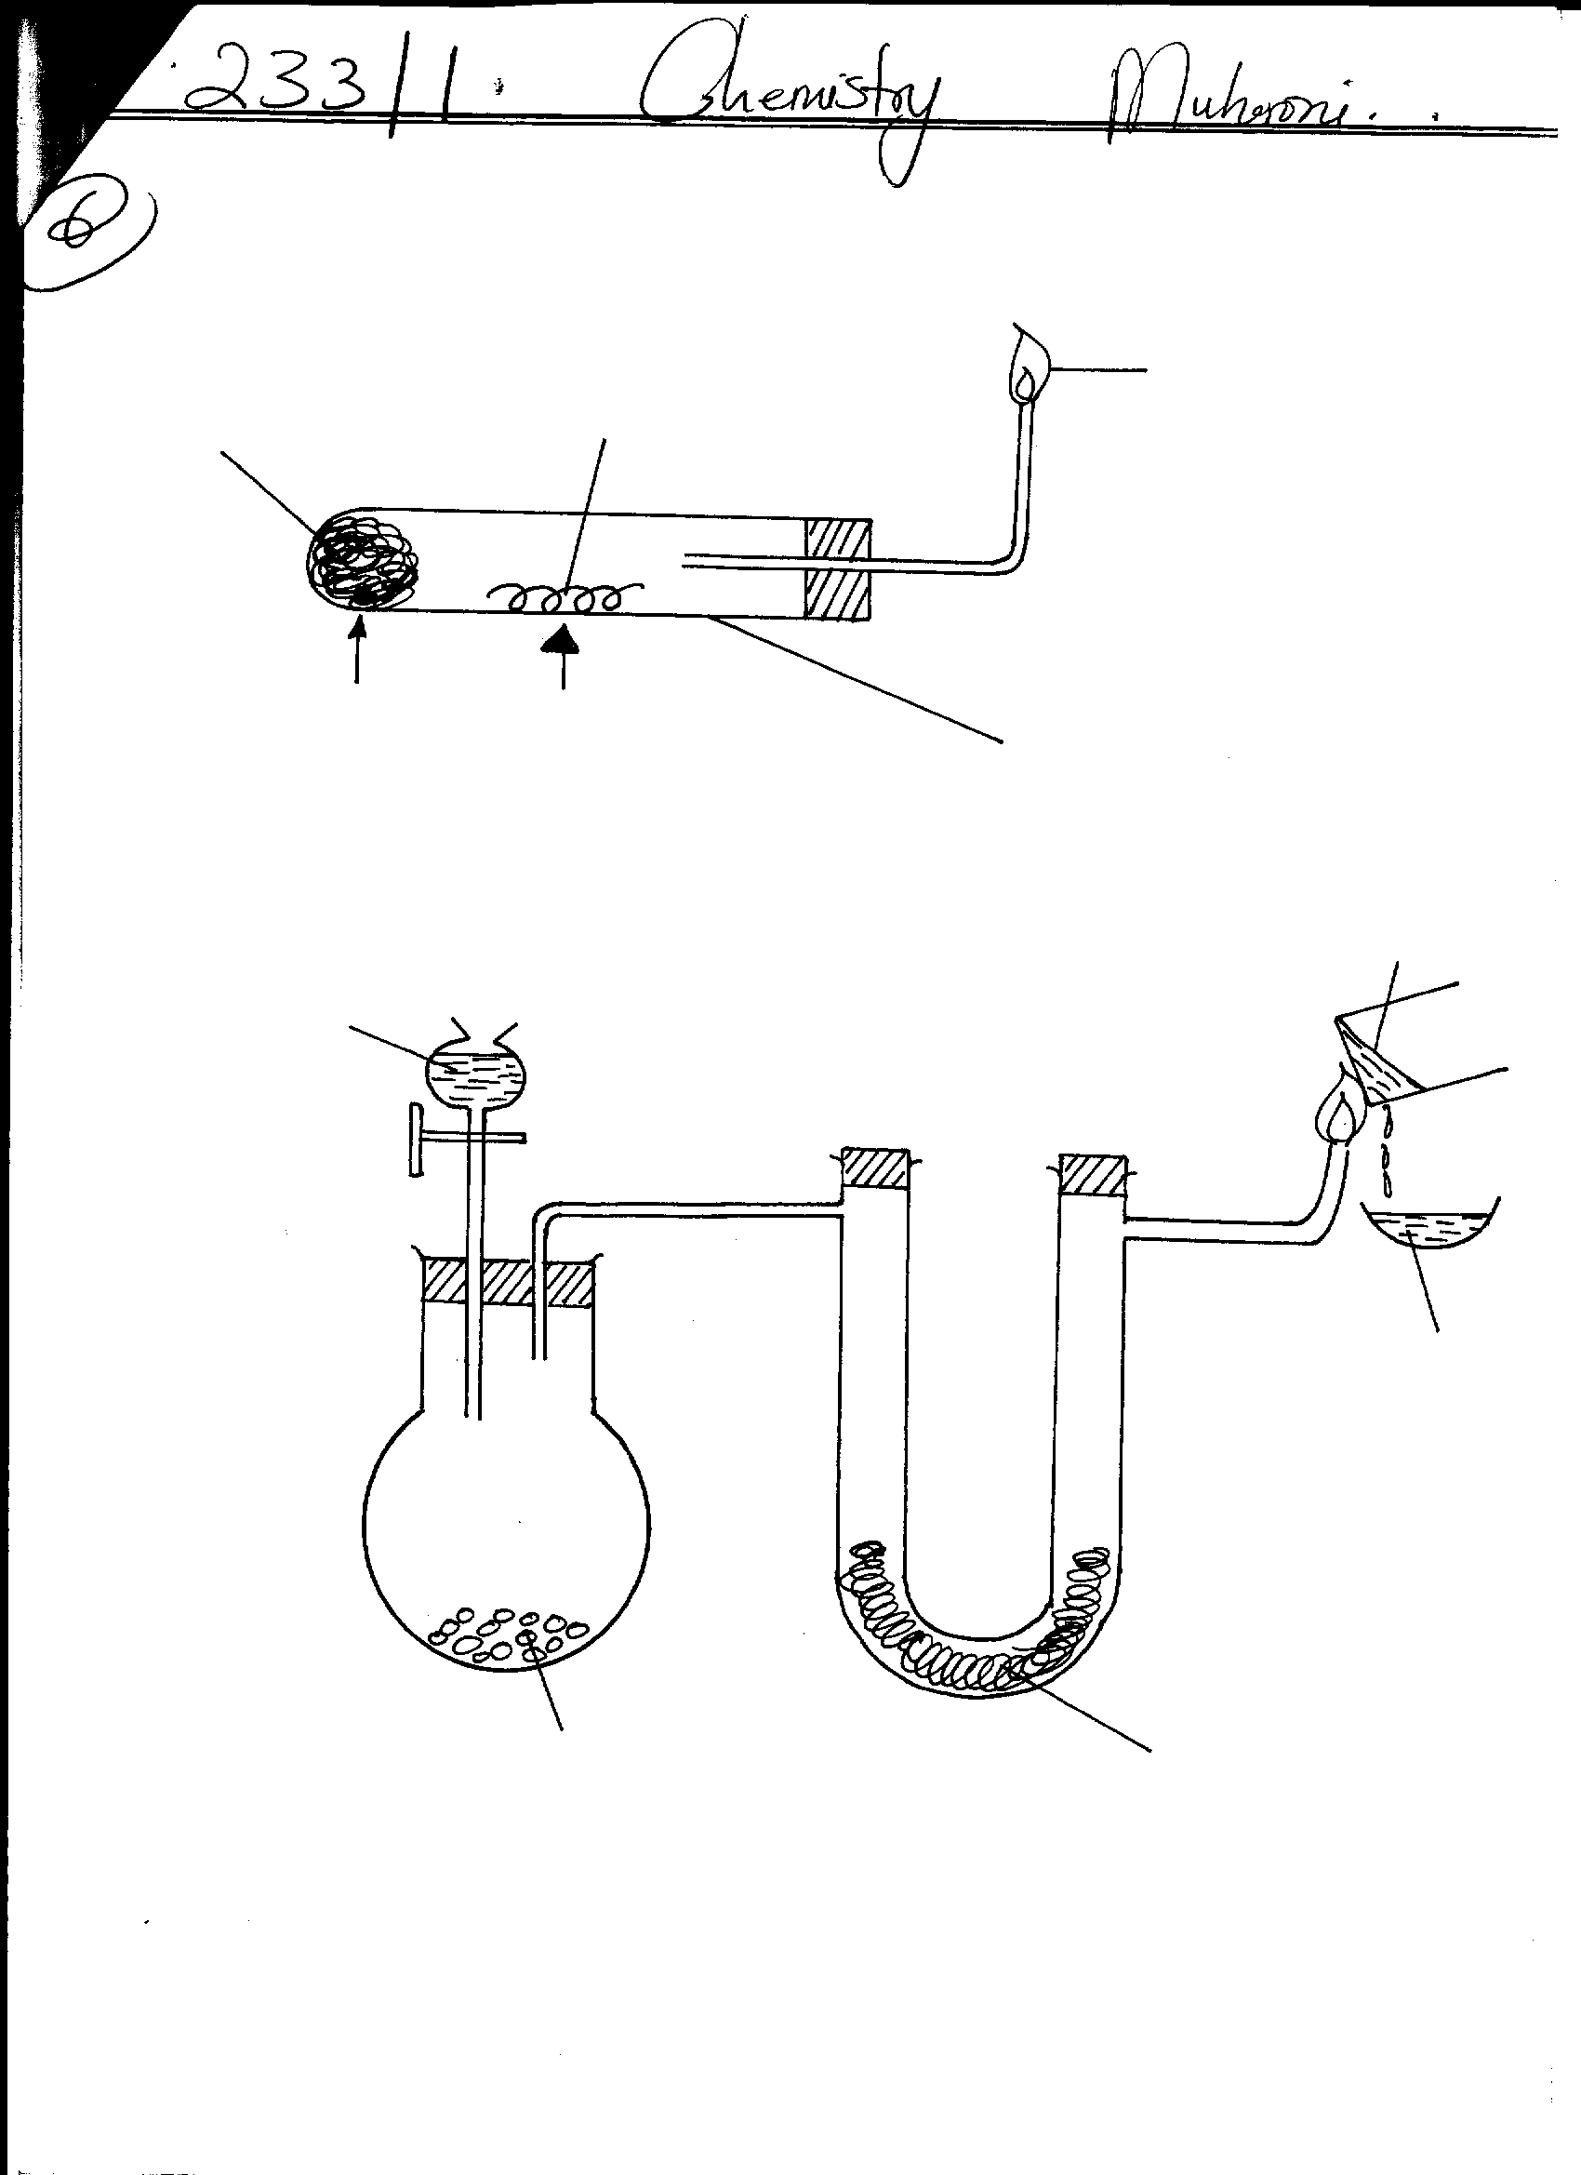
- Study the diagram below and answer the questions that follow.
Boiling tube
Heat
Magnesium
Blue flame
Cotton wool soaked in water
Heat

- State the observations that would be made when heat is applied. (1mk)
………………………………………………………………………………………………
………………………………………………………………………………………………
- Write chemical equations for the reactions taking place in :
- The boiling tube (1mk)
……………………………………………………………………………………………………………………………………………………………………
- The blue flame (1mk)
……………………………………………………………………………………………………………………………………………………………………
- (a) Give Bronsted and Lowry definition of an acid (1mk)
……………………………………………………………………………………………
…………………………………………………………………………………………….
- Differentiate between a strong acid and a concentrated acid (2mks)
………………………………………………………………………………………………
………………………………………………………………………………………………
……………………………………………………………………………………………....
- Study the flow chart below.
Rock salt
Conc
H₂SO_{4 (aq)}
Gas A
White precipitate
AgNO₃ _{(aq)}

- Identify
- Gas A (1mk)
………………………………………………………………………………………
- The white precipitate (1mk)
………………………………………………………………………………………

- Write an ionic equation for the formation of the white precipitate (1mk)

- In the production of Nitrogen (ii)oxide, Nitrogen and oxygen react according to the following equation.
N₂ _{(g)} + O₂ _{(g)} 2NO_{(g)} . ΔH = +180KJmol ⁻¹
Explain how the following would affect the yield of nitrogen (ii) oxide.
- Increase in pressure ( 1 ½ mks)
……………………………………………………………………………………………
……………………………………………………………………………………………
- Increase in temperature ( 1 ½ mks)
……………………………………………………………………………………………
……………………………………………………………………………………………
- The following table shows the P^{H} values of solutions A B and C
Solution | A | B | C
PH | 2 | 7 | 11

- Which solution is likely to be magnesium chloride. Give a reason. (1mk)
……………………………………………………………………………………………..
- Identify the solution in which a sample of aluminium chloride is likely to dissolve. Explain (2mks)
………………………………………………………………………………………………
………………………………………………………………………………………………
- The electronic configuration of ions x³⁺ and Y²⁻ are 2,8 and 2,8 respectively.
- State the atomic numbers of each of the elements x and y (1mk)
X……………………………………………………………………………………..
Y……………………………………………………………………………………..
- Write the formula of the compound formed when X and Y react. (1mk)
…………………………………………………………………………………………………………………………………………………………………………………….
- What type of bond would be formed in the compound named in (b) above? (1mk)
……………………………………………………………………………………………………………………………………………………………………………………..

- In an experiment a stream of dry hydrogen gas was passed over heated oxide of lead and the following results were obtained.
Mass of porcelain boat = 10.2g
Mass of porcelain boat + lead oxide = 17.37g
Final mass of porcelain boat + Lead = 16.41g
Determine the formula of the oxide of lead (pb = 207, O = 16) (3mks)
………………………………………………………………………………………………
………………………………………………………………………………………………
………………………………………………………………………………………………
………………………………………………………………………………………………
………………………………………………………………………………………………
- Study the reaction scheme below.
Alkanol R
Ethene
Ethene
Compound S
HCl _{(g)}
Process T
conc H₂SO₄ (l)

- Write the formula of.
(I) alkanol R ……………………………………………………………….. (1mk)
………………………………………………………………………………………
………………………………………………………………………………………
(II) Compound S ……………………………………………………………(1mk)
………………………………………………………………………………………
………………………………………………………………………………………
- Name process T ………………………………………………………….. (1mk)
………………………………………………………………………………………
………………………………………………………………………………………
- The following two tests were carried out on chlorine water contained in two test tubes.
- A piece of blue flower was dropped into the first test tube. Explain why the flower was bleached (2mks)
……………………………………………………………………………………………..
………………………………………………………………………………………………………………………………………………………………………………………………
- The second test tube was corked and it was found to contain a gas that rekindles a glowing splint.
Write an equation for the reaction which produced the gas. (1mk)
…………………………………………………………………………………………. …………………………………………………………………………………………..
- State and explain how the rate of reaction between Zinc granules and steam can be increased. (2mks)
………………………………………………………………………………………………
………………………………………………………………………………………………
- An element Q with atomic number 31 has two isotopes as shown below
Mass | % abundance
69 | 60.4
71 | 39.6

(\a) Determine the number of neutrons in the isotope with mass 71. (1mk)
………………………………………………………………………………………….
…………………………………………………………………………………………
(b) Calculate the relative atomic mass of element Q (2mks)
…………………………………………………………………………………………..
………………………………………………………………………………………….
…………………………………………………………………………………………..
…………………………………………………………………………………………..

- Study the set up below.
Substance P
Zinc grannules
Colourless liquid
Cold water
Dil. Sulphuric acid

- Name substance P (1mk)
…………………………………………………………………………………………
- Describe a chemical test that would be used to identify the colourless liquid (2mks)
……………………………………………………………………………………………..
……………………………………………………………………………………………..
- The table below gives some information about the physical properties of four substances which are represented by letters. L M N and K.

Substance | Melting point | Heat of vaporization | Electrical Conductivity  Solid molten
L  M  N  K | High  High  High  Low | High  High  High  Low | Poor  Good  Poor  Poor | Poor  Good  Good  Poor

Select with reasons an element which is likely to be:
- Copper metal (1mk)
………………………………………………………………………………………………
………………………………………………………………………………………………
- Silicon (iv) oxide (1mk)
………………………………………………………………………………………………
………………………………………………………………………………………………
- Potassium iodide (1mk)
…………………………………………………………………………………………….
………………………………………………………………………………………………

- Use the bond energies given below to calculate the heat of formation of Nitrogen tri fluoride (3mks)
Bond | N-F | N ≡ N | F-F
Bond enthalpy  kJ/mole | 278 | 945 | 159

N_{2 (g)} + 3F_{2(g)} 2 NF_{3 (g)}
…………………………………………………………………………………………………………………………………………………………………………………………………………………………………………………………………………………………………………………………………………………………………………………………………………………………………………………………………………………………….
- Chlorine gas was passed into moist hydrogen sulphide Contained in a boiling tube as shown below.
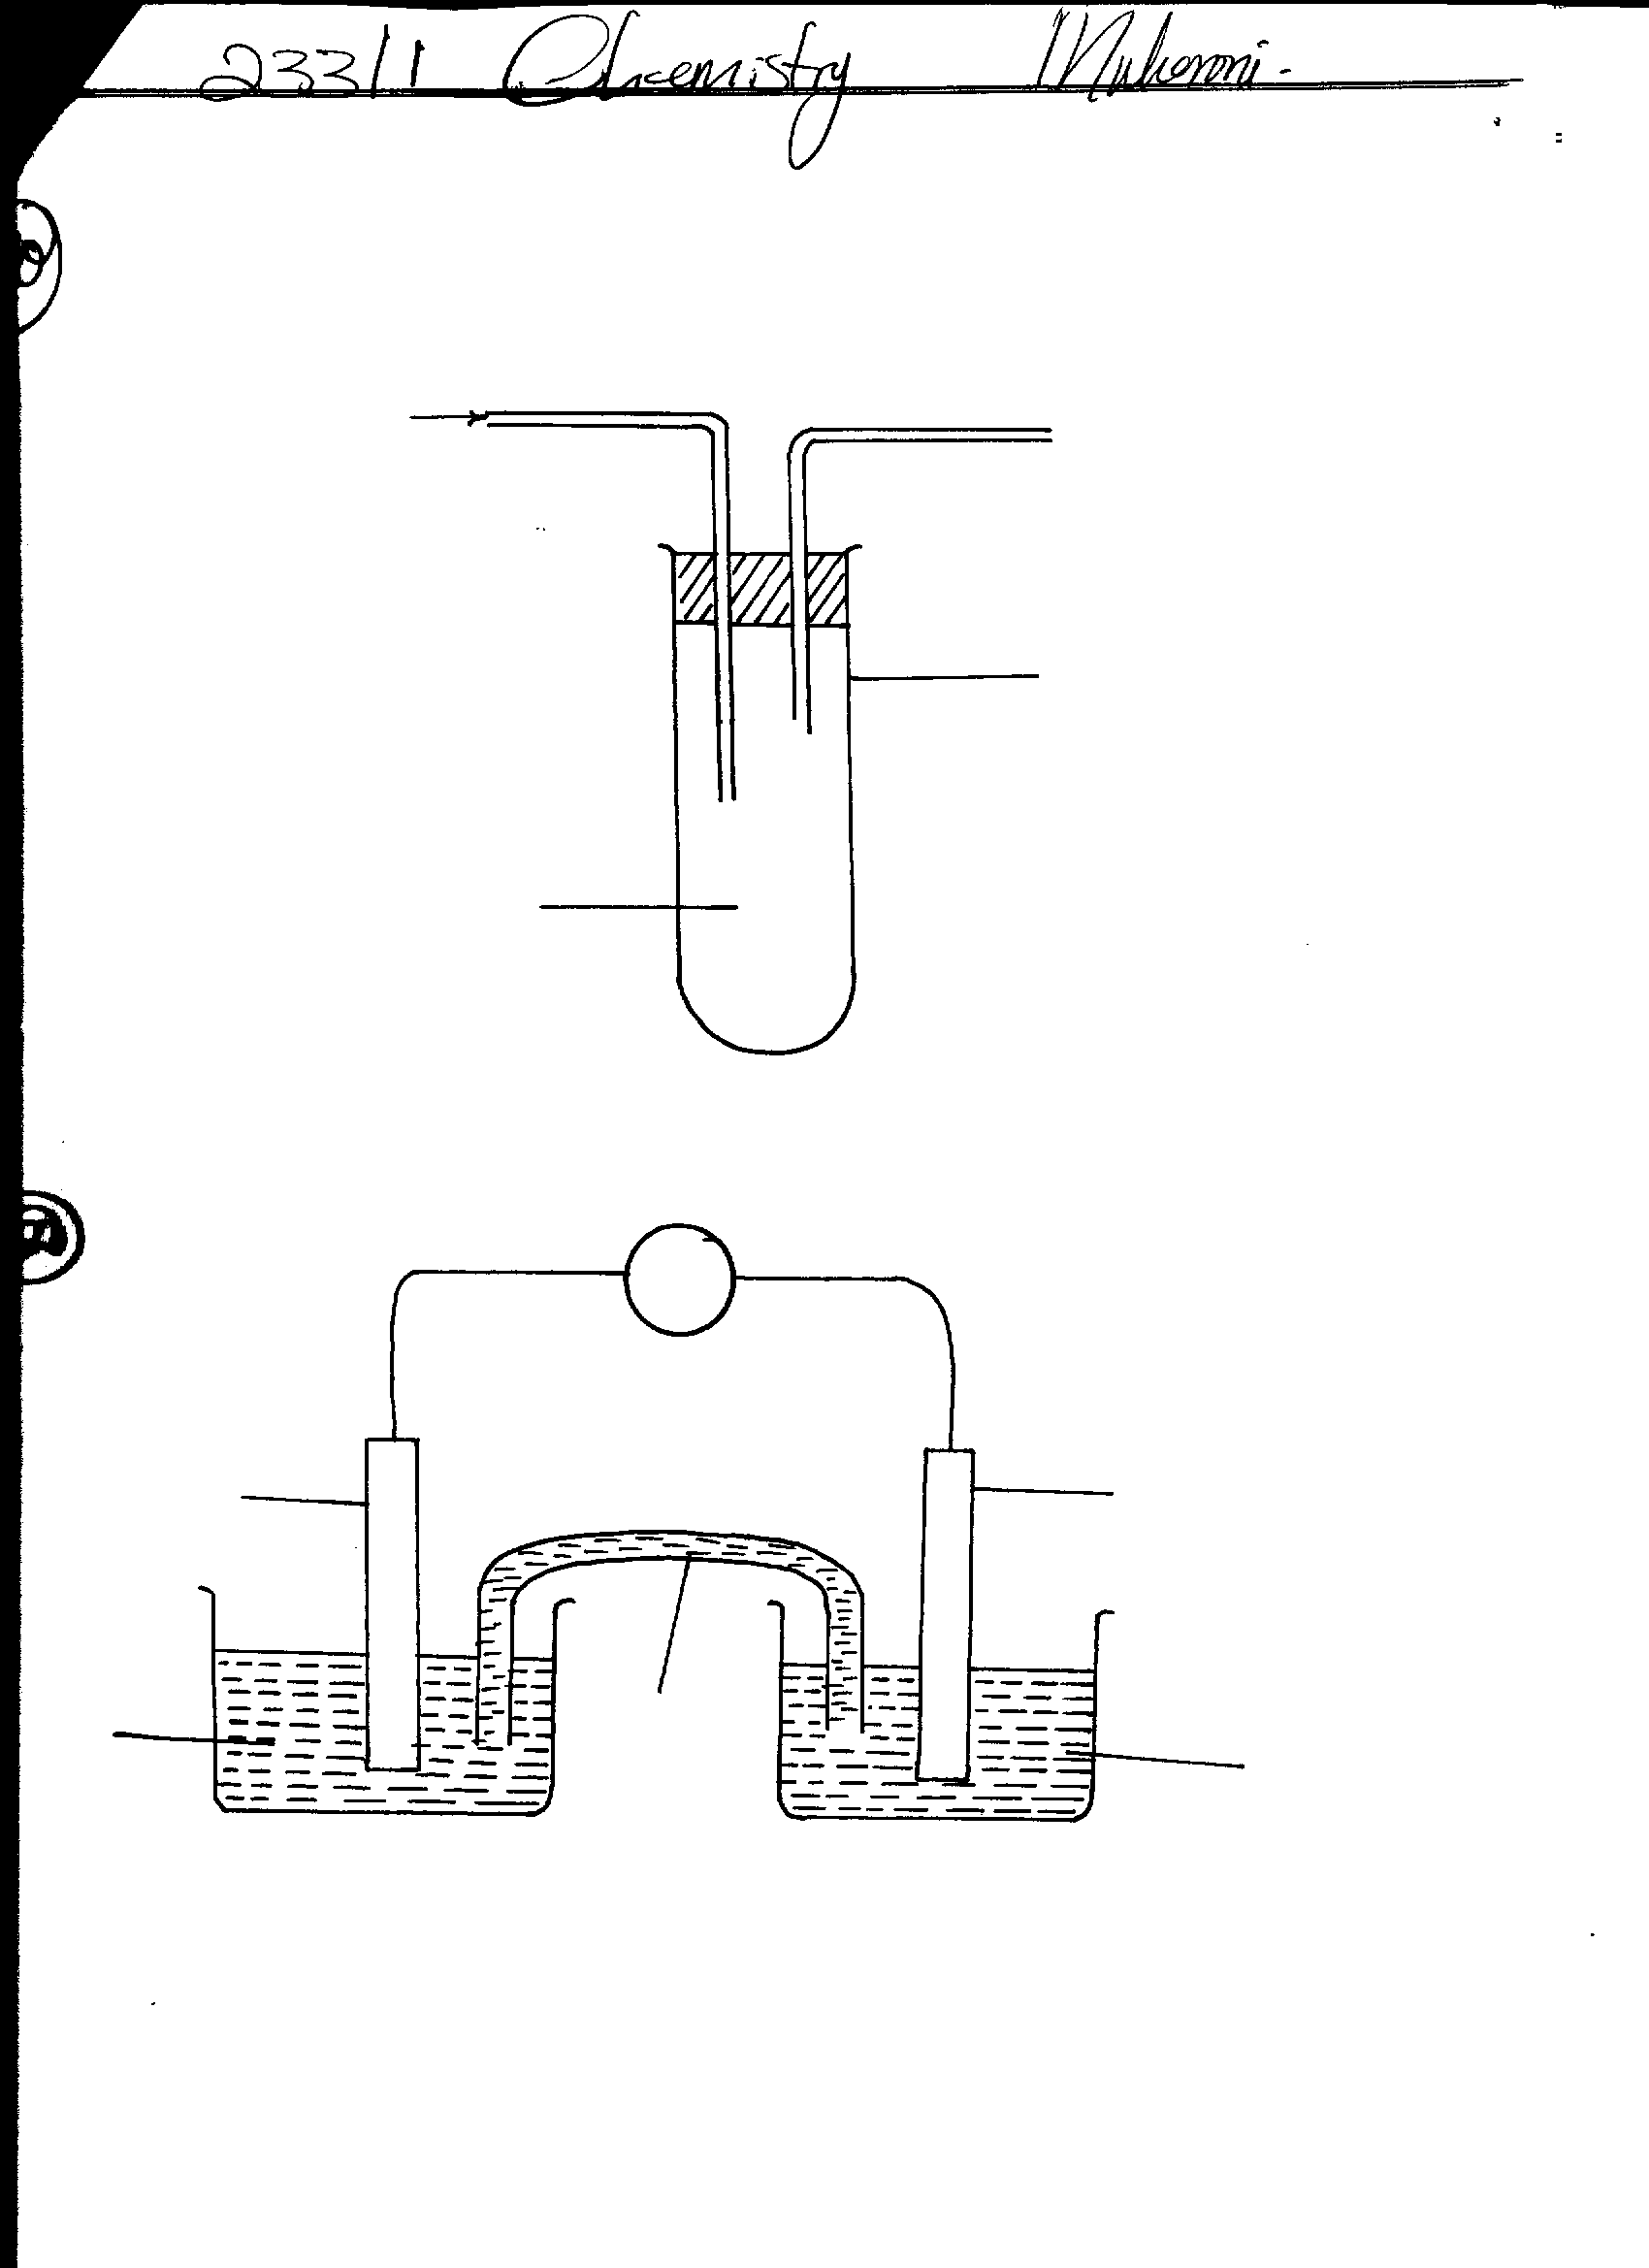
Chlorine

Hydrogen sulphide
Boiling tube

- What observation was made in the boiling tube ? (1mk)
…………………………………………………………………………………………….
……………………………………………………………………………………………..
- Write an equation for the above reaction (1mk)
…………………………………………………………………………………………………………………………………………………………………………………….

(c)What precaution should be taken when carrying out such an experiment?. Explain
………………………………………………………………………………………(2mk)
…………………………………………………………………………………………….
………………………………………………………………………………………………
- 0.24g of a divalent metal M dissolve in 50cm³ of 0.25M Sulphuric (vi) acid. The resulting solution required 5.0cm³ of 1.0M sodium hydroxide for complete neutralization. Determine the relative atomic mass of M. (3mks)
……………………………………………………………………………………………………………………………………………………………………………………………………………………………………………………………………………………………………………………………………………………………………………………………………………………………………………………………………………………………..
………………………………………………………………………………………………
- Study the set up of apparatus below.
V

Copper rod
Part C
Zinc rod
Zinc sulphate solution

Copper(ii)sulphate solution
- When the switch was closed, the voltmeter gave a reading only for a short while gradually reducing to zero. Explain. (1mk)
………………………………………………………………………………………………
……………………………………………………………………………………………..
- State the functions of part labeled C. (2mk)
................................................................................................................................................................................................................................................................................................
- Below are properties of some elements in period 3 of the periodic table
Element | Na | Mg | Al
Atomic radius (nm) | 0.152 | 0.136 | 0.125
Melting points (oC) | 97.8 | 650 | 660

(a) Explain the trend in the melting points (2mks)
…………………………………………………………………………………………….
………………………………………………………………………………………………
- Why is there a decrease in size of the atoms from Na to Al ? (1mk)
………………………………………………………………………………………………
…………………………………………………………………………………………........
………………………………………………………………………………………………
- Students used the set up below to investigate the properties of sulphuric (iv) oxide gas.

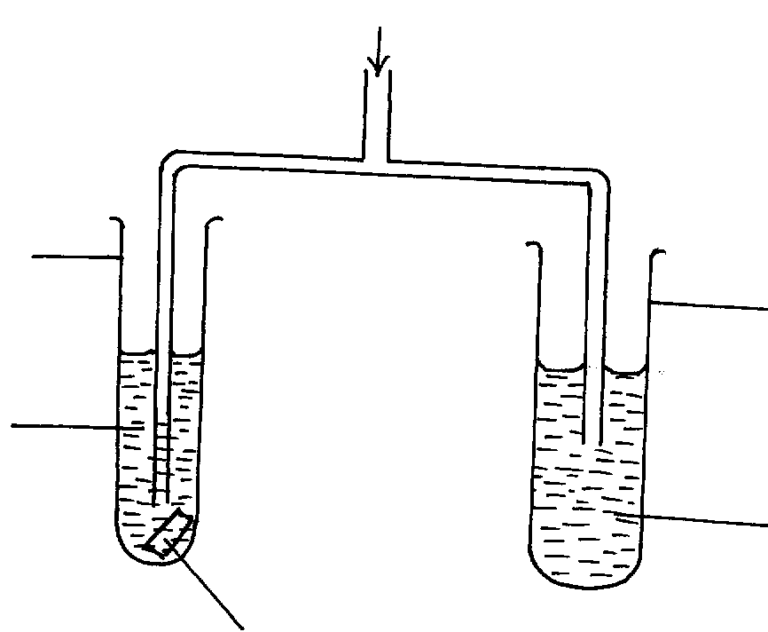
Test tube B
Iron(iii) sulphate yellow
Test tube A
Distilled water
Blue litmus paper
SO_{2 (g)}

- State and explain the observation made in test tube A (2mks)
………………………………………………………………………………………………
……………………………………………………………………………………………..
……………………………………………………………………………………………….
- What property of sulphur (iv) oxide is demonstrated by observation in test tube B ? (1mk)
……………………………………………………………………………………………………………………………………………………………………………………………..
- Calcium (Ca) and strontium (Sr) are group two elements and form ions by losing two electrons. The first and second ionoization energies of calcium and strontium are shown below.
 | 1st I.E kJ/mole | 2nd I.E KJmol -1
Calcium | 590 | 1145
Strontium | 550 | 1064

(a) Write an equation to represent the second ionization energy of calcium (1mk)
…………………………………………………………………………………………….
……………………………………………………………………………………………
(b) Explain why the 2nd ionization energies are higher than the 1st ionization energies
(1mk)
……………………………………………………………………………………………..
……………………………………………………………………………………………..
(c) Explain why the 1st and 2nd ionization energies of calcium are higher than those of strontium. (1mk)
……………………………………………………………………………………………
……………………………………………………………………………………………
……………………………………………………………………………………………

- (a) Define a half life (1mk)
………………………………………………………………………………………………………………………………………………………………………………………………
………………………………………………………………………………………………
(b) After 224 days, ¹/₁₆ of mass of a radioactive element remained. Determine the half life
of the element. (2mks)
…………………………………………………………………………………………….
…………………………………………………………………………………………….
…………………………………………………………………………………………….
- In the industrial extraction of copper, the ore is first concentrated by froth flotation; roasted then followed by smelting.
Describe how the copper ore is concentrated. (2mks)
………………………………………………………………………………………………………………………………………………………………………………………………………………………………………………………………………………………………………………………………………………………………………………………………
- Hydrogen chloride gas was passed through pure water and through melthyl benzene in separate test tubes. Blue litmus paper was then dipped in each of the solution formed.
State and explain the observation made in each case. (2mks)
………………………………………………………………………………………………………………………………………………………………………………………………
……………………………………………………………………………………………………………………………………………………………………………………………………………………………………………………………………………………………….

