Name: ………………………………………………… Index No: ……………………..........................
Date: ……………………......................
Candidate’s Signature…………………
School ……………………………………… ………..

233/2
CHEMISTRY
(Theory)
Paper 2
July/August 2014
Time: 2 Hours

Kenya Certificate of Secondary Education(K.C.S.E)

CHEMISTRY
Paper 2
July/August 2014
Time: 2 Hours

INSTRUCTIONS TO THE CANDIDATES

- Write your name and index no in the spaces provided.
- Sign and write the date of examination
- Answer all questions in the spaces provided
- Mathematical tables and silent electronic calculators may be used.
- All working must be clearly shown where necessary.

FOR EXAMINER’S USE ONLY

QUESTION | MAXIMUM SCORE | CANDIDATE’S SCORE
1 | 13
2 | 14
3 | 13
4 | 10
5 | 12
6 | 10
7 | 08
TOTAL SCORE | 80

This paper consists of 9 printed pages. Candidates should check to ascertain that all pages are printed as indicated and that no questions are missing.

- (a)What is meant by molar heat of neutralization (1mk)
……………………………………………………………………………………………………….
……………………………………………………………………………………………………….
(b) State Hess’s Law. (1mk)
…………………………………………………………………………………………………….
…………………………………………………………………………………………………….
(c) Given the following molar heat of combustion of graphite, hydrogen and anthracene as
θ
ΔH (Graphite) = - 394KJ mol ^{– 1}
c

_{c}
θ
ΔH (H₂ _{(g)} ) = - 286KJmol ⁻¹

θ
c
ΔH ( C₁₄ H₁₀) = - 711.4KJmol ⁻¹
- Write the equation for formation of anthracene (1mk)
……………………………………………………………………………………………………………………………………………………………………………………………
- Draw an energy cycle diagram that links heat of formation of anthracene with heat of combustion of hydrogen, graphite and anthracene. (2mks)
…………………………………………………………………………………………….
……………………………………………………………………………………………………………………………………………………………………………………………………………………………………………………………………………………………..
- Calculate the standard heat of formation of anthracene (2mks)
……………………………………………………………………………………………………………………………………………………………………………………………………………………………………………………………………………………………………………………………………………………………………………………………..

(d) (i) When excess Iron fillings were added to 25.0cm³ of 0.4M copper (ii) sulphate solution, temperature rose by 15.0ºC. Other than rise in temperature state and explain any other observations made. (1mk)
……………………………………………………………………………………………………………………………………………………………………………………………………………….
(ii) Determine the molar heat change.
( C= 4.2 J g ⁻¹k ⁻¹, density of solution = 1 g/cm³) (3mks)
………………………………………………………………………………………………………
………………………………………………………………………………………………………
………………………………………………………………………………………………………
……………………………………………………………………………………………………....
(iii) Draw an energy level diagram to represent the above reaction (2mks)
……………………………………………………………………………………………………………………………………………………………………………………………………………………………………………………………………………………………………………………………………………………………………………………………………………………………
2. Given the following

Mg²⁺ _{(aq)} + 2ē Mg _{(s)} E ^{θ}= - 2.38v

Cu²⁺ _{(aq)} + 2ē Cu _{(s)} E ^{θ} = + 0.34v

- Identify the reducing agent. (1mk)
…………………………………………………………………………………………………………………………………………………………………………………………………….
- Write the ionic equation for the reaction that takes place when Magnesium ribbon is dipped in a solution of copper(ii) ions (1mk)
……………………………………………………………………………………………………………………………………………………………………………………………………
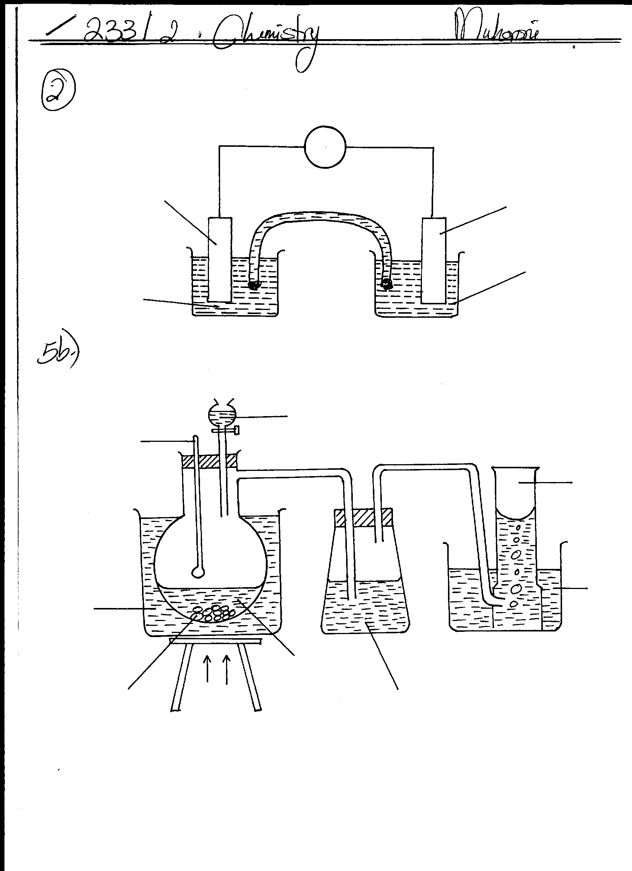
- The diagram below shows an electrochemical cell. Study it and answer the questions that follow.

A
B
U
CuCl₂ _{(aq)}
MgCl_{2 (aq)}

- Label the rods A and B (1mk)
A ……………………………………………………………………………………..

B……………………………………………………………………………………….

- Show on the diagram using an arrow, the direction of flow of electrons. (1mk)
……………………………………………………………………………………………………………………………………………………………………………………
- Starting with solid copper (ii) sulphate, describe how solid copper (ii) hydroxide can be obtained. (3mks)
………………………………………………………………………………………………………………………………………………………………………………………………………………………………………………………………………………………………………………………………………………………………………………………………………………………………………………………………………………………………………….
- Explain why Lead nitrate solution cannot be used to fill the part labeled U. (2mks)
………………………………………………………………………………………………………
………………………………………………………………………………………………………
- In another experiment copper was purified using electrolysis
- Draw a diagram to show the process would be carried out. (2mks)

- A current of 3A was passed through a solution of copper (ii) ions for 3hrs 30mins.
Determine the mass of copper deposited.
( Cu = 63. 5, 1 Faraday = 96500C) (3mks)
……………………………………………………………………………………………………………………………………………………………………………………………………………………………………………………………………………………………………………………………………………………………………………………………………………………………………………………………………
3. Study the table and answer the questions that follow.
Element | Atomic number | Atomic radius (nm) | Ionic radius (nm) | Melting point ºC
A | 12 | 0.136 | 0.065 | 650
B | 14 | 0.118 | - | 1410
C | 17 | 0.099 | 0.181 | -101
D | 20 | 0.171 | 0.099 | 850

- Identify two elements with similar chemical properties . Explain (2mks)
………………………………………………………………………………………………………
……………………………………………………………………………………………………
3. (b) Explain why A has a large atomic radius than B. (1mk)
……………………………………………………………………………………………………….
………………………………………………………………………………………………………
(c)State the observations made when element A is placed in a beaker filled with water. (2mks)
………………………………………………………………………………………………………
……………………………………………………………………………………………………..
…………………………………………………………………………………………………….

(d) Explain the difference in melting points of element B and C (2mks)
…………………………………………………………………………………………………….
…………………………………………………………………………………………………….
(e) How would you expect the P^{H} values of aqueous solutions of the oxides of C and D to compare . Explain. (2mks)
……………………………………………………………………………………………………
……………………………………………………………………………………………………
(f)Describe how crystals of sodium sulphate can be prepared starting with sodium metal.(3mks)
…………………………………………………………………………………………………….
…………………………………………………………………………………………………….
……………………………………………………………………………………………………….
…………………………………………………………………………………………………….

- State one use of element D (1mk)
……………………………………………………………………………………………………..
……………………………………………………………………………………………………..
4. The table below shows the results obtained when a radioactive nuclide was placed near a detector for radioactive emission.

Time in minutes | 5 | 10 | 20 | 30 | 40 | 50
Counts rate | 650 | 485 | 325 | 200 | 122 | 82

(i)Define the term radioactivity (1mk)
…………………………………………………………………………………………………….
…………………………………………………………………………………………………….
(ii)Plot a graph of counts rate against time for the nuclide used in the experiment (3mks)

- From your graph determine the half life of this nuclide (1mk)

- If 50g of the nuclide were initially present. Determine the mass decayed after 15hours. (2mks)

- What are values of m and a in the nuclear equation given below. (2mks)
a
X Y + 2α + 2ß
90
230
m

m……………………………………………………………………
a……………………………………………………………………..

- Give one use of radioactive isotope in medicine (1mk)
…………………………………………………………………………………………………..
………………………………………………………………………………………………......
5. (a) Give the names of the following compounds (2mks)

(i)CH₃ CHCHCH₃…………………………….
O

(ii)CH₃ CH₂ C - OH …………………………

- Ethane and Ethene reacts with bromine according to the equation given below.
- C₂H₆ _{(g)} + Br₂ _{(g)} C₂ H₅ Br _{(l)} + HB r _{(g)}

- C₂H₄ _{(g)} + Br₂ _{(g)} C₂ H₄ Br ₍₂₎

5b (i) Name the type of bromination reaction that takes place in.
I………………………………………………………………………………………………(1mk)
II………………………………………………………………………………………………

(c)The set up below was used to prepare gas V.
Water
Gas V
Conc H₂SO₄
NaOH
Ethanol
HEAT
Water bath
Broken porceilain
180ºC

(i)Name gas V. (1mk)
…………………………………………………………………………………………………..
(ii)What is the role of Broken porcelain (1mk)
……………………………………………………………………………………………………….
Sodium hydroxide (1mk)
……………………………………………………………………………………………………….
(iii) Explain why water bath is used instead of direct heating in the a bove set up (1mk)
…………………………………………………………………………………………………..
…………………………………………………………………………………………………..
(d)The polymerization of tetrafluoroethane ( C₂ F₄) is similar to that of ethane (C₂ H₄)
(i) Define the term polymerization (1mk)
……………………………………………………………………………………………………
…………………………………………………………………………………………………….

(ii)Draw the structural formula of a portion of the polymer obtained from the monomer C₂F₄ (1mks)

- State any two advantages that synthetic polymers have over natural polymers. (2mks)
…………………………………………………………………………………………………………………………………………………………………………………………………….
………………………………………………………………………………………………….
6. Study the flow chart below and answer the questions that follow.
Ore N
Na OH _{(s)}
Step (i)
Step (ii)
Q
Solution x
Residue
Al₂O₃
Molten mixture
Step (iii)
Molten Aluminium
Electrolysis
(iv)

- Name one Ore of N. (1mk)
……………………………………………………………………………………………………
- Explain why the ore is first dissolved in excess sodium hydroxide solution (1mk)
……………………………………………………………………………………………………
……………………………………………………………………………………………………
- Name the major compound present in the residue. (1mk)
………………………………………………………………………………………………………
- Give the formula of the aluminium compound present in solution X (1mk)
………………………………………………………………………………………………………
- Explain how to obtain aluminium hydroxide from solution X (1mks)
……………………………………………………………………………………………………….
………………………………………………………………………………………………………
- (i) Write an equation of the reaction that takes place in (e) above (1mk)
…………………………………………………………………………………………………….
(ii)What is the role of cryolite (Na₃ Alf₆) in the extraction of Aluminium: (1mk)
……………………………………………………………………………………………………..
……………………………………………………………………………………………………..
(iii) Explain why Na⁺ and F – ions are not discharged during electrolysis in step (iv) (1mk)
……………………………………………………………………………………………………..
……………………………………………………………………………………………………..
(iv)Aluminium is a good conductor of electricity. State two uses of aluminium based on that property. (2mks)
………………………………………………………………………………………………………
……………………………………………………………………………………………………….
7. In an experiment ammonia gas was prepared by heating an ammonium salt with an alkali. After drying 120cm³ of ammonia gas were collected at room temperature and pressure. All the ammonia gas was then reacted completely with 250cm³ solution of phosphoric acid.
- What is meant by the term alkali (1mk)
………………………………………………………………………………………………………………………………………………………………………………………………………………
- Explain using physical properties of the gas why ammonia was not collected over water (1mk)
………………………………………………………………………………………………………
………………………………………………………………………………………………………
- Ammonmia turns red litmus paper blue. Which ion is responsible for the reaction . (1mk)
…………………………………………………………………………………………………….
- The equation below shows the reaction between ammonia and phosphoric acid.
3NH₃ _{(g)} + H₃PO_{4(aq)} (NH₄)₃PO₄ _{(aq)}
(i)Explain how crystals of ammonium phosphate could be obtained in the experiment (2mks )
……………………………………………………………………………………………………….
……………………………………………………………………………………………………….

(e) Calculate the maximum mass of ammonium phosphate that could be obtained in the experiment (3mks)
(N = 14.0, O= 16.0, P = 31.0, H=1.0)
Molar gas volume 24dm³ at R.T.P
……………………………………………………………………………………………………………………………………………………………………………………………………………………………………………………………………………………………………………………………………………………………………………………………………………………………………………………………………………………………………………………………………..
……………………………………………………………………………………………………..

