Name......................................................................................................... Adm. No...................................
TANGANYIKA SECONDARY SCHOOL
P.O. BOX 1495 – 90200 KITUI
FORM 3
TERM I

231/3
Biology
Practical

INSTRUCTION TO LEARNERS
1. Answer all questions in the spaces provided.
2. Students will be penalized for mispelling technical terms.

FOR EXAMINER USE ONLY
QUESTION | TOTAL MARKS | CANDIDATE’S MARKS
1 | 15
2 | 15
3 | 10
 | TOTAL

TURN OVER
- You are provided with 2 pieces of Specimen F and hydrogen peroxide.
- Measure 25cm³ hydrogen peroxide and pour it into a 100ml beaker. Put one piece of Specimen F in the 100ml beaker. Record your observations below. (3 marks)

- Give a reason for your observations in a) above (4 marks)

- Which food substance is being tested for? (1 mark)

- Name another organ in the body where the food substance in c) above is present (1 mark)

- Put the remaining piece of Specimen F in a mortar and pestle and crush it. Using the reagents provided, conduct a food test. (6 marks)

FOOD | PROCEDURE | OBSERVATION | CONCLUSION

- Study the photographs below and answer the questions that follow:
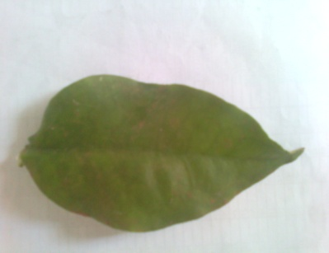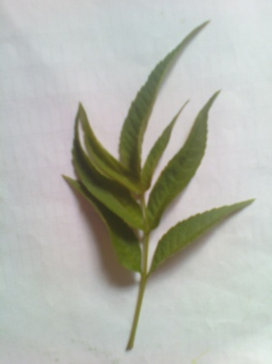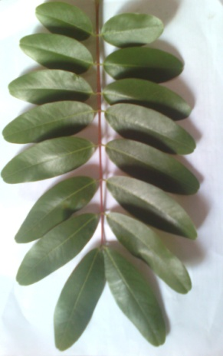
LEAF A LEAF B LEAF C

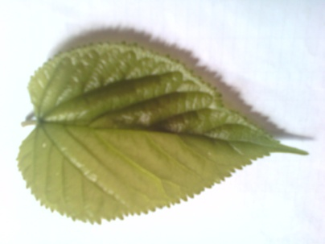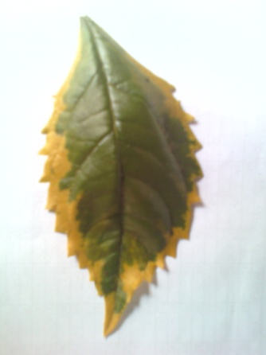
E
D
C
B
A
LEAF D LEAF E

- Construct a dichotomous key to identify each leaf (8 marks)

- Name the parts labeled A –E on Leaf D (5 marks)
A-

B-

C-

D-

E-

- Using your dichotomous key in a) above, construct a path to identify Leaf C (2 mark)

- Study the photographs below and answer the questions that follow:
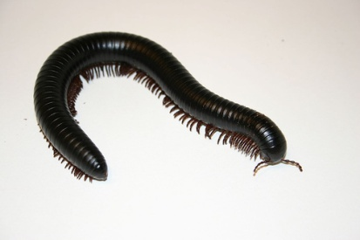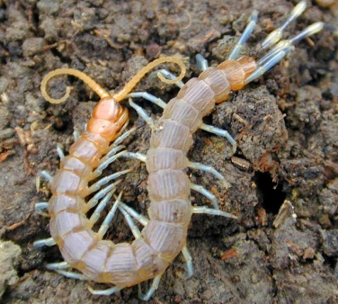
SPECIMEN P SPECIMEN R

- Give three differences between Specimen P and Specimen R which are visible in the photographs. (6 marks)

Specimen P | Specimen R

- Classify the two organisms up to class level (4 marks)
Specimen P | Specimen R
Kingdom: Animalia  Phylum: .  Class . | Kingdom: Animalia  Phylum: .  Class .

