JARAMOGI OGINGA ODINGA UNIVERSITY OF SCIENCE & TECHNOLOGY
SCHOOL OF BIOLOGICAL AND PHYSICAL SCIENCES
DEPARTMENT OF BIOLOGICAL SCIENCES
UNIVERSITY EXAMINATION FOR THE DEGREE OF MASTER OF SCIENCE IN PLANT ECOLOGY
1ST YEAR 2NDSEMESTER 2016/2017 ACADEMIC YEAR
MAIN CAMPUS - REGULAR
COURSE CODE: SBT 816
COURSE TITLE: PRODUCTION ECOLOGY
EXAM VENUE: LR 1 STREAM: (MSC)
DATE: 20/04/17 EXAM SESSION: 2.00 – 5.00 PM
TIME: 3 HOURS
______________________________________________________________________________
Instructions:
- Answer ALL questions in Section A and Any two questions in Section B
- Candidates are advised not to write on question paper
- Candidates must hand in their answer booklets to the invigilator while in the examination room

SECTION A: SHORT ANSWER QUESTIONS (30 MARKS)
- Using an illustration, discuss how light is distributed through a meadow stand. (3 marks)
- With an illustration, describe the evolution of the chloroplast. (3 marks)
- Using the Fusion model, explain how the reaction centers 1 and 2 evolved in the plant cells.
(3 marks)
- Distinguish between P680 and P700 reaction centers of the chlorophyll. (3 marks)
- Distinguish between C4 and C3 photosynthesis. (3 marks)
- Briefly explain 2 events that led to the evolution of C4 grasses during the Oligocene and their southward spread in the Miocene. How are these conditions different from those of the Anthropocene? (3 marks)
- The Figure below shows altitudinal distribution of C4 and C3 photosynthesis, label it appropriately, showing which line represent C3/C4 and the region of dominance. (3 marks)

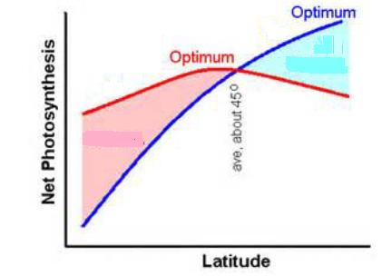
- Fick’s first Law of diffusion explains the movement of gas molecules across the stomata, write an equation describing this Law and explain which component describes the active regulation by the stomata. (3 marks)
- Distinguish between “Homobaric” and “Heterobaric” leaves. (3 marks)
- What do you understand by the term “patchy stomata” explain how it affects leaf productivity.
(3 marks)

SECTION B: ESSAY QUESTIONS (30 MARKS)
- Discuss the historical and current challenges to the existence of grassland ecosystems in Eastern Africa. (15 marks)
- Discuss the methodsused to determine grassland productivity. (15 marks)
- Discuss in detail, factors limiting photosynthesis in plants. (15 marks)
- Discuss mechanisms of stomatal opening in the regulation of leaf gas exchange. (15 marks)

