NAME………………………………………………………... ADM NO……………………….

Candidates Signature…………………………………………. Date……………………………..

PRIMARY TEACHER EDUCATION

SEMESTER: FOUR 2017 Time: 1 HOUR
VISION EMPOWERMENT TRAINING INSTITUTE
Sunrays House, 4th floors Branch Milele Centre, 2nd floor
Near Khoja Round about, opp.old Behind Equity Bank, Kitengela
Nation hse. Behind Fire Station, P.O. Box 10829-00400Nairobi
Tom Mboya Street Tel: 0720655582 /0707585084
www.veti.ac.ke Email:visionpowerment2006@yahoo.com

Unit: SCIENCE

INSTRUCTIONS TO CANDIDATES
Write your name and admission number in the space provided above.
Sign and write the date of examination in the spaces provided
This paper consists of THREEquestions.
Answer ALL thequestions

For Examiners Use Only
Question | 1 | 2 | 3 | Totals
Maximum Score | 10 | 10 | 10 | 30
Candidate’s Score

Candidate should check the question papers to ascertain all the pages and questions are printed as indicated and none is missing.

QUESTION ONE
- Define the following terms: (2 Marks)
- Mechanical energy

- Light energy

- Differentiate between kinetic energy and potential energy (2 Marks)

- Differentiate between heat energy and temperature. (2 Marks)

- The sun burns with a very loud noise. Explain why this noise cannot be heard from the earth while its heat can be felt from the earth. (2 Marks)

- Differentiate between conduction and convection. (2 Marks)

QUESTION TWO
- Calculate the work done by a ceiling by holding a bulb weighing 50g for 2 days. (2 Marks)

- Study the diagram below and answer the questions that follow:
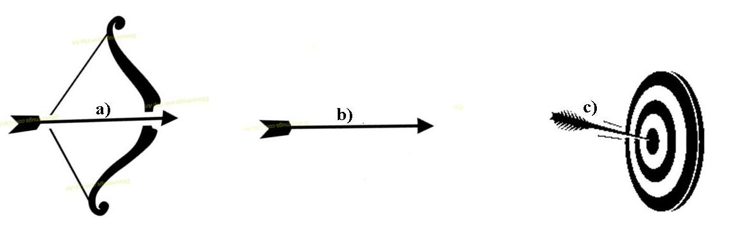
Target
- Using well explained points, identify the point of: (4 Marks)
Maximum potential energy

Maximum kinetic energy

- Given that the distance from the bow to the target is 200m and that the arrow is moving using a force of 10.5N, calculate the amount of work done. (2 Marks)

- On an academic trip, a boy observed that water was flowing from a dam into a waterfall and produced a lot of sound. Outline the energy transformations that the water underwent. (2 Marks)

QUESTION THREE
- Classify the various sources of light. (4 Marks)

- Differentiate between transparent translucent and opaque materials (3 Marks)

- Study the diagram below and answer the questions that follow:
Z
Y
R
P
Q
X

- Name the parts labeled: (2 Marks)
X –
Y –
Z –
Q –
- Given that angle XQZ is 35º, determine the size of angle YQZ (1 Marks)

