Name: …………………………………………………… Index No: …………………….…..……………

School: ………………………………………………….. Date: ……………………………………………

231/1
BIOLOGY
Paper 1
Time: 2 Hours

KCSE TRIAL & PRACTICE EXAMINATION 2017

Kenya Certificate of Secondary Education

BIOLOGY
Paper 1
Time: 2 Hours

INSTRUCTIONS TO CANDIDATES:

- Write your name , Index Number and School in the spaces provided above.
- Answer all the questions in this question paper.
- Answers must be written in the spaces provided in this booklet.
- All answers must be written in English
- This paper consists of 11 printed pages. Candidates should check to ascertain that all papers are printed as indicated and that no questions are missing

EXAMINER’S USE ONLY

Question | Maximum score | Candidate’s score
1- 30 | 80

Turn over

- What do the following branches of Biology entail? (2marks)
  - Cytology

........................................................................................................................................................................
........................................................................................................................................................................

  - Entomology
........................................................................................................................................................................
........................................................................................................................................................................
- State TWO characteristics of kingdom Monera that are not found in other kingdoms. (2marks).
........................................................................................................................................................................
........................................................................................................................................................................
........................................................................................................................................................................
.......................................................................................................................................................................

- Two species in an ecosystem cannot occupy the same niche. Explain. (1 mark)

........................................................................................................................................................................
........................................................................................................................................................................
........................................................................................................................................................................
........................................................................................................................................................................

- State the significance of metamorphosis to the life of insects. (2 marks)
........................................................................................................................................................................
........................................................................................................................................................................
........................................................................................................................................................................

- The diagram below shows results of what happens to plant cell when placed in a certain solution.

X

- What was the nature of the solution in which the cell was placed? (1 mark)
........................................................................................................................................................................
........................................................................................................................................................................

- Identify the force represented by the arrow X and explain how it develops. (2 marks)
........................................................................................................................................................................
........................................................................................................................................................................
........................................................................................................................................................................

- Which organelle would be numerous in the following cells; (2 marks)
- Liver cell
........................................................................................................................................................................
.....................................................................................................................................................................
- Palisade cell
........................................................................................................................................................................
........................................................................................................................................................................

- The scientific names of three animals leopard, wolf and lion in the family carnivora are; Panthera pardus, Canis lupas and Panthera leo respectively.
- Why are scientific names given in Latin? (1 mark)
........................................................................................................................................................................
........................................................................................................................................................................

- What does Canis refer to? (1 mark)
........................................................................................................................................................................
........................................................................................................................................................................
- Giving a reason, state the organisms that are MOST closely related. (1 mark)
........................................................................................................................................................................
........................................................................................................................................................................
- The word equation below shows a biological process.
Water Hydrogen atom + oxygen
- Name the process. (1 mark)
........................................................................................................................................................................
........................................................................................................................................................................

- Where does the process named in a) above take place? (1 mark)
........................................................................................................................................................................
.......................................................................................................................................................................
- State two conditions necessary for the process to occur. (2 marks)
........................................................................................................................................................................
........................................................................................................................................................................
........................................................................................................................................................................
........................................................................................................................................................................

- a) What is the importance of heartbeat in blood circulation? (1 mark)
........................................................................................................................................................................
.....................................................................................................................................................................

b) If the nerve supply to the heart of a mammal is servered, the rhythmic heart movement will still go on and the heart continues to beat. Explain this observation. (1 mark)
........................................................................................................................................................................
........................................................................................................................................................................
........................................................................................................................................................................
- The ovaries of an expectant woman can be removed after the first four months of pregnancy
without terminating the pregnancy. Explain. (2 marks)
........................................................................................................................................................................
........................................................................................................................................................................
........................................................................................................................................................................
........................................................................................................................................................................
- The diagram below represents a stage during cell division.
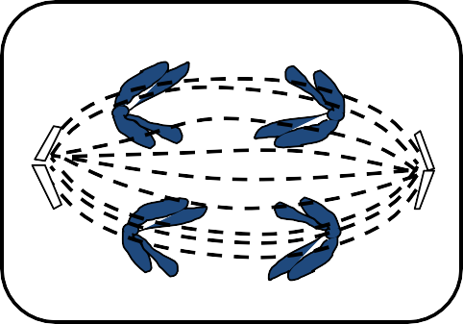
- Name the stage of cell division. (1 mark)
........................................................................................................................................................................
........................................................................................................................................................................

- Give two reasons for your answer in a) above. (2 marks)
........................................................................................................................................................................
........................................................................................................................................................................
........................................................................................................................................................................
........................................................................................................................................................................
- State the significance of this stage of cell division in living organisms. (1 mark)
........................................................................................................................................................................
........................................................................................................................................................................

12.) Name the causative agent for the following diseases;
- Typhoid (1 mark)
........................................................................................................................................................................
........................................................................................................................................................................
- Syphilis (1 mark)
........................................................................................................................................................................
........................................................................................................................................................................
- A student set up an experiment as shown in the diagram below. The set up was kept at room temperature for one week.
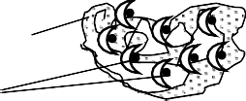A B

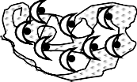Pyrogallic acid

Moist cotton wool
Seeds

  - What was the aim of the experiment? (1 mark)

........................................................................................................................................................................
.......................................................................................................................................................................

  - State the expected observation at the end of the experiment. (2 marks)

........................................................................................................................................................................
........................................................................................................................................................................
........................................................................................................................................................................
........................................................................................................................................................................

  - Account for the observation made in set up A. (1 mark)

........................................................................................................................................................................
........................................................................................................................................................................
.......................................................................................................................................................................

- a) Name the respiratory surface for gaseous exchange in insects. (1 mark)
........................................................................................................................................................................
........................................................................................................................................................................

b) State two adaptations of the site named in a) above. (2 marks)

........................................................................................................................................................................
........................................................................................................................................................................
.......................................................................................................................................................................

- A portion of a nucleic acid is shown below;

-S-P-S-P-S-P-S-P-S-P- S -

C C G U G C

  - Name the nucleic acid to which the portion belongs. Give a reason. (2 marks)
........................................................................................................................................................................
.......................................................................................................................................................................
  - Write down the sequence of bases of a complimentary strand to the one above. (1 mark)
........................................................................................................................................................................
.......................................................................................................................................................................
- Explain the meaning of the following terms;
  - Basal Metabolic Rate (1 mark)
........................................................................................................................................................................
........................................................................................................................................................................

  - Oxygen Debt (1 mark)
........................................................................................................................................................................
........................................................................................................................................................................

- In an experiment, the concentration of ions in the cell sap of reeds growing in a swampy area and the water in the swamp were determined. The data below was obtained. Study it and answer the questions that follow:

Sample | Na⁺ | Mg2+ | Cl⁻ | SO42-
Cell sap | 50 | 11 | 101 | 13
Swamp water | 1.2 | 30 | 10.2 | 0.67

  - Name the process by which uptake of the following ions by the reeds occurs. (2 marks) Na⁺ ions .....................................................
Mg²⁺ ions ......................................................

  - What effect would reduced oxygen supply have on the uptake of sulphate ions? (2 marks) Explain your answer.
........................................................................................................................................................................
........................................................................................................................................................................
........................................................................................................................................................................
- The diagram below shows a part of a nephron.

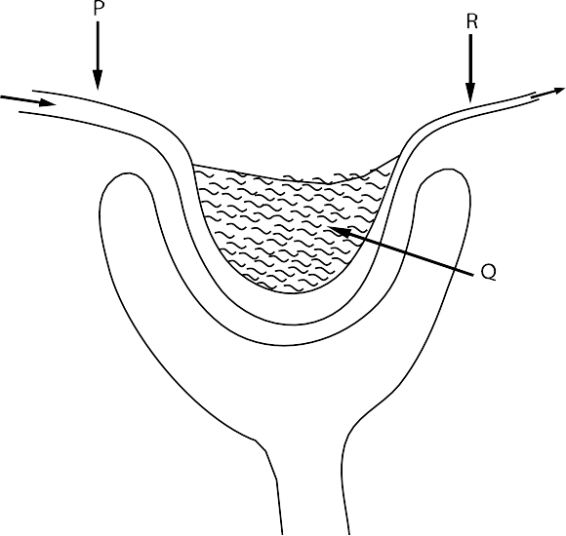
  - State TWO differences in composition of blood in parts P and R. (2 marks)
........................................................................................................................................................................
........................................................................................................................................................................
........................................................................................................................................................................
.......................................................................................................................................................................
  - State a characteristic feature of blood capillaries in part Q that is not found in other capillarities
(1 mark)
........................................................................................................................................................................
.......................................................................................................................................................................
- (a) Name two types of light sensitive cells found in the human eye. (1 mark)
........................................................................................................................................................................
........................................................................................................................................................................
(b) State ONE functional difference between the cells you have named in a) above. (1 mark)
........................................................................................................................................................................
........................................................................................................................................................................

- A set up was used to investigate a certain process in plants as shown in the diagram below.

Leafy shoot

Rubber tubing
Air bubble Tap
Ruler

Capillary tube Beaker
Water

Retort stand

- What process was being investigated? (1 mark)
........................................................................................................................................................................
.......................................................................................................................................................................
- Giving a reason, state one precaution that should be taken when setting up this experiment.
(1 mark)
........................................................................................................................................................................
........................................................................................................................................................................
.......................................................................................................................................................................
- How would changes in temperature affect the rate of movement of the air bubble? (1 mark)

........................................................................................................................................................................
......................................................................................................................................................................
- Julie observed eight onion epidermal cells across the field of view of a light microscope. If the field of view was 4mm in diameter, estimate the average size of the cells in micrometers
(1mm= 1000𝜇𝜇m). (2 marks)
........................................................................................................................................................................
........................................................................................................................................................................
........................................................................................................................................................................
........................................................................................................................................................................
- How is support brought about in herbaceous plants? (2 marks)
........................................................................................................................................................................
........................................................................................................................................................................
........................................................................................................................................................................
.......................................................................................................................................................................

- State the functions of the following parts of the mammalian ear.
Biology paper 1

  - Eustachian tube (1mark)
........................................................................................................................................................................
........................................................................................................................................................................
  - The utriculus and sacculus (1mark)
........................................................................................................................................................................
........................................................................................................................................................................
........................................................................................................................................................................
.......................................................................................................................................................................

- In an experiment, a shoot of maize seedling was exposed to light on one side. It was observed that it grew bending towards the direction of the source of light.
  - Explain how the bending towards light occurs. (2marks)
........................................................................................................................................................................
........................................................................................................................................................................
........................................................................................................................................................................
........................................................................................................................................................................
........................................................................................................................................................................
  - State the survival value of the response named in a) above. (1 mark)

........................................................................................................................................................................
........................................................................................................................................................................
- The diagram below show various types of gene mutations. Mutation I;
K | L | M | N | O | P | Q

K | L | M | P | Q

Mutation II;
S | T | U | N | W | X | Y

S | T | U | V | W | X | Y

- Identify the type of mutations shown above (2 marks)
........................................................................................................................................................................
........................................................................................................................................................................

- Name one disorder that results from gene mutation II. (1 mark)
........................................................................................................................................................................
.......................................................................................................................................................................

Biology paper 1
- State THREE adaptations of a leaf to gaseous exchange. (3 marks)

........................................................................................................................................................................
........................................................................................................................................................................
........................................................................................................................................................................
........................................................................................................................................................................
........................................................................................................................................................................
.......................................................................................................................................................................
- Distinguish between analogous structures and homologous structures. For each structure give an example. (4 marks)
........................................................................................................................................................................
........................................................................................................................................................................
........................................................................................................................................................................
........................................................................................................................................................................
........................................................................................................................................................................

- The diagram below shows a bone that was obtained from a mammal.

  - Identify the bone. (1 mark)
........................................................................................................................................................................
.......................................................................................................................................................................

  - i) Name the type of joint formed at the part marked P. (1 mark)

........................................................................................................................................................................

ii) State one characteristic of the joint named in b) i) above. (1 mark)

........................................................................................................................................................................
.......................................................................................................................................................................
- What is the importance of the pollen tube in fertilization in plants? (1 marks)

........................................................................................................................................................................
........................................................................................................................................................................
........................................................................................................................................................................
.......................................................................................................................................................................

Biology paper 1
- a) The action of pepsin stops in the duodenum. Explain. (2 marks)

........................................................................................................................................................................
........................................................................................................................................................................
........................................................................................................................................................................
........................................................................................................................................................................
b) State two functions of the muscles found in the alimentary canal of mammals. (2 marks)

........................................................................................................................................................................
........................................................................................................................................................................
........................................................................................................................................................................
........................................................................................................................................................................

