Name: ………………………………………………………Index No …......…..........................

School: …………………………………………Candidate’s Sign……………………………..

Date: ……………………………….

443/1
AGRICULTURE
Paper 1
March / April 2014
Time: 2 Hours

Kenya Certificate of Secondary Education (K.C.S.E.)

INSTRUCTIONS TO CANDIDATES:

- This paper consists of three sections; A, B and C.
- Answer all questions in section A and B.and any two questions from section C..
- All answers must be written in the spaces provided.
For Examiner’s Use Only;
SECTION | QUESTION | MAXIMUM SCORE | CANDIDATE′S SCORE
A | 1 - 18 | 30
B | 19 – 22 | 20
C | 23  24  25 | 20
 |  | 20
 | TOTAL SCORE | 90

This paper consists of 11printed pages. Candidates should check the question paper to ascertain that all pages are printed as indicated and that no questions are missing
SECTION A(30MKS)
Answer all question in this section in the spaces provided.
1. (a) What is organic farming? ( ½ mk)
………………………………………………………………………………………………………
………………………………………………………………………………………………………
(b) List any four climatic factors that influence crop production (2mks)
………………………………………………………………………………………………………
………………………………………………………………………………………………………
………………………………………………………………………………………………………
………………………………………………………………………………………………………
(c) State four conditions under which shifting cultivation is practicable (2mks)
………………………………………………………………………………………………………
………………………………………………………………………………………………………
………………………………………………………………………………………………………
………………………………………………………………………………………………………
2. (a) Give four ways the government can regulate the amount of imported agricultural goods (2mks)
………………………………………………………………………………………………………
………………………………………………………………………………………………………
………………………………………………………………………………………………………
………………………………………………………………………………………………………
(b) State two ways in which hard pans are caused by cultivation (2mks)
………………………………………………………………………………………………………
………………………………………………………………………………………………………
3. Outline four factors that determine the number of times secondary cultivation is done (2mks)
………………………………………………………………………………………………………
………………………………………………………………………………………………………
………………………………………………………………………………………………………
………………………………………………………………………………………………………
4. Give four farming practices that farmers can use to achieve minimum tillage (2mks)
………………………………………………………………………………………………………
………………………………………………………………………………………………………
………………………………………………………………………………………………………
………………………………………………………………………………………………………

5. Give a reason in each case for carrying out the following management practices in a vegetable nursery
(i) Pricking out ( ½ mk)
………………………………………………………………………………………………………
(ii) Rogueing ( ½ mk
………………………………………………………………………………………………………
6. List three practices that can be carried out to increase the amount of light harnessed by
crops (1 ½ mks)
………………………………………………………………………………………………………
………………………………………………………………………………………………………
………………………………………………………………………………………………………
7. (a) What is hardening off as used in crop production (1mk)
………………………………………………………………………………………………………
………………………………………………………………………………………………………
(b) State two ways in which the above practices can be carried out (1mk)
………………………………………………………………………………………………………
………………………………………………………………………………………………………
8. Calculate the amount of K₂O that is contained in 400kg of a compound fertilizer 25:10:5 (show your calculations) (1mk)

9. Outline four characteristics of plants that are used in preparation of green manures (2mks)
………………………………………………………………………………………………………
………………………………………………………………………………………………………
………………………………………………………………………………………………………
………………………………………………………………………………………………………
10. A farmer has a piece of land measuring 90m by 60m to plant the maize crop the spacing was 90cm by 30cm. Calculate the plant population in the field if all seeds germinated (show your working) (2mks)

11. (a) Give two forms of collective land tenure system in Kenya (1mk)
………………………………………………………………………………………………………
………………………………………………………………………………………………………
(b) Outline four advantages of land consolidation in agricultural production (2mks)
………………………………………………………………………………………………………
………………………………………………………………………………………………………
………………………………………………………………………………………………………
………………………………………………………………………………………………………
12. (a) State four factors of production in agriculture (2mks)
………………………………………………………………………………………………………
………………………………………………………………………………………………………
………………………………………………………………………………………………………
………………………………………………………………………………………………………
(b) Give four types of farm record that a maize farmer would keep (2mks)
………………………………………………………………………………………………………
………………………………………………………………………………………………………
………………………………………………………………………………………………………
………………………………………………………………………………………………………
13. (a ) List two methods of layering that are use in propagation of plants (1mk)
………………………………………………………………………………………………………
………………………………………………………………………………………………………
(b) Give two ways in which check dams control soil erosion (1mk)
………………………………………………………………………………………………………
………………………………………………………………………………………………………
SECTION B (20mrks)
Answer all questions in the section.
14. The diagrams below are illustrations of some weeds. Study them and answer the questions that follow
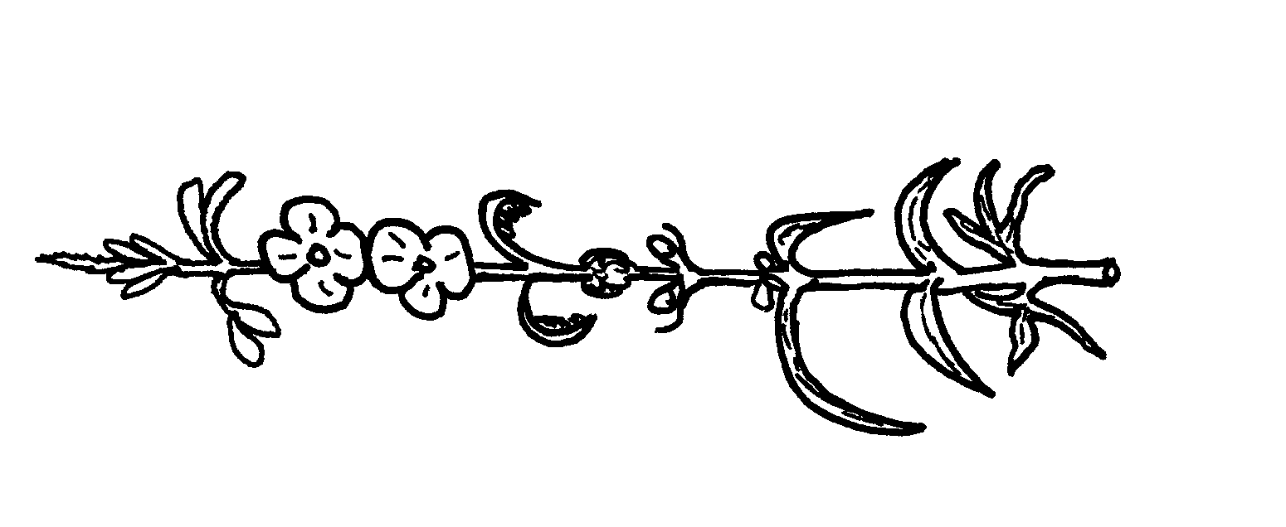
M
L

(a) Identify the weeds (1mk)
………………………………………………………………………………………………………
(b) On the basis of morphology classify the weed labeled h (1mk)
………………………………………………………………………………………………………
(c) Give two harmful effects of the weed labeled M (2nks)
………………………………………………………………………………………………………
………………………………………………………………………………………………………
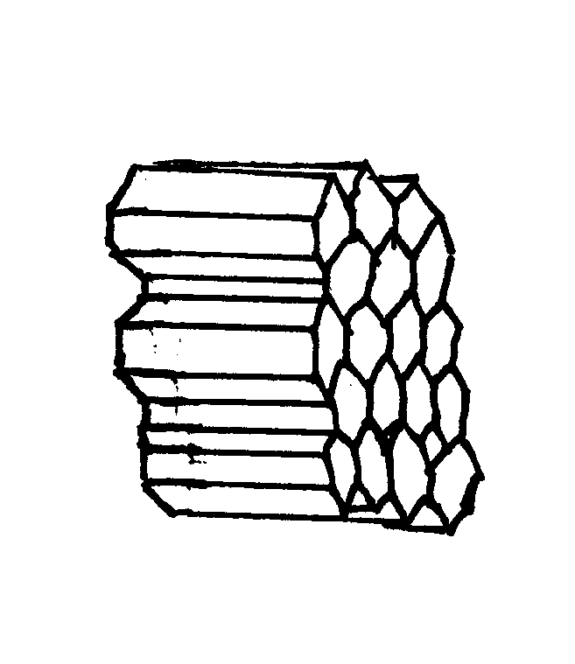
15. Below are two types of soil structures P and Q

Q
P

(a) Identify the type of soil structure (1mk)
………………………………………………………………………………………………………
(b) State where the above soil structure are likely to be found (1mk)
………………………………………………………………………………………………………
(c) Outline three main ways by which soil structure influence crop production (3mks)
………………………………………………………………………………………………………
………………………………………………………………………………………………………
………………………………………………………………………………………………………
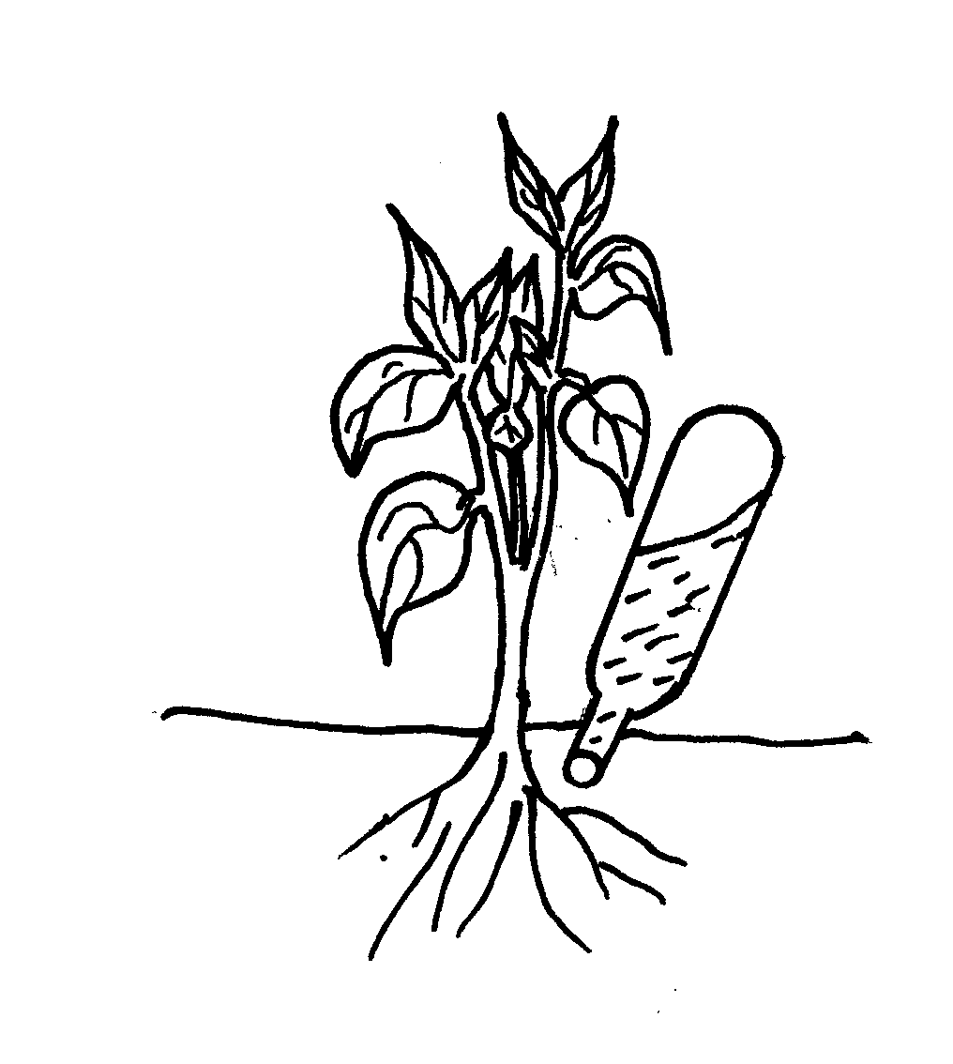
16. The diagram below gives an illustration of a type of irrigation. Study it and use it to answer questions that follow

(a) Identify the irrigation method shown above (1mk)
………………………………………………………………………………………………………
(b) State two main advantages of this type of irrigation (2mks)
………………………………………………………………………………………………………
………………………………………………………………………………………………………
(c) Outline two main reasons why the above type of irrigation is not popular among farmers (2mks)
………………………………………………………………………………………………………
………………………………………………………………………………………………………
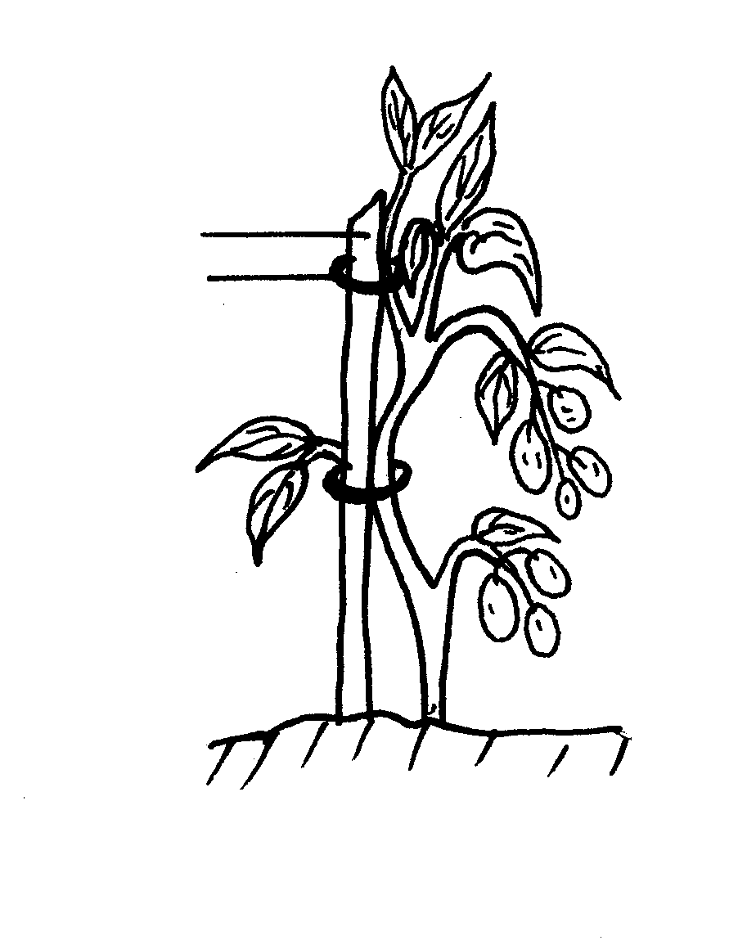
17. The illustration below shows a certain practice carried in crop production. Study them and answer questions that follow

M
N

(a) Identify that practice illustrated above (1mk)
………………………………………………………………………………………………………
(b) Name the materials used in N and M a and their uses (1mk)
………………………………………………………………………………………………………
………………………………………………………………………………………………………
SECTION C(40MRKS)
Answer any two questions from this section
18. (a) Describe the production of maize for grain under the following subheadings
(i) Seedbed preparation (4mks)
(ii) Field practices (6mks)
(b) Explain five factors that should be considered when designing a crop rotation
programme (10mks)
19. (a) Explain the factors that determine the choice of method for controlling pests and diseases
in crop production (10mks)
(b) Explain seven ways of breaking seed dormancy (7mks)
(c) Give three reasons why it is advantageous to use farm yard manure instead f a straight
Fertilizer (3mks)
20. (a) State the characteristics of a fertile soil (5mks)
(b) Explain six physical or structural methods of soil erosion control (12mks)
(c) State the problems associated with the use of herbicides (3mks)
………………………………………………………………………………………………………
………………………………………………………………………………………………………
………………………………………………………………………………………………………
………………………………………………………………………………………………………
………………………………………………………………………………………………………
………………………………………………………………………………………………………
………………………………………………………………………………………………………
………………………………………………………………………………………………………
………………………………………………………………………………………………………
………………………………………………………………………………………………………
………………………………………………………………………………………………………
………………………………………………………………………………………………………
………………………………………………………………………………………………………
………………………………………………………………………………………………………
………………………………………………………………………………………………………
………………………………………………………………………………………………………
………………………………………………………………………………………………………
………………………………………………………………………………………………………
………………………………………………………………………………………………………
………………………………………………………………………………………………………
………………………………………………………………………………………………………
………………………………………………………………………………………………………
………………………………………………………………………………………………………
………………………………………………………………………………………………………
………………………………………………………………………………………………………
………………………………………………………………………………………………………
………………………………………………………………………………………………………
………………………………………………………………………………………………………
………………………………………………………………………………………………………
………………………………………………………………………………………………………
………………………………………………………………………………………………………
………………………………………………………………………………………………………
………………………………………………………………………………………………………
………………………………………………………………………………………………………
………………………………………………………………………………………………………
………………………………………………………………………………………………………
………………………………………………………………………………………………………
………………………………………………………………………………………………………
………………………………………………………………………………………………………
………………………………………………………………………………………………………
………………………………………………………………………………………………………
………………………………………………………………………………………………………
………………………………………………………………………………………………………
………………………………………………………………………………………………………
………………………………………………………………………………………………………
………………………………………………………………………………………………………
………………………………………………………………………………………………………
………………………………………………………………………………………………………
………………………………………………………………………………………………………
………………………………………………………………………………………………………
………………………………………………………………………………………………………
………………………………………………………………………………………………………
………………………………………………………………………………………………………
………………………………………………………………………………………………………
………………………………………………………………………………………………………
………………………………………………………………………………………………………
………………………………………………………………………………………………………
………………………………………………………………………………………………………
………………………………………………………………………………………………………
………………………………………………………………………………………………………
………………………………………………………………………………………………………
………………………………………………………………………………………………………
………………………………………………………………………………………………………
………………………………………………………………………………………………………
………………………………………………………………………………………………………
………………………………………………………………………………………………………
………………………………………………………………………………………………………
………………………………………………………………………………………………………
………………………………………………………………………………………………………

