Name: …………………………………………………………… Index no ………....................................

School: ………………………………………………………….. Candidate’s sign…….....…...…........…

Date: ……………………………………………………………

443/2
AGRICULTURE
PAPER 2
TIME: 2 HOURS
MARCH/APRIL 2014

Kenya Certificate of Secondary Education (K.C.S.E.)

Agriculture
Paper 2

INSTRUCTIONS TO CANDIDATES:

- Write your name and index number in the spaces provided
- Sign and write the date of examination in spaces above
- This paper consists of three sections; A, B and C.
- Answer all questions in section A and B and any other two questions in section C in the spaces provided

For Examiner’s Use Only

SECTION | QUESTION | MAXIMUM  SCORE | CANDIDATE’S SCORE
A | 1 - 20 | 30
B | 21 - 24 | 20
C | 25-27 | 40
 | TOTAL SCORE | 90

This paper consists of 9 printed pages. Candidates should check to ascertain that all the pages are printed as indicated and no questions are missing.

SECTION A (30 MARKS)
Answer all questions in this section
1. Give four structures necessary for handling dairy animals (2mks)
……………………………………………………………………………………………………..
……………………………………………………………………………………………………..
……………………………………………………………………………………………………..
……………………………………………………………………………………………………..
……………………………………………………………………………………………………..
2. Name four methods of dehorning cattle (2mks)
……………………………………………………………………………………………………..
……………………………………………………………………………………………………..
……………………………………………………………………………………………………..
……………………………………………………………………………………………………..
3. Give two reasons for weighing livestock at weaning stage (1mk)
……………………………………………………………………………………………………..
……………………………………………………………………………………………………..
4. State two factors that determine the type of materials to use in building farm structures (1mk)
……………………………………………………………………………………………………..
……………………………………………………………………………………………………..
5. State two functions of calcium in animal nutrition (1mk)
……………………………………………………………………………………………………..
……………………………………………………………………………………………………..
6. Give two disadvantages of using wood/charcoal as a source of energy on the farm (1mk)
……………………………………………………………………………………………………..
……………………………………………………………………………………………………..
7. Name two non-pathogenic diseases of livestock (1mk)
……………………………………………………………………………………………………..
……………………………………………………………………………………………………..
8. State two practices that can assist in avoiding flavors in the milk (1mk)
……………………………………………………………………………………………………..
……………………………………………………………………………………………………..
9. Name any four tractor systems (2mks)
……………………………………………………………………………………………………..
……………………………………………………………………………………………………..
……………………………………………………………………………………………………..
……………………………………………………………………………………………………..
10. Give two reasons why feed additives are important in livestock diet (1mk)
……………………………………………………………………………………………………..
……………………………………………………………………………………………………..
11. State four reasons for breeding in cattle (2mks)
……………………………………………………………………………………………………..
……………………………………………………………………………………………………..
……………………………………………………………………………………………………..
……………………………………………………………………………………………………..
12. State two advantages of dry-cow therapy (1mk)
……………………………………………………………………………………………………..
……………………………………………………………………………………………………..
13. Name the vectors of the following livestock diseases (3mks)
(a) East Coast fever……………………………….
(b) Rift Valley fever……………………………….
(c) Trypanosomiasis……………………………….
14. Why is drenching alone not an effective method of controlling internal parasites in livestock (1mk)
……………………………………………………………………………………………………..
……………………………………………………………………………………………………..
15. Give four methods of controlling cannibalism in a flock of layers in a deep litter system (2mks)
……………………………………………………………………………………………………..
……………………………………………………………………………………………………..
……………………………………………………………………………………………………..
……………………………………………………………………………………………………..
16. State any two reasons why a farmer should use concrete floors for dairy sheds (1mk)
……………………………………………………………………………………………………..
……………………………………………………………………………………………………..
17. Outline any four daily maintenance services carried out on a tractor (2mks)
……………………………………………………………………………………………………..
……………………………………………………………………………………………………..
……………………………………………………………………………………………………..
……………………………………………………………………………………………………..
18. (a) Define the term “milk let down” (1mk)
……………………………………………………………………………………………………..
……………………………………………………………………………………………………..

(b) State four conditions that may hinder milk let down (2mks)
……………………………………………………………………………………………………..
……………………………………………………………………………………………………..
……………………………………………………………………………………………………..
……………………………………………………………………………………………………..
19. State any two maintenance practices carried out on a panga (1mk)
……………………………………………………………………………………………………..
……………………………………………………………………………………………………..
……………………………………………………………………………………………………..
……………………………………………………………………………………………………..
20. Give one reason why it is advisable to cool milk immediately after milking (1mk)
……………………………………………………………………………………………………..
SECTION B (20MARKS)
Answer all the questions in this section
21. Diagram G,H and J illustrates some livestock parasites
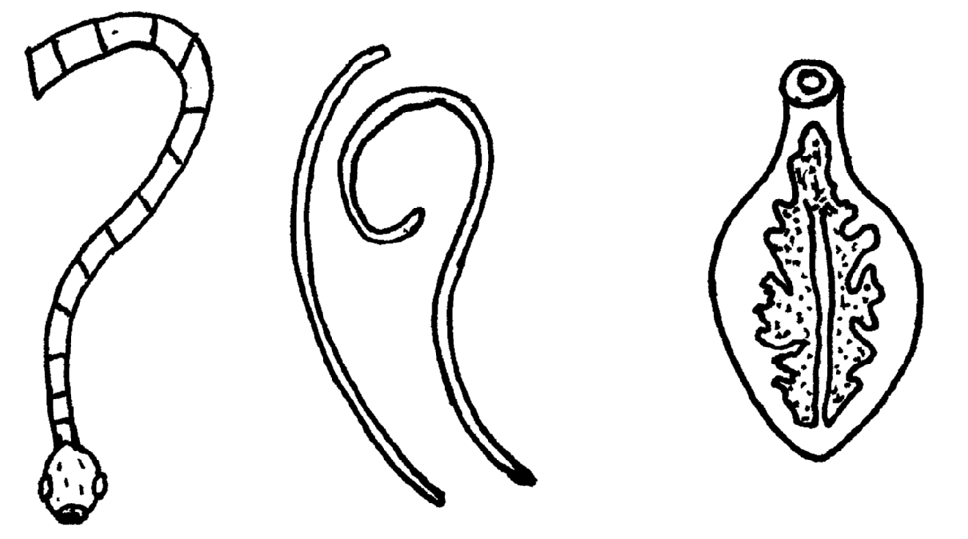

J
H
G

(a) Identify parasites G,H and J (1 ½ mks)
G……………………………………….
H……………………………………….
J………………………………………..
(b) Name the parts of the host body where parasites G and J are found (1mk)
……………………………………………………………………………………………………..
(c) Name the intermediate host of parasites G and J (1mk)
……………………………………………………………………………………………………..
……………………………………………………………………………………………………..

(d) Outline four symptoms of attack in livestock by parasite J (2mks)
……………………………………………………………………………………………………..
……………………………………………………………………………………………………..
……………………………………………………………………………………………………..
……………………………………………………………………………………………………..
22. Study the diagram of an ox-drawn plough below and answer the questions that follow

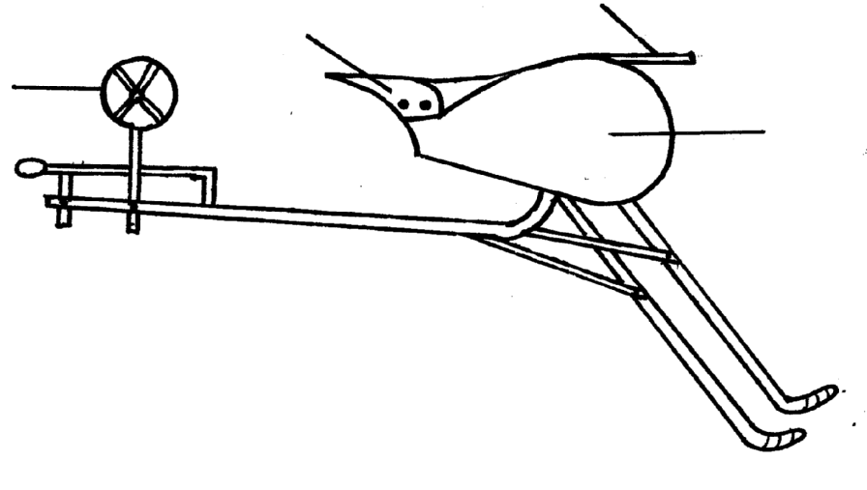
MS
LS
TS
S

(a) Name the parts labeled T,M, L and S (2mks)
……………………………………………………………………………………………………..
……………………………………………………………………………………………………..
……………………………………………………………………………………………………..
……………………………………………………………………………………………………..
(b) State three maintenance practices carried out on the above implement ( ½ mk)
……………………………………………………………………………………………………..
……………………………………………………………………………………………………..
……………………………………………………………………………………………………..
(c) State the function of the parts labeled T and S (1mk)
……………………………………………………………………………………………………..
(d) What adjustment should be carried out on the implement so as to reduce the depth of
Ploughing ( ½ mk)
……………………………………………………………………………………………………..

23. The following diagram shows parts of a roof. Study it carefully and answer the questions that follow
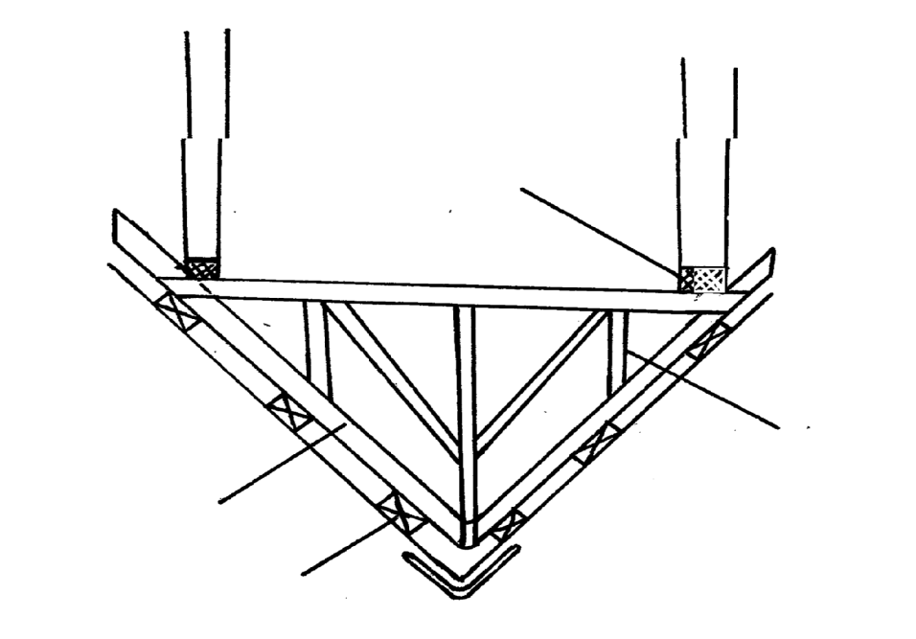
P
R
O
Q
(a) Name the parts labelled O,P,Q and R (2mks)
R……………………………………….
O……………………………………..
P……………………………………….
Q………………………………………
(b) State the function of the part labeled O and R (1mk)
……………………………………………………………………………………………………..
……………………………………………………………………………………………………..
(c) Give three reasons for treating timber before use in the construction of farm structures ( 1 ½ mk)
……………………………………………………………………………………………………..
……………………………………………………………………………………………………..
……………………………………………………………………………………………………..
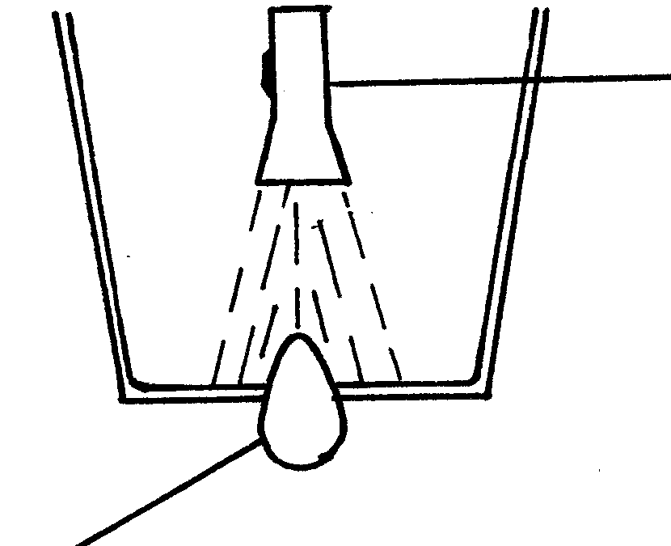
24. The following diagram shows an activity which is carried out by a poultry farmer. Study it carefully and answer the questions that follow

Egg
Torch

(i) (a) Identify the equipment being used (1mk)
……………………………………………………………………………………………………..
(b) State two uses of the above equipment in poultry production (1mk)
……………………………………………………………………………………………………..
……………………………………………………………………………………………………..
(c) Outline three qualities of good eggs for incubation (1 ½ mk)
……………………………………………………………………………………………………..
……………………………………………………………………………………………………..
……………………………………………………………………………………………………..
(ii) Below is an illustration showing one of the four strokes of a four stroke cycle engine.
Study it carefully and answer the questions that follow
Spark plug
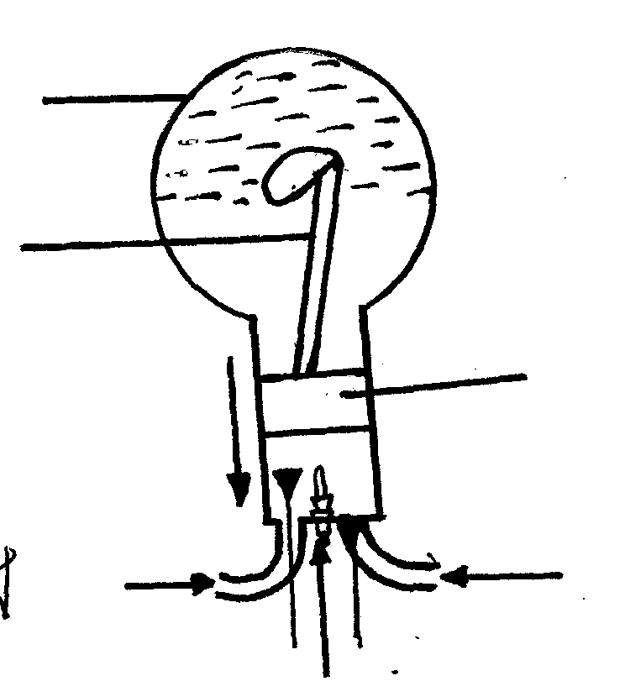

V
T
Crank case
Inlet valve
Exhaust valve

(a) Identify the stroke illustrated above ( ½ mk)
……………………………………………………………………………………………………..
(b) Name the parts labeled T and U (1mk)
……………………………………………………………………………………………………..
……………………………………………………………………………………………………..
(c) Identify the material contained in the crankcase ( ½ mk)
……………………………………………………………………………………………………..
SECTION C (40 MARKS)
Answer any two question

25 (a) State and explain five factors that influence the power of the output of draught animals (10mks)
(b) Discuss the factors that farmers should consider when constructing a poultry deep litter house (10mks)
26. (a) Describe the maintenance practices carried out on a tractor battery (10mks)
(b) Describe the management of a dairy heifer calf from birth until it is mature for first service (10mks)
27. (a) State four advantages of the long stroth beehive (4mks)
(b) Describe the procedure of processing wax (8mks)
(c) Outline the uses of farm fences (8mks)

