Name…………………………………… …………………………..………… Index No:………………………….

231/2 Candidate’s Signature …………..……………
BIOLOGY Date: …………………………
Paper 2
(Theory)
March/April 2014
Time: 2 Hours

Kenya Certificate of Secondary Education (K.C.S.E.)

Biology
Paper 2
(Theory)
March/April 2014
Time: 2 Hours

INSTRUCTIONS TO CANDIDATES

- Write your name and index number in the spaces provided above
- Sign and write the date of examination in the spaces provided.
- This paper consist of two sections A and B.
- Answer all the questions in section A in the spaces provided.
- In section B answer question 6 (Compulsory) and either question 7 or 8 in the spaces provided after question 8
For Examiners Use Only
SECTION | QUESTION | MAX.SCORE | CANDIDATE’S SCORE
A | 1  2  3  4  5 | 8  8  8  8  8
B | 6  7  8 | 20  20  20

This paper consists of 8 printed pages. Candidates should check to ascertain that all pages are printed as indicated and that no questions are missing.
1. (a) Name one human disorder caused by gene mutation and are not sex-liked. (1mrk)
(b) Study the genetic chart below showing inheritance of a gene responsible for sickle cell condition
In a family (Note; Let HbA represent gene for normal hemoglobin, and Hbs to represent gene for sickle cell trait).

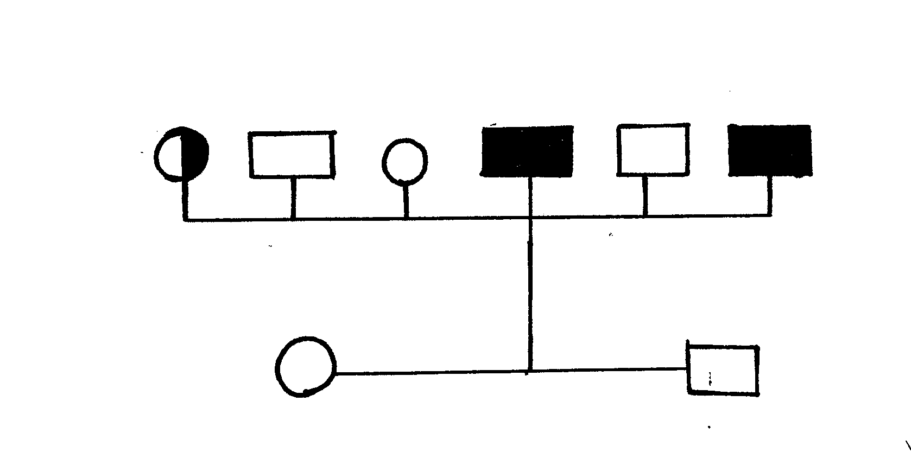
6
5
4
3
2
1

KEY:
Normal male
Woman with sickle cell trait
Man with sickle cell anemia
Woman with sickle cell anemia
Normal female
(i) Write the genotypes for individual number 1 and 6. (2mrks)
1 ……………………………………………………………….
6 ………………………………………………………………
(ii) Suppose a family member 6 marries a male with sickle cell anemia, what will be the phenotypic ratio of the off springs? Show your working. (4mrks)
…………………………………………………………………………………………………………………………………………………………………………………………………………………………………………………………………………………………………………………………………………………………………………………………………………
(iii) What are sex –linked gene? (1mrk)
……………………………………………………………………………………………………………………………………………………………………………………………………
2. Student in a certain school carried out an ecological study of woodland and recorded the following observations.
(i) Rabbits feed on plants.
(ii) Hawks feed on rabbits and small birds.
(iii) Snails feed on plants.
(iv) Small birds feed on snails.
(v) Fox feeds on rabbits and small birds.

- Using the above observations, construct a food web. (3mrks)

- From your web,
- Draw a food chain that ends with hawks as tertiary consumer. (1mrk)

- Name two carnivores that compete in the woodland and state the food they compete for. (1mrk)

- Suggest the most likely method of sampling used to estimate the rabbit population in the woodland. (1mrk)
…………………………………………………………………………………………………
- State two precautions the student have taken when using the sampling method named in (c) above.
- ………………………………………………………………………………………………
- ………………………………………………………………………………………………
3. The equation below shows a chemical reaction that takes place in green plants under certain conditions.
Carbon (IV) oxide + water Glucose + X.

(a) What is the name of substance X? (1mrk)
……………………………………………………………………………………………………..
(b) Other than the reagents, state two conditions necessary for this reaction. (2mrks)
(i) ……………………………………………………………………………………….
(ii) ………………………………………………………………………………………
(c) Name two types of cells in which this process occurs. (2mrks)
……………………………………………………………………………………………………
…………………………………………………………………………………………………….
- Name the process represented by the equation given above. (1mrk)
……………………………………………………………………………………………………
…………………………………………………………………………………………………….
- State two importance of the above process. (2mrks)
……………………………………………………………………………………………………
…………………………………………………………………………………………………….

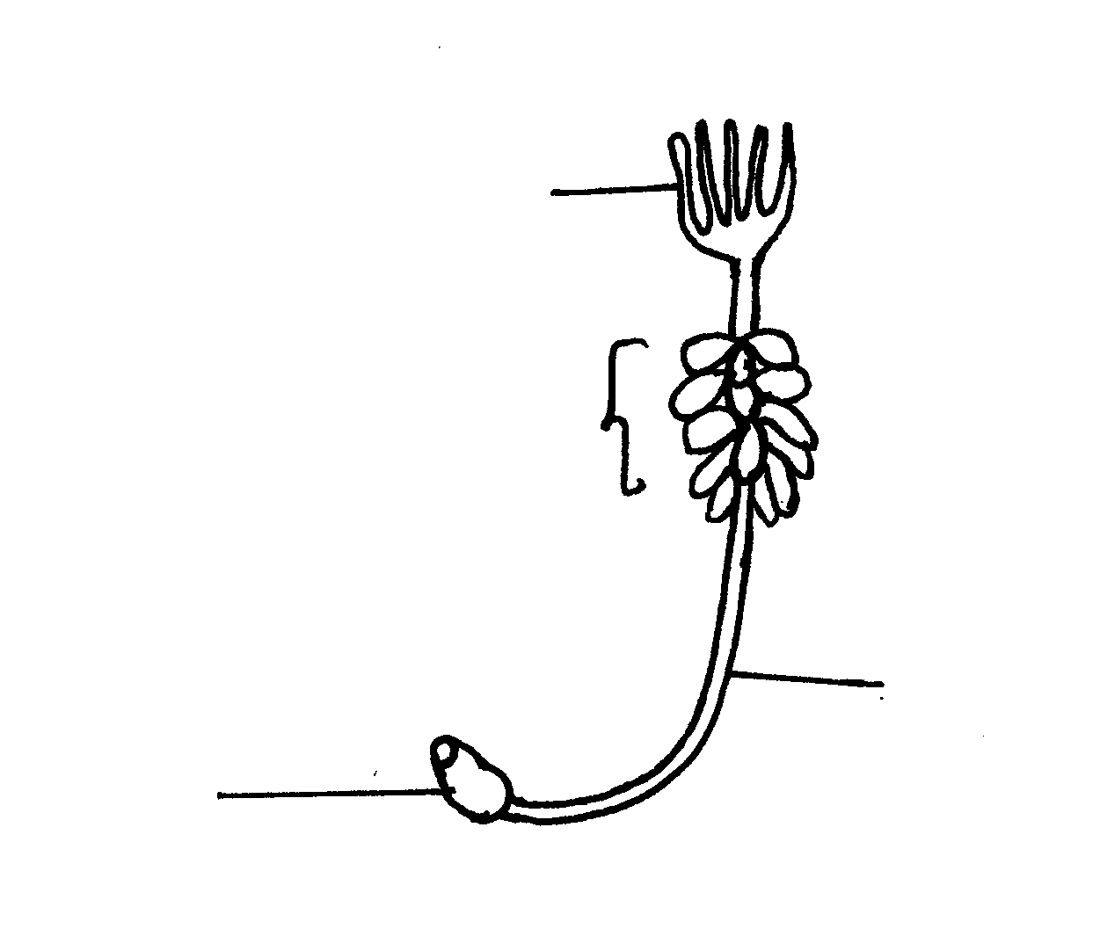
4. The diagram below represents certain type of plant.

B
C
D
A
- Identify the division of plant kingdom the plant belongs. (1mrk)
……………………………………………………………………………………………………
……………………………………………………………………………………………………
- Name the part labeled A,B and D. (3mrks)
A ………………………………………………………………………………………..
B ………………………………………………………………………………………..
D ………………………………………………………………………………………
- State two functions of part labeled C. (2mrks)
……………………………………………………………………………………………………
……………………………………………………………………………………………………
- Sate two characteristics of the division the plant belongs. (2mrks)
……………………………………………………………………………………………………
……………………………………………………………………………………………………
5. The diagram shows a plant cell after having been subjected to certain treatment.
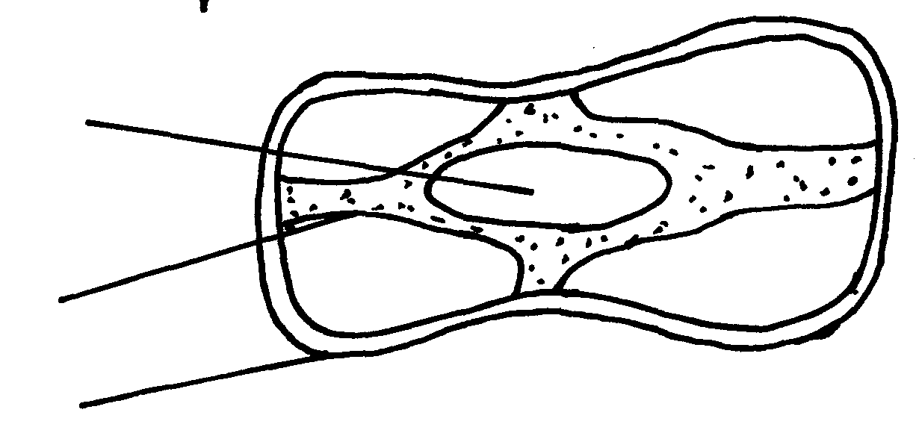
A

B

Sap vacuole

(a) Name the physiological process being investigated. (1mrk)
……………………………………………………………………………………………………
……………………………………………………………………………………………………
(b) Account for the shape of the cell shown above. (3mrks)
……………………………………………………………………………………………………
……………………………………………………………………………………………………
……………………………………………………………………………………………………
……………………………………………………………………………………………………

(c) State the functions of the parts labeled A and B. (3mrks)
A ………………………………………………………………………………………..
B ………………………………………………………………………………………..
SECTION B
Answer question 6 compulsory in the paces provided. Answer either question 7 or 8 in the spaces provided after question 68.

6. An investigation was conducted to compare water loss from twigs of two species, of plants Q and L. The apparatus shown below was used for the investigation. The twigs had equal leaf surface.

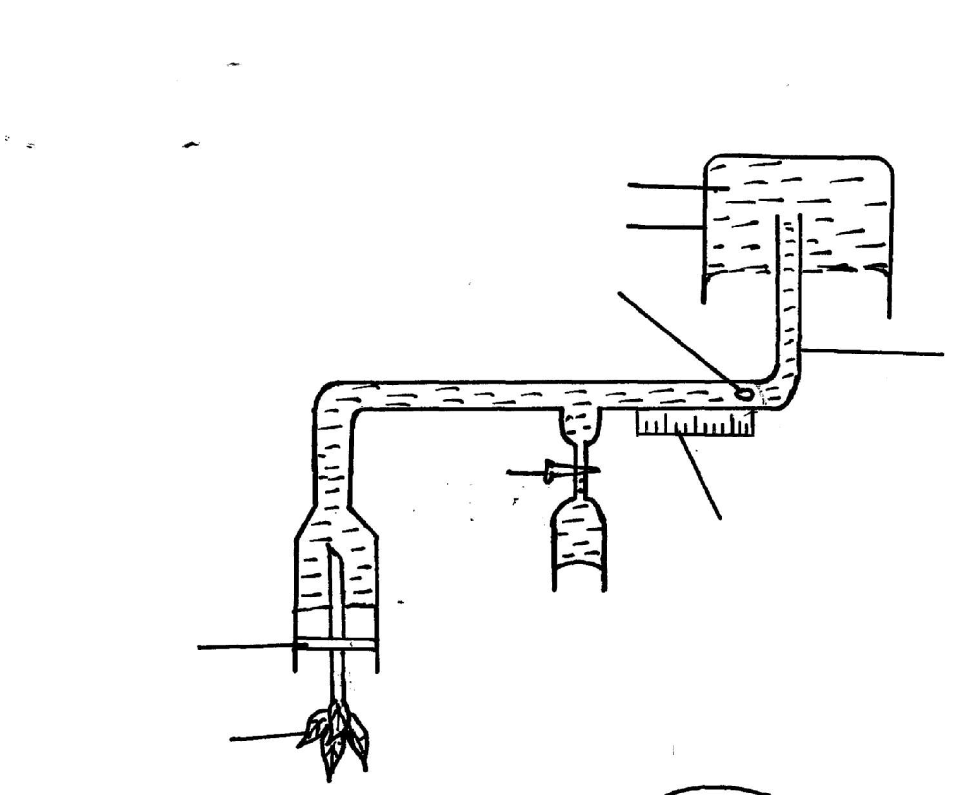
Water
Beaker
Air bubble
Capillary tubing
Ruler
Tap
Rubber band
Leaf shoot

- The results of the investigation were recorded in the table below.

Time of day | 6.am | 8.am | 10.am | 12noon | 1pm | 2pm | 3pm | 4pm | 6pm | 8pm | 12midnight
Water loss gh⁻¹ | 0 | 4 | 20 | 40 | 55 | 36 | 26 | 20 | 2 | 0 | 0
Water loss gh⁻¹ species L | 8 | 20 | 39 | 131 | 198 | 182 | 130 | 81 | 45 | 12 | 12

- Plot a graph of water-loss gh⁻¹ against time for the two plan. (7mrks)

