**Name**…………………………………… …………………………..………… Index No:………………………….

233/2 Candidate’s Signature …………..……………

**Chemistry** Date: …………………………

Paper 2

(Theory)

March/April 2014

**Time: 2 Hours**

***Kenya Certificate of Secondary Education (K.C.S.E.)***

**Chemistry**

Paper 2

(Theory)

**INSTRUCTIONS TO CANDIDATES**

* Write your name and Index number in spaces provided above.
* Sign and write the date of examination in the spaces provided above
* Answer all the questions in the spaces provided above.
* KNEC Mathematical tables and silent electronic calculators may be used.
* All working must be clearly shown where necessary.
* Candidates should answer the questions in English.

**For Examiners Use Only**

|  |  |  |
| --- | --- | --- |
| **Question** | **Maximum score** | **Candidate’s score** |
| 1 | 13 |  |
| 2 | 11 |  |
| 3 | 10 |  |
| 4 | 12 |  |
| 5 | 12 |  |
| 6 | 12 |  |
| **7** | **10** |  |
| **Total score** | **80** |  |

*This paper consists of 8 printed pages. Candidates should check to ascertain that all pages are printed as indicated and that no questions are missing.*

1. Study the information in the table below and answer the questions that follow. The letters do not represent actual symbols of the elements

|  |  |  |  |  |  |
| --- | --- | --- | --- | --- | --- |
| Element | Atomic number | Melting point (oC) | Boiling point (oC) | Atomic radii (nm) | Ionic radius (nm) |
| L  M  N  P  Q  R  S  T  U | 3  9  11  12  13  15  16  17  19 | 179  -220  98  650  660  44.2,590  113,119  -101  63.5 | 1340  -188  890  1110  2470  280  445  -35  775 | 0.108  0.101  0.135  0.126  0.125  0.111  0.103  0.109  0.107 | 0.100  0.105  0.132  0.124  0.120  0.119  0.109  0.120  0.160 |

(a) Write the electronic configuration of an ion of element **T** and **U**

**T**……………………………………………………….. ( ½ mk)

**U**………………………………………………………. ( ½ mk)

(b) Why do elements represented by **R** and **S** have two values of melting points (1mk)

…………………………………………………………………………………………………………………………………………………….

(c) Explain the following observations in terms of structure and bonding

(i) There is an increase of boiling points and melting points from **N** to **Q** (2mks)

…………………………………………………………………………………………………

…………………………………………………………………………………………………

…………………………………………………………………………………………………

(ii) There is an decrease in melting points from **R** to **T** (2mks)

…………………………………………………………………………………………………

…………………………………………………………………………………………………

(d) Select an element

(i) Which is most electronegative (1mk)

…………………………………………………………………………………………………

(ii)That belongs to period (IV) (1mk)

…………………………………………………………………………………………………

(iii) That is a gas at room temperature (1mk)

…………………………………………………………………………………………………

…………………………………………………………………………………………………

e) Explain why

(i) Ionic radius of **R** is bigger than its atomic radius (1mk)

…………………………………………………………………………………………………

…………………………………………………………………………………………………

(ii) Atomic radius of **L** is bigger than its ionic radius (1mk)

…………………………………………………………………………………………………

…………………………………………………………………………………………………

(f) Give the formula of

(i) An oxide of element **Q** (1mk)

…………………………………………………………………………………………………

(ii) Chloride of element **R** (1mk)

…………………………………………………………………………………………………

2.

SO2

SO3

F

H2SO4(l)

G

HNO3

**C**

**B**

NH3

**E**

Air

Step 3

Step 4

H

D

Step 5

Step 6

D

A

A

A

Step 2

Step 1

H2(g)

N2(g)

(a) Name substances (2mks)

**A**…………………………………………..

**B**…………………………………………..

**D**…………………………………………..

**F**…………………………………………..

(b) Substance **E** and ammonium nitrate have one common use. State the use (1mk)

…………………………………………………………………………………………………

(c) Name the suitable catalyst in step 3 (1mk)

…………………………………………………………………………………………………

(d) Write the chemical equation in step 4 (1mk)

…………………………………………………………………………………………………

(e) Identify **two** gaseous environmental pollutants from the above flow chart (1mk)

…………………………………………………………………………………………………

(f) State the observation when potassium hydroxide is warmed with substance **G** (1mk)

…………………………………………………………………………………………………

(g) Calcium oxide can react with Sulphur (VI) oxide to form calcium sulphate. State the

property which makes it possible for calcium oxide to react. (1mk)

…………………………………………………………………………………………………

…………………………………………………………………………………………………

(h) Write a chemical equation where concentrated sulphuric (VI) acid is used as an oxidizing agent (2mks)

(i) What type of reaction is shown below?

KNO3(s) + H2SO4(l) KHSO4(aq) + HNO3(g)

…………………………………………………………………………………………………

…………………………………………………………………………………………………

3. Study the flow chart below and use it to answer the questions that follow

Compound Q

Step 4 Ethanol H+

Heat

step 5

Compound N

H+/KMnO4(aq)

step 5

CH3CH2CH2Na + gas A

Alcohol M

step 3 Conc. H2SO4 170oC

HBr

Room temperature

gas H2

step 1

Compound S

Compound R

Compound P

step 2

-CH-CH2-CH-CH-

+ n

CH3

CH3

(a)Name and give the molecular formula of each of the following

**M**……………………………………………………………………………………………..(1mk)

**P**……………………………………………………………………………………………..(1mk)

**S**……………………………………………………………………………………………..(1mk)

**R**……………………………………………………………………………………………..(1mk)

(b) State the conditions necessary in step **1** (1mk)

…………………………………………………………………………………………………

…………………………………………………………………………………………………

(c) Write the chemical equation for the reactions in step **4** (1mk)

…………………………………………………………………………………………………

…………………………………………………………………………………………………

(d) Name **T** (1mk)

…………………………………………………………………………………………………

(e) (i) Calculate the mass of salt U that would be formed using 10.95 tones of N when it

reacts with excess sodium hydroxide *(C=12,H=1,Na=23, O=16)* (2mks)

(ii) Why is sodium hydroxide used in excess (1mk)

…………………………………………………………………………………………………

…………………………………………………………………………………………………

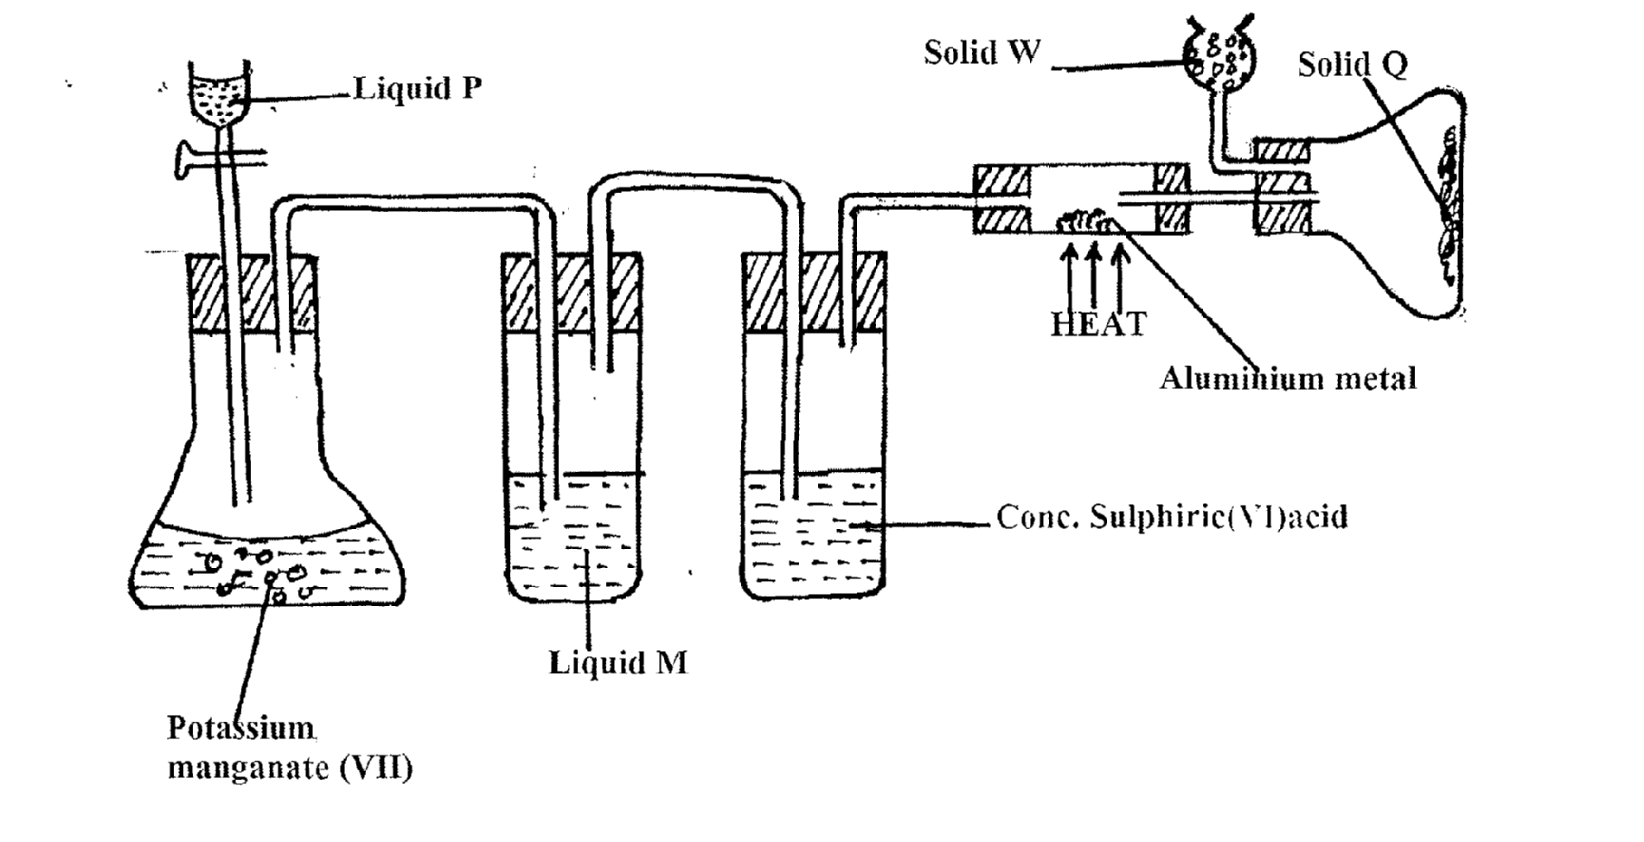4. (a) Study the diagram below and use it to answer the questions that follow

**Solid Q**

**Solid W**

**Liquid P**

**Aluminum metal**

**HEAT Solid W**

(i) Name liquid:

**Liquid M**

**Conc. Sulphuric (VI) acid**

**P**……………………………………………………….. (1mk)

**Potassium manganate (VII)**

**M**………………………………………………………. (1mk)

(ii) What is the function of concentrated sulphuric (VI) acid in the set-up? (1mk)

…………………………………………………………………………………………………

…………………………………………………………………………………………………

(iii) Suggest a suitable reagent than can be used as solid **W** (1mk)

…………………………………………………………………………………………………

…………………………………………………………………………………………………

(iv) State the role of solid **W** in the set up (1mk)

…………………………………………………………………………………………………

…………………………………………………………………………………………………

(v) Explain why solid **Q** collect further away from heated aluminum metal (1mk)

…………………………………………………………………………………………………

…………………………………………………………………………………………………

(vi) In the reaction above, 0.645g of aluminum metal reacted completely with 1800cm3 of chlorine gas at room temperatures. Determine the molecular formula of solid **Q**, given that its relative formula mass is 267 (Al= 27.0, Cl=35.5, molar volume of gas at r.t.p is 24.0 litres) (3mks)

(b) The flow chart below shows part of an analysis of a mixture that contains two salts

Step I

Step II

Add dilute hydrochloric acid

Mixture

Residue

Filtrate

Two metallic oxides H2O(g) CO(g) NO2(g) and O2(g)

(i) What conditions is necessary for the process in step I to take place? (1mk)

…………………………………………………………………………………………………

…………………………………………………………………………………………………

(ii) Draw a well labeled set-up of apparatus that could be used to separate the mixtures formed

in step II (2mks)

5. The flow chart below shows industrial extraction of aluminum metal. Study it and answer questions that follow

Bauxite (Al2O3.XH2O) with Iron oxides and silicate as impurities

Aluminum (Al2O3) with Iron oxide and silicates

Solution containing Al(OH)-4 ions

Residue P

Molten aluminum oxide

Pure solid aluminum oxide

Molten aluminum

Duralam alloy for air craft part 2 and window frames

Metal foil lining for food packets

Heat

Process T

Precipitation and heating

Cryolite

heat

(a) (i) Explain how process **T** is carried out (2mks)

…………………………………………………………………………………………………

…………………………………………………………………………………………………

(ii) Name the residue **P** gives a reason (1mk)

…………………………………………………………………………………………………

…………………………………………………………………………………………………

(iii) Explain why is it necessary to heat aluminum oxide in the presence f cryolite

before electrolysis is carried out (1mk)

…………………………………………………………………………………………………

…………………………………………………………………………………………………

(b) Suggest a reason why:

(i) Aluminum is not used for marine purpose? (1mk)

…………………………………………………………………………………………………

(ii) Carbon is not used for the reduction of aluminum oxide (1mk)

…………………………………………………………………………………………………

…………………………………………………………………………………………………

(c)What properties of Aluminum and its alloy make them suitable for the user as indicated?

…………………………………………………………………………………………………

…………………………………………………………………………………………………

(d) When 3.12g of hydrated aluminum oxide (Al2O3.XH2O) was heat to a constant mass 20.6g

of aluminum oxide (Al2O3) was obtained. Determine the value of **X** in hydrated oxide

*(Al=27.0, O=16.0, H=1.0)*

6. (a) In an experiment to determine the enthalpy change for the displacement reaction:

Mg(s) + Zn2+(aq)  Mg2+(aq) + Zn(s)

25cm3 of 1M Zinc chloride solution was placed in a beaker. The temperature of the solution was recorded every half minute for 1 ½ minutes. At exactly two minutes, excess Zinc powder was added and temperature of the mixture recorded every half minutes. The mixture was stirred continuously with a thermometer during the experiment. The results obtained are given below

|  |  |  |  |  |  |  |  |  |  |  |
| --- | --- | --- | --- | --- | --- | --- | --- | --- | --- | --- |
| Time (min) | 0.0 | 0.5 | 1.0 | 1.5 | 2.0 | 2.5 | 3.0 | 3.5 | 4.0 | 4.5 |
| Temp (oC) | 24.5 | 25.0 | 25.0 | 25.0 | - | 70.0 | 72.0 | 71.0 | 70.0 | 68.0 |

(i)Plot a graph of temperature (vertical axis) against time (4mks)

ii) Determine the maximum temperature rise from the graph (1mk)

(ii) Calculate the molar enthalpy of displacement of Zinc (II) ions by magnesium. Take density

of final solution =1 g/cm3, specific heat capacity of solution =4.2KJ/Kg/oC (3mks)

(b) (i) State Hess’ law (1mk)

…………………………………………………………………………………………………

…………………………………………………………………………………………………

(ii) Use the following equations to determine the heat of formation of butane

C(s) + O2(g)  CO2(g) ΔH1=-293KJ/mol

H2(g) + ½ O2(g)  H2O(g) Δ2=-286KJ/mol

C4H10(g) + 13/2O2(g)  4CO2(g)+5H2O(l) Δ=-2877KJ/mol

(I) Draw an energy cycle diagram for the information of butane (2mks)

(II) Calculate the heat of the formation of butane (2mks)

7. (a) Use the standard electrode potential for elements **A**,**B**,**C** ,**D** and **F** given below to answer the questions that follow, the letters do not represent the actual symbols of the elements

Eθ volts

A2+(aq) + 2e- A(s)  -2.90

B2+(aq) + 2e- B(s)  -2.38

C+(aq) + e- ½ C2(g) 0.00

D2+(aq) +2e- D(s) +0.34

F2(g) +e- F-(aq) +2.87

(i)Which element is likely to be hydrogen? Give a reason for your answer (2mks)

………………………………………………………………………………………………… …………………………………………………………………………………………………

(ii) In the space provided below, draw a labeled diagram of the electro chemical cell that would

be obtained when half cells of element **B** and **D** are obtained (3mks)

(iii) Calculate the Eθ value of the electrochemical cell constructed in (ii) above (1mk)

(b) During the electrolysis of aqueous copper (II) sulphate using copper electrodes, a current

of 0.2 amperes was passed through the cell for 5 hours

(i) Write an ionic equation for the reaction that took place at the anode (1mk)

…………………………………………………………………………………………………

…………………………………………………………………………………………………

(ii)Determine the change in the mass of the anode which occurred as a result of the electrolysis process *(Cu=63.5, 1 Faraday= 96500C)* (3mks)