312/1
GEOGRAPHY
Paper 1
March/April 2014
Time: 2 ¾ Hours

Kenya Certificate of Secondary Education (K.C.S.E.)

Geography
Paper 1
March/April 2014
Time: 2 ¾ Hours

INSTRUCTIONS TO CANDIDATES

- This paper has two sections A and B.
- Answer all questions in section A.
- Answer question 6 and any other two questions from section B..
- Candidates should answer the questions in English.

This paper consists of 4 printed pages. Candidates should check to ascertain that all pages are printed as indicated and that no questions are missing.
SECTION A
Answer all questions in this section

- The diagram below shows the structure of the earth.

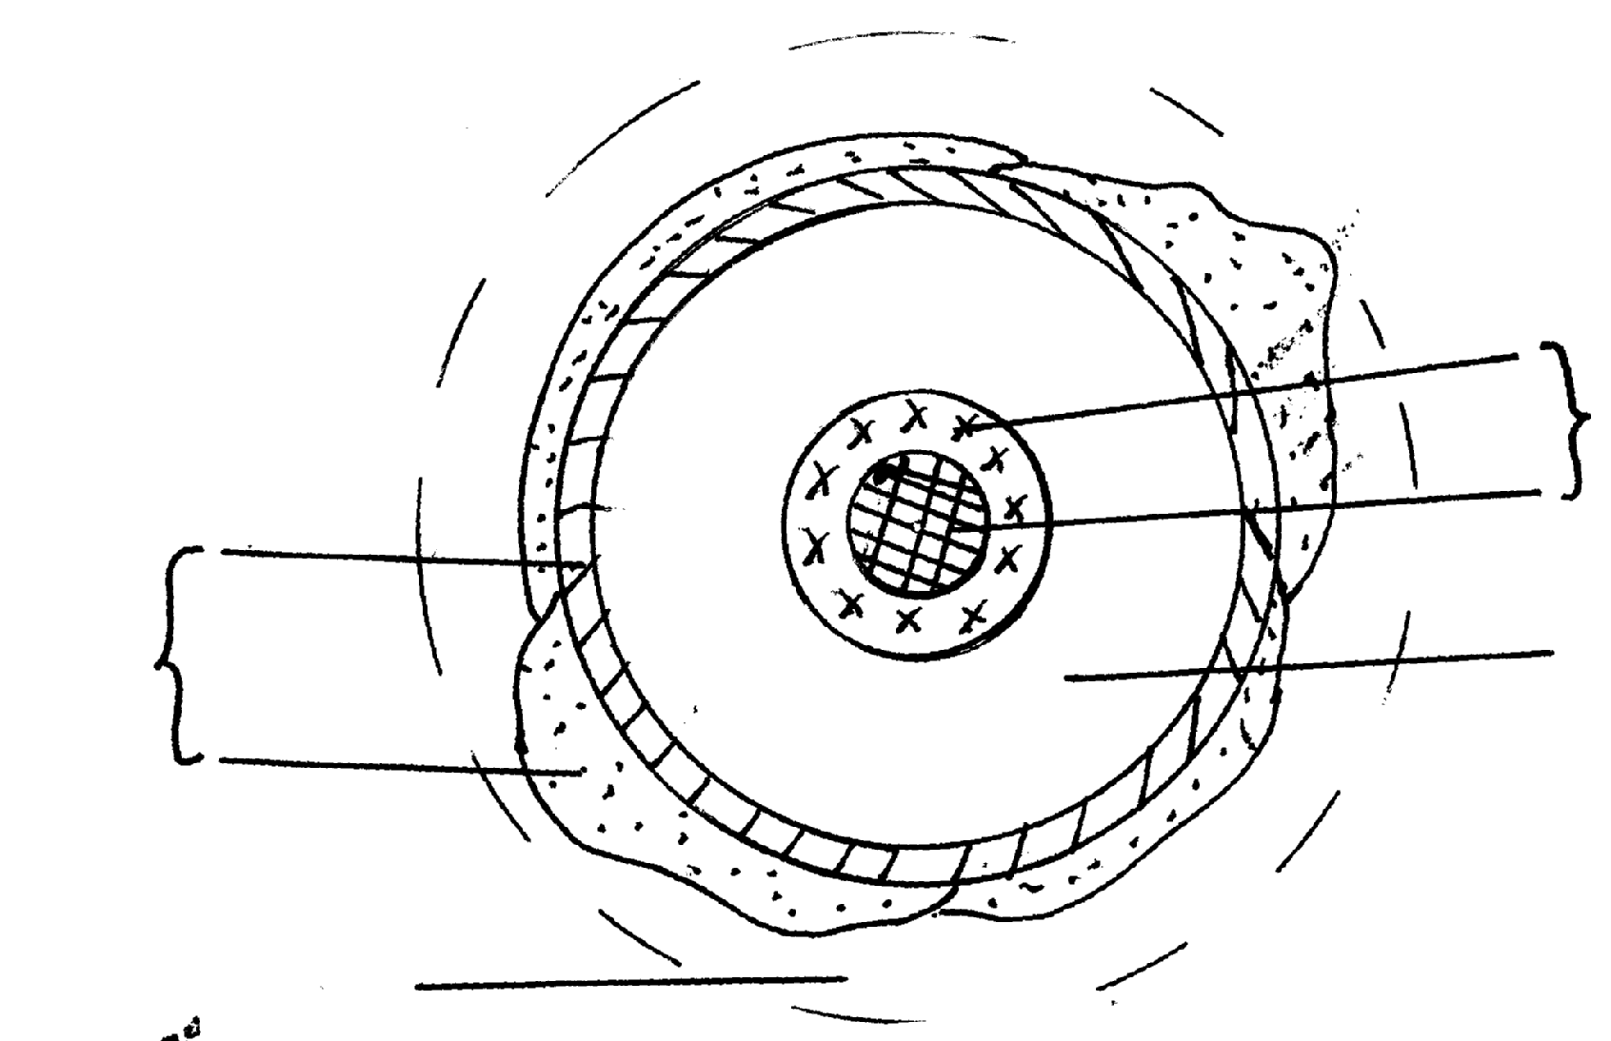
Inner core
Outer core
P
Sial
Sima
R

Barysphere

Q

- Name the parts labelled P,Q and R. (3mrks)
- Name the minerals that make up Sima. (2mrks)

2. (a) Draw a well labelled diagram of the hydrological cycle. (5mrks)
(b) State two ways in which underground water may reach the surface of the earth. (2mrks)

3. The diagram below shows some features found in the karst Scenery.
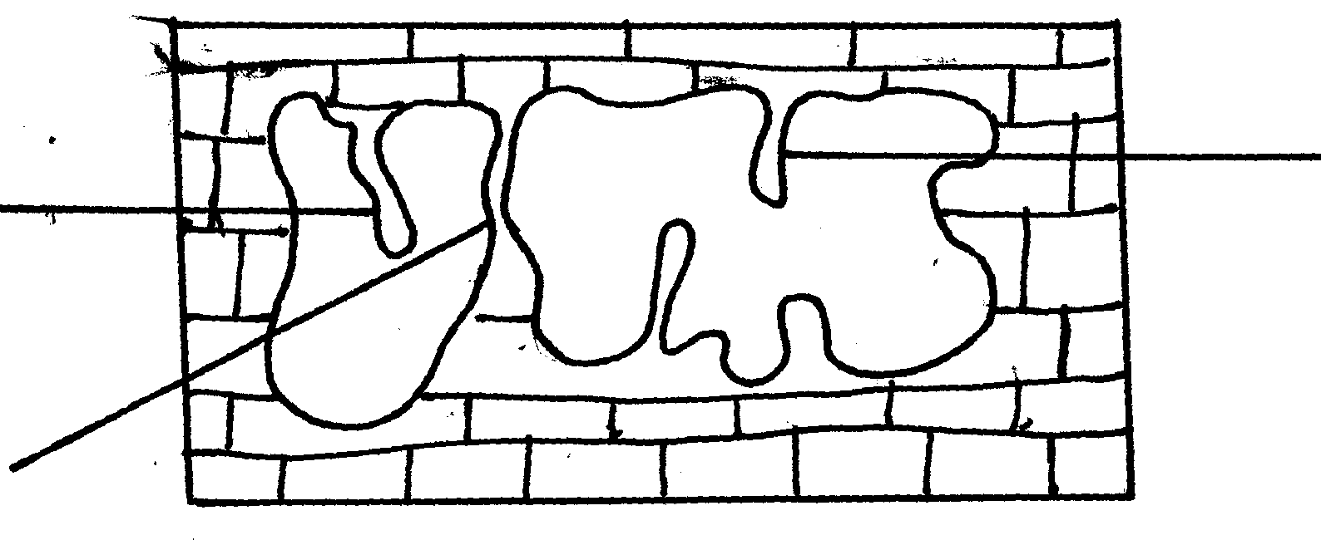

Y
Z
X

- Name the features marked X, Y and Z. (3mrks)

4. (a) State three causes of earthquakes. (3mrks)
(b) Give two effects of earthquakes in built up areas. (2mrks)

5. (a) Name three external land forming processes that lead to the formation of lakes. (3mrks)
(b) State two ways in which lakes influence natural environment. (2mrks)

SECTION B(75marks)
Answer question 6 and any other two questions from this section.

6. (a) (i) Convert the Ratio Scale of the map into statement scale. (1mrk)
(ii) Give the longitudinal and latitudinal extent of the area covered by the map. (2mrks)
(iii) Give the magnetic variation of the area covered by the map. (1mrk)

- (i) Calculate the area of mount Kenya forest to the east of the district boundary. Give your answer in km² (2mrks)
(ii) Citing evidence from the map state three economic activities of area covered by the map.
(3mrks)
- (i) Using ascale of 1cm to represent 50m, draw a cross-section from grid reference 800505 to 860505. On it mark and name
- River Sagana
- All weather road loose surface.
- Calculate the vertical exaggeration of your cross-section. (2mrks)
- (i) Describe the drainage of the area covered by the map. (5mrks)
(ii) Citing evidence from the map state three factors that influence distribution of settlement on the map. (3mrks)

7. (a) Give three examples of chemically formed sedimentary rocks. (3mrks)
(b) (i) State three conditions necessary for growth of corals. (3mrks)
(ii) Describe how coral rocks are formed. (4mrks)
- Explain four ways in which rocks contribute to the economy of Kenya. (8mrks)
- Some students are planning to carry out a field study on rock weathering around their school.
- List three secondary sources of information they are likely to use as they prepare for their study
- Apart from using secondary sources , State four ways in which they will prepare themselves for the study. (4mrks).

8. (a) State three characteristic of the inter tropical convergence zone. (3mrks)
(b) With the aid of a well labelled diagram; describe how relief rainfall is formed. (6mrks)
(c) State five characteristics of the hot desert climate. (5mrks)
(d)You intended to carry out a field study to determine the relationship between climate and vegetation in your district.
(i) Give three reasons why you will need the map of the district.. (3mrks)
(ii) Name two sampling techniques you are likely to use for this study. (2mrks)
(iii) Give two reasons why sampling would be appropriate for this field study. (2mrks)
(iv) Sate four methods you would use to record data during the field study. (4mrks)
9. (a) (i) Apart from the Rift Valley name two other relief features that were formed as a result of
faulting. (2mrks)
(ii) With aid of well labeled diagram, describe how a Rift Valley is formed by tensional
forces. (8mrks)
(b) Explain four effects of faulting on drainage. (8mrks)
(c) Student from Nambomboto sec school are planning to carry out a field study of an area affected
by faulting.
- State four reasons why it is important for students to have a pre-visit of the area.
- One of the ways they would use to collect data is through direct observation in the study of such an area. (3mrks)
- Give three disadvantages of direct observation in the study of such an area. (3mrks)

10. Use the diagram below to answer question (a)

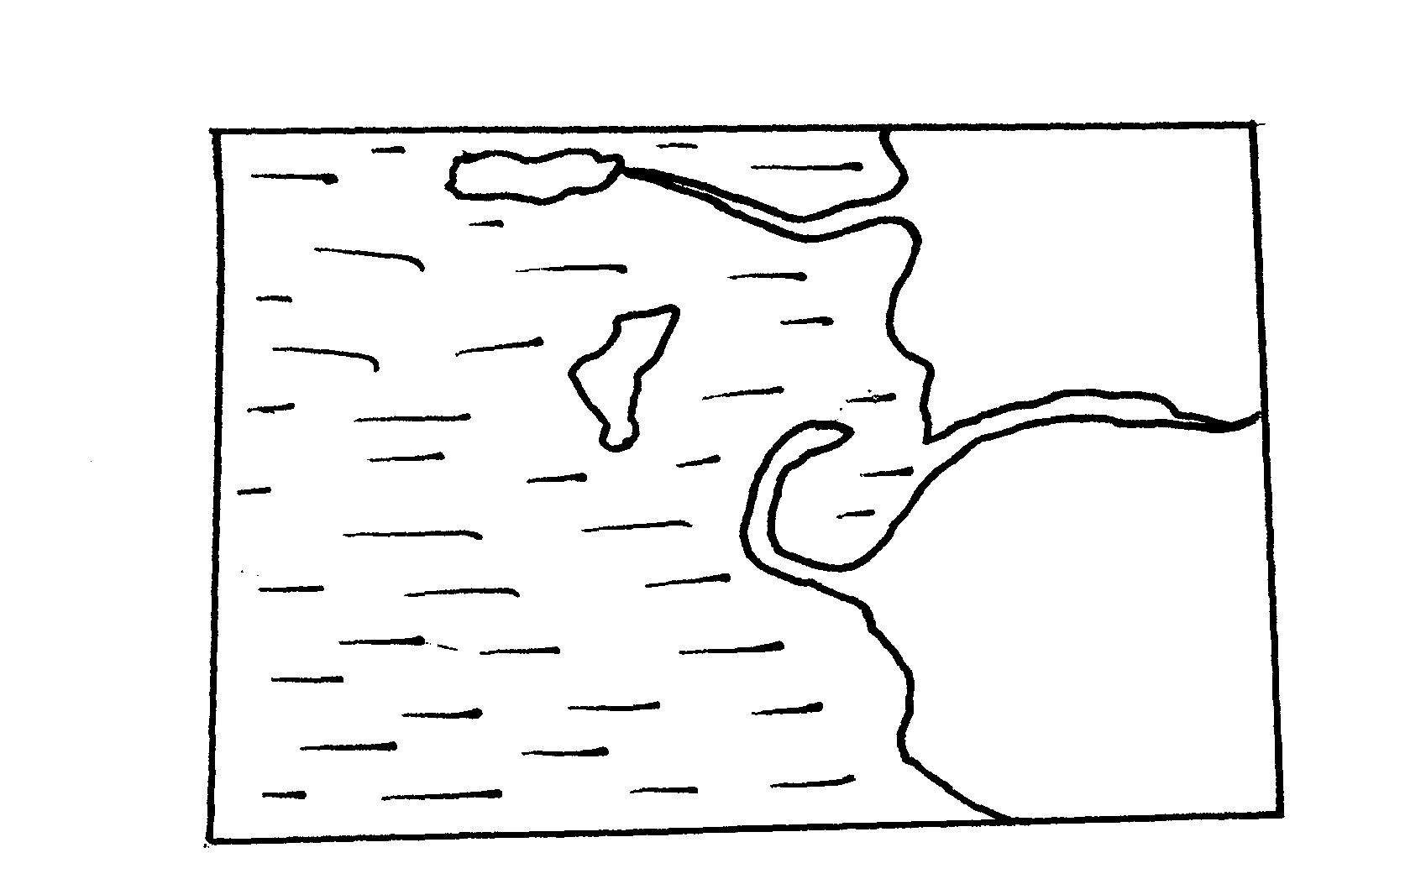
River M
Mainland
Ocean
Island
K
H
J

(a) Name the coastal features marked H,J,K,L and M. (5mrks)
(b) (i) Sate four conditions necessary for the formation of a beach. (4mrks)
(ii) Describe the processes involved in marine erosion. (6mrks)
(c) Explain how the following factors influence wave deposition
(i) Gradient of the shore. (4mrks)
(ii) depth of the sea. (4mrks)
- You are planning to carry out a field study on the deposition features along the coast of Kenya.
(i) State two objective you would formulated for your study. (2mrks)

