312/2

GEOGRAPHY

Paper 2

March/April 2014

**Time: 2 ¾ Hours**

***Kenya Certificate of Secondary Education (K.C.S.E.)***

**Geography**

Paper 2

March/April 2014

**Time: 2 ¾ Hours**

**INSTRUCTIONS TO CANDIDATES**

* This paper has two sections **A** and **B.**
* Answer ***all*** the questions in section **A**, in section **B** answer question 6 and any other two questions.
* All answers must be written in the answer sheets provided.

*This paper consists of 3 printed pages. Candidates should check to ascertain that all pages are printed as indicated and that no questions are missing.*

***SECTION A(25marks)***

***Answer all questions in this section***

1. (a) What is a polder? (1mrks)

(b) State **four** methods of land reclamation used in Kenya. (4mrks)

2. (a) State **three** physical conditions that are necessary for the growing of Cocoa in Ghana.(3mrks)

(b) Give **two** economic problems experienced in Cocoa growing in Ghana. (2mrks)

3. (a) Define eco-tourism. (2mrks)

(b) Give **three** reasons why the government is encouraging domestic tourism. (3mrks)

4. (a) Name **two** main areas in Kenya where geothermal energy is generated. (2mrks)

(b) State **three** physical factors that favour the location of hydroelectric power stations. (3mrks)

5. (a) What is containerization. (2mrks)

(b) State **three** factors that hinder the development of river transport in Africa. (3mrks)

***SECTION B(75marks)***

***Answer question 6 and any other two questions from this section.***

6. Study the population pyramid carefully and answer the following questions.

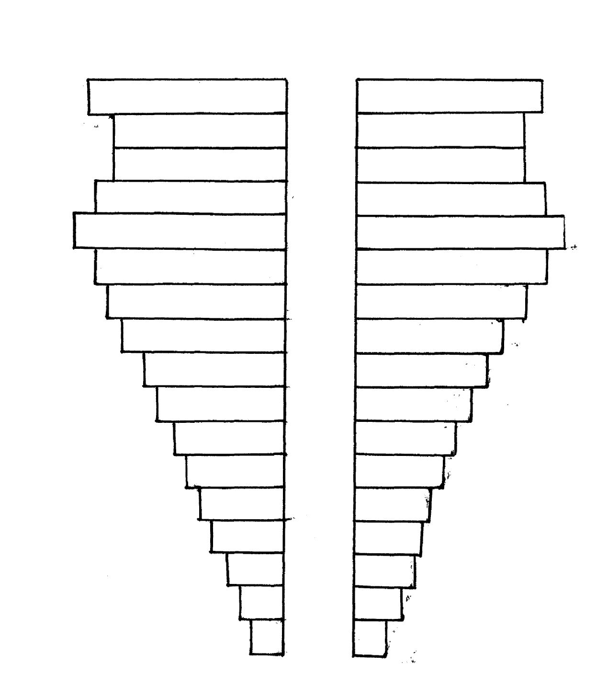

**80 and above**

**70-74**

**75-79**

**60-64**

**65-69**

**50-54**

**55-59**

**40-44**

**45-49**

**30-34**

**35-39**

**25-29**

**0-4**

**5-9**

**10-14**

**15-19**

**20-24**

1. (i) Identify the nature of country such a pyramid represents. (1mrk)

(ii)Describe the characteristics of the population represented by the pyramid. (5mrks)

(iii) Explain **three** socio economic implication of the population structure above. (6mrks)

1. Explain **four** factors that influence the rapid population growth in Kenya. (4mrks)
2. (i) State **three** causes of rural – rural migration. (3mrks)

(ii) Explain the effects of migration on the place of destination. (6mrks)

7. (a) Define

(i) Livestock ranching. (1mrk)

(ii) Transhumance. (1mrk)

(b) (i) Explain **three** problems facing nomadic pastoralists in Kenya. (3mrks)

(ii) Give **four** differences between beef farming in Kenya and Argentina. (4mrks)

(c) (i) State **three** problems facing dairy farming in Kenya. (3mrks)

(ii) Expalin the measures the Kenya government has taken to solve the problems above.(8mrks)

1. Explain **five** reasons why dairy farming is more developed in Denmark than Kenya. (5mrks)

8. (a) What is the relationship between ocean currents and abundance of fish. (3mrks)

(b) (i) Describe trawling as a major fishing method. (4mrks)

(ii) Explain **five** factors that have encouraged the fishing industry in Japan. (10mrks)

(c) Explain **four** problems experienced by fishermen while fishing in Lake Victoria. (8mrks)

9. (a) (i) What is mining? (2mrks)

(ii) State **three** effects of open cast mining on the environment. (3mrks)

(b) Describe how deep –shaft mining is carried out. (4mrks)

(c) Explain **four** factors that affect the formation of soda ash. (8mrks)

(d) Explain **four** problems facing the mining industry in Kenya.

10. (a) (i) What is agroforestry?. (2mrks)

(ii) Give **three** reasons why agroforestry is being encouraged in Kenya.

(b) (i) Give **two** reasons why hard wood tree species are in danger of extinction in Kenya. (2mrks)

(ii) Explain **three** factors that limit exploitation of tropical rainforests.

(c) Differentiate between forestry in Kenya and Canada.

(d) (i) Which **two** factors that favour the growth of forests on Mt. Kenya.

(ii) Name **two** problems that affect forestry in Kenya.