NAME ____________________________________ INDEX NO. _______________
SCHOOL ____________________________________ SIGNATURE _______________ DATE _______________

443/2
AGRICULTURE
PAPER 2
JULY/AUGUST, 2015
TIME: 2 HOURS

BRILLIANT

443/2
AGRICULTURE
PAPER 2
TIME: 2 HOURS

INSTRUCTIONS TO CANDIDATES
- Write your name, school and index number in the spaces provided above.
- Sign and write the date of the examination in the spaces provided above.
- This paper consists of three sections: A, B and C.
- Answer all the questions in section A and B and any two questions from section C.
- All answers must be written in the spaces provided in this booklet.
- This paper consists of 12 printed pages.
- Candidates should check the question paper to ascertain that all pages are printed as indicated and that no questions are missing

For OFFICIAL use only
SECTION | QUESTIONS | MAXIMUM SCORE | CANDIDATE’S SCORE
A | 1 − 19 | 30
B | 20− 22 | 20
C |  | 20
 |  | 20
 | TOTAL SCORE | 90

SECTION A (30MARKS)
Answer ALL the questions in this section in the spaces provided.
- State two reasons why drenching alone is not an effective method of controlling liver fluke. (1 mark)
______________________________________________________________________________________________________________________________________________________________________
- Name twodiseases in livestock that may be spread through breeding. (1 mark)
______________________________________________________________________________________________________________________________________________________________________
- Name two implements that may be connected to power take off shaft (P.T.O) on a tractor. (1 mark)
______________________________________________________________________________________________________________________________________________________________________
- State the functions of each of the following components in a tractor engine. (2 marks)
Carburetor
______________________________________________________________________________________________________________________________________________________________________
Lift pump
______________________________________________________________________________________________________________________________________________________________________
- State three uses of a spike tooth harrow. (1½ marks)
_________________________________________________________________________________________________________________________________________________________________________________________________________________________________________________________
- State four signs of kidding in nannies. (2 marks)
____________________________________________________________________________________________________________________________________________________________________________________________________________________________________________________________________________________________________________________________________________
- State four reasons for dehorning. (2 marks)
____________________________________________________________________________________________________________________________________________________________________________________________________________________________________________________________________________________________________________________________________________
- Differentiate between milk-let down and milk secretion in dairy cattle management. (1 mark)
____________________________________________________________________________________________________________________________________________________________________________________________________________________________________________________________________________________________________________________________________________
- Give the four strokes of a four stroke cycle engine. (2 marks)
____________________________________________________________________________________________________________________________________________________________________________________________________________________________________________________________________________________________________________________________________________
- State four qualities of a good feed store. (2 marks)
____________________________________________________________________________________________________________________________________________________________________________________________________________________________________________________________________________________________________________________________________________
- List four characters of a good creep feed. (2 marks)
____________________________________________________________________________________________________________________________________________________________________________________________________________________________________________________________________________________________________________________________________________
- Give four effects of livestock disease in agricultural production. (2 marks)
____________________________________________________________________________________________________________________________________________________________________________________________________________________________________________________________________________________________________________________________________________
- Give two limitations of coal as a source of farm power. (1 mark)
______________________________________________________________________________________________________________________________________________________________________
- List four precautions that should be followed when handling bees. (2 marks)
____________________________________________________________________________________________________________________________________________________________________________________________________________________________________________________________________________________________________________________________________________
- Which tool will be required for each of the following farm operations? (1 mark)
- Cutting overgrown hooves in sheep.
___________________________________________________________________________________
- Castrating piglets.
___________________________________________________________________________________
- State three demerits of live fences. (1½ marks)
_________________________________________________________________________________________________________________________________________________________________________________________________________________________________________________________
- Give two methods of drug administration in the control of endo-parasites. (2 marks)
______________________________________________________________________________________________________________________________________________________________________
- Under what conditions would a farmer prefer to use an ox-cart instead of a tractor-drawn
trailer? (2 marks)
____________________________________________________________________________________________________________________________________________________________________________________________________________________________________________________________________________________________________________________________________________
- Name two breeds of dual-purpose cattle. (1 mark)
______________________________________________________________________________________________________________________________________________________________________

SECTION B (20 MARKS)
Answer ALL questions from this section in the spaces provided
- Below is a diagram of an ox-plough.Use it to answer the questions that follow.
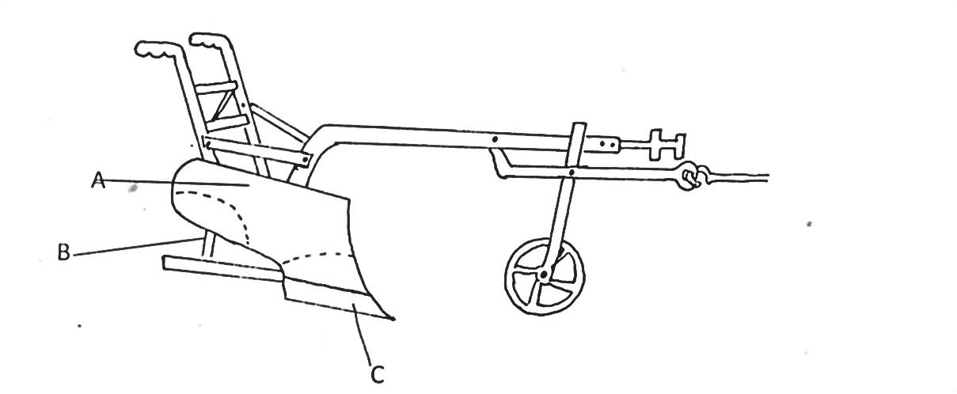
A
B
C
- Label the parts A – C. (3 marks)
A ______________________________________________________________________________
B ______________________________________________________________________________
C ______________________________________________________________________________
- State two adjustments done on the implement during working. (2 marks)
______________________________________________________________________________________________________________________________________________________________________
- State two advantages of an ox-plough over a tractor mouldboard. (2 marks)
____________________________________________________________________________________________________________________________________________________________________________________________________________________________________________________________________________________________________________________________________________

- Below are some care and maintenance practices for a certain farm tool.
- Knobs should be replaced when worn out.
- Cap iron should be replaced when worn out.
- Cutting edge should be sharpened on an oilstone when blunt.
- Identify the tool. (1 mark)
___________________________________________________________________________________
- Give three different types of the above named tool. (3 marks)
_________________________________________________________________________________________________________________________________________________________________________________________________________________________________________________________
- Name two other tools that can be used to do the same job as the above mentioned tools. (2 marks)
______________________________________________________________________________________________________________________________________________________________________
- The diagram below is across- section of part of a cow udder.
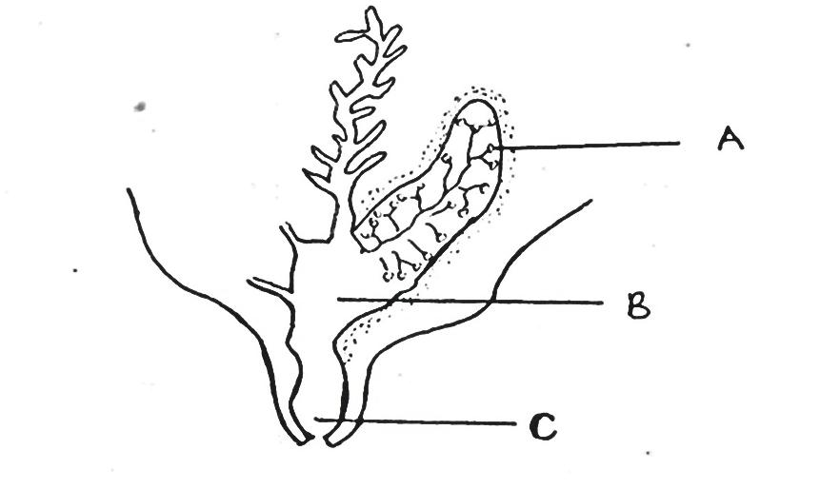
C
B
A
- Name the parts labelled A, B and C. (1½ marks)
A ______________________________________________________________________________
B ______________________________________________________________________________
C ______________________________________________________________________________
- What is milk letdown? (1 mark)
______________________________________________________________________________________________________________________________________________________________________
- State the hormone which stimulates milk letdown. (½ mark)
___________________________________________________________________________________
- State three practices which are carried out to control mastitis in lactating cows. (3 marks)
_________________________________________________________________________________________________________________________________________________________________________________________________________________________________________________________

SECTION C (40 MARKS)
Answer any TWO questions from this section in the spaces provided after question 25.
- a) State four major uses of a tractor in the farm. (4 marks)
b) List four disadvantages of using wood fuel as a source of power in the farm. (4 marks)
c) Name and explain functions of the main parts of a tractor that make up the transmission
system of atractor. (8 marks)
d) Explain the functions of four secondary tillage implements. (4 marks)

- a) What causes milk fever in dairy cows? (2 marks)
b) State five symptoms that would show that a cow is suffering from milk fever (5 marks)
c) How would the disease be controlled? (6 marks)
d) Name two other animals that may suffer milk fever. (2 marks)
e) Name five predisposing factors of diseases to livestock. (5 marks)

- a) Describe the factors a farmer would consider when selecting a young female pig (gilt)
for breeding. (5 marks)
b) Describe five requirements of a deep litter system. (5 marks)
c) Explain five routine management practices done on a calf. (10 marks)

____________________________________________________________________________________________________________________________________________________________________________________________________________________________________________________________________________________________________________________________________________________________________________________________________________________________________________________________________________________________________________________________________________________________________________________________________________________________________________________________________________________________________________________________________________________________________________________________________________________________________________________________________________________________________________________________________________________________________________________________________________________________________________________________________________________________________________________________________________________________________________________________________________________________________________________________________________________________________________________________________________________________________________________________________________________________________________________________________________________________________________________________________________________________________________________________________________________________________________________________________________________________________________________________________________________________________________________________________________________________________________________________________________________________________________________________________________________________________________________________________________________________________________________________________________________________________________________________________________________________________________________________________________________________________________________________________________________________________________________________________________________________________________________________________________________________________________________________________________________________________________________________________________________________________________________________________________________________________________________________________________________________________________________________________________________________________________________________________________________________________________________________________________________________________________________________________________________________________________________________________________________________________________________________________________________________________________________________________________________________________________________________________________________________________________________________________________________________________________________________________________________________________________________________________________________________________________________________________________________________________________________________________________________________________________________________________________________________________________________________________________________________________________________________________________________________________________________________________________________________________________________________________________________________________________________________________________________________________________________________________________________________________________________________________________________________________________________________________________________________________________________________________________________________________________________________________________________________________________________________________________________________________________________________________________________________________________________________________________________________________________________________________________________________________________________________________________________________________________________________________________________________________________________________________________________________________________________________________________________________________________________________________________________________________________________________________________________________________________________________________________________________________________________________________________________________________________________________________________________________________________________________________________________________________________________________________________________________________________________________________________________________________________________________________________________________________________________________________________________________________________________________________________________________________________________________________________________________________________________________________________________________________________________________________________________________________________________________________________________________________________________________________________________________________________________________________________________________________________________________________________________________________________________________________________________________________________________________________________________________________________________________________________________________________________________________________________________________________________________________________________________________________________________________________________________________________________________________________________________________________________________________________________________________________________________________________________________________________________________________________________________________________________________________________________________________________________________________________________________________________________________________________________________________________________________________________________________________________________________________________________________________________________________________________________________________________________________________________________________________________________________________________________________________________________________________________________________________________________________________________________________________________________________________________________________________________________________________________________________________________________________________________________________________________________________________________________________________________________________________________________________________________________________________________________________________________________________________________________________________________________________________________________________________________________________________________________________________________________________________________________________________________________________________________________________________________________________________________________________________________________________________________________________________________________________________________________________________________________________________________________________________________________________________________________________________________________________________________________________________________________________________________________________________________________________________________________________________________________________________________________________________________________________________________________________________________________________________________________________________________________________________________________________________________________________________________________________________________________________________________________________________________________________________
_____________________________________________________________________________________________________________________________________________________________________________________________________________________________________________________________________________________________________________________________________________________________________________________________________________________________________________________________________________________________________________________________________________________________________________________________________________________________________________________________________________________________________________________________________________________________________________________________________________________________________________________________________________________________________________________________________________________________________________________________
_____________________________________________________________________________________________________________________________________________________________________________________________________________________________________________________________________________________________________________________________________________________________________________________________________________________________________________________________________________________________________________________________________________________________________________________________________________________________________________________________________________________________________________________________________________________________________________________________________________________________________________________________________________________________________________________________________________________________________________________________
_____________________________________________________________________________________________________________________________________________________________________________________________________________________________________________________________________________________________________________________________________________________________________________________________________________________________________________________________________________________________________________________________________________________________________________________________________________________________________________________________________________________________________________________________________________________________________________________________________________________________________________________________________________________________________________________________________________________________________________________________
_____________________________________________________________________________________________________________________________________________________________________________________________________________________________________________________________________________________________________________________________________________________________________________________________________________________________________________________________________________________________________________________________________________________________________________________________________________________________________________________________________________________________________________________________________________________________________________________________________________________________________________________________________________________________________________________________________________________________________________________________
_____________________________________________________________________________________________________________________________________________________________________________________________________________________________________________________________________________________________________________________________________________________________________________________________________________________________________________________________________________________________________________________________________________________________________________________________________________________________________________________________________________________________________________________________________________________________________________________________________________________________________________________________________________________________________________________________________________________________________________________________
_____________________________________________________________________________________________________________________________________________________________________________________________________________________________________________________________________________________________________________________________________________________________________________________________________________________________________________________________________________________________________________________________________________________________________________________________________________________________________________________________________________________________________________________________________________________________________________________________________________________________________________________________________________________________________________________________________________________________________________________________
_____________________________________________________________________________________________________________________________________________________________________________________________________________________________________________________________________________________________________________________________________________________________________________________________________________________________________________________________________________________________________________________________________________________________________________________________________________________________________________________________________________________________________________________________________________________________________________________________________________________________________________________________________________________________________________________________________________________________________________________________
________________________________________________________________________________________________________________________________________________________________________________________________________________________________________________________________________________________________________________________________________________________________________________________________________________________________________________________________________________________________________________________________________________________________________________________________________________________________________________________________________________________________________________________

