NAME ____________________________________ INDEX NO. _______________
SCHOOL ____________________________________ SIGNATURE _______________ DATE _______________

231/1
BIOLOGY
(THEORY)

PAPER 1
JULY / AUGUST, 2017

TIME: 2 HOURS

BRILLIANT

231/1
BIOLOGY
(THEORY)
PAPER 1
TIME: 2 HOURS

INSTRUCTIONS TO CANDIDATES
- Write your name, school and index number in the spaces provided above.
- Sign and write date of examination in the spaces provided above.
- Answer all the questions in the spaces provided.
- Additional pages must not be inserted.
- Candidates may be penalized for false information and even wrong spellings of technical terms.
- This paper consists of8 printed pages.
- Candidates should check to ensure that all pages are printed as indicated and no questions are missing.

FOR OFFICIAL USE ONLY

Question | Maximum score | Candidate’s score
1 −26 | 80

- State two sense organs found in the arthropods for detecting stimuli. (2 marks)
______________________________________________________________________________________________________________________________________________________________________

- a) Which carbohydrate is likely to be:
- In human liver in large quantities? (1 mark)
___________________________________________________________________________________
- Stored in potato tuber? (1 mark)
___________________________________________________________________________________
b) Name two tissues in plants which are thickened with lignin. (2 marks)
______________________________________________________________________________________________________________________________________________________________________

- The diagram below shows the eggs of a certain amphibian.
Jelly
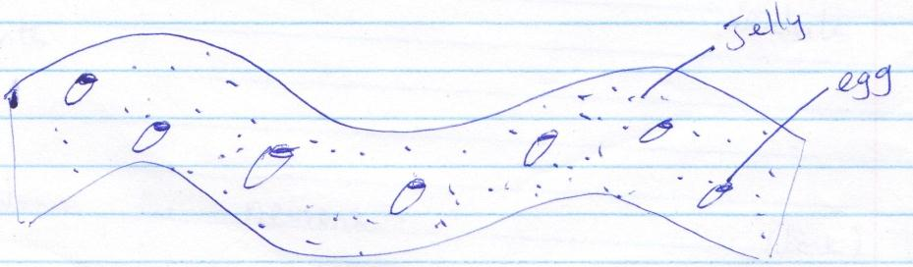
Egg
a) State the functions of the jelly. (3 marks)
______________________________________________________________________________________________________________________________________________________________________
______________________________________________________________________________________________________________________________________________________________________
b) What is the biological importance of the organism laying many eggs? (1 mark)
______________________________________________________________________________________________________________________________________________________________________

- State two functions of aerenchyma tissue in water plants such as water lily. (2 marks)
______________________________________________________________________________________________________________________________________________________________________

- a) Where in the human body are relay neurones found? (1 mark)
___________________________________________________________________________________

b) The diagram below represents a neurone.
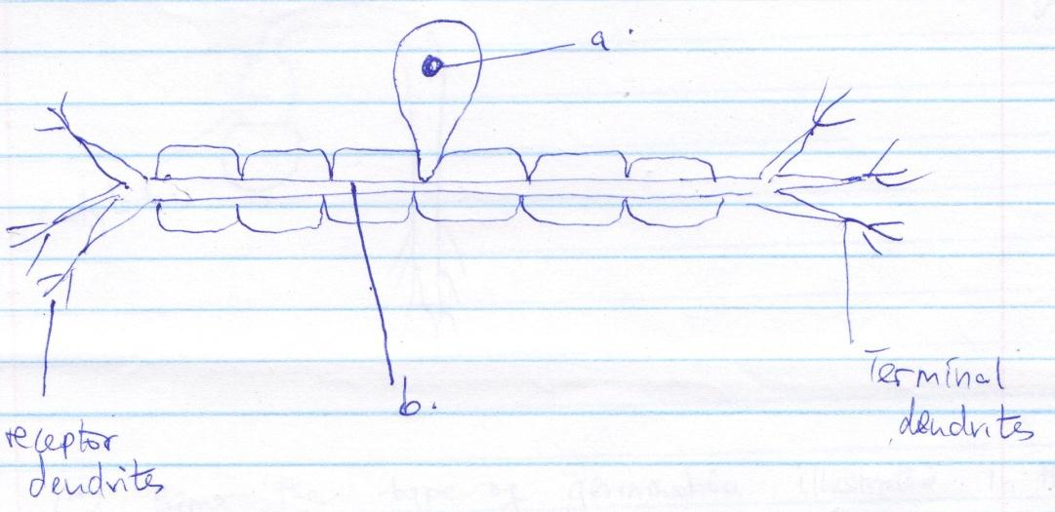
Terminal dendrites
Receptor dendrites
b
a
i) Name the neurone. (1 mark)
___________________________________________________________________________________
ii) Name the parts labelled a andb.
a _____________________________________________________________ (1 mark)
b _____________________________________________________________ (1 mark)
c) On the diagram, show the direction of the impulse conduction by use of an arrow. (1 mark)

- Distinguish between excretion and homeostasis. (2 marks)
____________________________________________________________________________________________________________________________________________________________________________________________________________________________________________________________________________________________________________________________________________

- The diagram below represents a stage during germination of a seed.
X
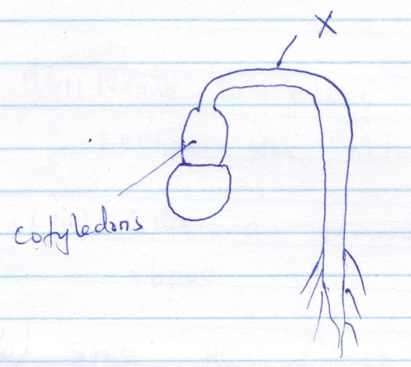
Cotyledons
- Name the type of germination illustrated in the diagram. (1 mark)
___________________________________________________________________________________
- Name the part labelled X. (1 mark)
___________________________________________________________________________________
- Explain how the seedling straightens . (2 marks)
____________________________________________________________________________________________________________________________________________________________________________________________________________________________________________________________________________________________________________________________________________

- State two reasons why plants lack complex excretory organs such as those found in animals. (2 marks)
____________________________________________________________________________________________________________________________________________________________________________________________________________________________________________________________________________________________________________________________________________

- The diagram below shows a section through a plant organ.
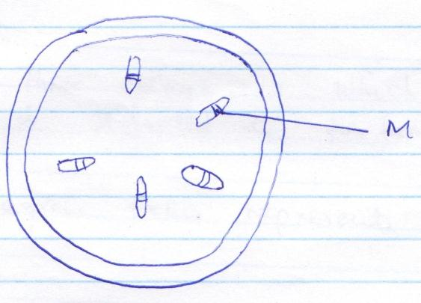
M
- i) Name the class of the plant from which the section was obtained. (1 mark)
___________________________________________________________________________________
ii) Give a reason for your answer in a i) above. (1 mark)
______________________________________________________________________________________________________________________________________________________________________
- State the function of the part labelled M. (1 mark)
______________________________________________________________________________________________________________________________________________________________________

- Give three characteristics of meristematic cells. (3 marks)
____________________________________________________________________________________________________________________________________________________________________________________________________________________________________________________________

- Define the following terms and give an example in each case.
- i) Homologous structures (1 mark)
______________________________________________________________________________________________________________________________________________________________________
ii) Example (1 mark)
___________________________________________________________________________________
- i) Analogous structures (1 mark)
______________________________________________________________________________________________________________________________________________________________________
ii) Example (1 mark)
___________________________________________________________________________________

- State three ways in which the trachea of a man is adapted to perform its functions. (3 marks)
_________________________________________________________________________________________________________________________________________________________________________________________________________________________________________________________

- The diagram represents a cell organelle.
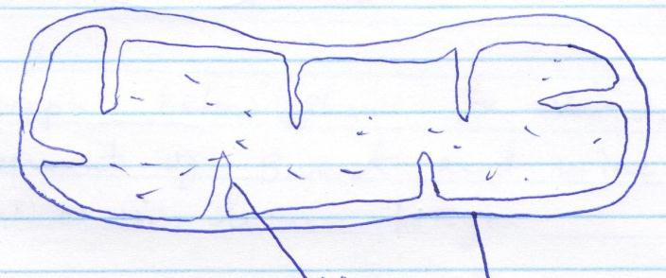
Y
X

- Identify the cell organelle. (1 mark)
___________________________________________________________________________________
- Give the names of the parts labelled X and Y.
X _______________________________________________________________ (1 mark)
Y _______________________________________________________________ (1 mark)
- Name two types of cells in humans beings in which the organelle named in ‘a’ above are
found in large numbers. (2 marks)
_________________________________________________________________________________________________________________________________________________________________________________________________________________________________________________________

- a) State three roles of active transport in human body. (3 marks)
_________________________________________________________________________________________________________________________________________________________________________________________________________________________________________________________
b) Explain why active transport can only take place in the living tissues. (1 mark)
______________________________________________________________________________________________________________________________________________________________________
- a) State two ways in which fungi are harmful to man. (2 marks)
______________________________________________________________________________________________________________________________________________________________________
b) How do the fungi differ from plantsnutritionally? (1 mark)
______________________________________________________________________________________________________________________________________________________________________

- The graph below shows the variations in the amount of sweat and urine with temperature in human beings.
- How does the increase in temperature affect:
- Urine production? (1 mark)
______________________________________________________________________________________________________________________________________________________________________
- Sweat production? (1 mark)
______________________________________________________________________________________________________________________________________________________________________
- State two conditions under which human beings pass little volumes of concentrated urine. (2 marks)
______________________________________________________________________________________________________________________________________________________________________

- List three functions of blood plasma. (3 marks)
_________________________________________________________________________________________________________________________________________________________________________________________________________________________________________________________

- a) Define the term accommodation as used in the mammalian eye? (1 mark)
_________________________________________________________________________________________________________________________________________________________________________________________________________________________________________________________

b) Explain what happens to iris during accommodation in dim light. (2 marks)
_________________________________________________________________________________________________________________________________________________________________________________________________________________________________________________________

- The diagram below represents a stage during cell division.
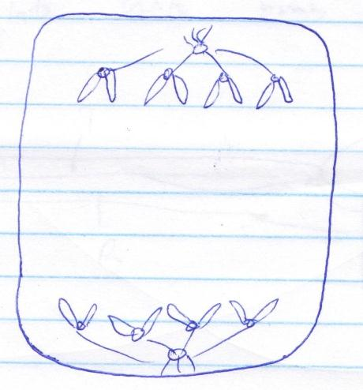
- State the type of cell division. (1 mark)
___________________________________________________________________________________
- i) Identify the stage of the cell division. (1 mark)
___________________________________________________________________________________
ii) Give a reason for your answer in b) i) above. (1 mark)
______________________________________________________________________________________________________________________________________________________________________

- State two factors within the seed that cause seed dormancy. (2 marks)
______________________________________________________________________________________________________________________________________________________________________

- a) What is nitrogen cycle? (1 mark)
______________________________________________________________________________________________________________________________________________________________________
b) Name the denitrifying bacteria. (2 marks)
___________________________________________________________________________________
c) What is the role of rhizobium bacteria in the nitrogen cycle? (1 mark)
______________________________________________________________________________________________________________________________________________________________________

- The diagram below shows how specimen S articulates with bones T and R.

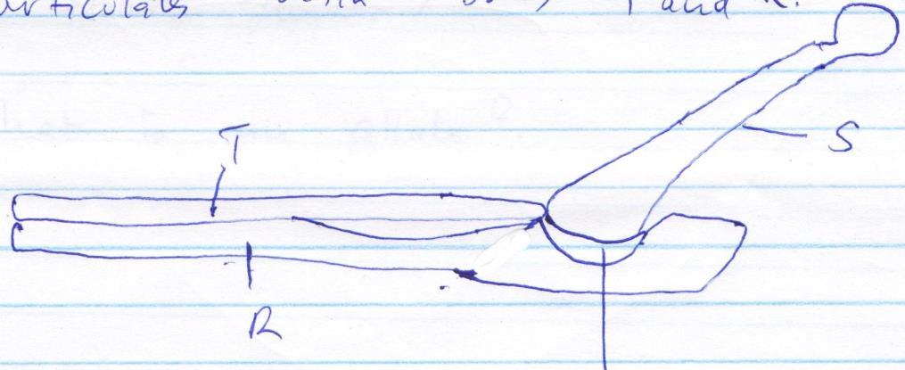
S
T
R
Sigmoid notch

- Identify the bones labelled R, T and S. (3 marks)
R ______________________________________________________________________________
T ______________________________________________________________________________
S ______________________________________________________________________________
- Name the type of joint which exists when the bones articulate at the sigmoid notch. (1 mark)
___________________________________________________________________________________

- Explain how the fallopian tubes in the female reproductive system are adapted to their function. (3 marks)
_______________________________________________________________________________________________________________________________________________________________________________________________________________________________________________________________________________________________________________________________________________________________________________________________________________________________

- Distinguish between osmosis and diffusion. (2 marks)
_______________________________________________________________________________________________________________________________________________________________________________________________________________________________________________________________________________________________________________________________________________________________________________________________________________________________

- What is meant by the following terms?
- Hypogynous flower. (1 mark)
______________________________________________________________________________________________________________________________________________________________________
- Pistillate flower. (1 mark)
______________________________________________________________________________________________________________________________________________________________________

- What is an allele? (1 mark)
______________________________________________________________________________________________________________________________________________________________________

