NAME ____________________________________ INDEX NO. _______________
SCHOOL ____________________________________ SIGNATURE _______________
DATE _______________

231/3
BIOLOGY
Paper 3
(PRACTICAL)
July/August, 2017
TIME: 1¾ HOURS

BRILLIANT

BIOLOGY
Paper 3
(PRACTICAL)
TIME: 1¾ HOURS

INSTRUCTIONS TO CANDIDATES
- Write your name, school and index number in the spaces provided above.
- Write the date of examination and sign in the spaces provided above.
- You are required to spend the first 15 minutes of the 1¾ allowed for this paper reading the whole paper carefully before commencing your work.
- Answer all the questions in spaces provided.
- Additional pages must not be inserted.
- Candidates may be penalized for recording irrelevant information and for incorrect spellings especially of technical terms.
- This paper consists of 5 printed pages.
- Candidates should check to ensure that all pages are printed as indicated and no questions are missing.

FOR OFFICIAL USE ONLY
QUESTION | MAXIMUM SCORE | CANDIDATE’S SCORE
1 | 10
2 | 14
3 | 16
TOTAL SCORE | 40

- You are provided with specimen K_{1.}Examine the specimen.
- Given that the specimen K₁ is a modified stem, draw and label a diagram of the specimen showing observable features which support this view. (4 marks)

- Using a mortar and a pestle crush a piece of specimen K₁ and use the resulting pulp to test for the
food substances present using the given reagents provided. (6 marks)
Food substance | Procedure | Observation | Conclusion

- You are provided with photographs of specimen U, X, Y and Z
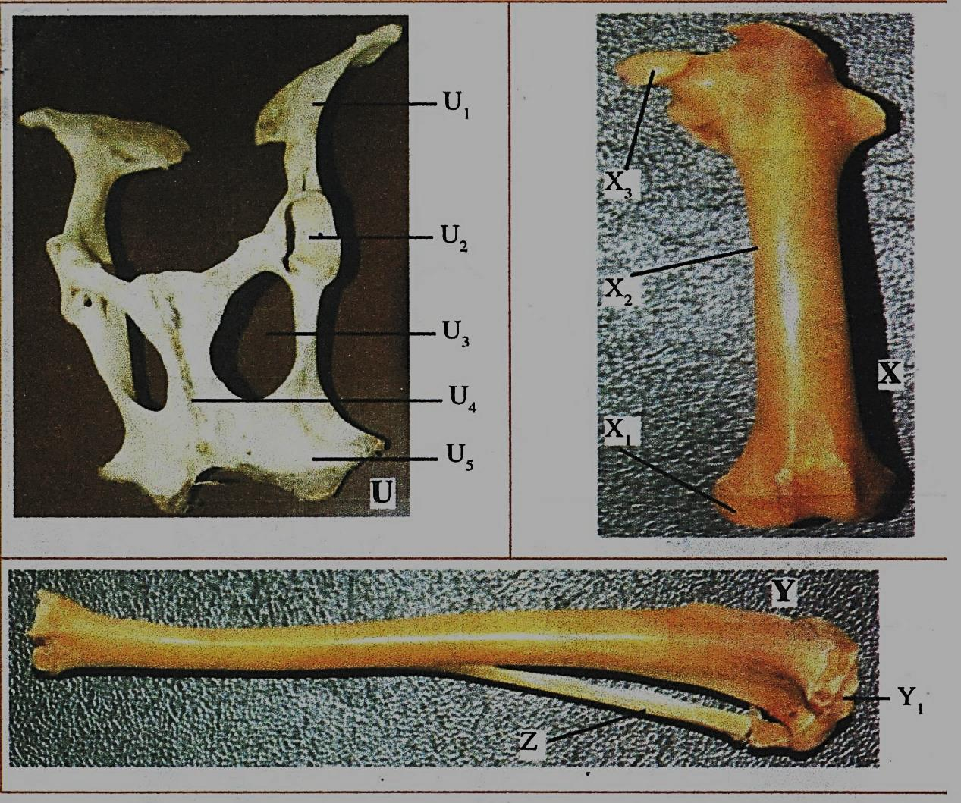
- Name the bones labelled U₁, U₂, U₅, X, Y and Z where each is located in the mammalian body.
(10 marks)
Bone labelled | Bone identity | Location in the mammalian body
U₁
U₄
U₅
X
Y

- Name the joint formed at the proximal end of bone X and its distal end. (2 marks)
- Proximal end _______________________________________________________________
- Distal end _______________________________________________________________
- Name the structures that join the bones together at the joint formed between X₁ and Y_{1.} (1 mark)
___________________________________________________________________________________
- Name the structure at the elbow that performs same function as the patella (1 mark)
___________________________________________________________________________________

- Below are photographs of specimens obtained from plants. Examine the photographs.

- In the table below name the mode of dispersal and feature that adapt the specimen(s) to that mode
of dispersal . (12 marks)
Specimen | Mode of dispersal | Adaptive features

- i) Label any two parts on specimen L. (2 marks)
ii) State the type of placentation in specimen L. (1 mark)
______________________________________________________________________________________________________________________________________________________________________
- Name the structure labelled Won specimen P. (1 mark)
______________________________________________________________________________________________________________________________________________________________________

