Name: …………………………………………………………Index No: ……………………..……………
Candidate’s Signature:……………………………….
Date: ……………….……………….…

443/1
AGRICULTURE
PAPER 1
JULY/AUGUST 2014
TIME: 2 HOURS

Kenya Certificate of Secondary Education

443/1
Agriculture
Paper 1
2 hours

INSTRUCTIONS TO CANDIDATES:
- This paper contains three sections A, B and C
- Answer ALL the questions in section A and B
- Answer any Two questions from section C
- All answers should be written in the spaces provided.

FOR EXAMINERS USE ONLY
SECTION | QUESTIONS | MAX SCORE | CANDIDATES SCORE
A | 1-14 | 30
B | 15-18 | 20
C |  | 20
C |  | 20
TOTAL |  | 90

This paper consists of 8 printed pages. Candidates should check to ascertain that all pages are printed as indicated and that no questions are missing.

SECTION A (30 MARKS)
Answer ALL the questions in this section in the spaces provided
1. Give four reasons why seed selection is important in crop production (2mks)
……………………………………………………………………………………………….……………………
……………………………………………………………………………………………….……………………
……………………………………………………………………………………………….……………………
……………………………………………………………………………………………….……………………
2. State four benefits of a good soil structure to crop production (2mks)
……………………………………………………………………………………………….……………………
……………………………………………………………………………………………….……………………
……………………………………………………………………………………………….……………………
……………………………………………………………………………………………….……………………
3. (a) Define the terms (1mk)
(i) Afforestation
……………………………………………………………………………………………….……………………
(ii) Re-afforestation
……………………………………………………………………………………………….……………………

(b) State four ways by which afforestation helps in land reclamation (2mks)
……………………………………………………………………………………………….……………………
……………………………………………………………………………………………….……………………
……………………………………………………………………………………………….……………………
……………………………………………………………………………………………….……………………
4. List four ways of applying fertilizer in crops (2mks)
……………………………………………………………………………………………….……………………
……………………………………………………………………………………………….……………………
……………………………………………………………………………………………….……………………
……………………………………………………………………………………………….……………………
5. State any four factors that determine the spacing f annual cop (2mks)
……………………………………………………………………………………………….……………………
……………………………………………………………………………………………….……………………
……………………………………………………………………………………………….……………………
……………………………………………………………………………………………….……………………
6. Give four ways by which farmers minimize grain looses in stores (2mks)
……………………………………………………………………………………………….……………………
……………………………………………………………………………………………….……………………
……………………………………………………………………………………………….……………………
……………………………………………………………………………………………….……………………
7. At what stage of growth should tomato seedlings be transplanted (1mk)
……………………………………………………………………………………………….……………………
……………………………………………………………………………………………….……………………
8. Give reasons for carrying out each of the following practices in a tomato nursery (2mks)
(i) Pricking out
……………………………………………………………………………………………….……………………
(ii) Hardening off
……………………………………………………………………………………………….……………………
9. List four materials used for constructing a gabion (2mks)
……………………………………………………………………………………………….……………………
……………………………………………………………………………………………….……………………
……………………………………………………………………………………………….……………………
……………………………………………………………………………………………….……………………
10. State four control measures of maize streak viral disease (2mks)
……………………………………………………………………………………………….……………………
……………………………………………………………………………………………….……………………
……………………………………………………………………………………………….……………………
……………………………………………………………………………………………….……………………
11. (a)Differentiate between undersowing and oversowing in pasture management (1mk)
……………………………………………………………………………………………….……………………
……………………………………………………………………………………………….……………………
(b) State four advantages of undersowing in pasture production (2mks)
……………………………………………………………………………………………….……………………
……………………………………………………………………………………………….……………………
……………………………………………………………………………………………….……………………
……………………………………………………………………………………………….……………………
12. (a) Under what conditions would a farmers business be described as solvent (1mk)
……………………………………………………………………………………………….……………………
……………………………………………………………………………………………….……………………
……………………………………………………………………………………………….……………………
(b) State four ways in which a farmer can increase production efficiency without incurring
extra cost (2mks)
……………………………………………………………………………………………….……………………
……………………………………………………………………………………………….……………………
……………………………………………………………………………………………….……………………
……………………………………………………………………………………………….……………………
13. Explain the following terms as used in farm accounting (2mks)
(i) Cash account
……………………………………………………………………………………………….……………………
(ii) Ledge
……………………………………………………………………………………………….……………………
14. List four benefits a farmer would derive from being a member of dairy co-operative society (2mks)
……………………………………………………………………………………………….……………………
……………………………………………………………………………………………….……………………
……………………………………………………………………………………………….……………………
……………………………………………………………………………………………….……………………
SECTION B (20MARKS)
Answer ALL Questions in this section
15. The diagram below shows a common weed in crop land, use it to answer questions below

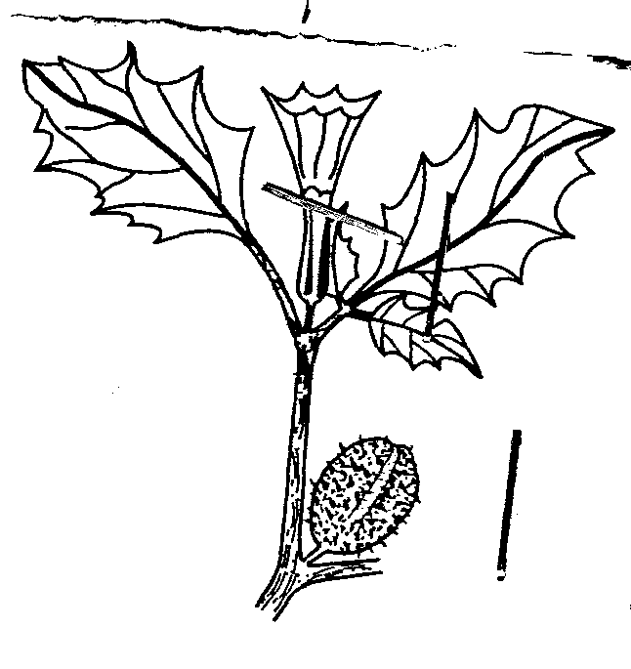

(a) Identify the weed (1mk)
……………………………………………………………………………………………….……………………
(b) State two harmful effect of the above weed to crop production (2mks)
……………………………………………………………………………………………….……………………
……………………………………………………………………………………………….……………………
(c) List two morphological features of a weed that influence its selectivity to herbicides (2mks)
……………………………………………………………………………………………….……………………
……………………………………………………………………………………………….……………………
16. The diagram below shows a structure used in collecting water in the farm
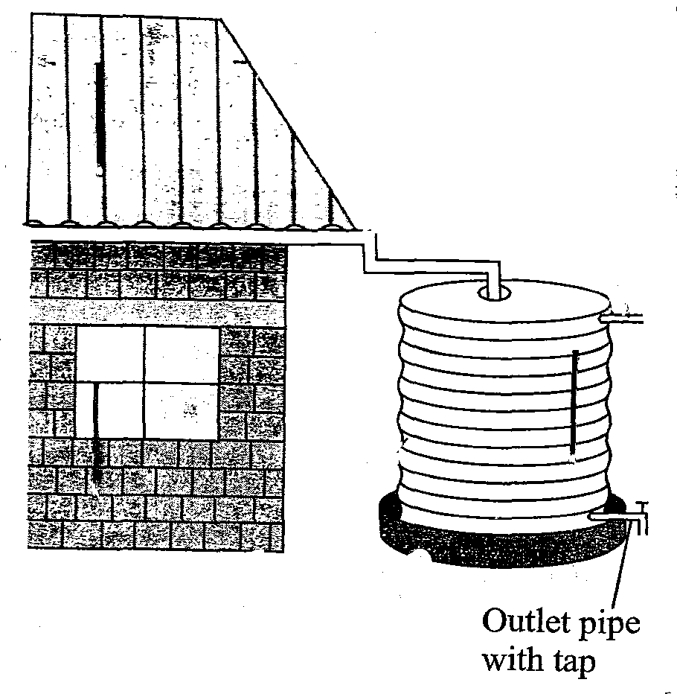

(a) Identify the method of collection above (1mk)
……………………………………………………………………………………………….……………………
(b) Give two factors that will determine the amount of water collected in the above mentioned structure (2mks)
……………………………………………………………………………………………….……………………
……………………………………………………………………………………………….……………………
(c) Outline one maintenance practice that should be carried out on part labeled C above (2mks)
……………………………………………………………………………………………….……………………
(d) Name one other method used in collecting water in the farm (1mk
……………………………………………………………………………………………….……………………

17. Describe the procedure of sampling soil for testing (5mks)
……………………………………………………………………………………………….……………………
……………………………………………………………………………………………….……………………
……………………………………………………………………………………………….……………………
……………………………………………………………………………………………….……………………
……………………………………………………………………………………………….……………………

18. The following information was obtained from Mr. Onyangos farm. Study it and prepare a balance sheet for the farm for the ending 31st December 2013.
5 year loan to the bank 450,000
Land 650,000
1 year loan with AFC 150,000
Creditors 47,000
Unpaid wages 23,000
Owners equity 549,000
Buildings 370,000
Chicken 180,000
Chicken feed 15,000
Cash at hand 10,000
(a) Prepare a balance sheet using the above information ( 4 ½ mks)

(b) Is the farm solvent of insolvent ( ½ mk)
……………………………………………………………………………………………….……………………
SECTION C (40MARKS)
Answer any two Questions in this section
19. (a) Explain how climate influence the rate of soil formation in a given region (6mks)
(b) Describe five factors that are considered in choosing seed rates (10msk)
(c) Outline four problems associated with land fragmentation (4mks)
20. (a) Describe rice production under the following subheadings
(i)Land preparation (5mks)
(ii) Water control (5mks)
(iii) Fertilizer application (2mks)
(b) Describe the various agricultural services available to farmers in Kenya (8mks)
21. (a) Describe the various methods of tree harvesting (6mks)
(b) Explain the various methods of cultural disease control (9mks)
(c) Outline the procedure of preparing a vegetable nursery (5mks)
……………………………………………………………………………………………….……………………
……………………………………………………………………………………………….……………………
……………………………………………………………………………………………….……………………
……………………………………………………………………………………………….……………………
……………………………………………………………………………………………….……………………
……………………………………………………………………………………………….……………………
……………………………………………………………………………………………….……………………
……………………………………………………………………………………………….……………………
……………………………………………………………………………………………….……………………
……………………………………………………………………………………………….……………………
……………………………………………………………………………………………….……………………
……………………………………………………………………………………………….……………………
……………………………………………………………………………………………….……………………
……………………………………………………………………………………………….……………………
……………………………………………………………………………………………….……………………
……………………………………………………………………………………………….……………………
……………………………………………………………………………………………….……………………
……………………………………………………………………………………………….……………………
……………………………………………………………………………………………….……………………
……………………………………………………………………………………………….……………………
……………………………………………………………………………………………….……………………
……………………………………………………………………………………………….……………………
……………………………………………………………………………………………….……………………
……………………………………………………………………………………………….……………………
……………………………………………………………………………………………….……………………
……………………………………………………………………………………………….……………………
……………………………………………………………………………………………….……………………
……………………………………………………………………………………………….……………………
……………………………………………………………………………………………….……………………
……………………………………………………………………………………………….……………………
……………………………………………………………………………………………….……………………
……………………………………………………………………………………………….……………………
……………………………………………………………………………………………….……………………
……………………………………………………………………………………………….……………………
……………………………………………………………………………………………….……………………
……………………………………………………………………………………………….……………………
……………………………………………………………………………………………….……………………
……………………………………………………………………………………………….……………………
……………………………………………………………………………………………….……………………
……………………………………………………………………………………………….……………………
……………………………………………………………………………………………….……………………
……………………………………………………………………………………………….……………………
……………………………………………………………………………………………….……………………
……………………………………………………………………………………………….……………………
……………………………………………………………………………………………….……………………
……………………………………………………………………………………………….……………………
……………………………………………………………………………………………….……………………
……………………………………………………………………………………………….……………………
……………………………………………………………………………………………….……………………
……………………………………………………………………………………………….……………………
……………………………………………………………………………………………….……………………
……………………………………………………………………………………………….……………………
……………………………………………………………………………………………….……………………
……………………………………………………………………………………………….……………………
……………………………………………………………………………………………….……………………
……………………………………………………………………………………………….……………………
……………………………………………………………………………………………….……………………
……………………………………………………………………………………………….……………………
……………………………………………………………………………………………….……………………
……………………………………………………………………………………………….……………………
……………………………………………………………………………………………….……………………
……………………………………………………………………………………………….……………………
……………………………………………………………………………………………….……………………
……………………………………………………………………………………………….……………………
……………………………………………………………………………………………….……………………
……………………………………………………………………………………………….……………………
……………………………………………………………………………………………….……………………
……………………………………………………………………………………………….……………………
……………………………………………………………………………………………….……………………
……………………………………………………………………………………………….……………………
……………………………………………………………………………………………….……………………
……………………………………………………………………………………………….……………………
……………………………………………………………………………………………….……………………
……………………………………………………………………………………………….……………………
……………………………………………………………………………………………….……………………
……………………………………………………………………………………………….……………………
……………………………………………………………………………………………….……………………
……………………………………………………………………………………………….……………………
……………………………………………………………………………………………….……………………
……………………………………………………………………………………………….……………………
……………………………………………………………………………………………….……………………
……………………………………………………………………………………………….……………………
……………………………………………………………………………………………….……………………
……………………………………………………………………………………………….……………………
……………………………………………………………………………………………….……………………
……………………………………………………………………………………………….……………………
……………………………………………………………………………………………….……………………
……………………………………………………………………………………………….……………………
……………………………………………………………………………………………….……………………
……………………………………………………………………………………………….……………………
……………………………………………………………………………………………….……………………
……………………………………………………………………………………………….……………………
……………………………………………………………………………………………….……………………
……………………………………………………………………………………………….……………………
……………………………………………………………………………………………….……………………
……………………………………………………………………………………………….……………………
……………………………………………………………………………………………….……………………
……………………………………………………………………………………………….……………………
……………………………………………………………………………………………….……………………
……………………………………………………………………………………………….……………………
……………………………………………………………………………………………….……………………
……………………………………………………………………………………………….……………………
……………………………………………………………………………………………….……………………
……………………………………………………………………………………………….……………………
……………………………………………………………………………………………….……………………
……………………………………………………………………………………………….……………………
……………………………………………………………………………………………….……………………
……………………………………………………………………………………………….……………………
……………………………………………………………………………………………….……………………
……………………………………………………………………………………………….……………………
……………………………………………………………………………………………….……………………
……………………………………………………………………………………………….……………………
……………………………………………………………………………………………….……………………
……………………………………………………………………………………………….……………………
……………………………………………………………………………………………….……………………
……………………………………………………………………………………………….……………………
……………………………………………………………………………………………….……………………

