Name: …………………………………………………………Index No: ……………………..……………
Candidate’s Signature:……………………………….
Date: ……………….……………….…

443/2
AGRICULTURE
PAPER 2
JULY/AUGUST 2014
TIME: 2 HOURS

Kenya Certificate of Secondary Education (K.C.S.E)

44//2
Agriculture 2
Paper 2
2 hours

INSTRUCTIONS TO CANDIDATES:
- Write your name and index number in the spaces provided.
- Sign and write the date of examination in the spaces provided
- This paper consists of three section A,B and C
- Answer all questions in section B and C
- Answer any two questions in section C
- All the questions should answered in the spaces provided
FOR EXAMINERS USE ONLY
SECTION | QUESTIONS | MAX SCORE | CANDIDATES SCORE
A | 1-18 | 30
B | 19-23 | 20
C  TOTAL |  | 20
C  TOTAL |  | 20
C  TOTAL |  | 90

This paper consists of 8 printed pages. Candidates should check to ascertain that all pages are printed as indicated and that no questions are missing.
SECTION A (30MARKS)
Answer all the questions in this section in the spaces provided
1. List four livestock management practices that can be carried out in a crush (2mks)
…………………………………………………..………………………………………………………
…………………………………………………..………………………………………………………
…………………………………………………..………………………………………………………
…………………………………………………..………………………………………………………
2. Give four products of microbial digestion in the rumen of cattle (2mks)
…………………………………………………..………………………………………………………
…………………………………………………..………………………………………………………
…………………………………………………..………………………………………………………
…………………………………………………..………………………………………………………
3. Name four parts of the animal preferred by two horst tick (2mks)
…………………………………………………..………………………………………………………
…………………………………………………..………………………………………………………
…………………………………………………..………………………………………………………
…………………………………………………..………………………………………………………
4. Why is drenching alone not an effective method of controlling internal parasites (1mk)
…………………………………………………..………………………………………………………
…………………………………………………..………………………………………………………
5. State four causes of infertility in dairy cattle (2mks)
…………………………………………………..………………………………………………………
…………………………………………………..………………………………………………………
…………………………………………………..………………………………………………………
…………………………………………………..………………………………………………………
6. Define the following terms as used in livestock breeding
(i) Inbreeding ( ½ mk)
…………………………………………………..………………………………………………………
…………………………………………………..………………………………………………………
(ii) Outcrossing ( ½ mk)
…………………………………………………..………………………………………………………
…………………………………………………..………………………………………………………
7. Give four reasons why the feeding on colostrums is important in the rearing of piglets (2mks)
…………………………………………………..………………………………………………………
…………………………………………………..………………………………………………………
…………………………………………………..………………………………………………………
…………………………………………………..………………………………………………………
8. State four functions of the worker bee in a colony (2mks)
…………………………………………………..………………………………………………………
…………………………………………………..………………………………………………………
…………………………………………………..………………………………………………………
…………………………………………………..………………………………………………………
9. List any six tools used when constructing a wooden fence (3mks)
…………………………………………………..………………………………………………………
…………………………………………………..………………………………………………………
…………………………………………………..………………………………………………………
…………………………………………………..………………………………………………………
…………………………………………………..………………………………………………………
…………………………………………………..………………………………………………………
10. Name any two wood preservatives (1mk)
…………………………………………………..………………………………………………………
…………………………………………………..………………………………………………………
11. (a)List four symptoms that would show that a cow is suffering from milk fever (2mks)
…………………………………………………..………………………………………………………
…………………………………………………..………………………………………………………
…………………………………………………..………………………………………………………
…………………………………………………..………………………………………………………
(b) Name two other farm animals that may suffer from milk fever (1mk)
…………………………………………………..………………………………………………………
…………………………………………………..………………………………………………………
12. State four observations in behavior of chicks which would indicate that the temperature of the brooder is too high (2mks)
…………………………………………………..………………………………………………………
…………………………………………………..………………………………………………………
…………………………………………………..………………………………………………………
…………………………………………………..………………………………………………………
13. How long is the gestation period in
(i) cattle ( ½ mk)
…………………………………………………..………………………………………………………
(ii) Rabbits ( ½ mk)
…………………………………………………..………………………………………………………

14. Give three ways of stimulating milk let down in a dairy cow (1 ½ mks)
…………………………………………………..………………………………………………………
…………………………………………………..………………………………………………………
…………………………………………………..………………………………………………………
15. State any three maintenance practices on an ox-plough ( 1 ½ mks)
…………………………………………………..………………………………………………………
…………………………………………………..………………………………………………………
…………………………………………………..………………………………………………………
16. Name two methods of increasing ploughing depth when using a disk plough (1mk)
…………………………………………………..………………………………………………………
…………………………………………………..………………………………………………………
17. Name two cattle diseases that can be controlled by administering one vaccine (1mk)
…………………………………………………..………………………………………………………
…………………………………………………..………………………………………………………
18. Outline two disadvantages of biogas as a source of farm power (1mk)
…………………………………………………..………………………………………………………
…………………………………………………..………………………………………………………
SECTION B (20 MARKS)
Answer all the questions in this section in the spaces provided.
19. A dairy farmer wanted to prepare 800kg of a calf rearing ration containing 20% DCP. If he were to use maize containing 10% DCP and sunflower containing 35% DCP, calculate the amount of each feedstuff needed to prepare the ration using Pearson’s square method. (Show your working) (4mks)

20. The diagram below shows some workshop tools. Study them and answer the questions that follow
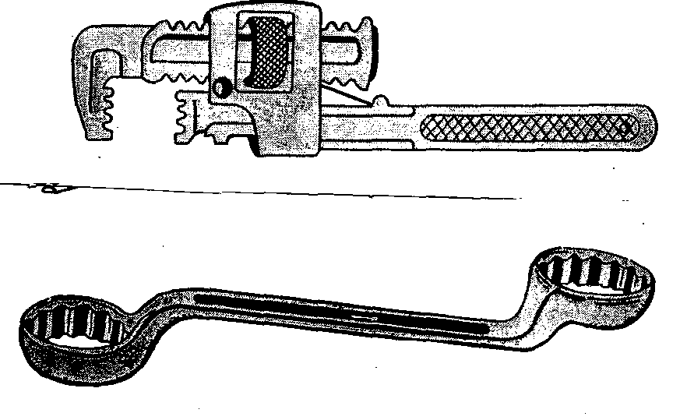

A B
(a) Identify the tools A and B (2mks)
A…………………………………………………..………………………………………
B…………………………………………………..………………………………………
(b) State the correct use of the tool labeled A (1mk)
…………………………………………………..………………………………………………………
(c) Explain one maintenance practice carried out on the tool A (1mk)
…………………………………………………..………………………………………………………
21. Below is a diagram of a rabbit breed kept in the farm
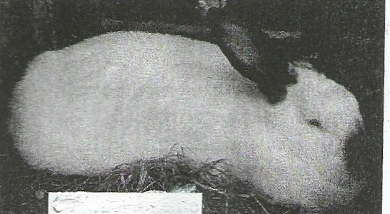

(a)(i) Name the rabbit breed shown above (1mk)
…………………………………………………..………………………………………………………
(ii) Give two reasons for your answer in a(i) above (2mks)
…………………………………………………..………………………………………………………
…………………………………………………..………………………………………………………
(b) State the purpose for which the above rabbit breed is kept (1mk)
…………………………………………………..………………………………………………………22. Study the diagram of a fence below and answer the questions that follow
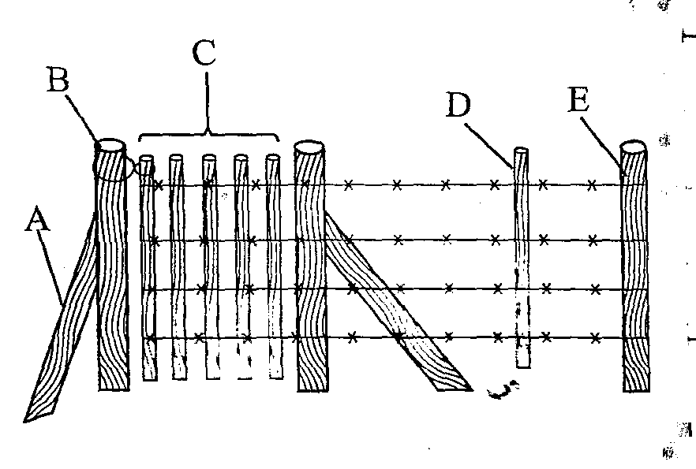

(a) Name the type of fence shown above (1mk)
…………………………………………………..………………………………………………………
(b) Name the parts labeled A and D (2mks)
A…………………………………………………..…………………………………………
B…………………………………………………..…………………………………………
(c) State the use of the part labeled D in the fence (1mk)
…………………………………………………..………………………………………………………
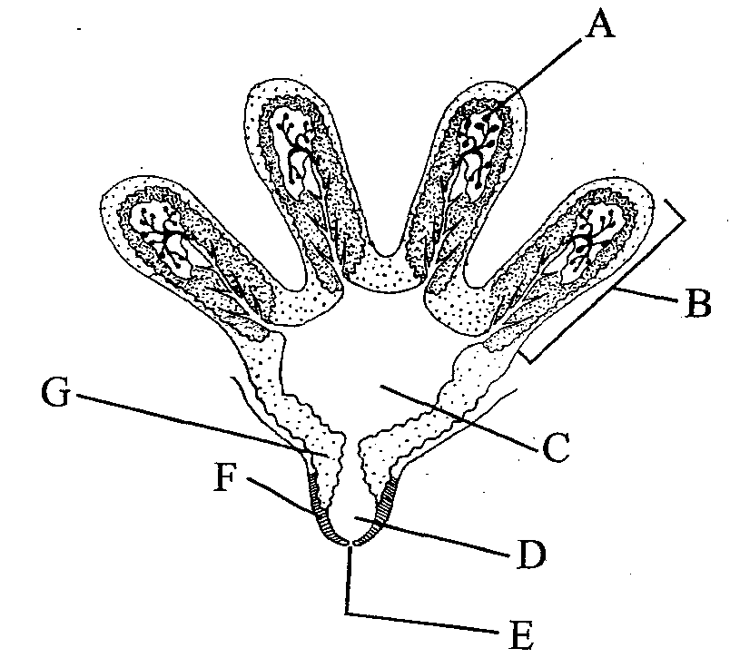
23. The diagram below shows the structure of the udder. Study it and answer the questions that follow

(a) Name the parts labeled B and D (2mks)
B………………………………………..
D………………………………………..
(b) In which of the labeled parts does milk secretion take place? (1mk)
…………………………………………………..………………………………………………………
(c) For how long should milking take place? (1mk)
…………………………………………………..………………………………………………………

SECTION C
Answer any two questions in this section in the spaces provided after question 26.
24. (a) Explain the reasons why the Boran cattle does well in arid and semi arid areas (5mks)
(b) Mention five symptoms of attack by internal parasites on livestock (5mks)
(c) Describe the short term maintenance practices on a tractor (10mks)
25. (a) Describe foot and mouth disease under the following subheadings:
(i) causal organism (1mk)
(ii) Animals affected (2mks)
(iii) Symptoms (4mks)
(iv) Control measures (3mks)
(b) Give five general heat signs observed in animals (5mks)
(c) Describe the procedure of training a calf from birth to weaning (12mks)
26. (a) Describe the management of a dairy calf from birth to weaning (12mks) (b) State five functions of water in an animals body (5mks)
(c) Outline three reasons for maintaining farm tools and equipment (3mks) …………………………………………………..………………………………………………………
…………………………………………………..………………………………………………………
…………………………………………………..………………………………………………………
…………………………………………………..………………………………………………………
…………………………………………………..………………………………………………………
…………………………………………………..………………………………………………………
…………………………………………………..………………………………………………………
…………………………………………………..………………………………………………………
…………………………………………………..………………………………………………………
…………………………………………………..………………………………………………………
…………………………………………………..………………………………………………………
…………………………………………………..………………………………………………………
…………………………………………………..………………………………………………………
…………………………………………………..………………………………………………………
…………………………………………………..………………………………………………………
…………………………………………………..………………………………………………………
…………………………………………………..………………………………………………………
…………………………………………………..………………………………………………………
…………………………………………………..………………………………………………………
…………………………………………………..………………………………………………………
…………………………………………………..………………………………………………………
…………………………………………………..………………………………………………………
…………………………………………………..………………………………………………………
…………………………………………………..………………………………………………………
…………………………………………………..………………………………………………………
…………………………………………………..………………………………………………………
…………………………………………………..………………………………………………………
…………………………………………………..………………………………………………………
…………………………………………………..………………………………………………………
…………………………………………………..………………………………………………………
…………………………………………………..………………………………………………………
…………………………………………………..………………………………………………………
…………………………………………………..………………………………………………………
…………………………………………………..………………………………………………………
…………………………………………………..………………………………………………………
…………………………………………………..………………………………………………………
…………………………………………………..………………………………………………………
…………………………………………………..………………………………………………………
…………………………………………………..………………………………………………………
…………………………………………………..………………………………………………………
…………………………………………………..………………………………………………………
…………………………………………………..………………………………………………………
…………………………………………………..………………………………………………………
…………………………………………………..………………………………………………………
…………………………………………………..………………………………………………………
…………………………………………………..………………………………………………………
…………………………………………………..………………………………………………………
…………………………………………………..………………………………………………………
…………………………………………………..………………………………………………………
…………………………………………………..………………………………………………………
…………………………………………………..………………………………………………………
…………………………………………………..………………………………………………………
…………………………………………………..………………………………………………………
…………………………………………………..………………………………………………………
…………………………………………………..………………………………………………………
…………………………………………………..………………………………………………………
…………………………………………………..………………………………………………………
…………………………………………………..………………………………………………………
…………………………………………………..………………………………………………………
…………………………………………………..………………………………………………………
…………………………………………………..………………………………………………………
…………………………………………………..………………………………………………………
…………………………………………………..………………………………………………………
…………………………………………………..………………………………………………………
…………………………………………………..………………………………………………………
…………………………………………………..………………………………………………………
…………………………………………………..………………………………………………………
…………………………………………………..………………………………………………………
…………………………………………………..………………………………………………………
…………………………………………………..………………………………………………………
…………………………………………………..………………………………………………………
…………………………………………………..………………………………………………………
…………………………………………………..………………………………………………………
…………………………………………………..………………………………………………………
…………………………………………………..………………………………………………………
…………………………………………………..………………………………………………………
…………………………………………………..………………………………………………………
…………………………………………………..………………………………………………………
…………………………………………………..………………………………………………………
…………………………………………………..………………………………………………………
…………………………………………………..………………………………………………………
…………………………………………………..………………………………………………………
…………………………………………………..………………………………………………………

