Name……………………………………………………..………… Index No:………………………….
231/2 Candidate’s Signature …………..……………
BIOLOGY Date: …………………………
PAPER 2
THEORY
JULY/AUGUST- 2014
TIME: 2 HOURS

Kenya Certificate of Secondary Education (K.C.S.E.)
2312
Biology
Paper 2

INSTRUCTIONS TO CANDIDATES
- Write your name and indexnumber in the spaces provided above
- Sign and write the date of examination in the spaces provided.
- This paper consists of two sections A and B
- In section B answer questions 6 compulsory and either question 7 or 8 in the spaces provided after question 8
- Answer all the questions in the spaces provided.
- Candidates should answer all the questions in English

For Examiners Use Only
Section | Question | Maximum score | Candidate’s score
A | 1 | 8
A | 2 | 8
A | 3 | 8
A | 4 | 8
A | 5 | 8
B | 6 | 20
B | 7 | 20
B | 8 | 20
TOTAL |  | 80

This paper consists of 8 printed pages. Candidates should check to ascertain that all pages are printed as indicated and that no questions are missing.
- The diagram below represent blood circulatory system in animal.
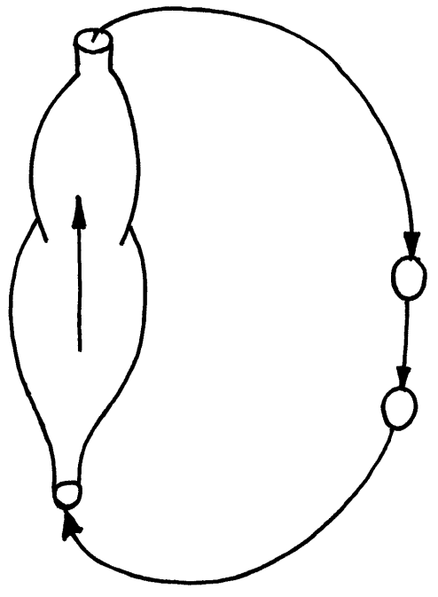
R
P
S

II

I

- Name the class whose member shows the circulatory system above. (1mk)
………………………………………………………………………………………………….
- (i) Name the parts labeled I and II (2mks)
I…………………………………………………….
II……………………………………………………
(ii) State two differences in blood composition and flow in blood vessels R and P ( 2mks)
………………………………………………………………………………………………….
………………………………………………………………………………………………….
- (i) Explain why root pressure stops when a root is deprived of oxygen. (1mk)
………………………………………………………………………………………………….
………………………………………………………………………………………………….
(ii) Explain why a plant stomata may close during a hot sunny afternoon only to reopen
a short while later. (2mks)
………………………………………………………………………………………………….
………………………………………………………………………………………………….
- In human haemophilia is caused by a recessive gene . A man whose mother was haemophiliac marries a normal woman whose father was haemophiliac. Set H represents dominant gene.
- Define the term recessive gene. (1mk)
………………………………………………………………………………………………….
- (i) What is the possible genotype of the woman. (1mk)
………………………………………………………………………………………………….

(ii) Using pannet square work the genotypes of the first filial generation. Show your work.
(4mks)
………………………………………………………………………………………………….
………………………………………………………………………………………………….
………………………………………………………………………………………………….
………………………………………………………………………………………………….
- (i) What is the probability of the daughter being haemophillic. (1mk)
………………………………………………………………………………………………….
(ii) State one advantage of mutation to plants. (1mk)
………………………………………………………………………………………………….
- A form 4 class set up an experiment as shown in the diagram below. All the three set ups had growing maize seedling in box.
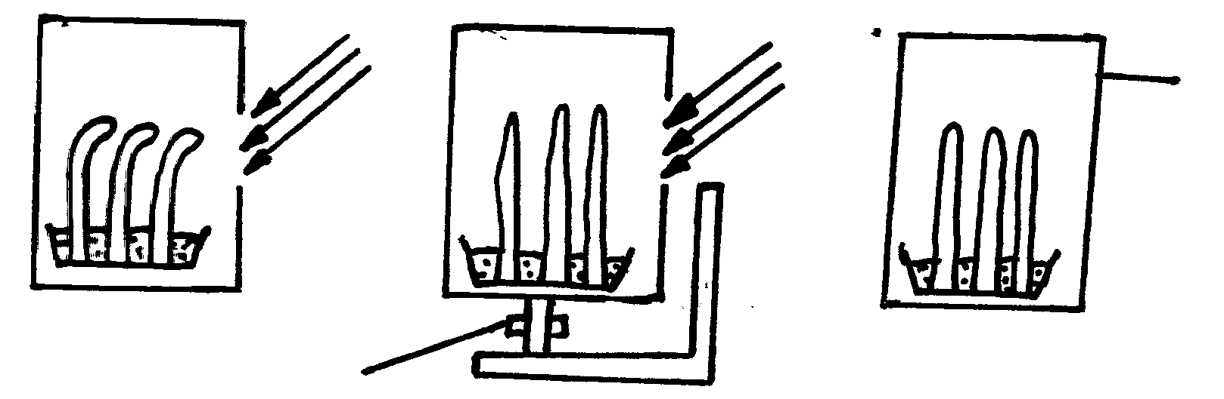
Set up C
Set up B
Set up A

Black paristed box
Revolving Unistat

- Suggest the aim of the experiment (1mk)
………………………………………………………………………………………………….
- (i) Account for the result shown in set up A (2mks)
………………………………………………………………………………………………….
………………………………………………………………………………………………….
(ii) What was the purpose of klirostay in the set up B. (1mk)
………………………………………………………………………………………………….
- (i) Name the phenomenon exhibited by the set up C result. (1mk)
………………………………………………………………………………………………….
(ii) What is the significance of the phenomenon named in C(i) above. (1mk)
………………………………………………………………………………………………….
- State two importance synapse in the neurone system (2mks)
………………………………………………………………………………………………….
………………………………………………………………………………………………….

- A group of students set up an experiment to demonstrate a certain process as shown below.
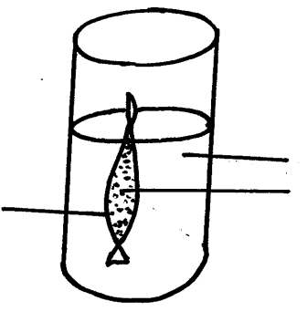

Iodine solution
Visking tubing
Starch solution boiled with dilute hydrochloric acid

After 10 minutes the students carried out iodine test inside and outside the visking tuning.

- State two rolesof the process being investigated in animals. (2mks)
………………………………………………………………………………………………….
………………………………………………………………………………………………….
- Account for the result expected in the experiment above. ( 3mks)
………………………………………………………………………………………………….
………………………………………………………………………………………………….
………………………………………………………………………………………………….
………………………………………………………………………………………………….
- (i) What is the importance of plasma membrane in active transport. (2mks)
………………………………………………………………………………………………….
………………………………………………………………………………………………….
(ii) Give one similarity between osmosis and active transport. (1mk)
………………………………………………………………………………………………….
………………………………………………………………………………………………….
- The diagram below represents a stage of growth in a seed during germination.
Q
P
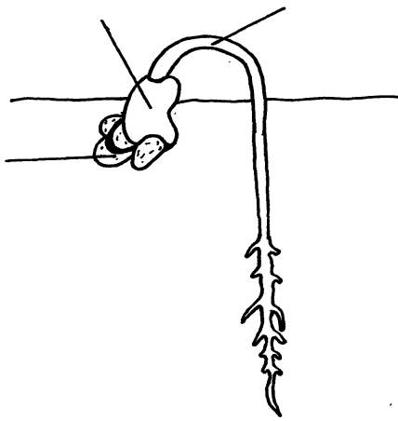

R

- (i) Name the type of germination illustrated above (1mk)
………………………………………………………………………………………………….
………………………………………………………………………………………………….
(ii) Give a reason for your answer in (i) above (1mk)
………………………………………………………………………………………………….
………………………………………………………………………………………………….
- Name the part labellled R in the above diagram. (1mk)
………………………………………………………………………………………………….
………………………………………………………………………………………………….
- Give two functions of the part labeled Q (2mks)
………………………………………………………………………………………………….
………………………………………………………………………………………………….
- Explain how the part labeled P straightens. ( 3mks)
………………………………………………………………………………………………….
………………………………………………………………………………………………….
………………………………………………………………………………………………….
………………………………………………………………………………………………….
6. An investigation was carried out to study the changes of fish population in a small lake. Two specimen of fish L and M was found to live there. It was found that on the 7th month of study, a factory was built near the lake and was found to discharge hot water. On the 8th month, sewage and industrial waste from a nearby town was diverted into the lake. On the 30th month, the ministry of environment intervened and the factory was closed. The sewage and industrial wastes were diverted elsewhere. Study the table below.
Time in month |  | 0 | 12 | 24 | 36 | 48 | 60 | 72
Number of fish | L | 6000 | 3600 | 1100 | 1400 | 2700 | 4750 | 7300
Number of fish | M | 4500 | 2000 | 300 | 350 | 500 | 1100 | 1600

- (i) using a suitable scale draw the two graphs of species L and M against the same axes (8mks)
(ii) in which month were the fish population lowest (1mk)
- Account for the low population of fish species with regard to the following.
(i) discharge of hot water ( 2mks)

(ii) Sewage dispersal (2mks)

(iii) Industrial refuse ( 2mks)

- (i) After how many months was the different in population of fish species L and M greatest. (1mk)

(ii) Explain why there was that great difference in two species. (3mks)
………………………………………………………………………………………………….
………………………………………………………………………………………………….
………………………………………………………………………………………………….
- State an appropriate sampling method they could have used to estimate the population of the fish.
(1mk)
………………………………………………………………………………………………….
………………………………………………………………………………………………….

7 (a) Explain the adaptations of Kidney tubules to their function (10mks)
(b) Describe the role of pituitary gland in female reproductive system. (10mks)

8 (a) describe the following evidences of evolution.
- Comparative anatomy (6mks)
- Cell biology (2mks)
- comparative embryology (2mks)
(b) Discuss the light and dark stage of photosynthesis. (10mks)

………………………………………………………………………………………………….
………………………………………………………………………………………………….
………………………………………………………………………………………………….
………………………………………………………………………………………………….
………………………………………………………………………………………………….
………………………………………………………………………………………………….
………………………………………………………………………………………………….
………………………………………………………………………………………………….
………………………………………………………………………………………………….
………………………………………………………………………………………………….
………………………………………………………………………………………………….
………………………………………………………………………………………………….
………………………………………………………………………………………………….
………………………………………………………………………………………………….
………………………………………………………………………………………………….
………………………………………………………………………………………………….
………………………………………………………………………………………………….
………………………………………………………………………………………………….
………………………………………………………………………………………………….
………………………………………………………………………………………………….
………………………………………………………………………………………………….
………………………………………………………………………………………………….
………………………………………………………………………………………………….
………………………………………………………………………………………………….
………………………………………………………………………………………………….
………………………………………………………………………………………………….
………………………………………………………………………………………………….
………………………………………………………………………………………………….
………………………………………………………………………………………………….
………………………………………………………………………………………………….
………………………………………………………………………………………………….
………………………………………………………………………………………………….
………………………………………………………………………………………………….
………………………………………………………………………………………………….
………………………………………………………………………………………………….
………………………………………………………………………………………………….
………………………………………………………………………………………………….
………………………………………………………………………………………………….
………………………………………………………………………………………………….
………………………………………………………………………………………………….
………………………………………………………………………………………………….
………………………………………………………………………………………………….
………………………………………………………………………………………………….
………………………………………………………………………………………………….
………………………………………………………………………………………………….
………………………………………………………………………………………………….
………………………………………………………………………………………………….
………………………………………………………………………………………………….
………………………………………………………………………………………………….
………………………………………………………………………………………………….
………………………………………………………………………………………………….
………………………………………………………………………………………………….
………………………………………………………………………………………………….
………………………………………………………………………………………………….
………………………………………………………………………………………………….
………………………………………………………………………………………………….
………………………………………………………………………………………………….
………………………………………………………………………………………………….
………………………………………………………………………………………………….
………………………………………………………………………………………………….
………………………………………………………………………………………………….
………………………………………………………………………………………………….

