Name…………………………………… …………………………..…Index No:………………………….
231/3 Candidate’s Signature …………..……………
BIOLOGY Date: …………………………
PAPER 3
PRACTICAL
JULY/AUGUIST- 2014
TIME: 1 ¾ HOURS

Kenya Certificate of Secondary Education (K.C.S.E.)
231/3
Biology
Paper 3
1 ¾ Hours

INSTRUCTIONS TO CANDIDATES

- Write your name and indexnumber in the spaces provided above
- Sign and write the date of examination in the spaces provided.
- Answer all the questions in the spaces provided.
- You are requiredtospend the first 15 minutes of the 1 ¾ hours allowed for this paper reading the whole paper carefully before commencing your work.
- Additional pages must not be inserted.
- Candidates should check to ascertain that all pages are printed as indicated and that no questions are missing.
- candidates must answer all questions in English

For Examiners Use Only
Question | Maximum score | Candidate’s score
1 | 12
2 | 16
3 | 12
Total | 40

This paper consists of 4 printed pages. Candidates should check to ascertain that all pages are printed as indicated and that no questions are missing.
- You are provided with a sample of food labeled B in solution form, DCPIP, sodium hydroxide, copper (II) sulphate Benedict’s reagent. Carry out tests on the food sample to identify the type of food substances present. (12mks)
Food being tested for | Procedure | Observation | Conclusion

- Bellow are photographs of specimens obtained from plants. Examine the photographs.

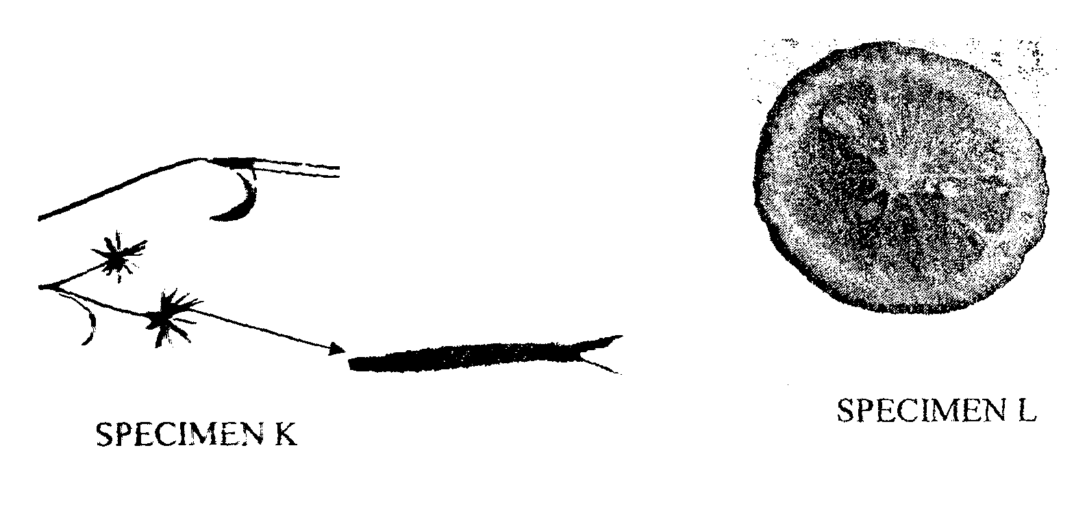
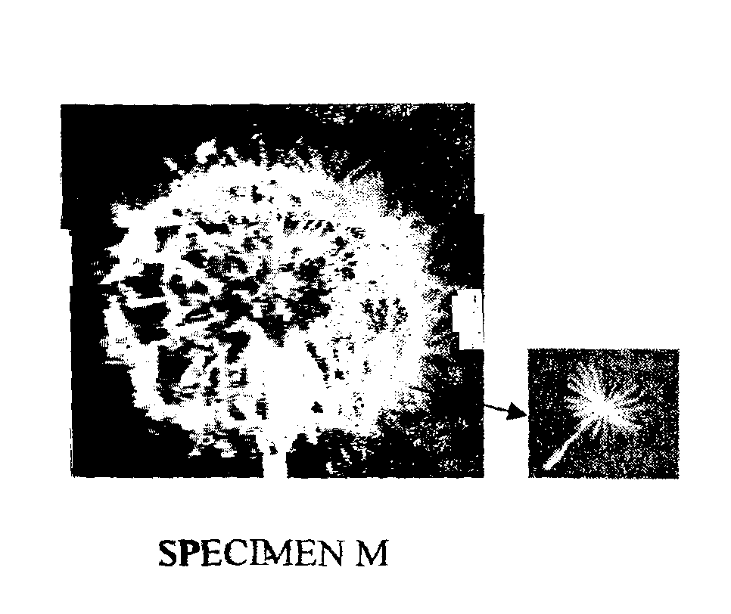
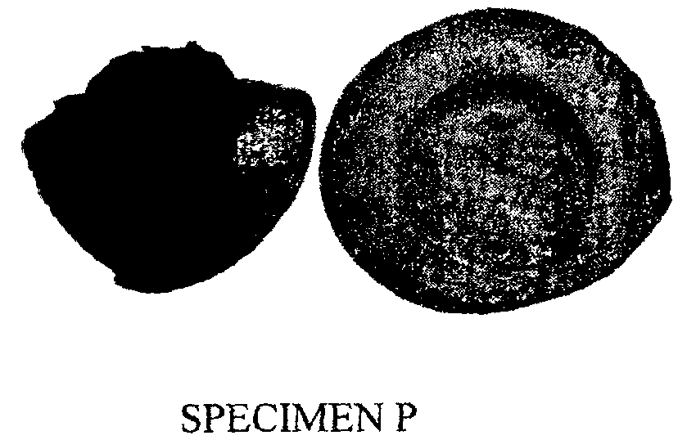
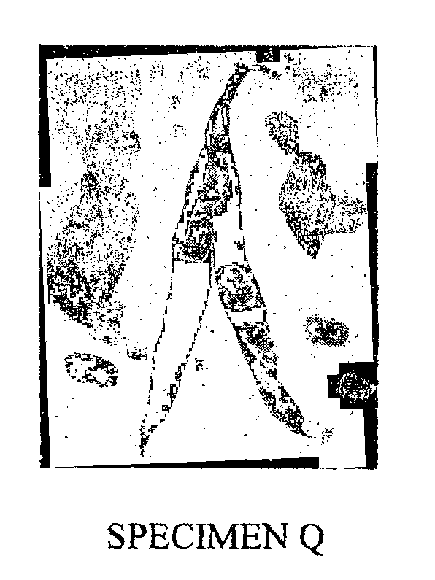
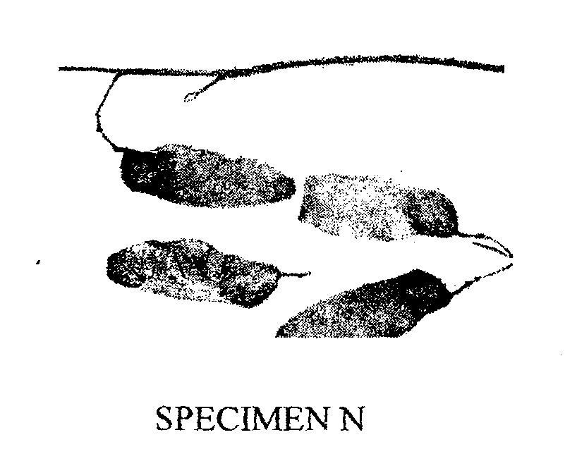

- In the table below name the mode of dispersal and the features that adapt the specimen(s) to that mode of dispersal. (12mk)

Specimen | Mode of dispersal | Adaptive features
K

L

M

N

P

Q

- (i) Label any two parts on specimen L. (2mks)
………………………………………………………………………………………………
………………………………………………………………………………………………
(ii) State the type of placentation in specimen L. (1mk)
………………………………………………………………………………………………
- Name the structure labeled W on specimen P. (1mk)
………………………………………………………………………………………………

- Examine photographs labeled T and S given below and use them to answer the questions that follow.
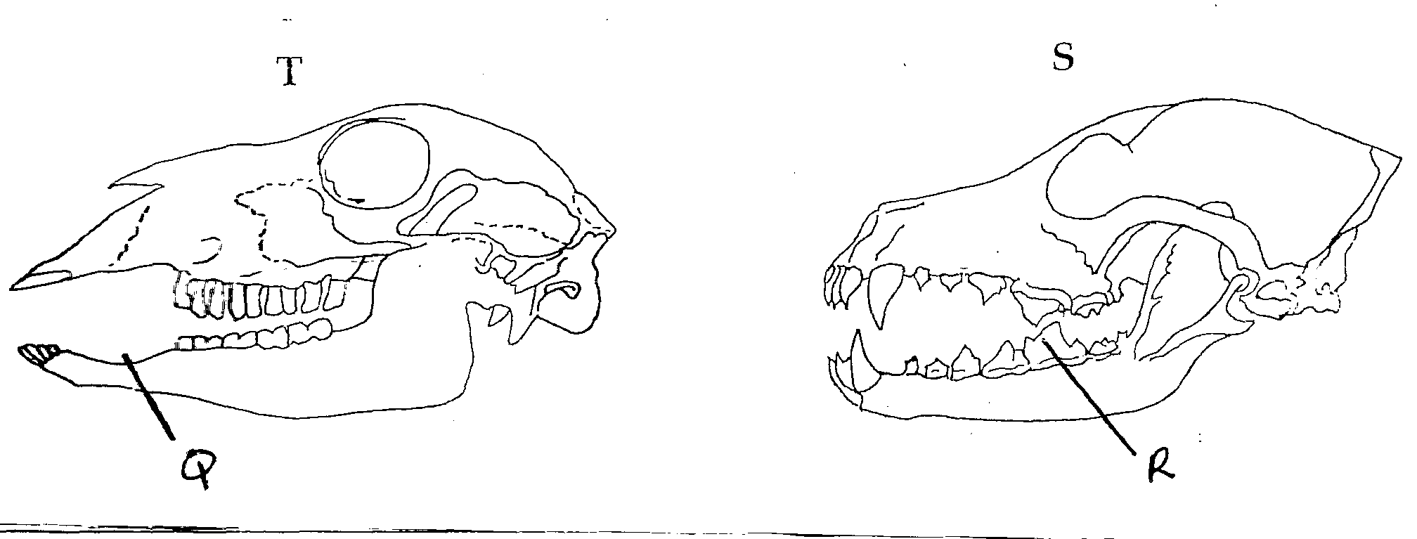

- Giving reasons ,name the mode of nutrition of the mammals whose skulls are shown in the photographs.
T………………………………………………. (1mk)
Reasons (2mks)
………………………………………………………………………………………………
………………………………………………………………………………………………
………………………………………………………………………………………………
………………………………………………………………………………………………

S………………………………………………. (1mk)
Reasons (2mks)
………………………………………………………………………………………………
………………………………………………………………………………………………
………………………………………………………………………………………………
………………………………………………………………………………………………
- In the appropriate diagram, label the position where the horny pad would be found in a living animals. (1mk)
- Name the part labelled Q and state its function in photograph T.
Name………………………………………………………………………. (1mk)
Function…………………………………………………………………….. (1mk)
- Explain how the part labeled R is adapted to its function. (3mks)
………………………………………………………………………………………………
………………………………………………………………………………………………
………………………………………………………………………………………………
………………………………………………………………………………………………

